1. One time only – Generate the token as below and save it.

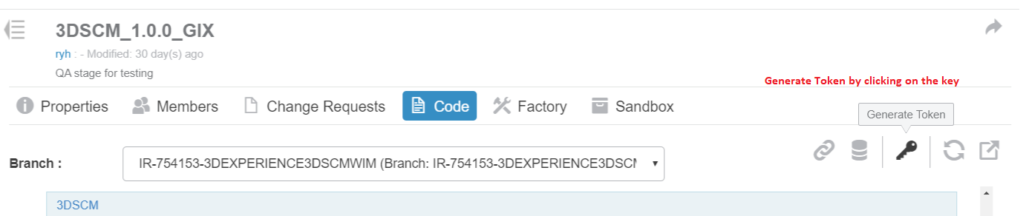

1. The token will be used during Git clone.

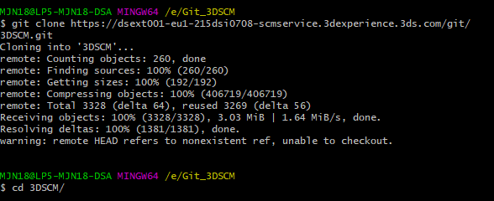

1. Clone the repo and checkout branch remotes/origin/IR-754153-3DEXPERIENCE3DSCMWIM_GIX
2. Merge with branch remotes/origin/version_3DSCM-1.0.0
3. Push the changes

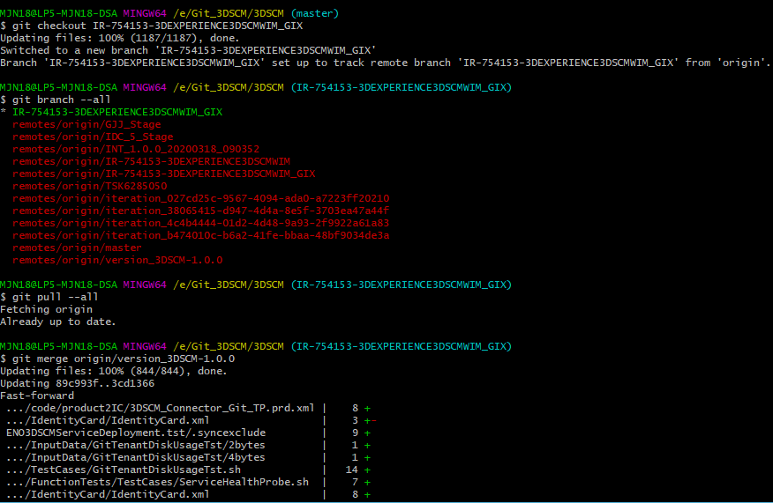

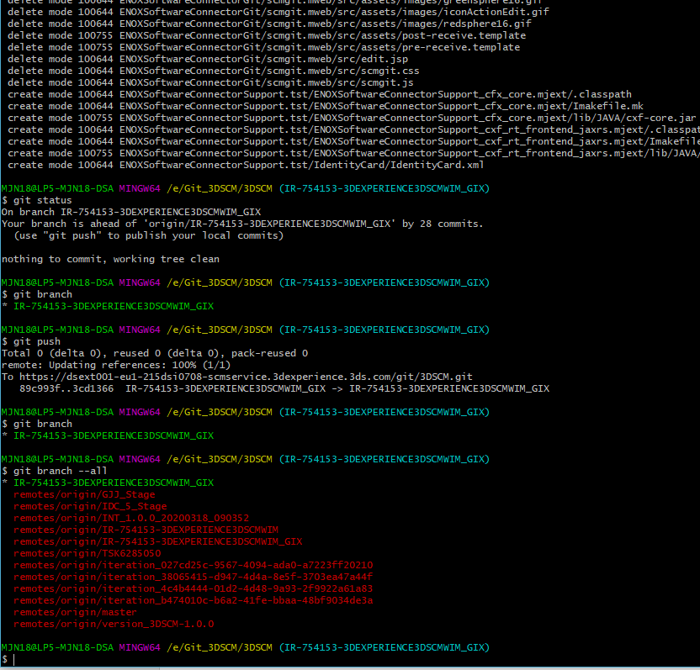

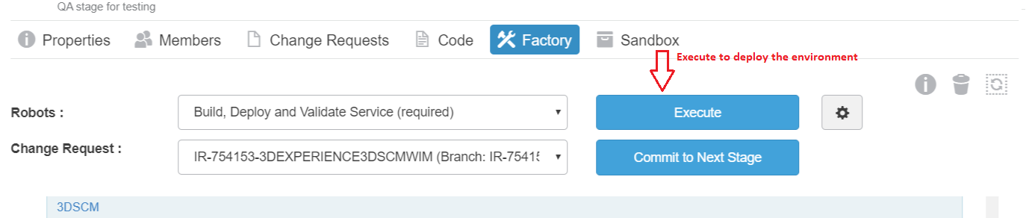

**Steps to link in 3DSCM running in my CD Sandbox to be accessible to XSF in Dev Sandbox**

1. Remotely login to the 3DSCM VM that's running the Dev Sandbox  
     
   > Doing this to copy the 3DPassport and 3DSearch URL's to my 3DSCM VM running in my CD sandbox  
     
   sh> vi /usr/local/tomcat2/apache-tomcat/WEB-INF/3DSCM/scmdaemon.xml
2. Remotely login to the 3DSCM VM that's running in my CD Sandbox

Copy the 3DPassport and 3DSearch URL's from step 1 into scmdaemon.xml in this VM

1. Stop and restart tomcat for the 3DSCM VM in the CD sandbox  
     
   sh> cd /usr/local/tomcat2/apache-tomcat/bin  
   sh> ./shutdown.sh  
   sh> ./startup.sh
2. Back in the Dev Sandbox, in the XSF webapp, create a new SCMRepository object of 3DSCM type.  
     
   => This will currently be pointing to the 3DSCM service running in the Dev Sandbox, which is not what you want, so we need to fix that.

1. (see notes above) Open up MQL on the Dev Sandbox “metadata_0” machine, set context to creator and the right tenant
2. Run this:  
   mql> modify bus SCMRepository NAME_OF_SCM_REPOSITORY_OBJECT - SCMRepository.address URL_COPIED_FROM_GIT_CONFIG_PAGE;  
     
   Where:  
   NAME_OF_SCM_REPOSITORY_OBJECT: Is the name of the new Repository object you just created.  
   URL_COPIED_FROM_GIT_CONFIG_PAGE: Is the “SCM Connector Address” which you should copy/paste from the Git Connector Configuration panel.