How to change Bitlocker for BCNC/IDE/IBC
https://spear.service-management.bosch.tech/support?article=KB0011356

For Windows Internet Clients (IBC/IDE) the BitLocker Recovery Key can be retrieved via this link:
https://uems.bosch.tech/blrec

Bitlocker recovery page, without using IT Workplace tool kit.
https://mbam.bosch.tech/SelfService/Recovery/Index

How to change password via VPN application:
https://service-management.bosch.tech/now/nav/ui/classic/params/target/kb_view.do%3Fid%3Dkb_article_view%26sys_kb_id%3Dfbb27075c35b1210ed903fcf050131fb
Try in this order when Outlook has serious issues:
- /safe — Check if problem disappears
- /resetnavpane
- /cleanviews
- /cleanprofile
- %localappdata%\Microsoft\Outlook\RoamCache

Created group chat quickly in ms teams
New Message: Ctrl + N. after type required user names and enter
2. Teams "Slash Commands" (In-App) [1]
To use these, click the Search bar at the top of Teams or press Ctrl + E, then type a forward slash (/) followed by a command. [1, 2]
Command [1, 2, 3, 4, 5, 6, 7, 8] | Action
/available | Set your status to Available
/away | Set your status to Away
/busy | Set your status to Busy
/dnd | Set your status to Do not disturb
/call | Start a call with a person or phone number
/chat | Send a quick message to a team member
/files | See your recently accessed files
/goto | Jump directly to a specific team or channel
/keys | View all available keyboard shortcuts
/unread | See all your unread activity in one place
/saved | Access your saved messages
Clear Cache (New Teams):
- del /F /S /Q %localappdata%\Packages\MSTeams_8wekyb3d8bbwe\LocalCache\Microsoft\MSTeams\*

How to check all drivers in CMD (run as admin)
Driverquery
Driverquery /v (for installation of all drivers)
Driverquery /si (to check the status fo all driver)
Update all drivers and software’s at a time in CMD
Winget upgrade –all (run as admin)
Use the System File Checker to specifically scan for corrupt Windows Audio components:
sfc /verifyonly
4. List Installed Audio Driver Details
driverquery /v | findstr /i "audio"
check the audio driver is corrupted or not?
wmic path win32_sounddevice get name, status, configmanagererrorcode
Temp files deletion
del /q /f /s %temp%\*
del /q /f /s C:\Windows\Temp\*
del /q /f /s %systemroot%\Prefetch\*

One-Click Batch Fix:
You can copy and paste this entire block into CMD to run them all at once:
cmd
ipconfig /flushdns && wsreset.exe && del /q /f /s %temp%\* && del /q /f /s C:\Windows\Temp\*

If your voice lag is caused by a poor connection to Microsoft's servers, clearing your DNS can help:
- ipconfig /flushdns
Outlook Hanging Workaround: https://spear.service-management.bosch.tech/support?article=KB0018376

New HR Portal: https://gbs.bosch.com/hrhub?id=home

Solution:
- Device certificate can only be updated from BCN LAN network if device certificate expired.
- Run below command to update certificate
- cd /opt/osd/certs
sudo ./osd-enroll-device save

LikeBe the first to like this
- No labels
- Edit Labels
2 Comments
- 
Roemer Kai (BSH GDE-EDEAS)
2026, Mar 04
Doesn't work!
sudo /opt/osd/certs/osd-enroll-device
sudo: /opt/osd/certs/osd-enroll-device: command not found

ITFM Policy: https://kor2vm0022.apac.bosch.com/stages/#/workspace/208/_vv/process/guidance/_9LDjANsJf5mw7rDR1FR43w
3- Sending logfiles during Bare Metal install (PE Phase / pre-OS)
https://inside-docupedia.bosch.com/confluence/spaces/SKBD/pages/716305362/3-+Sending+logfiles+during+Bare+Metal+install+PE+Phase+pre-OS
Internet speed test; Internet Speed Test | Fast.com
OSD Team: yvx1kor@bosch.com
OSD ISO Image download link: https://inside-docupedia.bosch.com/confluence/spaces/BSC2OSD/pages/677201113/OSD+ISO+Download
Mail Room Service : https://apxbgswapexprd.webapp.inside.bosch.cloud/apxbgswapexp/r/mailroomservice/mail-room-services/internal-within-bgsw-post-request?session=16512057719208
New Smite link: Support Toolbox
UEFI BIOS PATH: C:\ProgramData\Bosch\RBcm\Logs\packages\RBCM3091
UEFI BIOS Service in SMT: RBCM CMI PACKAGE ASSIGNMENT
UEFI BIOS Service group in SMT: RBCM CMD Operations CENTRAL
--------------------------------------------------------------------------------------------------
MFA Configuration steps: https://inside-docupedia.bosch.com/confluence/plugins/viewsource/viewpagesrc.action?pageId=40379390…
MPS and Non-MPS Printer Request configuration :
https://inside-docupedia.bosch.com/confluence2/spaces/GSOSDIN1/pages/664745733/Setup+New+Printer+fo…
EDMT Support Team: Gradisar Goran (BD/SLE-ESO5) goran.gradisar@hr.bosch.com
EDMT.SUPPORT <CH_CI_EDMT_SUPPORT@bosch.com>
Citrix workspace app: https://vwp-apac.bosch.com/Citrix/VwpSSOStoreWeb/
Apple: https://support.apple.com/en-gb/guide/apple-business-manager/axm200a54d59/web
Network Team: uhx2kor@bosch.com, GNQ3KOR
Static IP request Link: https://rb-ddi.ddi.bosch.com/dns_int_search.html
Bosch tube: Bosch Tube
SCCM Basicks:
https://sites.inside-share4.bosch.com/sites/000818/_layouts/15/WopiFrame.aspx?sourcedoc=%7B777DD0CF-493F-41B2-85D7-1FE28934ECBD%7D&file=LINKS_YOU_SHOULD_KNOW&action=default&CT=1762768331086&OR=DocLibClassicUI
New ServiceNow tools: Dashaputra Shreekant (BD/SLP-IN2): https://inside-docupedia.bosch.com/confluence2/... | ITSM.D Demo & QnA for External team members - Option 2 | Microsoft Teams
--------------------------------------------------------------------------------------------------------------------------
Microsoft Visual studio installation issue:
You need install through below path->take this path copy into local -> run as admin->then install
For more infor: https://inside-docupedia.bosch.com/confluence/spaces/SKBD/pages/604871894/Already+closed+issues
\\rb-cmi-central-fs.bosch.com\chs$\solutions\_OS\VCRedist
-------------------------------------------------------------------------------------------------------------------------
Windows defender installation issue:
A- Current issues and problems - SCCM Knowledge Base for Supporters - Docupedia
---------------------------------------------------------------------------------------------------------------------------
- Introduction to ITSM.D
- Incident Management
- Parallel Mode in SMT and ITSM.D
Dept: BD/ISA-NSC6 DNS depart
NTID: OAB3KOR
CMI Report link:
http://rb-sccm-reports.bosch.com/ReportServer/Pages/ReportViewer.aspx?%2fCustom+Reports%2fPublic%2fPortal&rs:Command=Render
-------------------------------------------------------------------------------------------------------------------------------------
UEFI BIOS Lock:
https://inside-docupedia.bosch.com/confluence/display/SKB/Support+Information+UEFI+BIOS+Lock#SupportInformationUEFIBIOSLock-NoBIOSpasswordisactive
------------------------------------------------------------------------------------------------------------------------------------
M365 License Consultation for Resource Accounts:
- https://inside-docupedia.bosch.com/confluence/display/PYK/M365+License+Questionnaire+for+Non-Person+%28Resource%29+Accounts

B) Need to fill this form
https://forms.office.com/pages/responsepage.aspx?id=GR7lCsgHS067bWSO5YQQ9FuVIEbx9WpKskvQh5dE7ZBUOEo1RkEzNjlBQTVGVzI3Vzk1N1IzVTdJVC4u

Citrix workspace: https://inside-docupedia.bosch.com/confluence/display/VWP/How+to+Repair+Citrix+Workspace+App
Virtual box: https: //inside-docupedia.bosch.com/confluence/pages/viewpage.action?pageId=5065393535
Downloading Citrix Workspace app: http://vwp-apac.bosch.com/Citrix/VwpSSOStoreWeb/
IDE Bitlocker: https://uems.bosch.tech/blrec
For any OEM quotation
Sytch form Lenovo side:
Lenovospares3 lenovospares3@teamsystech.com
Sandeep MH <sandeep@teamsystech.com>
Lenovo Spares10 lenovospares10@teamsystech.com
-------------------------------------
STI infortech
Divya V Divya@systemtech.biz
Karthick Palani Karthick.Palani@systemtech.biz
Ajish George ajish@systemtech.biz
---------------------------------------------------
Vectrae Infotech Pvt Ltd
Madhusudan Sharma <madhu@vectrae.com>; Neha Sharma <neha.s@vectrae.com>; Khusboo Bhardwaj sales4@vectrae.com;Navami Hegde salesblr@vectrae.com
-------------------------------------------------------
Best regards / Mit freundlichen Grüßen
Kor: Kor :  KOR_SMT_EDMT_Tickets.xlsx
Lenovo: Lenovo_OEM_Tracking_Sheet.xlsx
HP: HP_OEM_Tracking_Sheet.xlsx
Dell: Dell_OEM_Tracking_Sheet.xlsx
Bitlocker for OSD: OSD ISO Download - Bosch Linux - Open Source Desktop ( OSD ) - Docupedia
Restore CI client machine: 19.2.2 - Restore a decommissioned CMI client - SCCM Knowledge Base for Supporters - Docupedia
OneIDM: https://oneidm.bosch.com/oneidm/html/rbwebshop/#/start/home
NON SCCM: Installation / Uninstallation of non SCCM Software - IT Service Portal
Non SCCM: n case of any questions please contact your Third-Party Software Officer and Open Source Officer.
https://www.airtel.in/business/thanksforbusiness/login/
id : gautham.kukkemane@in.bosch.com
pw : GauKukke70*@
About Bosch OSD Linux - https://inside-docupedia.bosch.com/confluence/display/BSC2OSD/About+OSD

Linux Team: Parimala.Bandi@in.bosch.com

External hard disk for linux: https://inside-docupedia.bosch.com/confluence/display/BSC2OSD/How+to+mount+a+external+hard+disk?src=search

OSD: https://inside-docupedia.bosch.com/confluence/display/BSC2OSD/Information+for+Local+Support

OSD team: https://teams.microsoft.com/l/channel/19%3Ac552799f7bbb4efcaacef28a1e63014e%40thread.tacv2/OSD%20and%20BD%20Local%20Support?groupId=9a7e03a8-d584-4d63-8f67-f504073bc6ff&tenantId=
Content: Information for Local Support - Bosch Linux - Open Source Desktop ( OSD ) - Docupedia

Mail Room: https://banvm034.apac.bosch.com/PTR/Pages/Users/InternalRequestEntry.aspx

CCNA: https://marcelclasses.udemy.com/course/networkforyouccna/learn/lecture/22755983#learning-
tools
Mail id: malsekha@publicisgroupe.net
Password: Sekhar@90@90
SMT: https://rb-smt.de.bosch.com/arsys/forms/smt-backend/SHR:LandingConsole/Default+Administrator+View/?cacheid=350001fa
UDEMY: https://www.udemy.com/course/complete-networking-fundamentals-course-ccna-start/learn/lecture/18226608#overview
EDMT: EDMT - 1.50.001 (bosch.com)
IT Accessories: IT Accessories.xlsx (sharepoint.com)
New EDMT & SMT Sheet: BAN_GTP_SMT_EDMT_Tickets.xlsx (sharepoint.com)
LENOVO:
HP: https://sites.inside-share4.bosch.com/sites/061817/_layouts/15/WopiFrame2.aspx?sourcedoc={d56812a4-577c-4e25-b83a-278815502eb8}&action=edit&activeCell=%27BANM-GTP-HP%27!M51&wdInitialSession=f4734ea1-834b-f029-eabe-2f5526b0e6b7&wdRldC=1
VM deletion: Delete a Computer Name (Class-B / Virtual Local / Unique Device) - IT Service Portal (bosch.tech)
My HR link: https://inside-ws.bosch.com/myhr/en/startpage
Monitor clearance: sunil.nanaware@in.bosch.com
Iphone: https://kor2vm0022.apac.bosch.com/stages/#/workspace/208/_vv/process/guidance/_k42OAMDLf5mw7rDR1FR43w
Iphone2: https://mobileworkplace.bosch.tech/index.php

IDE: https://inside-docupedia.bosch.com/confluence/display/IDE/Windows+10+Internet+Client

For installing IDE in VM :https://inside-docupedia.bosch.com/confluence/display/IDE/2.+Virtual+NGW+client+on+Internet+Client+host

KMS on Internet Clients: https://kms.wam-sso.bosch.com/display/WICDRAFT/Company+Portal+installation+failed+or+is+uninstalled+on+the+IBC

For IDE in Ubuntu: https://inside-docupedia.bosch.com/confluence/display/IDE/Details+%7C+Linux+Internet+Client

For changing password in BCN: https://rb-pwd-change.bosch.com/
For changing password from public internet: https://password-change.bosch.com/

SIM: https://inside-docupedia.bosch.com/confluence/display/MOBSD/India+Rateplans

D_SMITE: \\bosch.com\dfsrb\DfsIN\LOC\KOR\CI\FSR-IN\ITFM_Replacements_trigger\SMITE_Project_Data
new link for Lenova central sheet: https://sites.inside-share4.bosch.com/sites/061817/_layouts/15/WopiFrame.aspx?sourcedoc=%7B4C197394-1717-428A-9380-34E98D3A7319%7D&file=Lenovo_HW_Tracking_Sheet.xlsx&action=default

SIM topic: https://sites.inside-share4.bosch.com/sites/000426/default.aspx?RootFolder=%2Fsites%2F000426%2FDocuments%2FKT%20Session%20on%20SIM%20topics&FolderCTID=0x01200059F2E1A9B88733479ED23DBDA640F72F&View=%7BA71AA431%2D3677%2D41D6%2DA5C5%2DF5EF7586C4FC%7D

Sim: https://sites.inside-share4.bosch.com/sites/000426/_layouts/15/WopiFrame.aspx?sourcedoc=%7BFE48E58A-D75C-4D5D-AB1B-A387547B0660%7D&file=KT%20Session.xlsx&action=default&CT=1739248065324&OR=DocLibClassicUI

Azure: https://portal.azure.com/#view/Microsoft_AAD_UsersAndTenants/UserManagementMenuBlade/~/AllUsers
M365 License for resource account: https://forms.office.com/pages/responsepage.aspx?id=GR7lCsgHS067bWSO5YQQ9FuVIEbx9WpKskvQh5dE7ZBUOEo1RkEzNjlBQTVGVzI3Vzk1N1IzVTdJVC4u

VMS: https://vms-bgsw-prod-webapp-appservice2-01.azurewebsites.net/vms/register
Loss of asset: https://kor2vm0022.apac.bosch.com/stages/#/workspace/208/_vv/process/artifact/_8qrjoEkbNPqhKIUeC2jUDA
Lenovo-New: Lenovo_OEM_Tracking_Sheet.xlsx
HP-New: HP_OEM_Tracking_Sheet.xlsx
Dell-New: Dell_OEM_Tracking_Sheet.xlsx

Dear All,

Greetings!

For your responsible locations, please take actions:

Please note that Unverified computers; Replacement trigger ‘STATUS’; EDMT open tickets; Quality reports (Dated 01Apr2025) has been updated as per the links in below email.

Unverified computers’ report for India will be downloaded and kept at below location for your actions: (Bi-Weekly)

\\bosch.com\dfsrb\DfsIN\LOC\KOR\CI\FSR-IN\ITFM_Replacements_trigger\CI_PFP_ITFM_Critcal_Follow_Ups\Unverified_Computers_IN\Year2025

Replacement trigger report will be at the below location: (Weekly report)

\\bosch.com\dfsrb\DfsIN\LOC\KOR\CI\FSR-IN\ITFM_Replacements_trigger\CI_PFP_ITFM_Critcal_Follow_Ups\Replacement_Triggers_Status\Year2025

EDMT Open ticket report will be at the below location: (Weekly report)

\\bosch.com\dfsrb\DfsIN\LOC\KOR\CI\FSR-IN\ITFM_Replacements_trigger\CI_PFP_ITFM_Critcal_Follow_Ups\EDMT_Open_Tickets\Year2025

Asset-Quality - Invalid Primary user report will be at the below location: (Weekly report)
{Cases of user IDs are already left organization; but computers are still in exit user names} The computer should be collected back or to be informed to the current user for change}

\\bosch.com\dfsrb\DfsIN\LOC\KOR\CI\FSR-IN\ITFM_Replacements_trigger\CI_PFP_ITFM_Critcal_Follow_Ups\Invalid_Primary_User\Year2025

Asset-Quality – Computer Disposed in CMDB but available in CMI/SCCM report will be at the below location: (Weekly report)
{Please check for the right status and make the corrections after proper checking}

\\bosch.com\dfsrb\DfsIN\LOC\KOR\CI\FSR-IN\ITFM_Replacements_trigger\CI_PFP_ITFM_Critcal_Follow_Ups\Computer_Available_in_CMI_But_Disposed_in_CMDB\Year2025

Dear Navaj,

Based on ITSP request (RITM004519693), we have allocated Bosch laptop (1170951 BANO-C-00132 HP ZBook 15 Fury G8) for you.
Please collect the laptop at KOR Office-905 Building, 5th floor, Room no - 533 on 2-Dec-2024 at 2:00pm.

NOTE: Kindly get your own laptop bag, as there will be no laptop bags provided.
After receiving the laptop from IT team kindly accept the confirmation mail. And if the laptop is not collected on/before 9-Dec-2024, it will be assigned to other priority tickets, then you need to raise one more request a computer ticket to get the laptop.

Kindly take your data back up to One drive & surrender your existing laptop at KOR Office-905 Building, 2nd floor, Room no - 227on same day.

Best regards
Alisha K

- How to do wipe disk through CMD?
- Open CMD in admin mode
- Type disk part
- Type list disk
- Select which one you want to erase the disk
- Like select disk 1
- Type clean all
- Then click on enter
- Once completed type exit
Hi all,
There is a change in process for installation of Mobile Workplace Lite in ANDROID devices.
Link - https://mobileworkplace.bosch.tech/index.php?page=mwl_enrollment&os=android
Previous Steps:
1 Download Intune Company portal
2 Users had to login to company portal using NT-ID@bosch.com
3 The device verification process will be initiated.
4 Outlook and Teams had to be downloaded through company portal via Play store
New Steps:
1 Download Intune company portal
2 Do not login to to portal. Just keep it on the device
3 Download Outlook and Teams via playstore
4 Login to app using NT-ID@bosch.com
5 The setup is complete
Note: This change is only for Installation. The pre-requisites of MFA, and lastest security pacth remains the same.

How to find the printer serial number:
ITSP link: https://service-management.bosch.tech/sp?id=sc_cat_item&sys_id=efd4d3b72b322a50398ef054ce91bfee&table=sc_cat_item&searchTerm=non%20mps%20printer
Steps 1: service name:
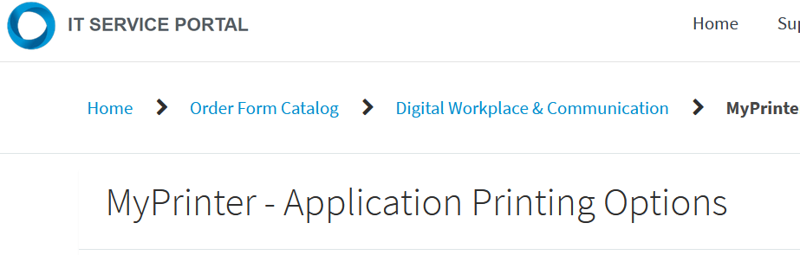
Step 2: Enter printer name
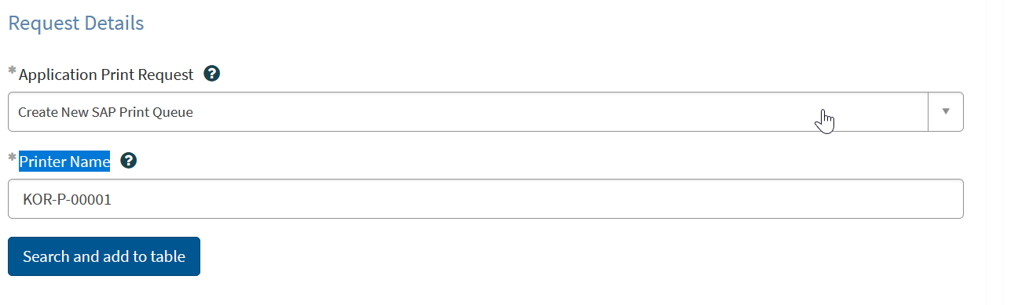

Step 3: you can find the printer serial number etc.
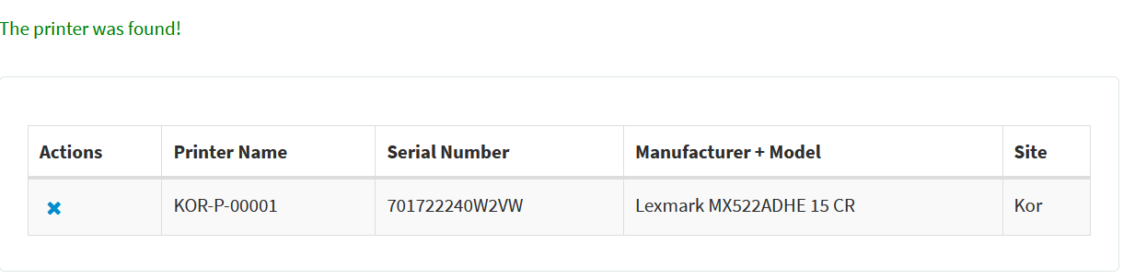

Internet slowmess issue
- Go to control panel select network and sharing option select change adapter seeting click on wifi or ethernet --> go to propoerties select client for miscosoft networks click on configure select adavance select prefered bandwidth value is 5ghz

