Jenkins

Why Jenkins is required in development?

Continiuos devlopment : continious monither the git source code repository & create a new build if any changes happened in the git source code

Continiuos deployment : get the latest build from git location & deploy the build in to testing env

Continiuos Develivery : get the latest build from git location & deploy the build in to UAT env

Why Jenkins is required in Automation?

Continious Intergration : execute selenium test scripts in testing env 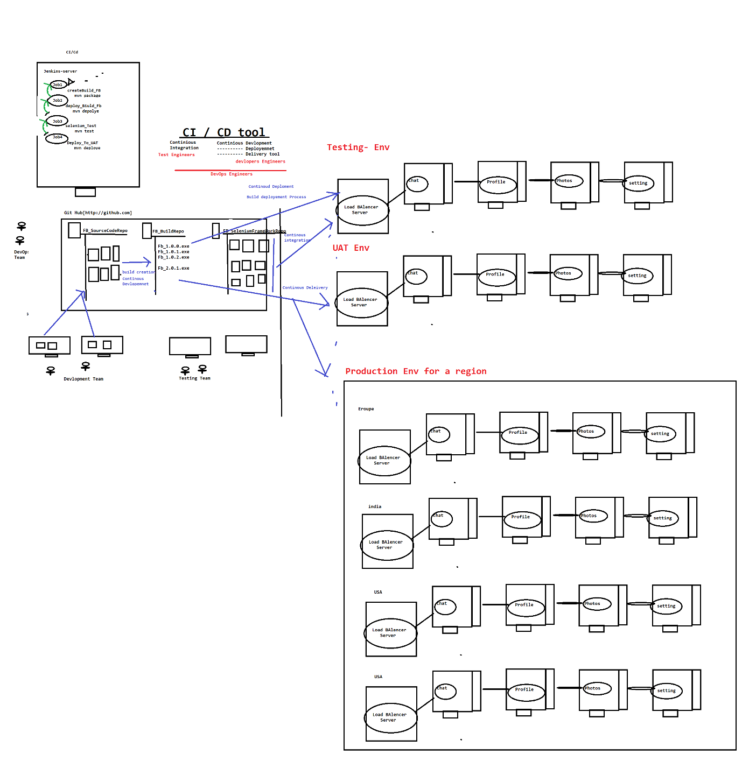

1. **Installation Steps :**
2. Download Jenkins & install
3. Precondition 1 : Login to Jenkins & install below Plugin

Jenkins 🡺 Manager Jenkins 🡺 Manage Plugin🡺 Select “Available”

Search & install below Plugins

. Maven Integration Plugin

GitHub Integration Plugin

PipleLine- Plugin

1. Precondition 2 : Configure Env variables in Jenkins for below env

Jenkins 🡺 Manager Jenkins🡺 Global tool Configuration

. JDK : C:\Program Files\Java\jdk1.8.0_161

. Maven : D:\apache-maven-3.5.2-bin\apache-maven-3.5.2

.Git : C:\Program Files\Git\bin\git.exe

1. What is use of Jenkins in Testing

Jenkins is a Continuous integration tool where continuously monitor the framework Build in git location, then perform appropriate action based on request

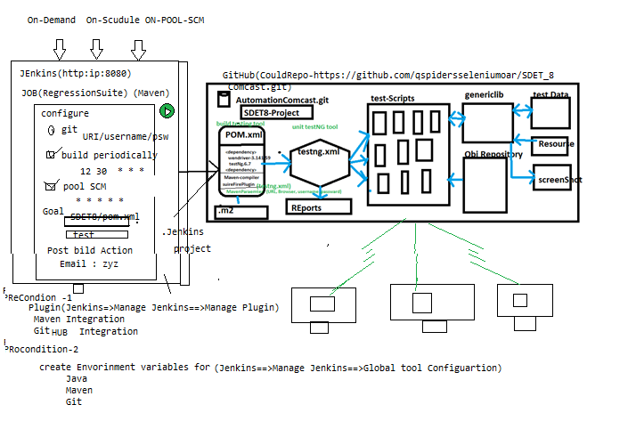

Advantages of Jenkins

1. Jenkins Provide 3 level of execution

. On demand : based on Customer demand we can start the execution

. On Scheduling: based on scheduled time , start the execution automatically

. POLL SCM : where continuously monitor the SCM(GitHub) & automatically start the execution whenever we get new Build / one new test script is getting added to Git

1. Email Notification:

. Jenkins sends out an execution Report via email, once execution is completed

. Jenkins also Send Build broken Email, when Compilation issue between the framework component

1. Jenkins also support run time **parameter**
2. **Jenkins also support PipleLines Job**
3. **How to create a Job in Jenkins :**

🡺 login to Jenkins

🡺 click on “new Item”

🡺select “Maven Project” & enter the Job Name

🡺click on OK button

1. **How to LINK selenium Framework which is available in GITHub , to Jenkins ?**

* **Login to Jenkins**
* **Get inside the Job**
* **Click on “Configure” link**
* **“click” git radio button & enter git information**

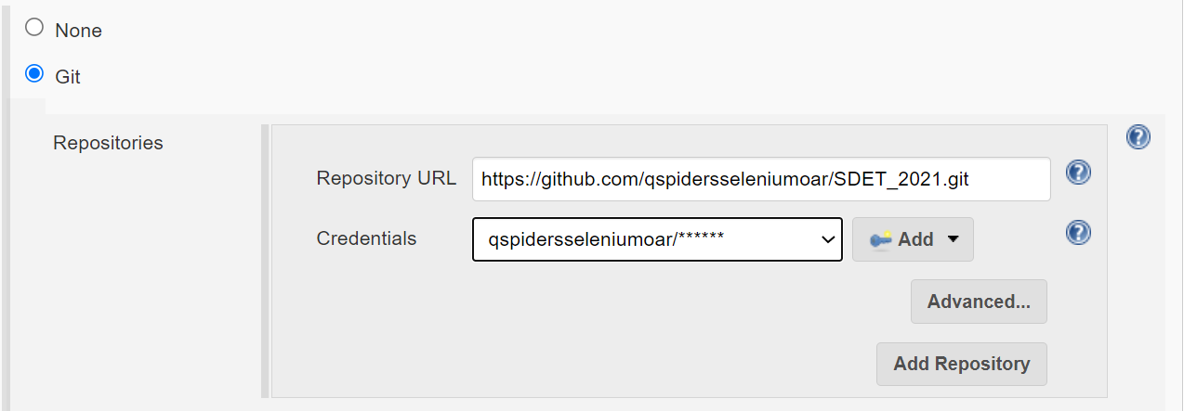

* Scroll down , go to build Division & provide the POM.xml path & goal

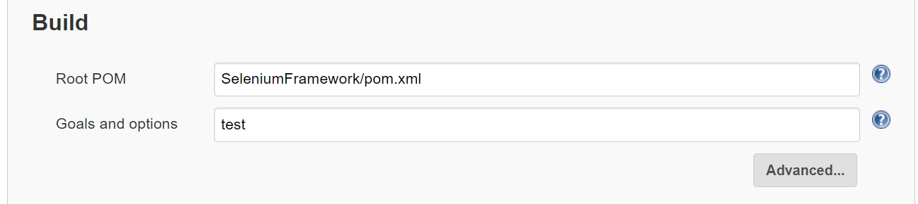

* Click on “save” button

1. **How to Execute Jenkins “job”?**

* **Login to Jenkins**
* **Get the inside Jenkins job**
* **Click on “Build now” button**

1. **How to see the Job Result in Jenkins after the Execution ?**

* Get the inside the Job
* Go to build history
* We can see all the Result with time stamp
* click on latest link
* click on “console OutPut”

1. **How to Schedule a Job in Jenkins**

* **Login to Jenkins**
* **Get the inside Jenkins job**
* **Click on configure file**
* **Click on “Build periodically” checkbox**
* **Provide the time based on * * * * * separated by space**

**EG :**

MINUTE HOUR DOM MONTH DOW

|  |  |
| --- | --- |
| MINUTE | Minutes within the hour (0–59) |
| HOUR | The hour of the day (0–23) |
| DOM | The day of the month (1–31) |
| MONTH | The month (1–12) |
| DOW | The day of the week (0–7) where 0 and 7 are Sunday. |

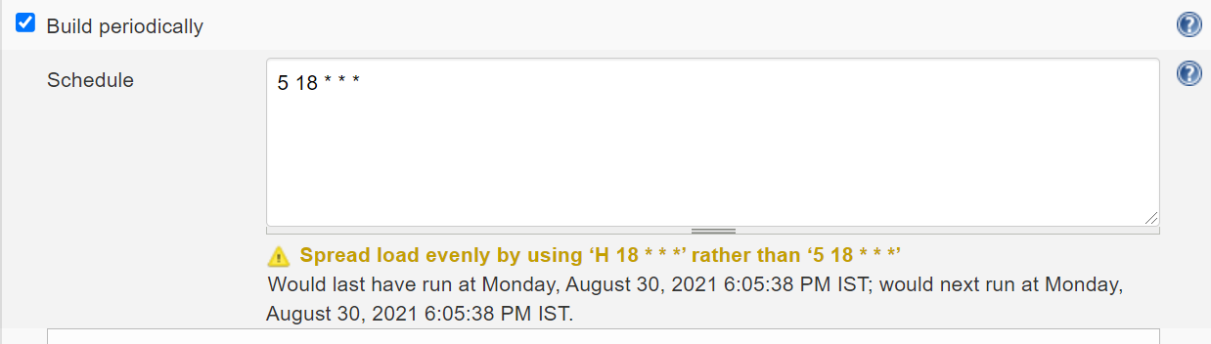

1. **How to configure Poll-SCM execution ?**

* **Login to Jenkins**
* **Get the inside Jenkins job**
* **Click on configure file**
* **Click on “Poll-SCM” checkbox**
* **Provide the time based on * * * * * separated by space**

**What is Jenkins Pipeline?**

Execute multiple job sequentially one after the other I called Jenkins Pipeline

Note : make sure “build pipeline” plugin should be installed in Jenkins

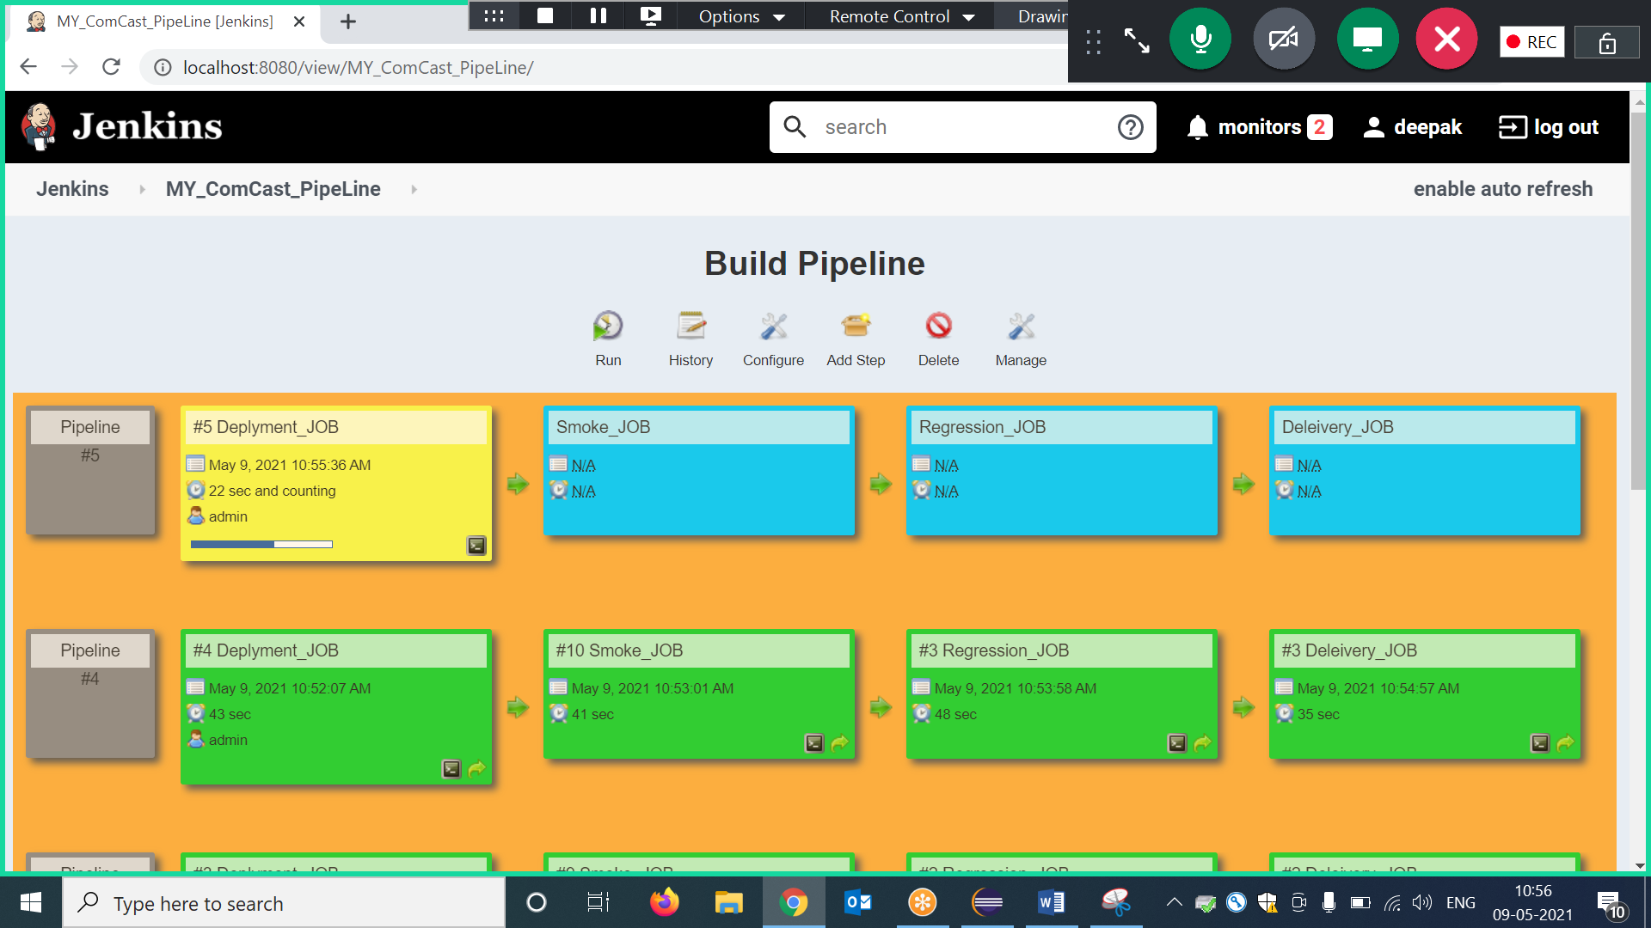

EG : below example is the list job’s are pipelined , & it mean just execute 1 st job then automatically all the jobs executed which is available in pipeline.

Job 1 -Build creation 🡺Job2- Build-Deploye🡺Job3-SmokeTest🡺Job4-Regressiontest🡺job4-Delivery;

1. **How to Set Jenkins parameter?**

Jenkins parameter help us to pass data in to test suite in run Time from Jenkins itself

* Login to Jenkins
* Get inside the Job
* Click on configure
* Click on “This project is parameterized” checkbox
* Click on add Parameter with 🡺 choice parameter option
* Enter the below details

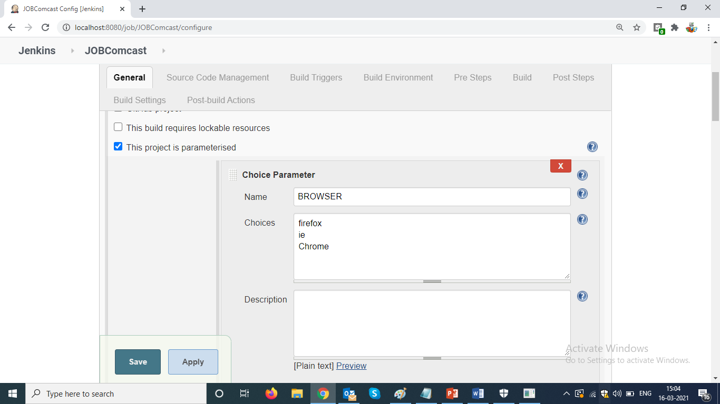

* Go to build option , & edit Goal to use Jenkins Paramters ,

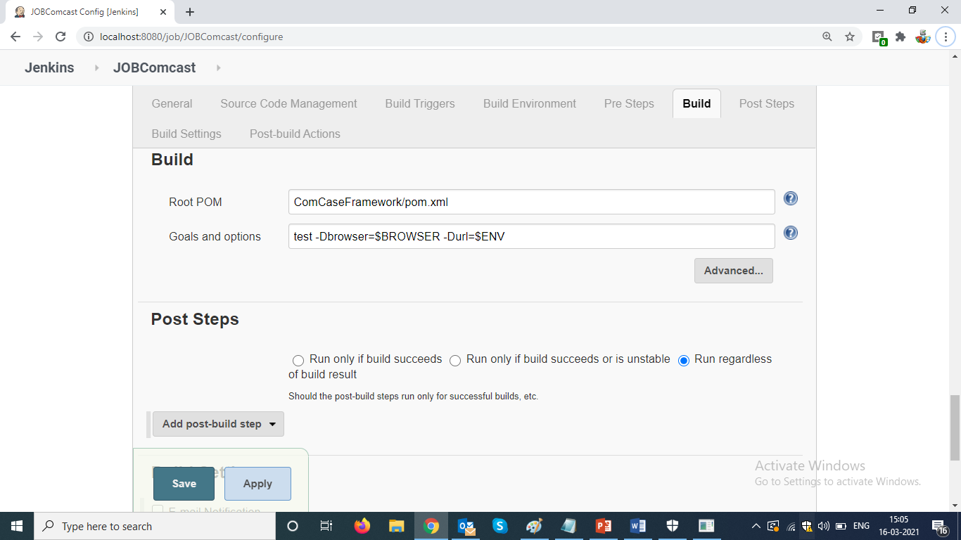

* Execute job with “build with parameter”

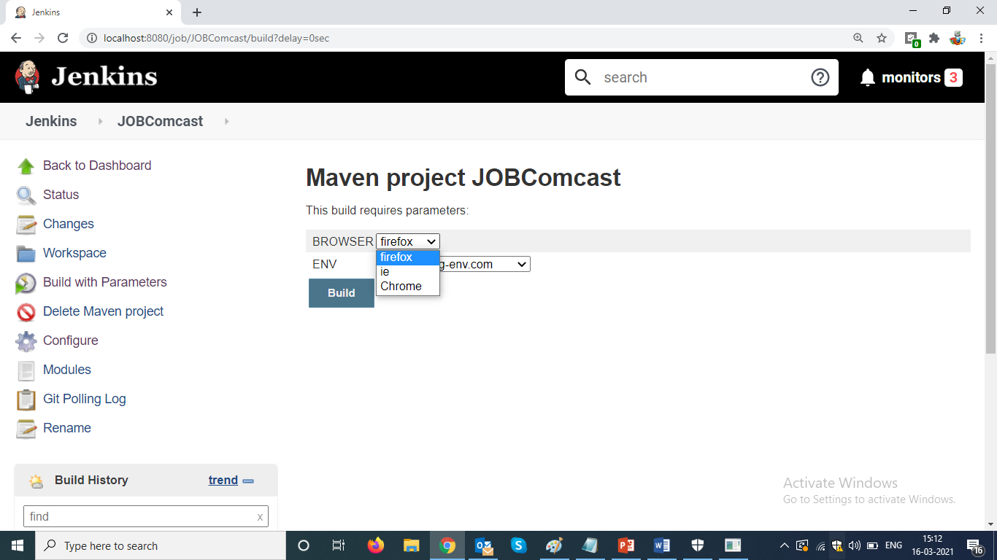

Note :

We should use maven parameter in Selenium Farmework :

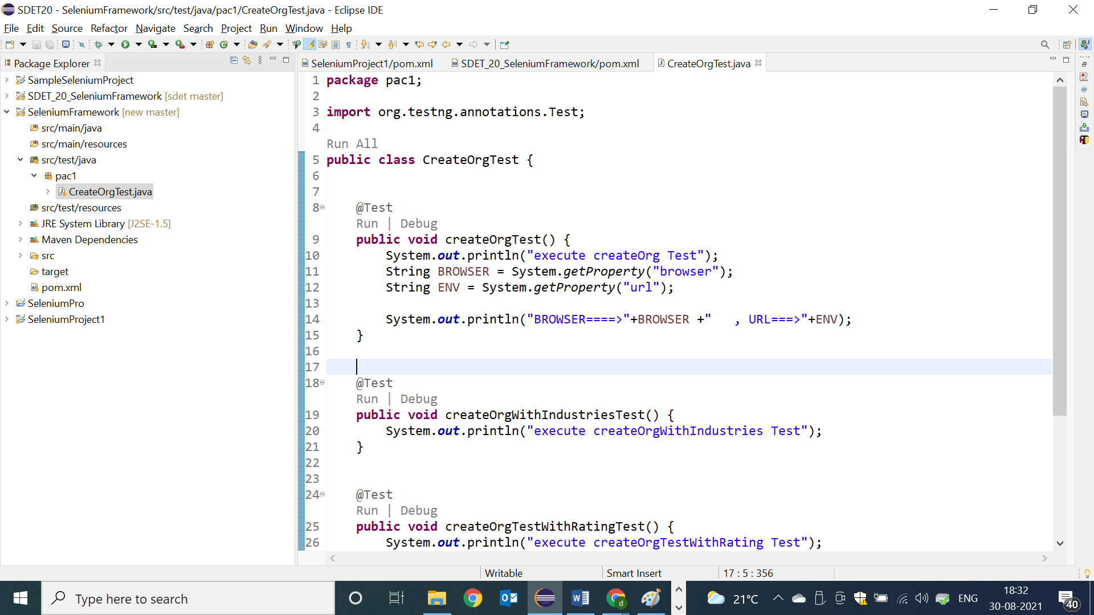

* To pass same paremter from the CMD
* 