C:\Users\Manju\Desktop\git folder>git init

Initialized empty Git repository in C:/Users/Manju/Desktop/git folder/.git/

C:\Users\Manju\Desktop\git folder>git remote add origin https://github.com/Manju-2002/TASK.git

C:\Users\Manju\Desktop\git folder>git add .

C:\Users\Manju\Desktop\git folder>git commit - m "initial commit"

error: pathspec '-' did not match any file(s) known to git

error: pathspec 'm' did not match any file(s) known to git

error: pathspec 'initial commit' did not match any file(s) known to git

C:\Users\Manju\Desktop\git folder>git commit -m "initial commit"

Author identity unknown

*** Please tell me who you are.

Run

git config --global user.email "you@example.com"

git config --global user.name "Your Name"

to set your account's default identity.

Omit --global to set the identity only in this repository.

fatal: unable to auto-detect email address (got 'Manju@DESKTOP-U8652UG.(none)')

C:\Users\Manju\Desktop\git folder>git config user.email "edigamanju007@gmail.com"

C:\Users\Manju\Desktop\git folder>git config user.name "Manju-2002"

C:\Users\Manju\Desktop\git folder>git commit -m "initial commit"

[master (root-commit) 98fcb25] initial commit

1 file changed, 50 insertions(+)

create mode 100644 TODOLIST CODE - Copy.txt

C:\Users\Manju\Desktop\git folder>git branch -M main

C:\Users\Manju\Desktop\git folder>git push -u origin main

info: please complete authentication in your browser...

Enumerating objects: 3, done.

Counting objects: 100% (3/3), done.

Delta compression using up to 12 threads

Compressing objects: 100% (3/3), done.

Writing objects: 100% (3/3), 824 bytes | 824.00 KiB/s, done.

Total 3 (delta 0), reused 0 (delta 0), pack-reused 0 (from 0)

To https://github.com/Manju-2002/TASK.git

* [new branch] main -> main

branch 'main' set up to track 'origin/main'.

C:\Users\Manju\Desktop\git folder>git pull

Already up to date.

C:\Users\Manju\Desktop\git folder>git add .

C:\Users\Manju\Desktop\git folder>git commit -m "add new file"

[main ce3f87a] add new file

1 file changed, 67 insertions(+)

create mode 100644 C++ codes.txt

C:\Users\Manju\Desktop\git folder>git push

Enumerating objects: 4, done.

Counting objects: 100% (4/4), done.

Delta compression using up to 12 threads

Compressing objects: 100% (3/3), done.

Writing objects: 100% (3/3), 844 bytes | 844.00 KiB/s, done.

Total 3 (delta 0), reused 0 (delta 0), pack-reused 0 (from 0)

To https://github.com/Manju-2002/TASK.git

98fcb25..ce3f87a main -> main

C:\Users\Manju\Desktop\git folder>git pull

Already up to date.

C:\Users\Manju\Desktop\git folder>git add .

C:\Users\Manju\Desktop\git folder>git commit -m "week3_task2"

[main f0a597d] week3_task2

1 file changed, 42 insertions(+)

create mode 100644 Week3_task2.txt

C:\Users\Manju\Desktop\git folder>git push

Enumerating objects: 4, done.

Counting objects: 100% (4/4), done.

Delta compression using up to 12 threads

Compressing objects: 100% (3/3), done.

Writing objects: 100% (3/3), 712 bytes | 712.00 KiB/s, done.

Total 3 (delta 0), reused 0 (delta 0), pack-reused 0 (from 0)

To https://github.com/Manju-2002/TASK.git

ce3f87a..f0a597d main -> main

C:\Users\Manju\Desktop\git folder>

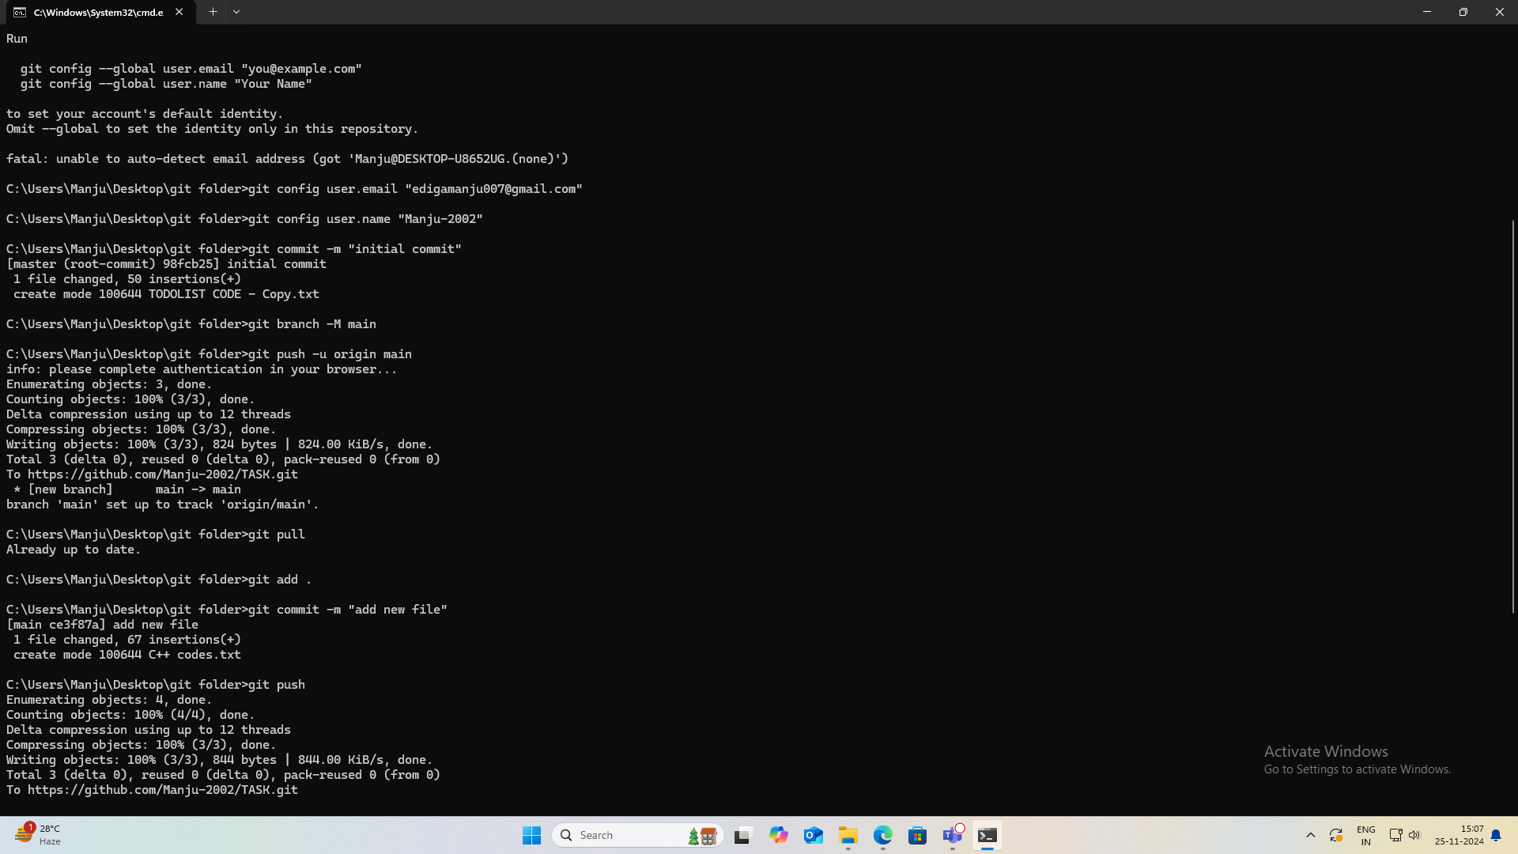  
  
https://github.com/Manju-2002/TASK.git