

**DEPARTMENT OF COMPUTER SCIENCE AND ENGINEERING**

**Applied Digital Logic Design and Computer Organization**

# CS234AI

### TOPIC : PREDICTIVE MAINTENANCE SYSTEM

### REPORT

**Submitted by**

**MOHITH S 1RV23CS119**

**MANJUSHREE YADAV D 1RV23CS406**

**NANTHAN SHETTY 1RV23CS411**

**JEEVAN 1RV23CS075**

**COMPUTER SCIENCE AND ENGINEERING**

**2023-2024**

**TABLE OF CONTENTS**

|  |  |  |
| --- | --- | --- |
| **Sl No**. | **CONTENTS** | Page No. |
| **1.** | Abstract | 1 |
| **2.** | Introduction | 2 |
|  | * 1. Problem Statement | 2 |
|  | * 1. Objectives | 2 |
| **3.** | Hardware Used | 3 |
| **4.** | Software Used | 4 |
| **5.** | Methodology | 5 |
| **6.** | Implementation | 7 |
| **7.** | Output | 9 |
| **8.** | Conclusion | 10 |

**ABSTRACT**

The Real-Time Sensor Data Analytics Platform is a revolutionary solution aimed at revolutionizing predictive maintenance in industrial settings. This report presents a comprehensive overview of the platform's development, implementation, and benefits. By harnessing the power of machine learning algorithms and real-time sensor data analysis, the platform enables organizations to detect equipment failures before they occur, optimize maintenance schedules, and enhance operational efficiency.

**INTRODUCTION**

The increasing complexity and scale of industrial operations necessitate proactive maintenance strategies to minimize downtime, reduce costs, and ensure operational continuity. Traditional reactive maintenance approaches are no longer sufficient, prompting the need for innovative solutions that can predict equipment failures in advance. The Real-Time Sensor Data Analytics Platform addresses this need by leveraging advanced machine learning techniques to analyse streaming sensor data and provide actionable insights in real-time.

**Problem Statement**

The traditional approach to maintenance in industrial settings is reactive, leading to unexpected equipment failures, downtime, and costly repairs. There is a critical need for a proactive maintenance solution that can predict equipment failures before they occur, enabling organizations to implement preventive measures and minimize operational disruptions.

**Objectives**

The primary objectives of the Real-Time Sensor Data Analytics Platform include:

* Develop a real-time sensor data analytics platform capable of analysing streaming sensor data from industrial equipment.
* Implement machine learning algorithms to predict equipment failures and error types based on historical sensor data.
* Enable real-time monitoring and visualization of predictive analytics to facilitate proactive maintenance decisions.
* Improve operational efficiency, reduce downtime, and optimize maintenance schedules through predictive maintenance strategies.

**HARDWARE USED**

The Real-Time Sensor Data Analytics Platform utilizes various hardware components, including:

* Industrial-grade sensors: These sensors capture real-time data from equipment and machinery, such as temperature, vibration, and moisture levels.
* Data acquisition devices: These devices aggregate and transmit sensor data to the analytics platform, either directly or through IoT gateways.
* Edge computing devices: These devices pre-process sensor data locally before transmitting it to the central analytics server, reducing latency and bandwidth requirements.
* Server infrastructure: The analytics platform is hosted on servers capable of processing and analysing streaming sensor data in real-time.

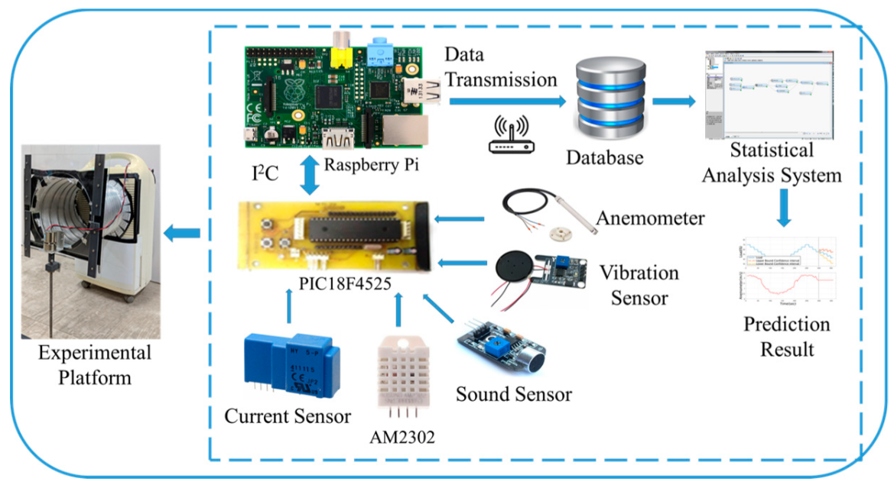

**SOFTWARE USED**

The software stack of the Real-Time Sensor Data Analytics Platform consists of:

* Programming Languages: Python is the primary language used for developing machine learning models, data preprocessing scripts, and analytics algorithms.
* Libraries and Frameworks: Pandas, NumPy, and Scikit-learn are used for data manipulation, feature engineering, and machine learning model training.
* Data Visualization Tools: Matplotlib and Plotly are employed for creating interactive visualizations and dashboards to present real-time sensor data and predictive analytics.
* Deployment Platforms: Docker is used for containerizing the analytics platform components, while Kubernetes is utilized for orchestrating container deployment and management in production environments.

**METHODOLOGY**

The methodology adopted for developing and implementing the Real-Time Sensor Data Analytics Platform involves several key steps, including:

* **Data Collection:** Gather sensor data from various sources, including industrial equipment, machinery, and IoT devices, using a combination of sensors, data acquisition devices, and edge computing devices. Ensure the data collection process is reliable, scalable, and capable of handling large volumes of streaming sensor data.
* **Data Preprocessing:** Clean, filter, and preprocess the raw sensor data to remove noise, handle missing values, and standardize data formats for further analysis. Implement techniques such as data imputation, outlier detection, and normalization to ensure the quality and consistency of the data.
* **Feature Engineering:** Extract relevant features from the sensor data, such as temperature, vibration, moisture levels, and other parameters, to train machine learning models for predictive maintenance. Utilize domain knowledge and statistical techniques to identify informative features that capture the underlying patterns and dynamics of the data..
* **Model Training:** Utilize historical sensor data to train and validate machine learning models for predicting equipment failures and error types. Experiment with different algorithms, model architectures, and hyperparameters to identify the most effective approach for the given dataset and problem domain. Evaluate model performance using appropriate metrics such as accuracy, precision, recall, and F1-score.
* **Real-Time Analysis:** Deploy trained models to analyze streaming sensor data in real-time and generate predictive insights. Implement algorithms for anomaly detection, pattern recognition, and time-series forecasting to identify potential equipment failures before they occur. Ensure the real-time analysis process is scalable, efficient, and capable of handling high-frequency data streams.
* **Visualization and Reporting:** Develop interactive dashboards and visualizations to present real-time sensor data, predictive analytics, and actionable insights to end-users. Utilize data visualization tools such as Matplotlib, Plotly, and Tableau to create informative charts, graphs, and maps that facilitate data exploration and decision-making. Enable users to customize dashboards, set alerts, and generate reports based on specific parameters and thresholds.

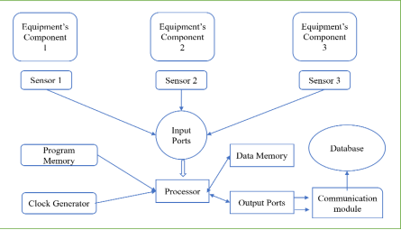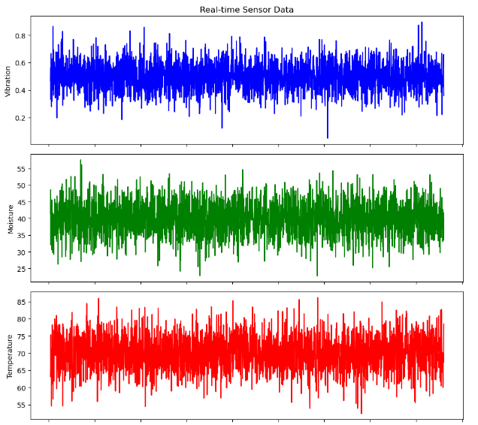

**IMPLEMENTATION**

import pandas as pd

import numpy as np

import matplotlib.pyplot as plt

from sklearn.model_selection import train_test_split

from sklearn.preprocessing import LabelEncoder

from sklearn.ensemble import RandomForestClassifier

from sklearn.multioutput import MultiOutputClassifier

from sklearn.metrics import accuracy_score, classification_report, confusion_matrix

import joblib

**# Load sensor data with labels and error types**

sensor_data = pd.read_csv('sensor_data_with_labels_and_error_types.csv')

**# Fill null values with the mean of respective columns**

numeric_cols = sensor_data.select_dtypes(include=['float64', 'int64']).columns

sensor_data[numeric_cols] = sensor_data[numeric_cols].fillna(sensor_data[numeric_cols].mean())

**# Replace 'None' values in 'FailureLabel' and 'ErrorType' columns with 'Healthy'**

sensor_data['FailureLabel'] = sensor_data['FailureLabel'].fillna('Healthy')

sensor_data['ErrorType'] = sensor_data['ErrorType'].fillna('Healthy')

**# Label encode 'ErrorType'**

label_encoder = LabelEncoder()

sensor_data['ErrorType'] = label_encoder.fit_transform(sensor_data['ErrorType'])

**# Prepare features and target variables**

X = sensor_data[['Vibration', 'Moisture', 'Temperature']]

y_failure = sensor_data['FailureLabel'] # Target variable for failure

y_error = sensor_data['ErrorType'] # Target variable for error type

**# Split data into training and testing sets**

X_train, X_test, y_failure_train, y_failure_test, y_error_train, y_error_test = train_test_split(

X, y_failure, y_error, test_size=0.2, random_state=42)

**# Initialize Random Forest classifier**

rf_classifier = RandomForestClassifier(n_estimators=100, random_state=42)

**# Create multi-output classifier**

multi_target_classifier = MultiOutputClassifier(rf_classifier, n_jobs=-1)

**# Train the multi-output classifier**

multi_target_classifier.fit(X_train, {'failure': y_failure_train, 'error': y_error_train})

**# Predict failure and error reason on the test set**

y_pred = multi_target_classifier.predict(X_test)

y_failure_pred = y_pred['failure']

y_error_pred = y_pred['error']

**# Evaluate failure prediction**

failure_accuracy = accuracy_score(y_failure_test, y_failure_pred)

print("Failure Prediction Accuracy:", failure_accuracy)

print("Classification Report for Failure Prediction:")

print(classification_report(y_failure_test, y_failure_pred))

print("Confusion Matrix for Failure Prediction:")

print(confusion_matrix(y_failure_test, y_failure_pred))

**# Evaluate error prediction**

error_accuracy = accuracy_score(y_error_test, y_error_pred)

print("Error Prediction Accuracy:", error_accuracy)

print("Classification Report for Error Prediction:")

print(classification_report(y_error_test, y_error_pred))

print("Confusion Matrix for Error Prediction:")

print(confusion_matrix(y_error_test, y_error_pred))

**# Save the model**

joblib.dump(multi_target_classifier, 'failure_and_error_prediction_model.pkl')

**OUTPUTS**

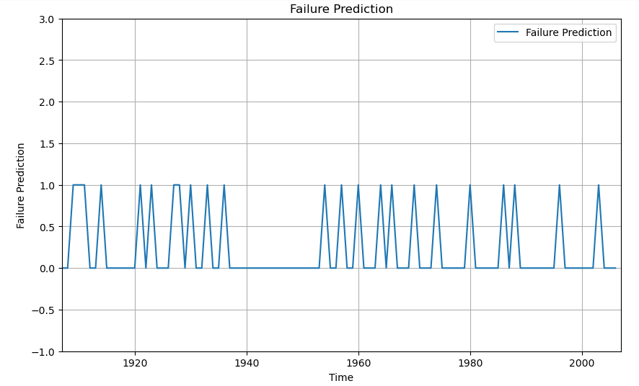

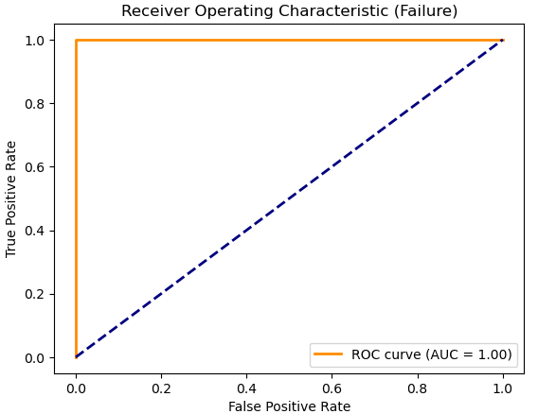

**CONCLUSION**

The Real-Time Sensor Data Analytics Platform represents a significant advancement in predictive maintenance technology, offering organizations the ability to proactively monitor equipment health, predict failures, and optimize maintenance schedules. By leveraging machine learning algorithms and real-time sensor data analysis, the platform enables organizations to enhance operational efficiency, reduce downtime, and maximize asset reliability.

**Future Work**

Moving forward, continued research and development efforts will focus on further improving the accuracy and scalability of the platform, as well as expanding its applicability to various industries and use cases. Additional features such as predictive maintenance scheduling, integration with existing enterprise systems, and support for edge computing environments will be explored.