SOW - ProHire

# Requirements:

1. **Client Score Card :**

**Number of positions** based on Allocation report/Allocations, the count should match if we use same filter in allocation report. **Potential Earning** calculated formula is Number of positions * CTC * Payout % and, if we use Offered, Invoiced and Won filter then the calculated formula is Number of positions * Closed Salary * Payout %. **CVs** based on Active candidate in Candidate database.

Filters should be User-friendly and visually appealing interface design. Excel Export option should be fixed. Export like below.

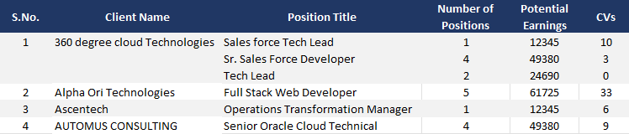

# CV Score Card :

The Table loading time is too long, it need to be fixed. Filters should be User-friendly and visually appealing interface design.

Number of Positions based on Allocation report/Allocations. Other headers based on Candidate database. Numbers should match if we use same filter in source data.

Excel Export option should be fixed.

# Stanco :

* In Status, No show need to be renamed as Turn Up.
* In add new Candidate, Need to remove mandatory for Email and the mobile number duplicates should be removed, Need to add CV DOC upload and Sector and it should show in the candidate list Colvis. Sectors same as like industry in Lead Tracker / Add New Lead.
* Need to add Bulk Candidate Export option.
* Need to add Identical tab, Which should show Duplicates based on mobile number and Email.
* Need to show entry in follow-up while creating new entry.
* In candidate list, Need to add Last modified date Based on Followup
* In Dashboard Tab, Need to fix Date Filter and need column wise grand total.
* Need to upload data in backend.

# Allocation Report:

In Allocations Need to add last modified date Based on Position Followup. Same as in Idendicals.

# Allocation list

In Invoiced and Won Tab, the Candidate name fetching incorrectly, it needs to be fixed.

# User list

After deleting existing user, unable to create same user with same EMP code.

1. **Stanco**

While clicking on pro hire hyperlink in Add new candidate button, it needs to redirect to the respective home page but it doesn’t.