**Postman Testing**

http://localhost:8080/swagger-ui/index.html

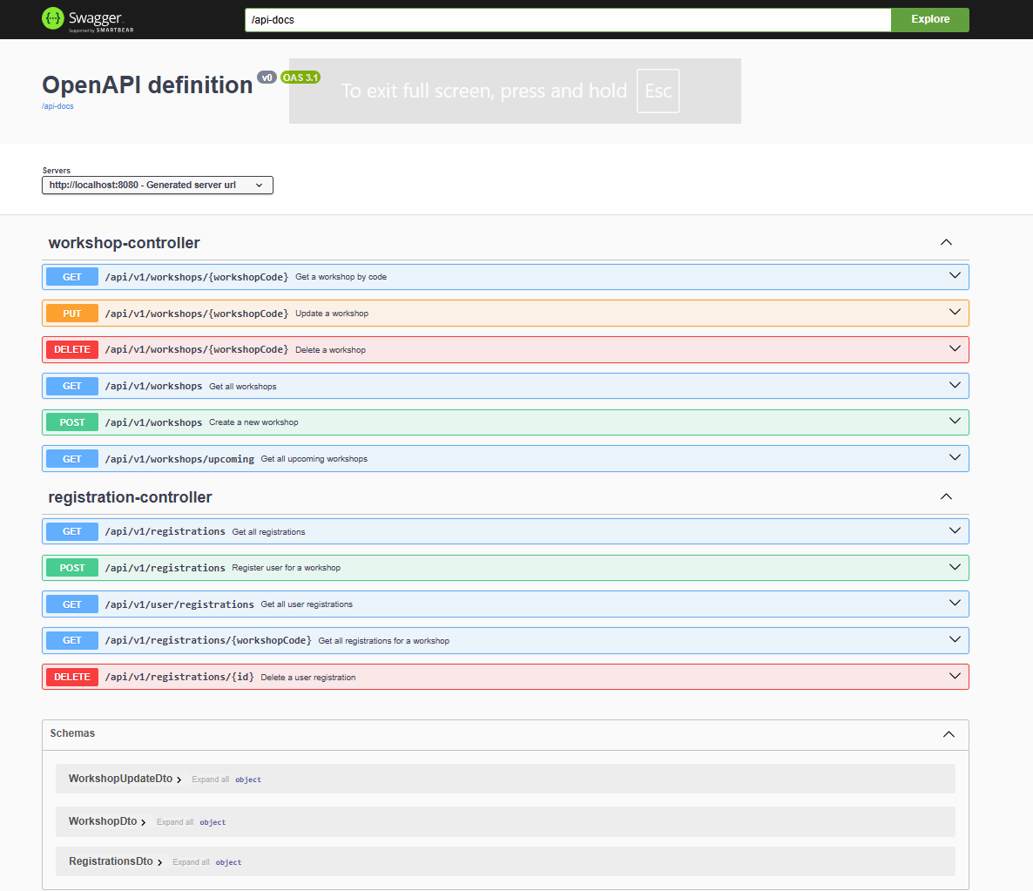

**GET: /api/v1/workshops/upcoming [No Auth]**

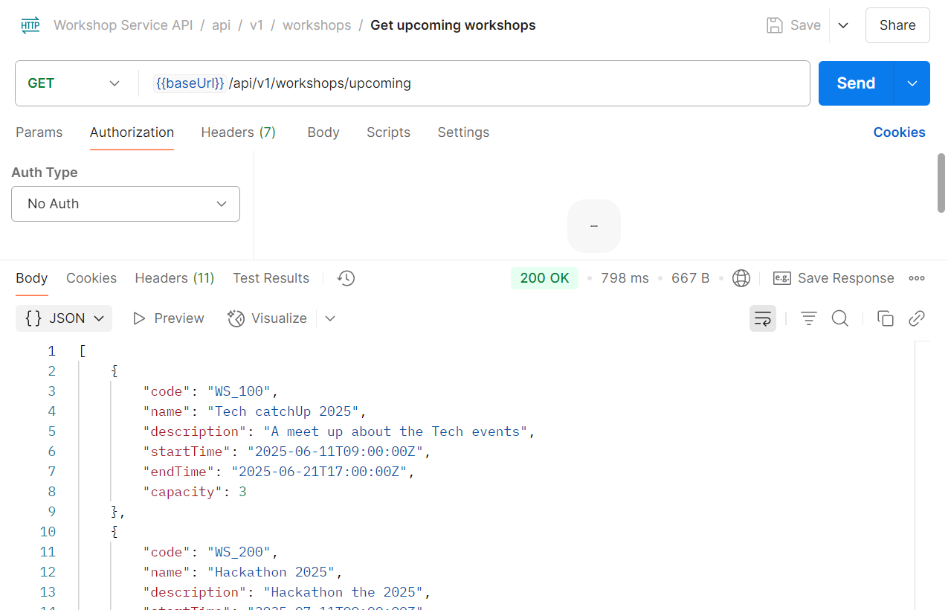

**GET: /api/v1/workshops [No Auth]**

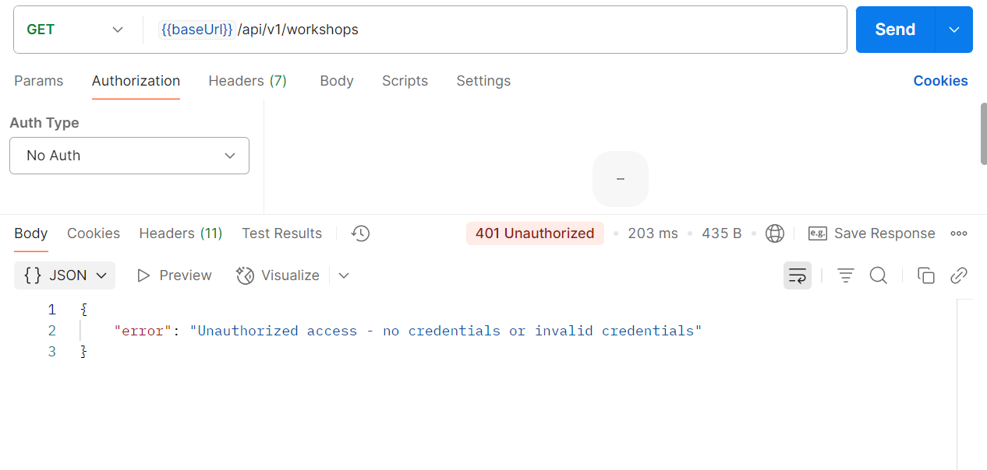

**GET: /api/v1/workshops [Admin]**

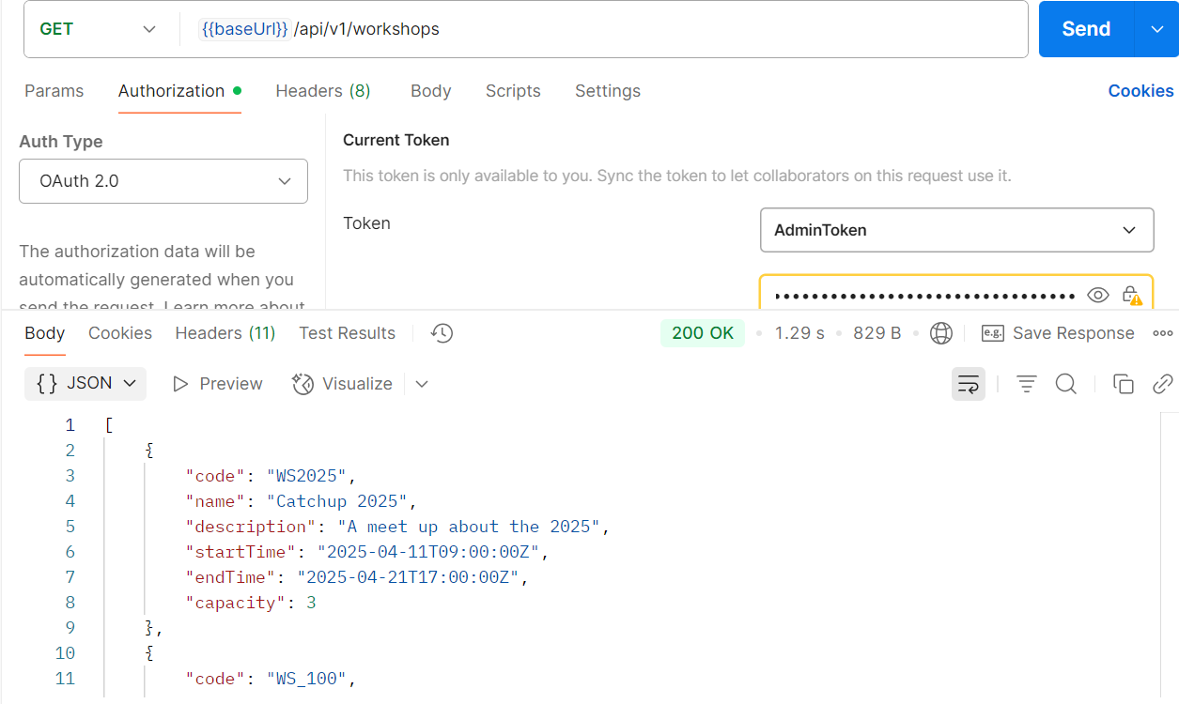

**GET: /api/v1/workshops [User]**

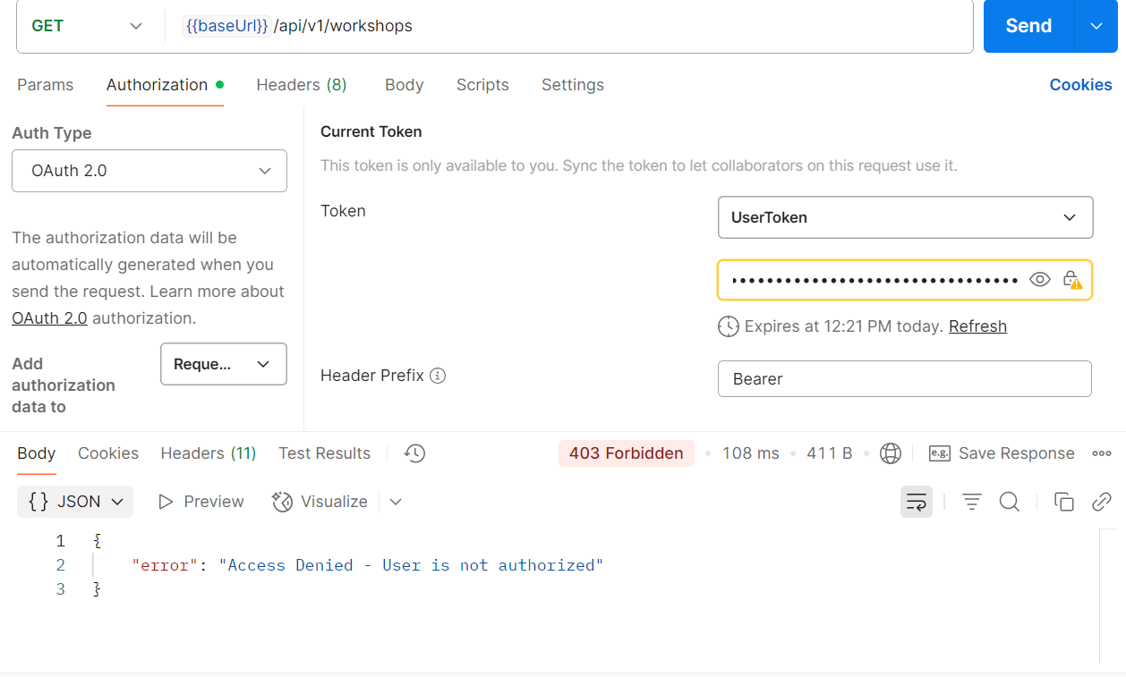

**GET:/api/v1/workshops/:workshopCode [Admin]**

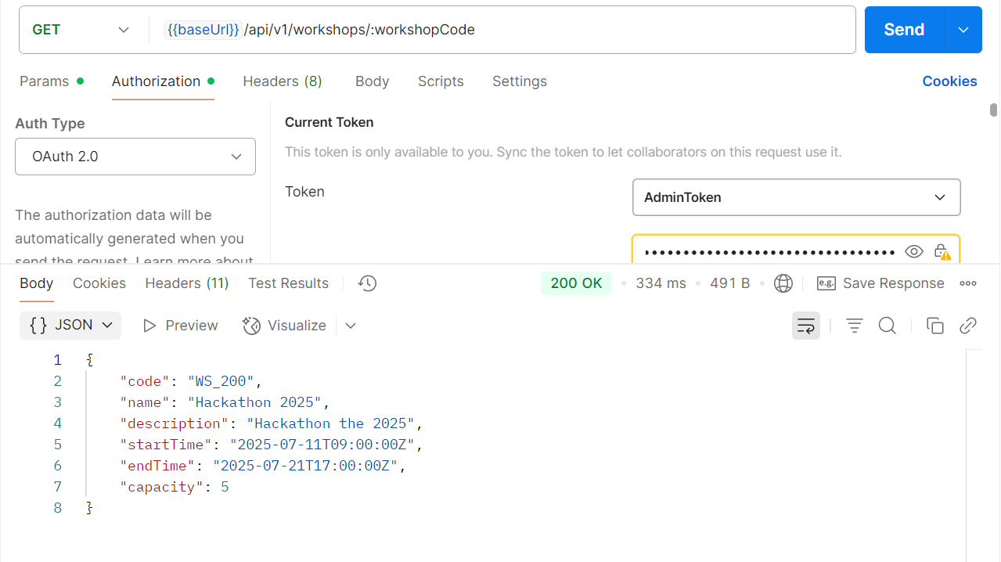

**POST: /api/v1/workshops [Admin]**

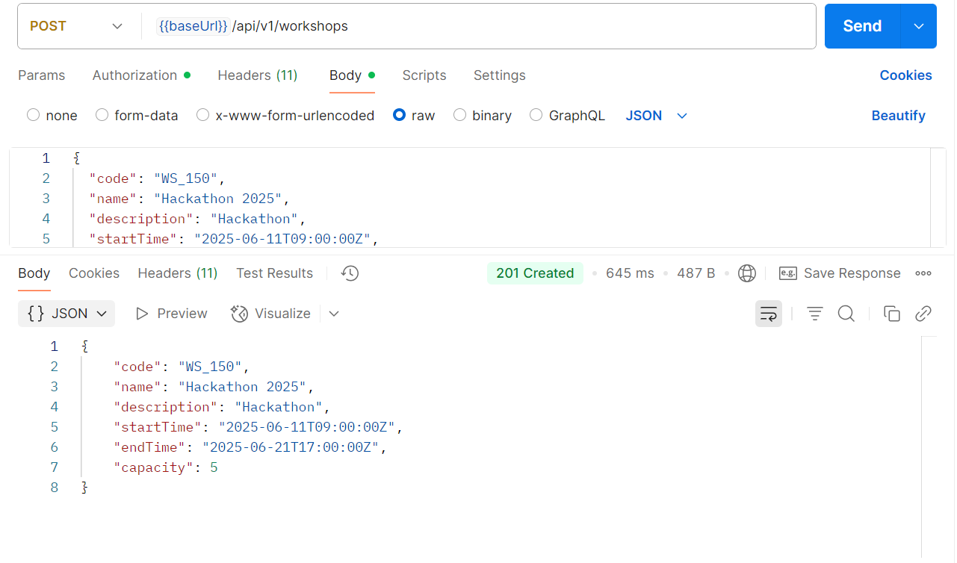

**POST: /api/v1/workshops [User]**

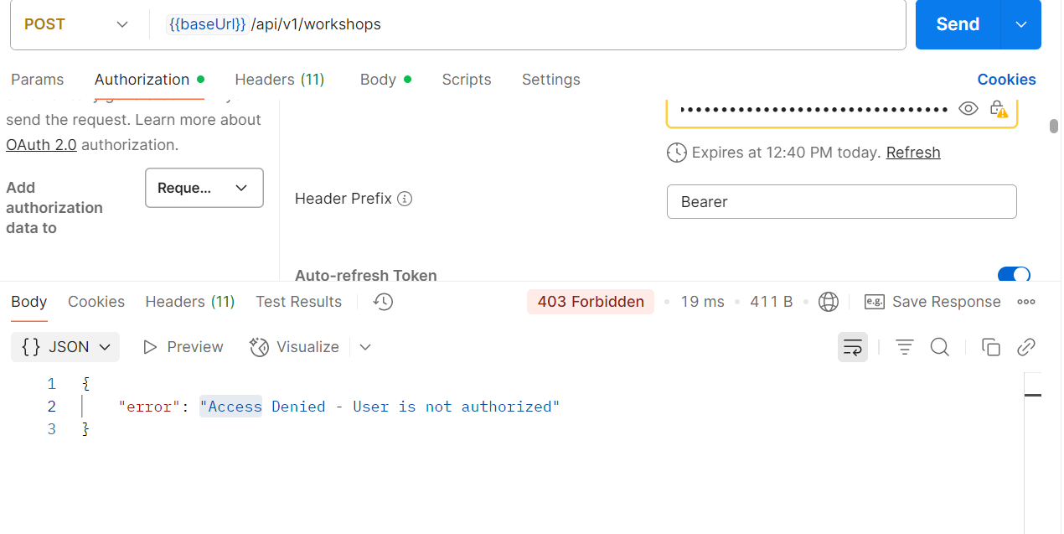

**PUT /api/v1/workshops/:workshopCode [Admin]**

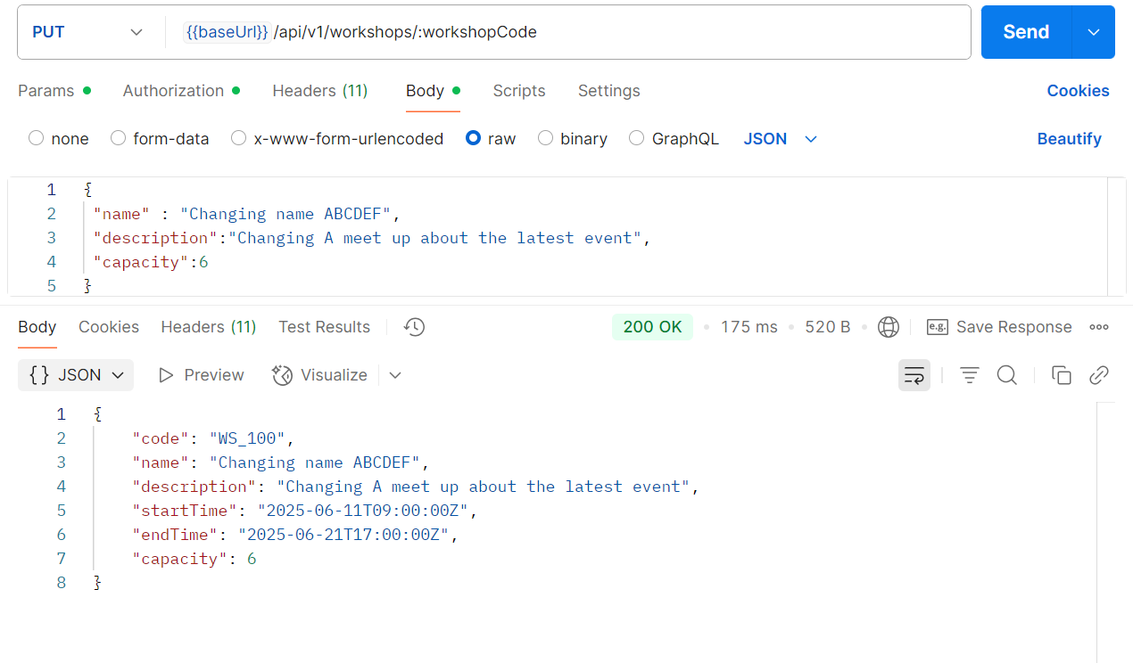

**DELETE: /api/v1/workshops/:workshopCode [Admin]**

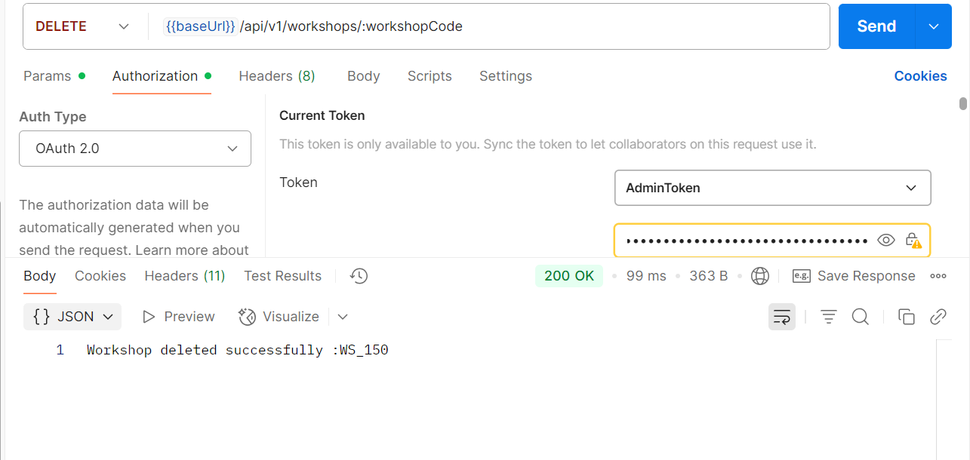

**POST: /api/v1/registrations[User]**

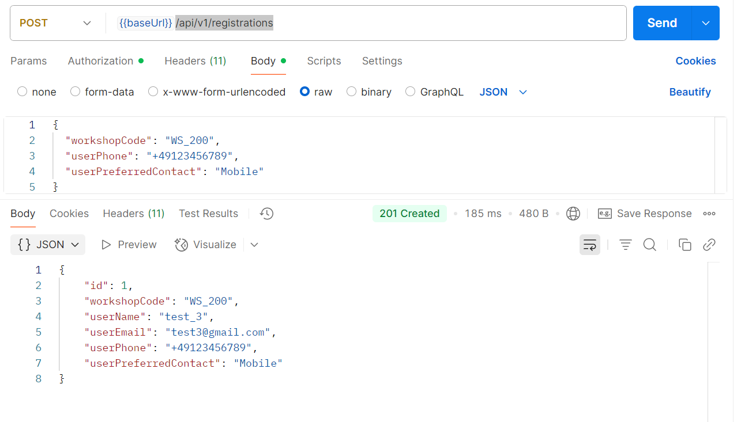

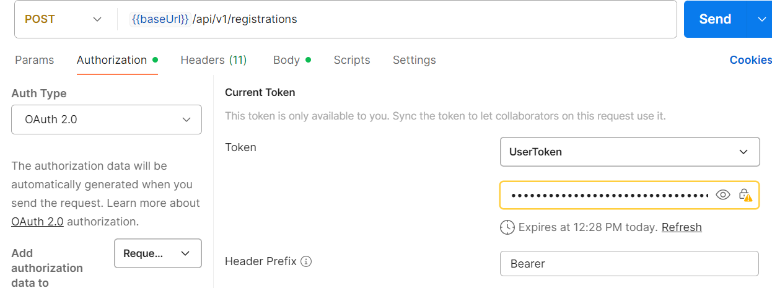

**Duplicate Registration**

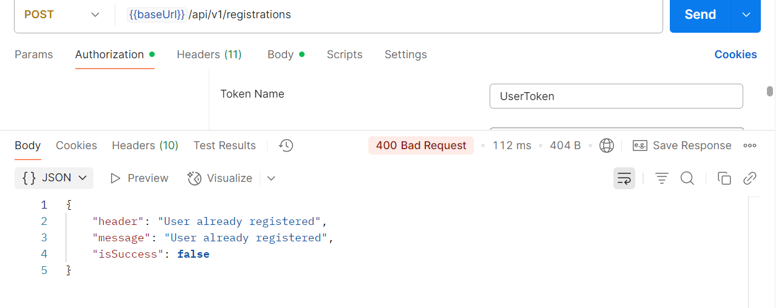

**GET:/api/v1/user/registrations [User]**

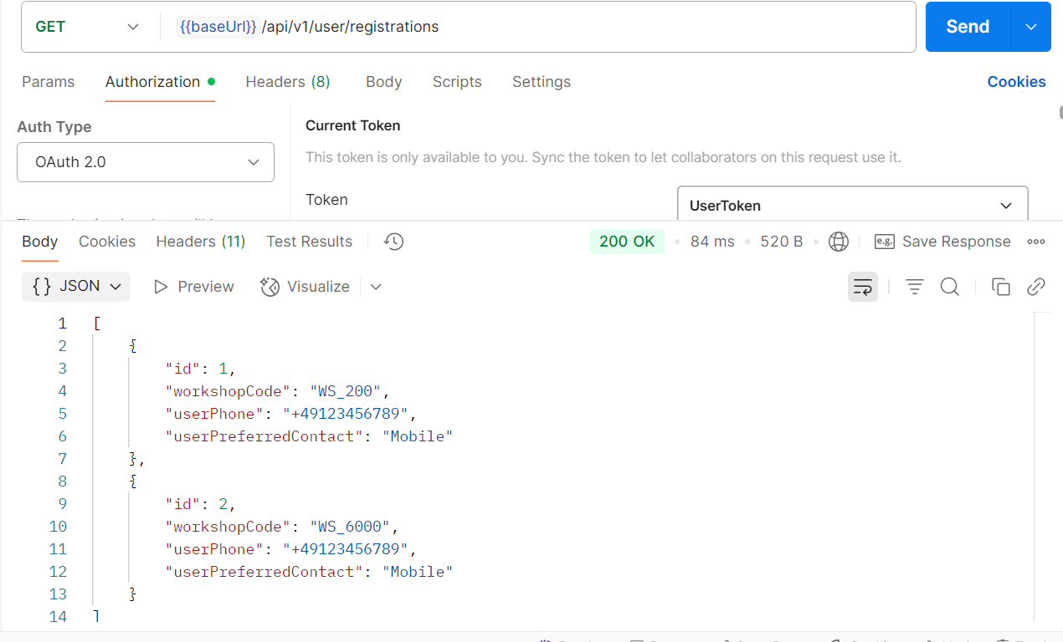

**GET:/api/v1/user/registrations [User – with no registrations]**

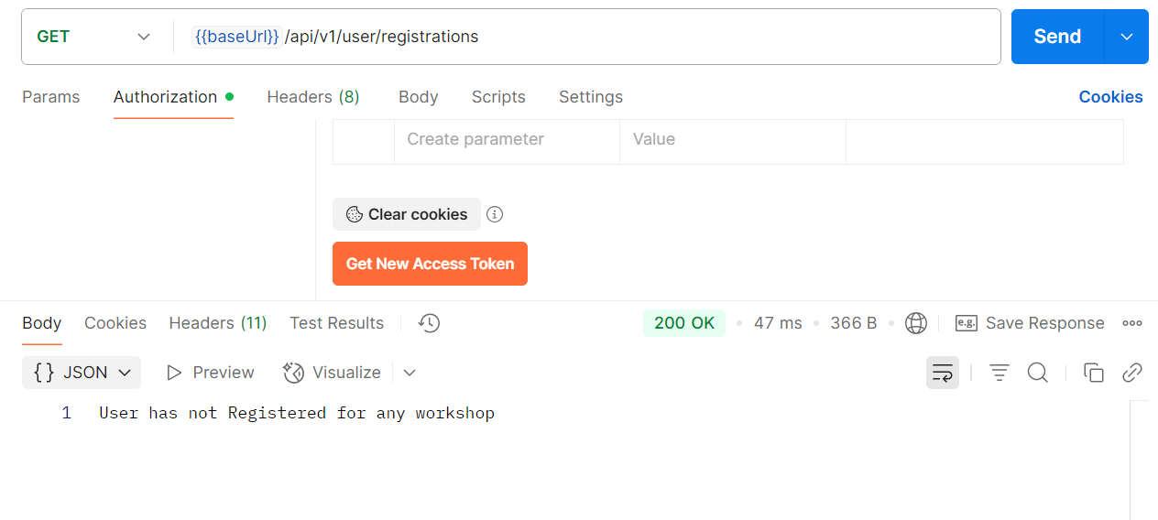

**GET: /api/v1/registrations[Admin]**

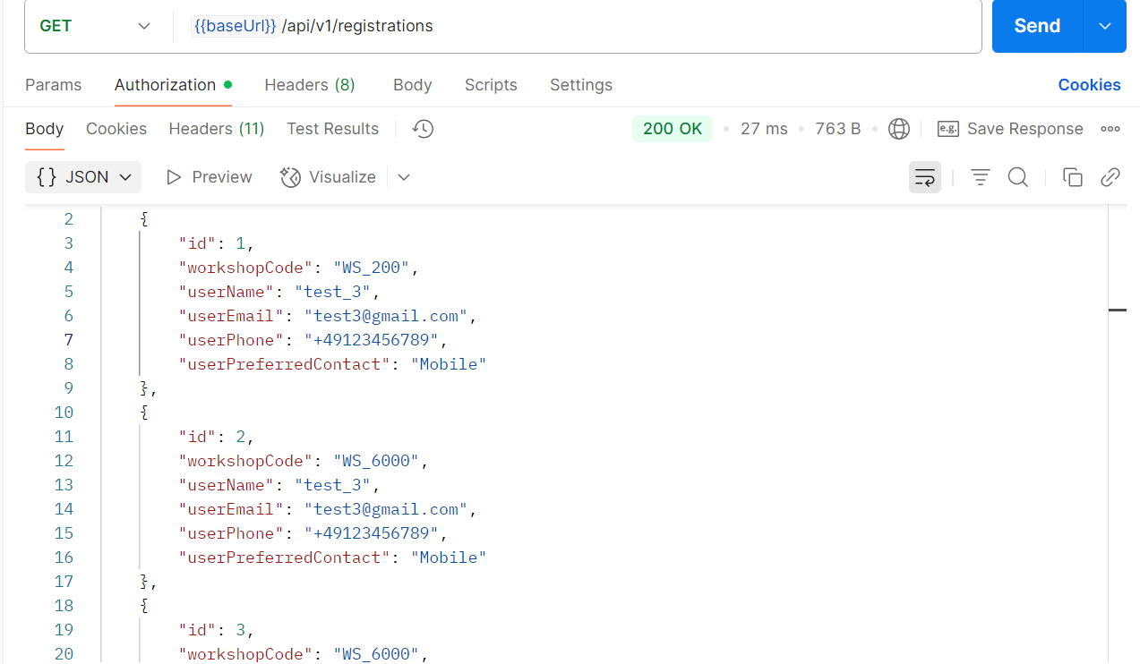

**DELETE: /api/v1/registrations[Admin]**

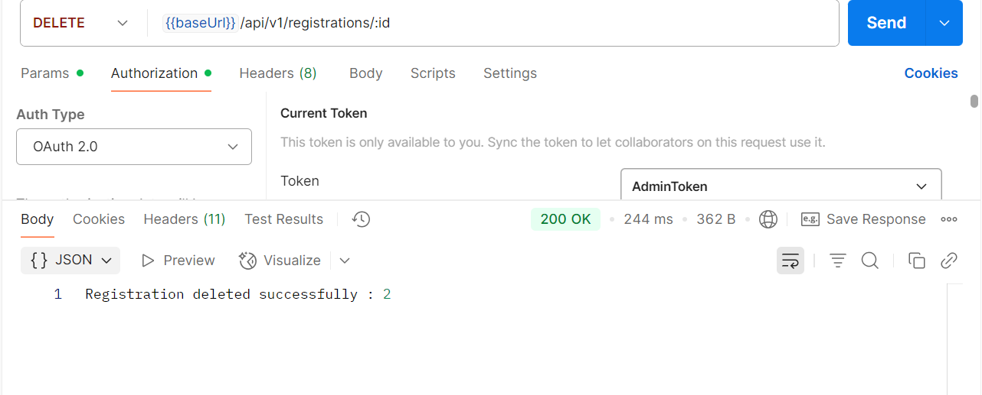

**DELETE: /api/v1/registrations[User]**

