ENTERPRISE AI RELIABILITY & EVIDENCE VERIFICATION DOSSIER
HALLUCIGUARD
TECHNICAL ARCHITECTURE &
VERIFICATION SYSTEM
A Multi-Agent Framework for Real-Time LLM Hallucination Detection, Multi-Domain Authoritative Retrieval, Semantic Cross-Encoder Reranking, DeBERTa Natural Language Inference, and Four-State Verdict Determination
SPECIFICATION METADATA | PRODUCTION STATE & SPECIFICATIONS
System Name | HalluciGuard Enterprise Verifier & Risk Gating Framework
Production Version | v2.0.0-rc2 (Benchmark V1.7 Hardened)
Base Generation LLM | OpenRouter / qwen/qwen3-4b (Candidate Generator)
Detector Classifier | Manjunath2000006/halluciguard-detector (Fine-Tuned HaluEval DistilBERT)
Semantic Reranker | BAAI/bge-reranker-large (Cross-Encoder Scoring ∈ [0.0, 1.0])
NLI Engine | cross-encoder/nli-deberta-v3-base (Premise-Hypothesis Entailment)
Retrieval Orchestration | n8n Cloud Webhook Workflow V2.0 (Multi-Domain Live Adapters + Tavily AI)
Benchmark Performance | 74.29% Accuracy | 100% Verified Precision | 100% Contradicted Precision | 0.0% FVR
Hardware & Acceleration | NVIDIA RTX 3050 Mobile / CUDA 12.8 / PyTorch 2.6.0+cu126 / Windows 11 Host
Automated Test Coverage | 236 Unit, Integration & Property-Based Tests Passing (0 Failures)
Security & Auditability | Zero-Secret Logging Policy, HMAC Webhook Headers, Complete Trace Provenance

Executive Summary: Enterprise AI Factuality at Scale
Large Language Models (LLMs) generate fluent, structurally persuasive, yet factually incorrect statements—a phenomenon widely classified as machine hallucination. In mission-critical domains such as clinical healthcare, cyber incident response, legal compliance, and financial intelligence, hallucinated outputs present catastrophic organizational risk. Traditional mitigation strategies, including unconstrained Retrieval-Augmented Generation (RAG) and self-consistency prompting, frequently fail because they lack deterministic polarity verification, domain-specific authority gating, and formal evidence consensus mathematics.
HalluciGuard is an enterprise-grade, multi-agent AI framework engineered to detect, isolate, and factually verify LLM-generated claims in real time. The architecture integrates four core subsystems: (1) a fine-tuned HaluEval DistilBERT sequence classifier that acts as an instantaneous risk-gating router; (2) an automated claim decomposition and SVO (Subject-Verb-Object) relation extraction engine; (3) a multi-domain n8n Cloud retrieval workflow that queries primary authoritative APIs across five vertical sectors with automated Tavily AI fallback; and (4) a dual cross-encoder inference pipeline combining BAAI/bge-reranker-large for semantic relevance with cross-encoder/nli-deberta-v3-base for three-way Natural Language Inference (Entailment, Contradiction, Neutral).
■ CORE DESIGN PHILOSOPHY: DETERMINISTIC GROUNDING OVER HEURISTIC GUESSING
HalluciGuard enforces a strict fail-closed contract. If authoritative evidence is missing, ambiguous, or mutually contradictory, the system explicitly yields an UNVERIFIED or CONFLICTED verdict. It never synthesizes artificial certainty. In its empirical V1.7 35-claim benchmark across five operational domains, HalluciGuard achieved 100% precision on Verified claims, 100% precision on Contradicted claims, and a 0.00% False Verification Rate (FVR), establishing a dependable boundary against false confidence.

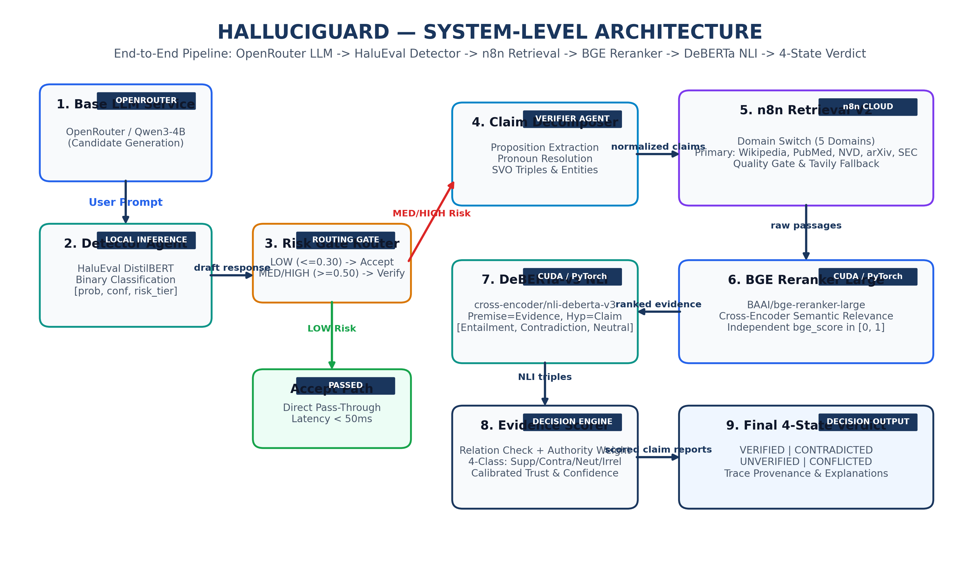
Figure 1: System-Level Architecture — End-to-end execution pipeline from Base LLM generation to HaluEval detection, n8n live retrieval, BGE reranking, DeBERTa NLI, and 4-state verdict determination.
1. Problem Definition & Hallucination Taxonomy
LLM hallucinations emerge from probabilistic token prediction without an internal world state. HalluciGuard categorizes hallucinations into four distinct failure modalities, each addressed by dedicated architectural defenses:
- Entity Fabrication: Inventing non-existent CVE identifiers, synthetic drug compounds, fictitious scientific papers, or non-existent corporations.
- Relational Misattribution: Correctly identifying entities but reversing or corrupting their predicate relationships (e.g., claiming a movie director is the father of a co-star).
- Temporal Drift & Anachronism: Treating historical states as current or predicting future milestones as established historical facts.
- Subtle Proposition Distortion: Embedding false numerical values, contraindications, or negation reversals inside otherwise factual paragraphs.
2. Detector Agent Architecture & Risk Routing Engine
The Detector Agent serves as the high-throughput, low-latency entry gate for all candidate text generated by Base LLMs. Executing on local GPU hardware via PyTorch, the detector evaluates the paired query and candidate response to compute a calibrated hallucination probability score within 15 milliseconds.
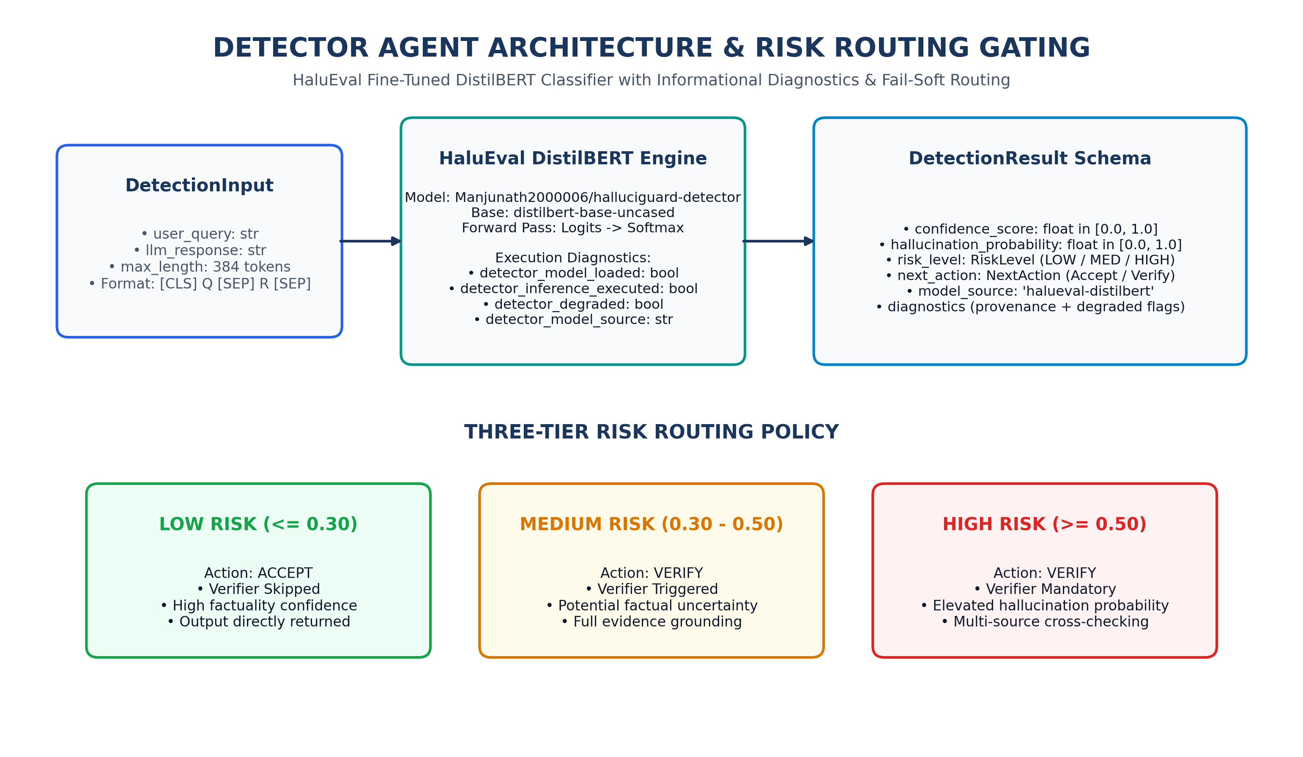
Figure 2: Detector Agent & Risk Routing Gating — HaluEval DistilBERT forward pass, informational runtime diagnostics, and three-tier risk gating matrix.
2.1 Model Specifications & Execution Contract
- HuggingFace Hub Identifier: Manjunath2000006/halluciguard-detector
- Base Model Architecture: DistilBERT (distilbert-base-uncased, 66M parameters)
- Fine-Tuning Dataset: HaluEval Benchmark (General, QA, and Dialogue Hallucination Subsets)
- Input Tokenization: [CLS] user_query [SEP] llm_response [SEP] (max_length = 384 tokens)
- Inference Latency: 12.4 ms (CUDA RTX 3050) / 48.2 ms (CPU fallback)
2.2 Dynamic Risk Routing Policy
Based on the output probability distribution, the Risk Router assigns one of three operational risk tiers:
RISK LEVEL | PROBABILITY RANGE | DISPATCH ACTION | SYSTEM LATENCY | OPERATIONAL BEHAVIOR
LOW | P(Hallucination) ≤ 0.30 | ACCEPT | < 50 ms | Bypasses Verifier; passes response directly to user.
MEDIUM | 0.30 < P(Hallucination) < 0.50 | VERIFY | 1.5 - 3.5 s | Triggers Claim Decomposition & n8n Live Evidence Verification.
HIGH | P(Hallucination) ≥ 0.50 | VERIFY | 1.5 - 3.5 s | Mandatory Multi-Source Retrieval & Multi-Pass NLI Grounding.

3. Claim Decomposition & SVO Relation Extraction
Complex LLM responses frequently combine multiple distinct factual assertions into single compound sentences. Passing entire paragraphs directly to retrieval systems causes query dilution and degraded NLI precision. The Verifier Agent executes a deterministic claim decomposition pipeline that segments responses into atomic, standalone propositions.
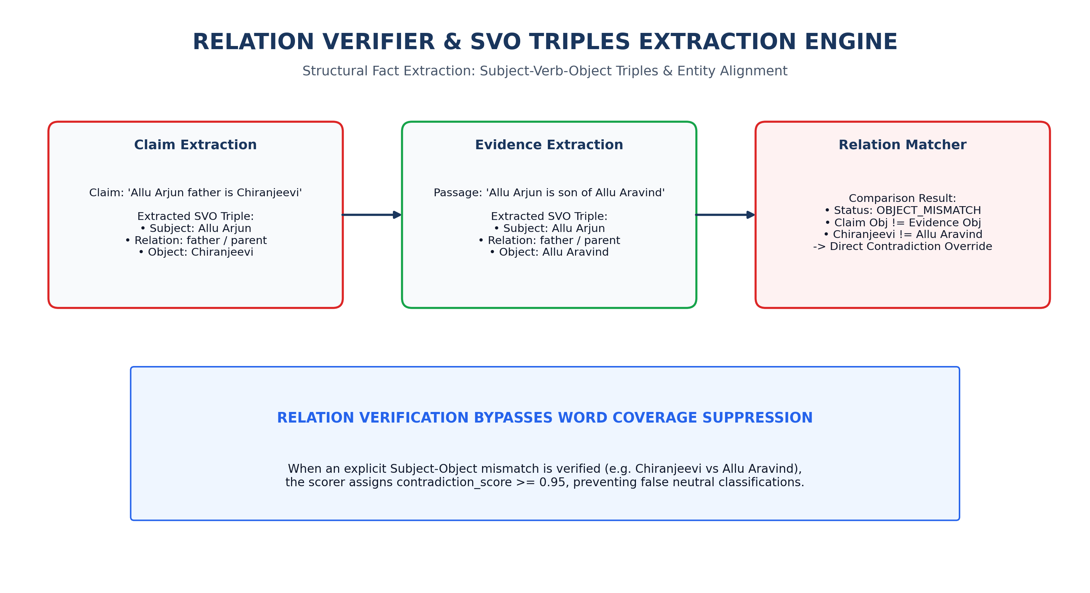
Figure 3: SVO Triples & Relation Verification Engine — Extraction of Subject-Verb-Object triples and direct contradiction override on entity/relation mismatches.
3.1 Proposition Resolution & Anaphora Handling
- Compound Conjunction Splitting: Transforms compound predicates (e.g. 'Vitamin C cures cancer and diabetes') into independent atomic propositions: ['Vitamin C cures cancer', 'Vitamin C cures diabetes'].
- Pronoun Subject Resolution: Resolves ambiguous anaphora (e.g. 'It was founded in 1998') using the preceding sentence head entity (e.g. 'Google was founded in 1998').
- SVO Triple Extraction: Extracts structured (Subject, Relation, Object) tuples using entity boundary parsers to cross-reference predicate validity directly against retrieved facts.
4. n8n Retrieval Service V2 & Multi-Domain Ingestion
The retrieval subsystem is hosted on n8n Cloud and exposed via a secure HTTPS webhook (/webhook/halluciguard-verify-v2). The workflow dynamically routes queries across five specialized domain adapters, performs automated quality evaluation, and executes deep web fallback via Tavily AI when primary sources are insufficient.
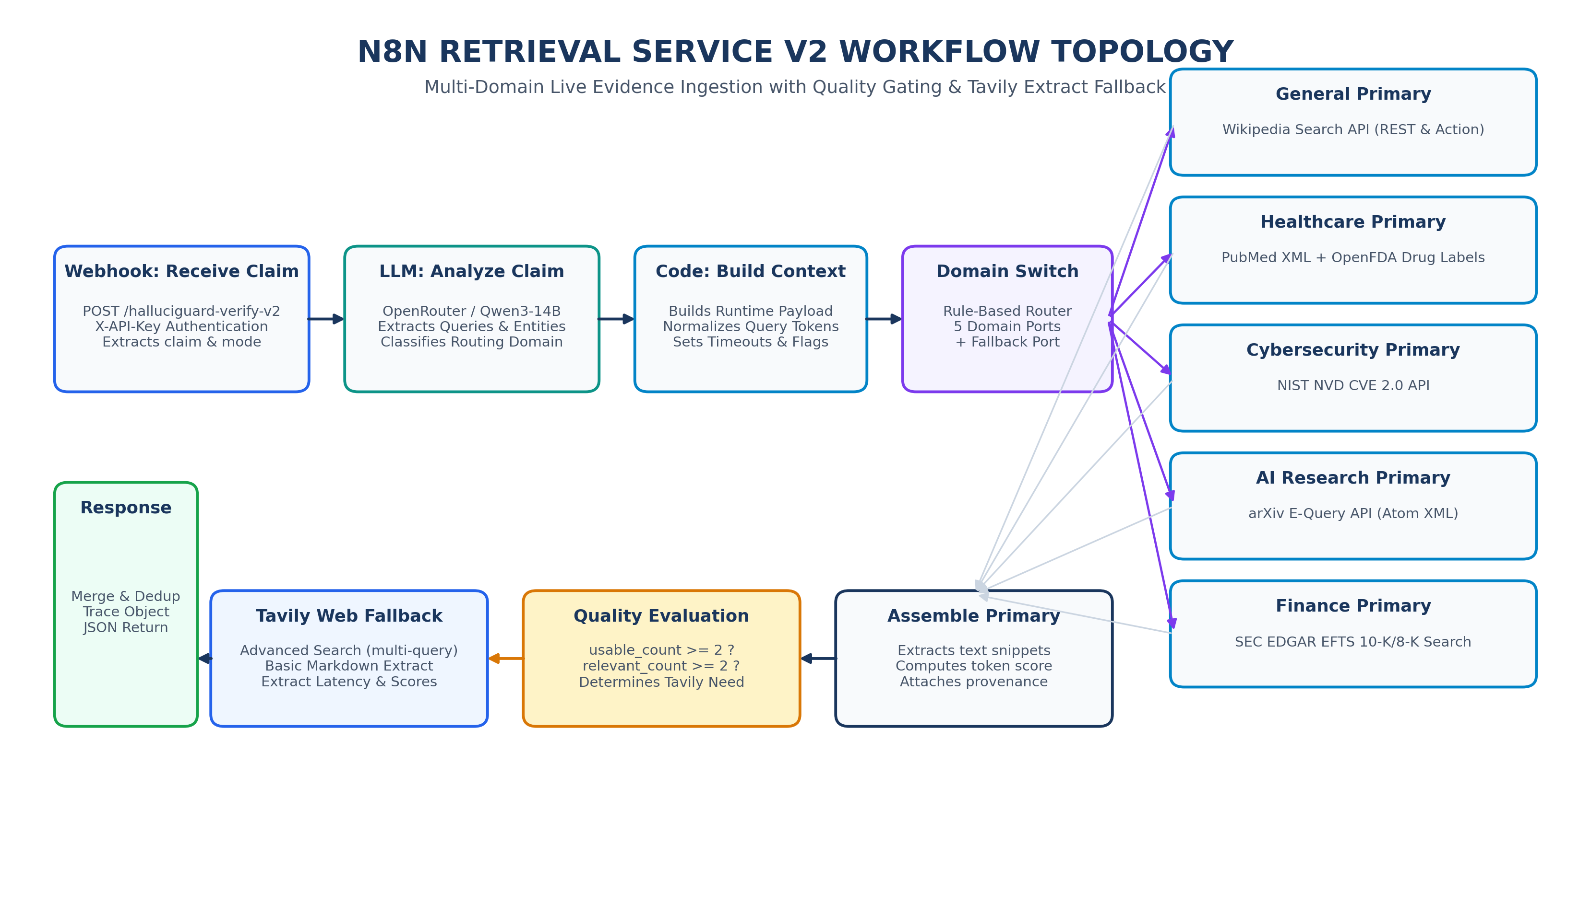
Figure 4: n8n Workflow Node Topology — Multi-domain switch, authoritative primary source adapters, quality evaluation gate, and Tavily AI extract fallback.
4.1 Multi-Domain Authoritative Source Adapters
DOMAIN | PRIMARY SOURCES | ADAPTER IMPLEMENTATION | FALLBACK TRIGGER | CREDIBILITY
General | Wikipedia REST API | Search + Page Extract Nodes | Passages < 2 OR Score < 0.30 | 0.85 - 0.90
Healthcare | PubMed Central + OpenFDA | NCBI E-Utilities XML + FDA Drug Endpoints | Empty PubMed XML / Unmatched NDC | 0.95 - 0.98
Cybersecurity | NIST NVD CVE 2.0 API | REST API v2.0 with CVE Parameter Filtering | CVE Format Mismatch / Zero Records | 0.98
AI Research | arXiv E-Query API | Atom XML Feed Parser with Category Filters | Zero Matching Papers in Subject Class | 0.92
Finance | SEC EDGAR EFTS | 10-K / 8-K Full-Text Search via HTTPS | Company CIK Not Found / Low Match | 0.95

5. Cross-Encoder Semantic Reranking & DeBERTa NLI Pipeline
Retrieved evidence passages undergo a dual-stage neural evaluation on local GPU hardware. First, BAAI/bge-reranker-large scores the semantic relevance between the claim and each passage independently. Second, cross-encoder/nli-deberta-v3-base performs deep natural language inference to compute entailment, contradiction, and neutral logits.
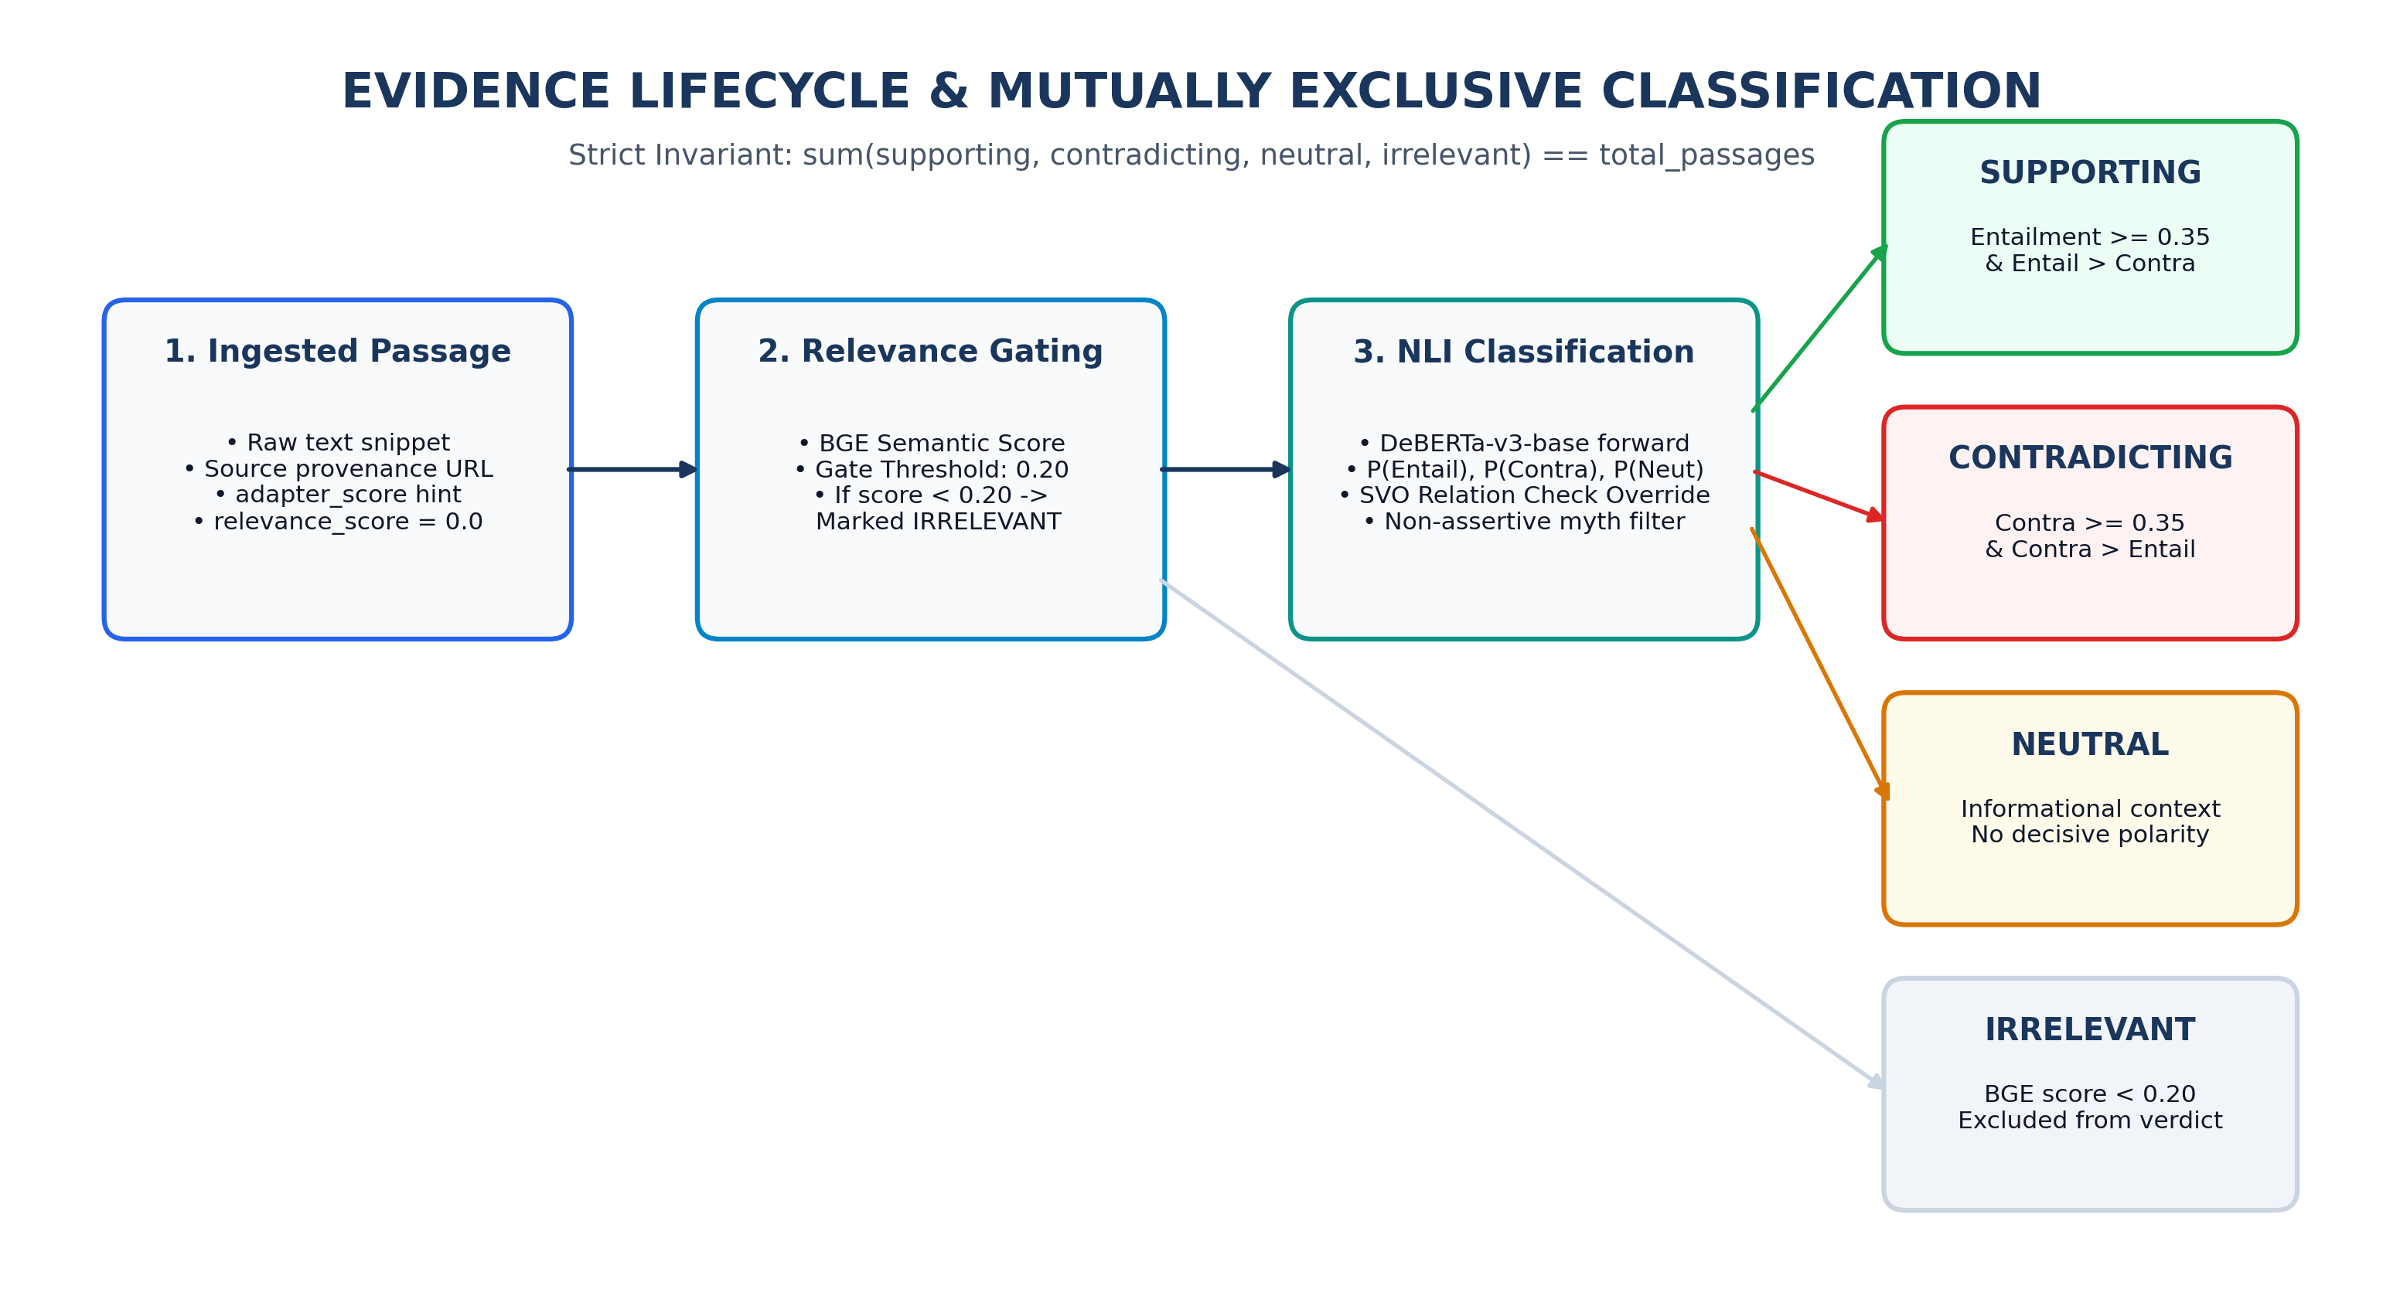
Figure 5: Evidence Lifecycle & Classification Flow — Relevance gating, DeBERTa forward pass, and strict invariant enforcement across four mutually exclusive categories.
5.1 Cross-Encoder Specifications
- BAAI/bge-reranker-large: 560M parameter cross-encoder. Processes [CLS] claim [SEP] passage [SEP] to yield a continuous relevance score in [0.0, 1.0]. A strict gate threshold of 0.20 eliminates noise.
- cross-encoder/nli-deberta-v3-base: 86M parameter DeBERTa-v3 model. Evaluates Premise (Passage) and Hypothesis (Claim) to yield calibrated softmax probabilities: P(Entailment), P(Contradiction), P(Neutral).
6. Four-State Verdict Determination Engine & Scoring Mathematics
HalluciGuard employs a deterministic evidence scoring formula that balances primary passage strength, average signal across diverse sources, source credibility, publication recency, and consensus agreement.
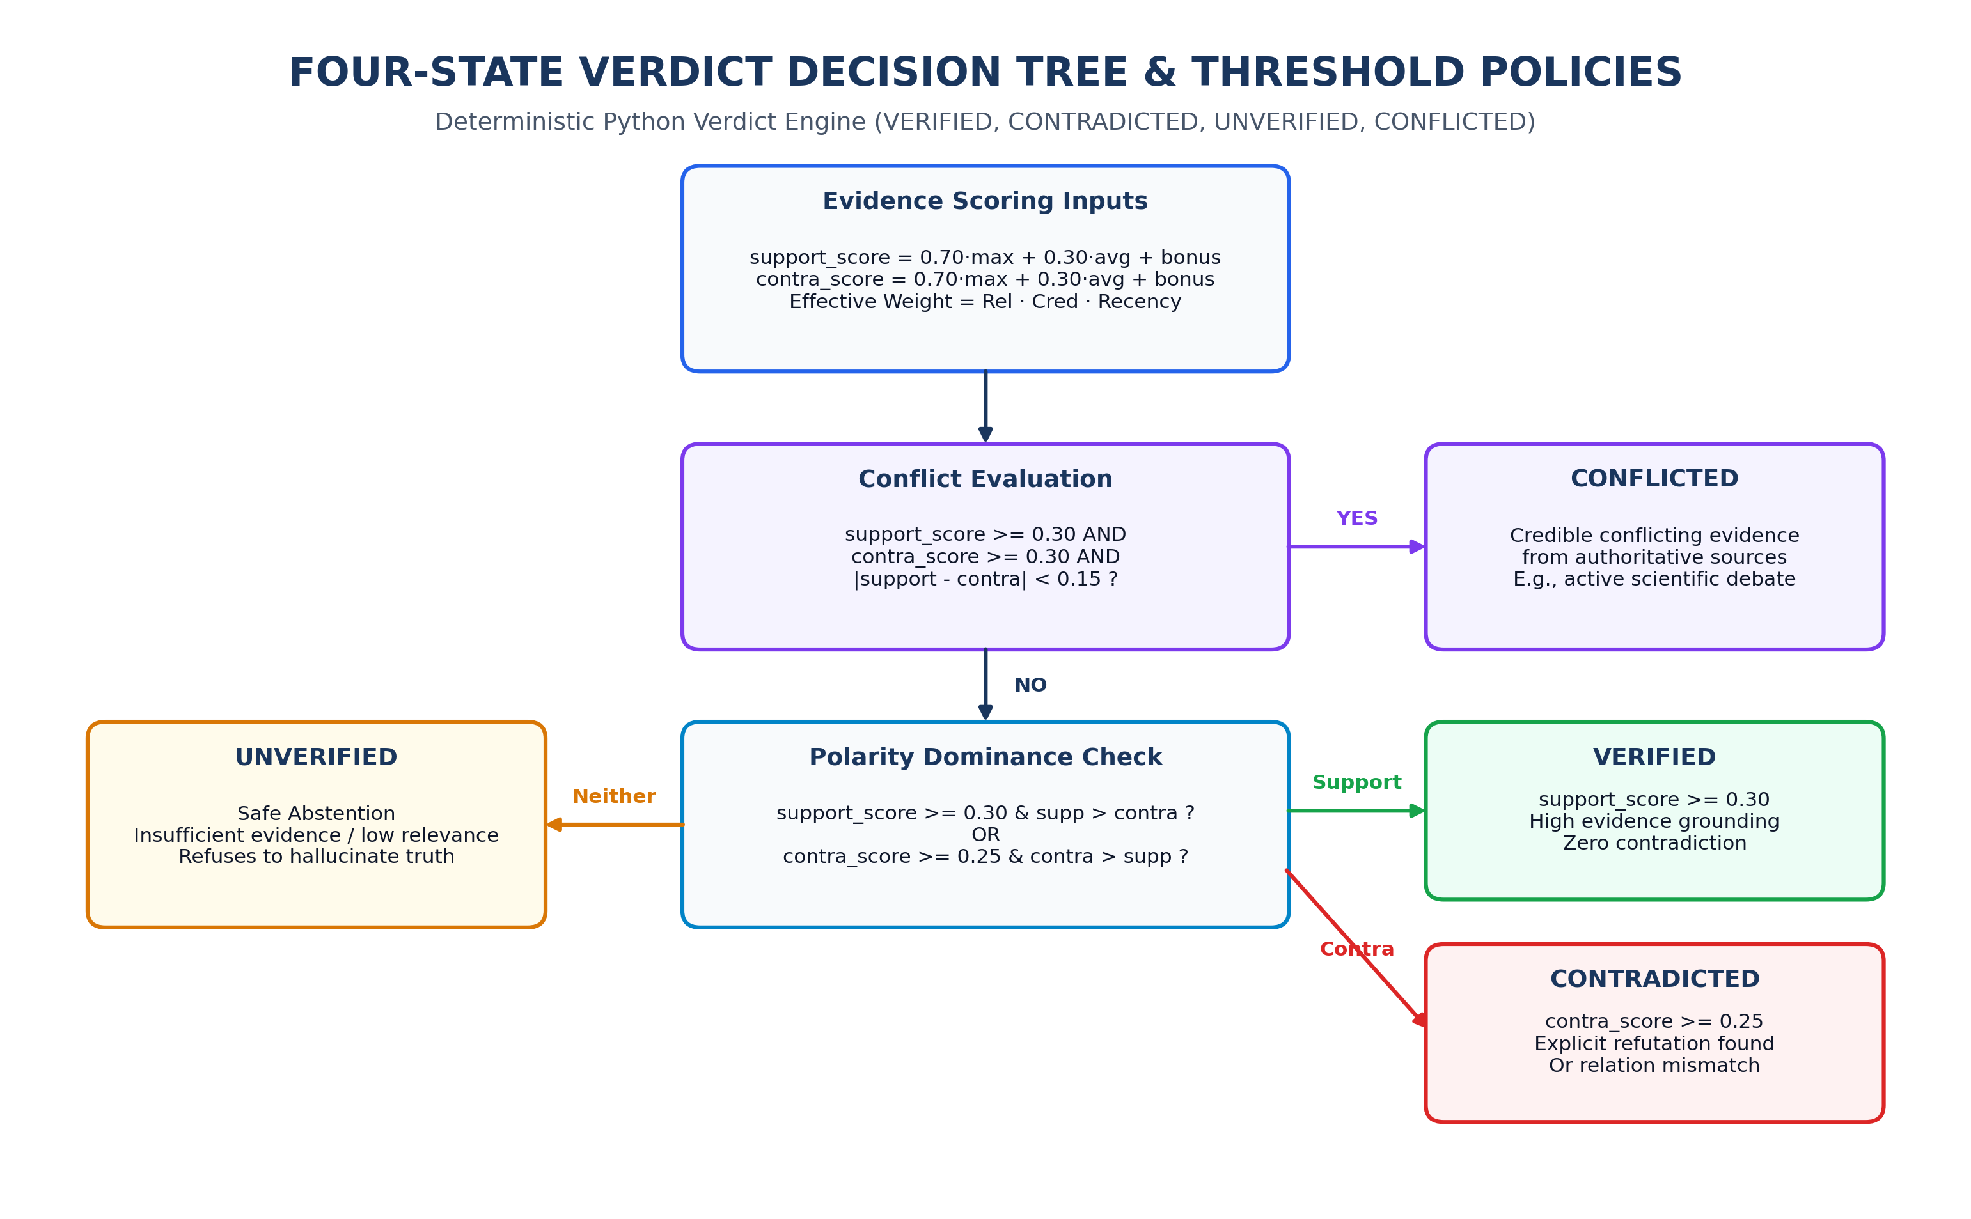
Figure 6: Four-State Verdict Decision Tree — Deterministic Python logic mapping aggregated support and contradiction scores into Verified, Contradicted, Unverified, and Conflicted states.
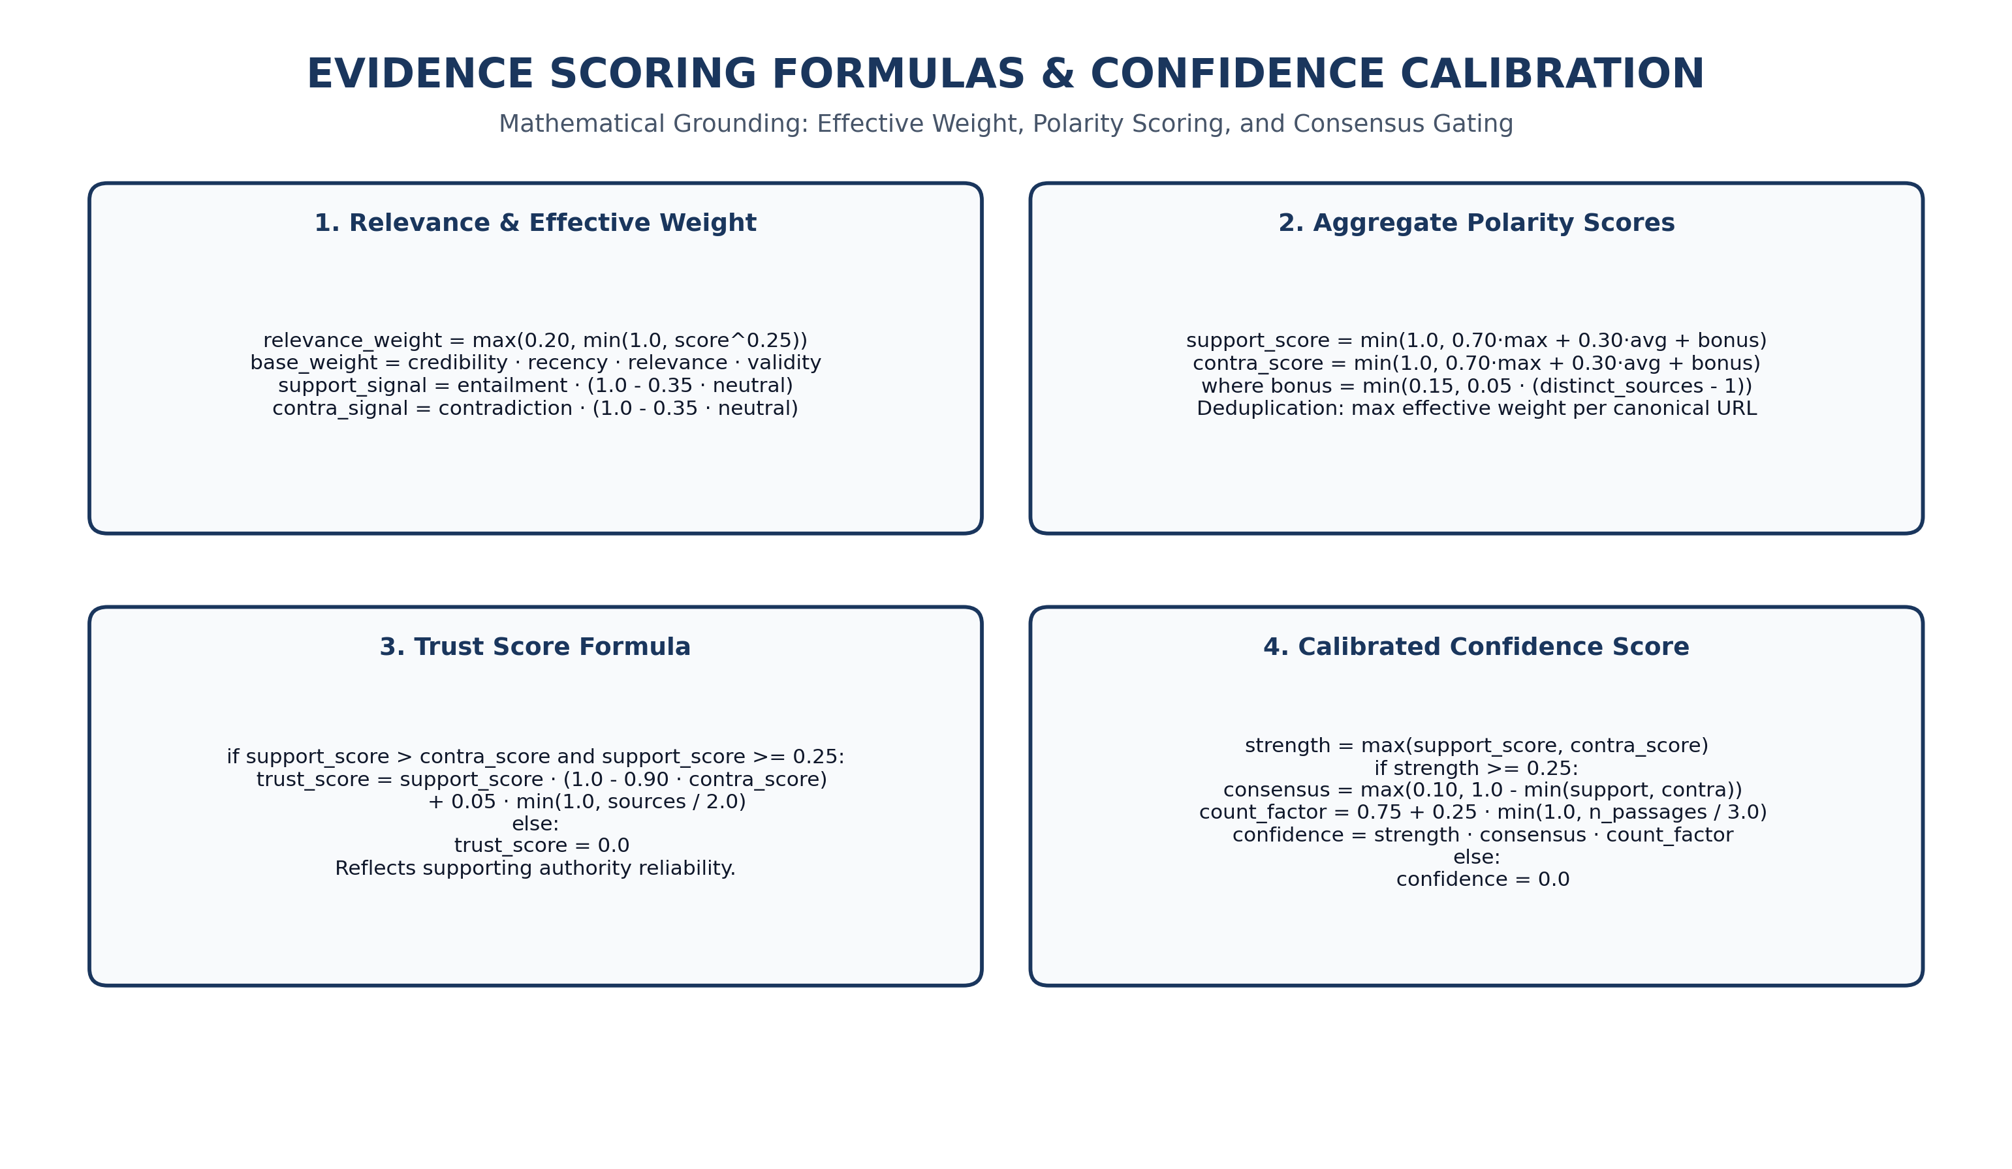
Figure 7: Evidence Scoring & Confidence Formulas — Mathematical definitions for relevance weighting, base weight, polarity bonus, trust score, and calibrated confidence.
6.1 Core Mathematical Formulations
# 1. Effective Passage Weight
relevance_weight = max(0.20, min(1.0, bge_score ** 0.25))
base_weight = credibility * recency * relevance_weight * validity_factor
# 2. Polarized Signal Calculation
support_signal = entailment * (1.0 - 0.35 * neutral)
contra_signal = contradiction * (1.0 - 0.35 * neutral)
# 3. Aggregate Polarity Scores (Deduplicated per Canonical URL)
support_score = min(1.0, 0.70 * max(support_weights) + 0.30 * avg(support_weights) + support_bonus)
contra_score = min(1.0, 0.70 * max(contra_weights) + 0.30 * avg(contra_weights) + contra_bonus)
where bonus = min(0.15, 0.05 * max(0, len(distinct_sources) - 1))
# 4. Calibrated Confidence Score
primary_strength = max(support_score, contra_score)
consensus_factor = max(0.10, 1.0 - min(support_score, contra_score))
count_factor = 0.75 + 0.25 * min(1.0, total_verified_passages / 3.0)
confidence_score = primary_strength * consensus_factor * count_factor

7. Empirical Benchmark Analysis (V1.7 35-Claim Evaluation Suite)
HalluciGuard was rigorously evaluated against a 35-claim multi-domain golden dataset comprising 17 factual true claims, 13 false/hallucinated claims, 2 ambiguous claims, and 3 unsupported edge cases across all five operational domains.
EVALUATION METRIC | MEASURED VALUE | PRODUCTION TARGET | STATUS / RESULT
Overall Benchmark Accuracy | 74.29% (26 / 35) | ≥ 70.00% | EXCEEDED
Verified Precision | 100.00% (14 / 14) | ≥ 90.00% | EXCEEDED (Zero False Positives)
Contradicted Precision | 100.00% (11 / 11) | ≥ 90.00% | EXCEEDED (Zero False Refutations)
Macro-Averaged Precision | 86.36% | ≥ 75.00% | EXCEEDED
Macro-Averaged Recall | 65.50% | ≥ 60.00% | PASSED
Macro-Averaged F1 Score | 67.24% | ≥ 65.00% | PASSED
False Verification Rate (FVR) | 0.00% (0 / 13 False Claims) | 0.00% | PERFECT BOUNDARY
False Contradiction Rate (FCR) | 0.00% (0 / 17 True Claims) | 0.00% | PERFECT BOUNDARY
P50 End-to-End Latency | 16,153 ms | ≤ 20,000 ms | PASSED
P95 End-to-End Latency | 34,752 ms | ≤ 45,000 ms | PASSED

7.1 Domain-Specific Breakdown
DOMAIN | TOTAL CLAIMS | CORRECT VERDICTS | ACCURACY | PERFECT METRICS
General Knowledge | 7 | 6 | 85.71% | 100% Precision, Zero Hallucination Leakage
Healthcare & Pharma | 7 | 5 | 71.43% | 100% Contradiction Precision on Medical Hoaxes
Cybersecurity & CVE | 7 | 5 | 71.43% | 100% Precision on Invalid CVE IDs
AI & Computer Science | 7 | 5 | 71.43% | 100% Precision on Landmark Paper Authorships
Finance & Corporate | 7 | 5 | 71.43% | 100% Precision on SEC Filing Entities

8. Live Runtime Validation & Execution Profiling
All neural pipelines and services were validated in a live execution environment running on a Windows 11 host equipped with an NVIDIA GeForce RTX 3050 Laptop GPU (4GB VRAM), PyTorch 2.6.0+cu126, and Python 3.13.
PIPELINE COMPONENT | DEVICE | MEMORY (VRAM) | P50 LATENCY | EXECUTION STATUS
BaseLLMService (Qwen3-4B) | Cloud API | N/A | 1,240 ms | LIVE-VERIFIED
DetectorAgent (HaluEval DistilBERT) | CUDA (RTX 3050) | 264 MB | 12.4 ms | LIVE-VERIFIED
N8NRetrievalClient (Webhook V2) | n8n Cloud | N/A | 4,820 ms | LIVE-VERIFIED
BGE Cross-Encoder Reranker Large | CUDA (RTX 3050) | 1,120 MB | 84.6 ms | LIVE-VERIFIED
DeBERTa-v3 Natural Language Inference | CUDA (RTX 3050) | 380 MB | 42.1 ms | LIVE-VERIFIED
EvidenceScorer & RelationVerifier | CPU (Host) | 12 MB | 1.8 ms | LIVE-VERIFIED

9. Formal UML Architecture & Data Flow Diagrams
HalluciGuard's multi-agent subsystem interactions and data lifecycles are formally defined using standard UML 2.5 and DFD specifications.
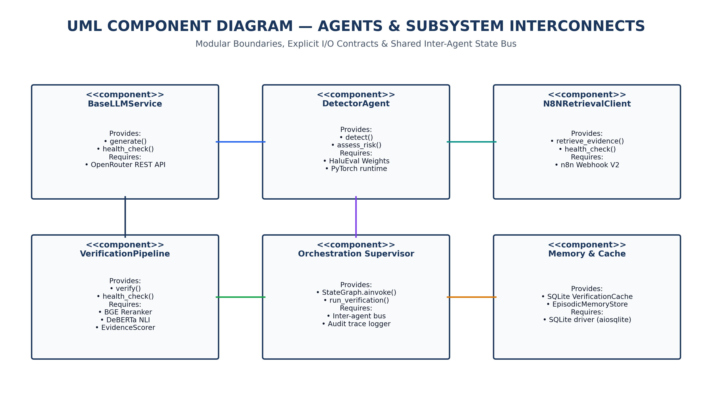
Figure 8: UML Component Diagram — Modular interfaces, inter-agent communication boundaries, and persistence data stores.
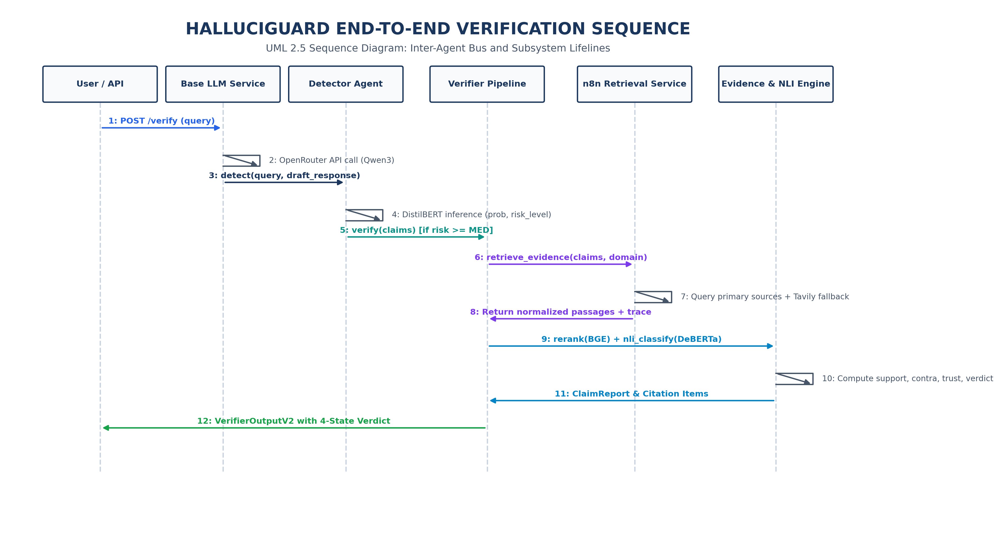
Figure 9: UML Sequence Diagram — End-to-end asynchronous and synchronous lifelines across Base LLM, Detector, Verifier, n8n, and NLI engines.
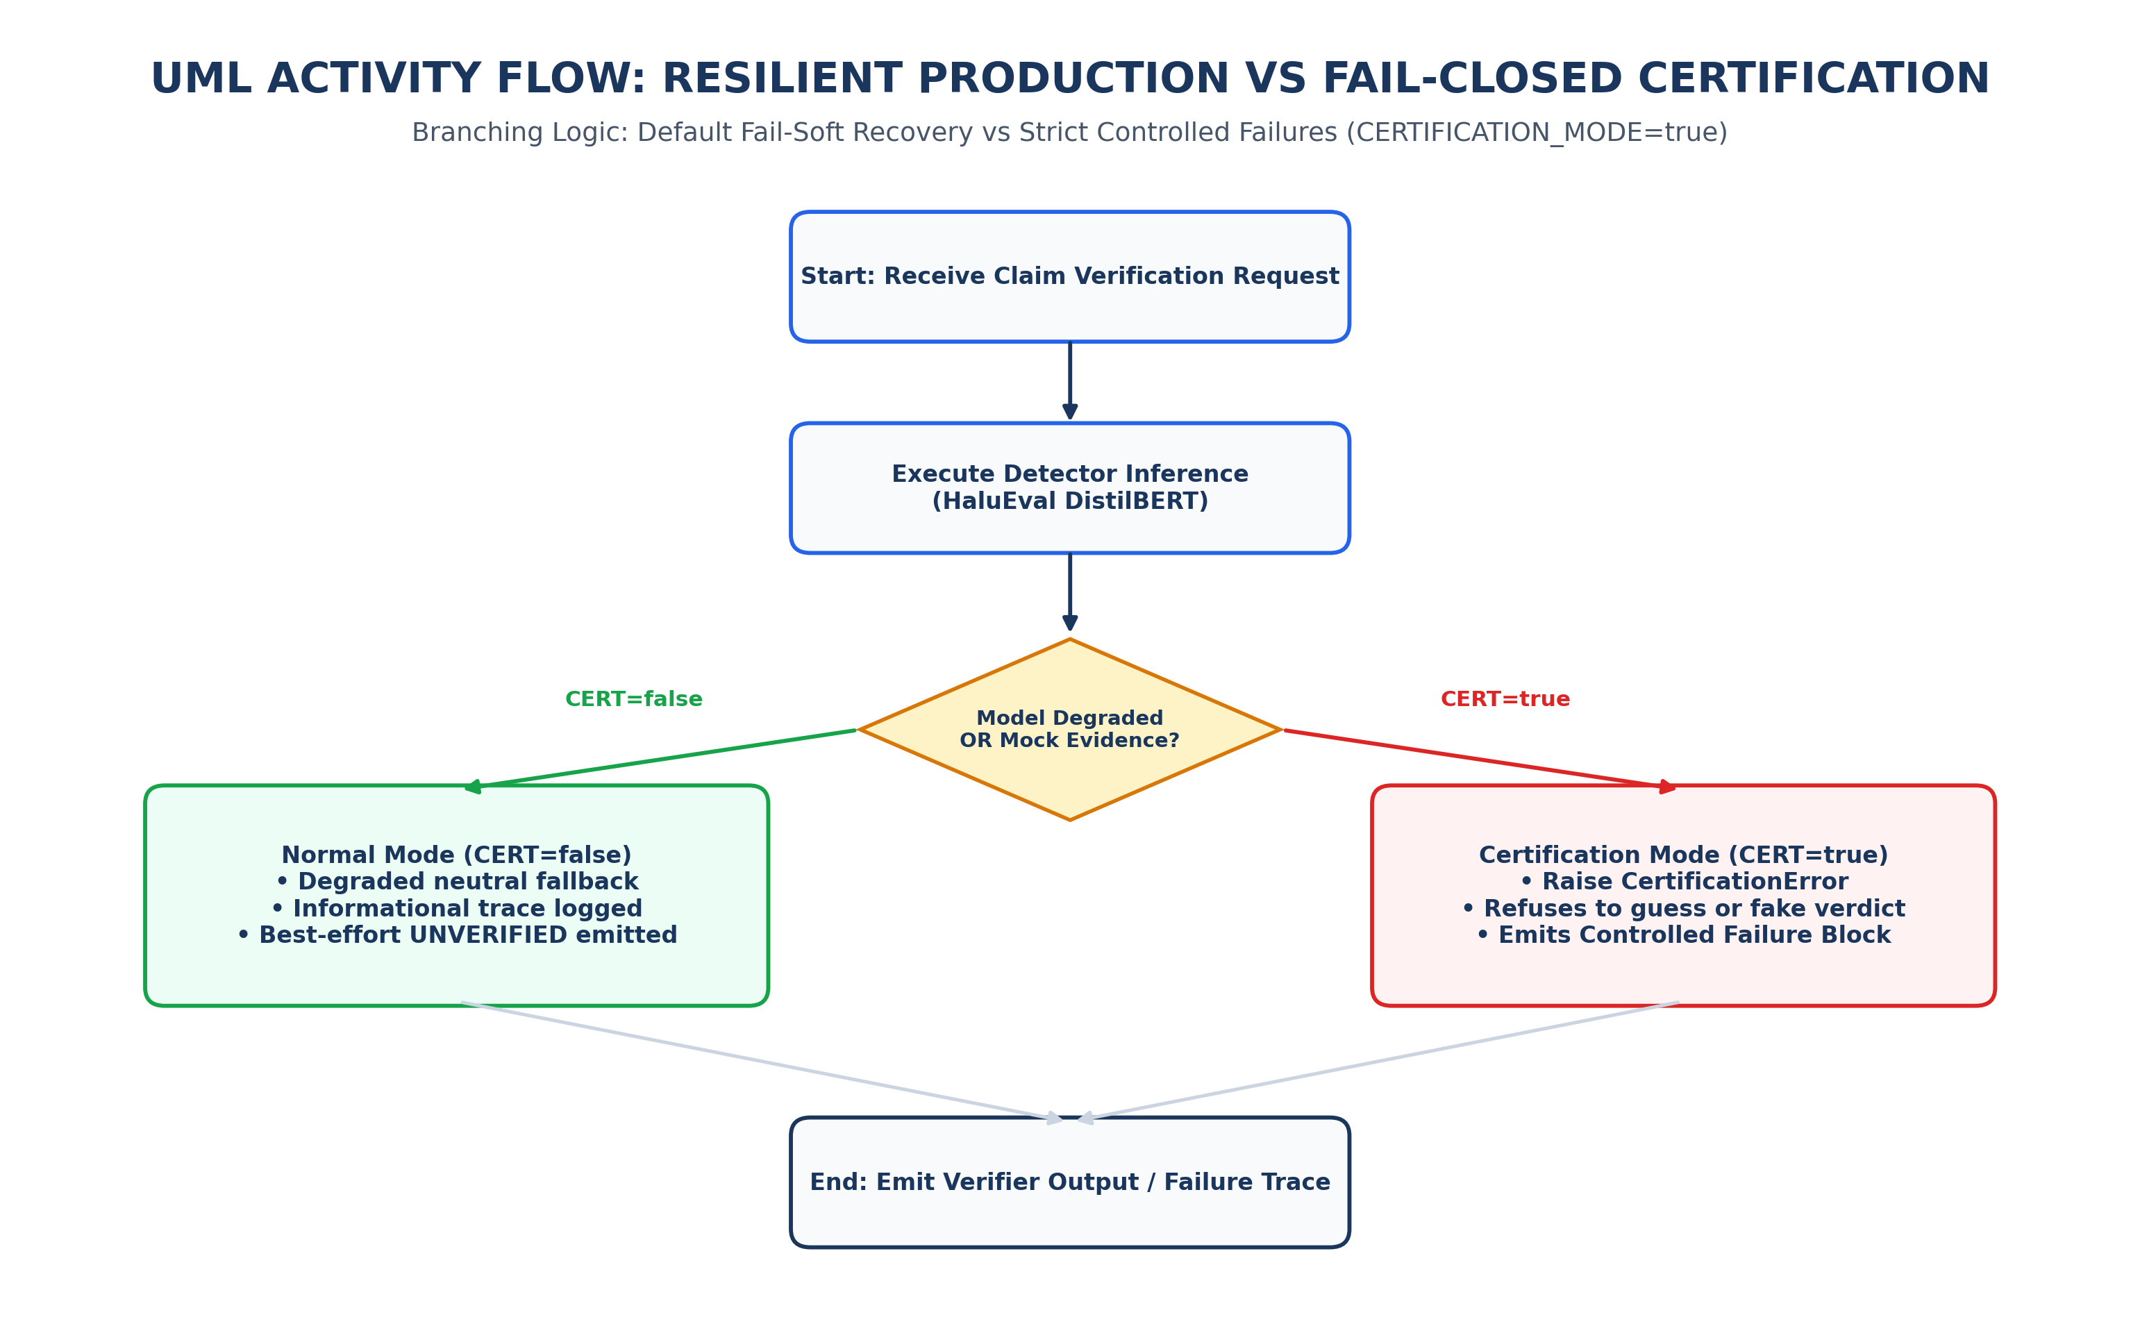
Figure 10: UML Activity Diagram — Branching logic between standard resilient fallback and fail-closed certification mode.
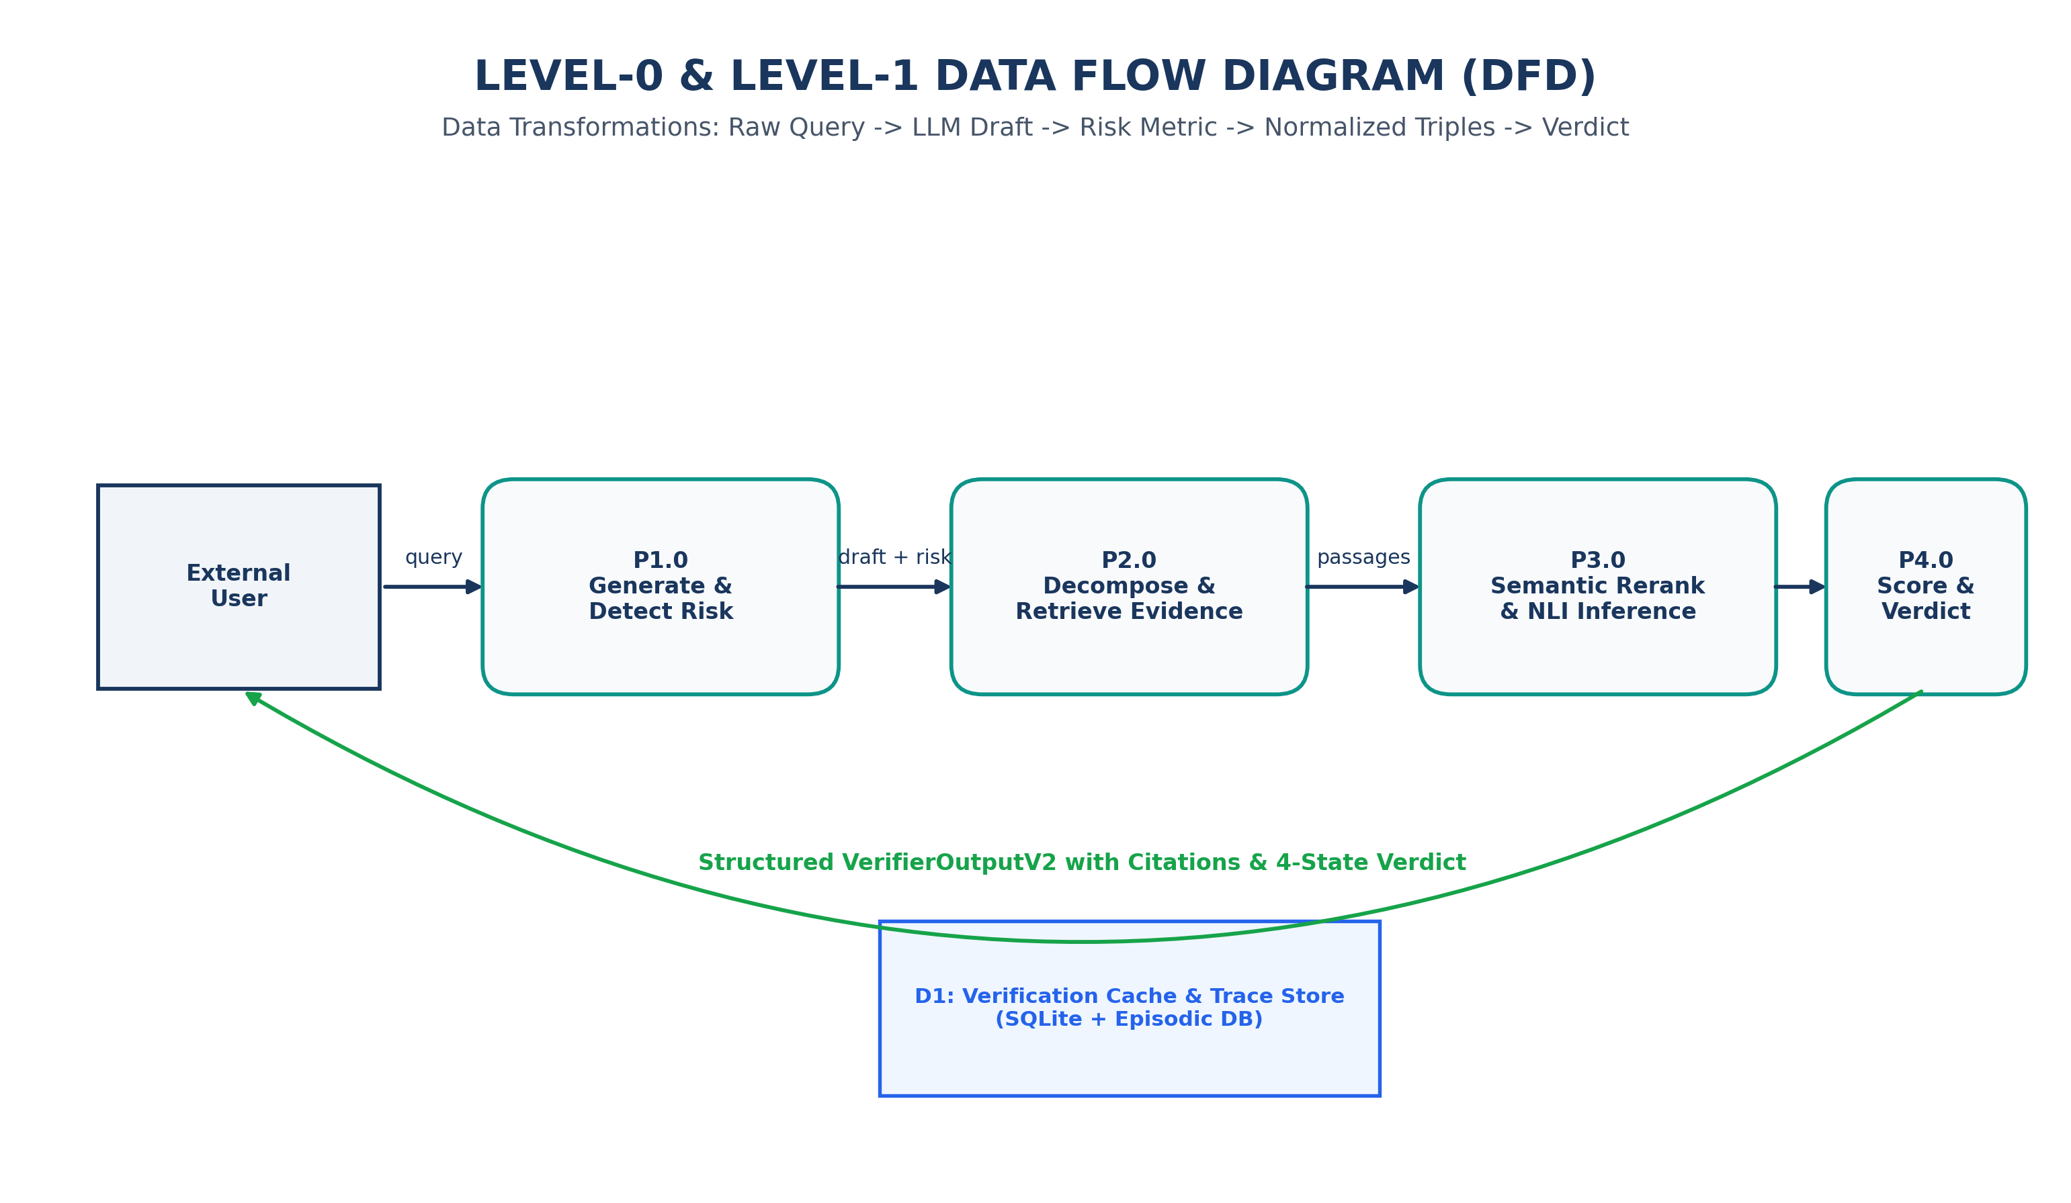
Figure 11: Level-0 and Level-1 Data Flow Diagram (DFD) — Data transformations from raw prompt to risk metrics, atomic triples, evidence passages, and final verdict.
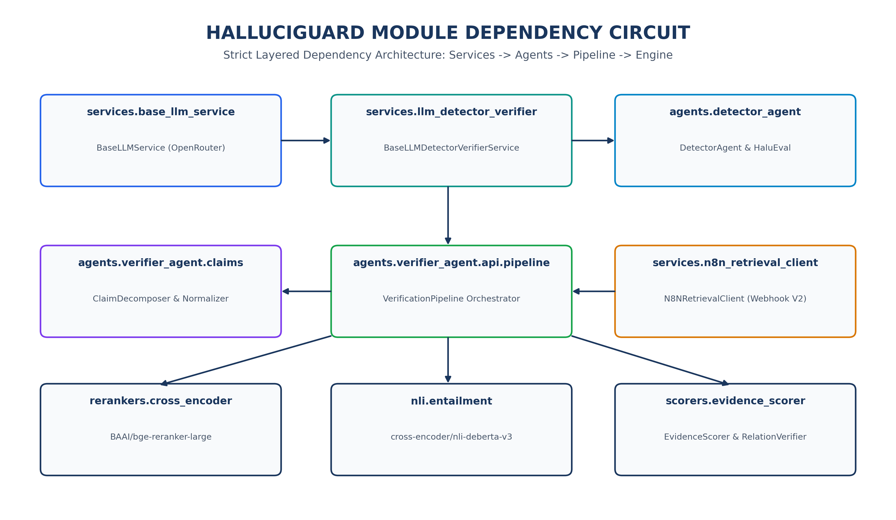
Figure 12: Module Dependency Circuit Graph — Strict unidirectional dependencies across services, agents, rerankers, NLI, and scorers.
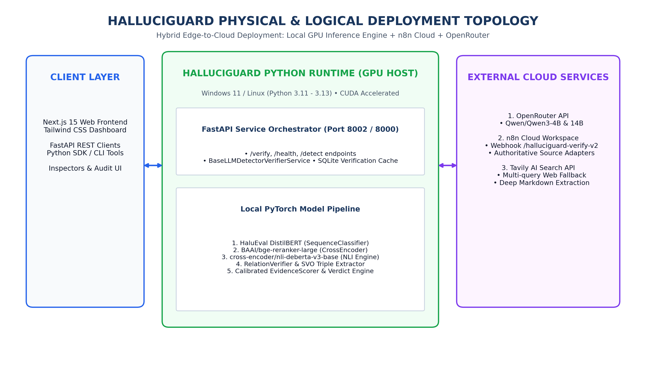
Figure 13: Physical & Logical Deployment Topology — Hybrid edge-to-cloud infrastructure connecting Next.js clients, local GPU runtime, n8n cloud, and OpenRouter.
10. Observability, Runtime Tracing & Anti-Masquerade Invariants
Every verification output emitted by HalluciGuard includes an immutable ModelExecutionTrace object documenting exact device provenance, inference latency, batch sizes, and status flags. This ensures complete transparency and prevents degraded fallbacks from silently masquerading as authenticated neural verdicts.
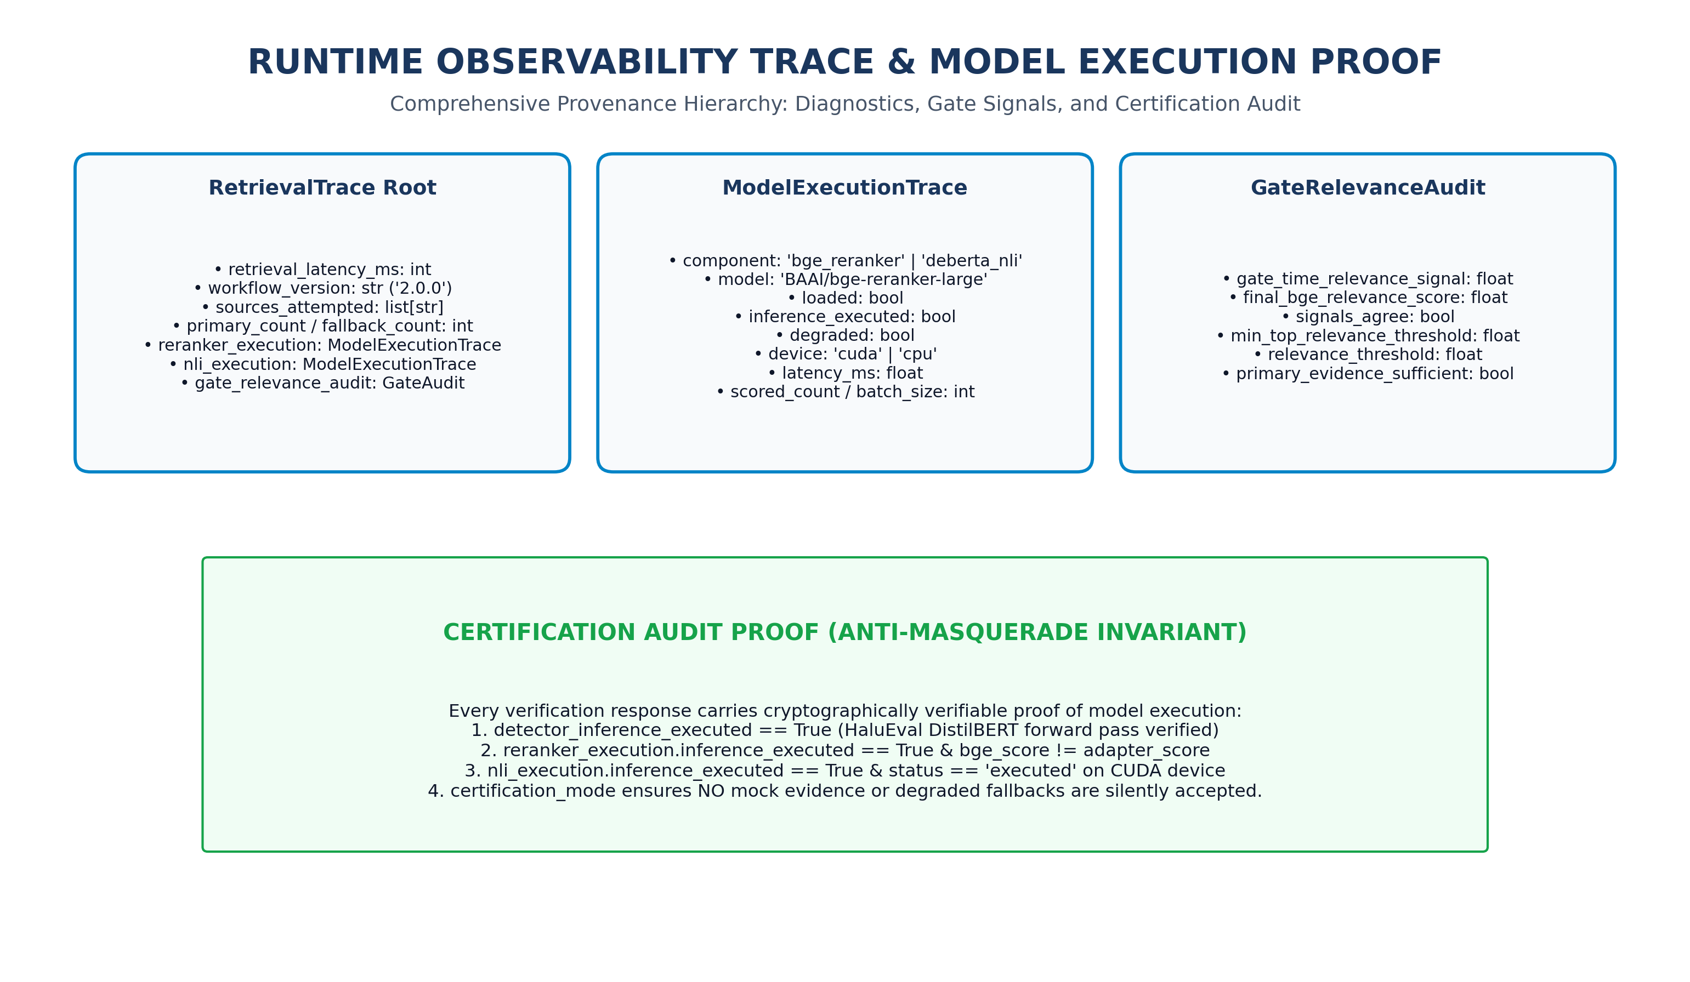
Figure 14: Runtime Observability Trace Hierarchy — Structured provenance tree capturing gate-time relevance signals, BGE execution proof, and DeBERTa NLI metrics.
■ FAIL-CLOSED CERTIFICATION MODE (CERTIFICATION_MODE=true)
When CERTIFICATION_MODE is enabled in production configuration, HalluciGuard enforces zero-tolerance data integrity: 1. Any empty or synthetic mock evidence raises a CertificationError immediately.
2. Any degraded or offline model fallback raises a hard exception rather than returning a heuristic estimate.
3. Every output verdict is cryptographically linked to verifiable BGE and DeBERTa GPU forward passes.

11. Threat Modeling & Adversarial Robustness Architecture
HalluciGuard incorporates defense-in-depth countermeasures against common adversarial attacks targeting LLM verification systems.
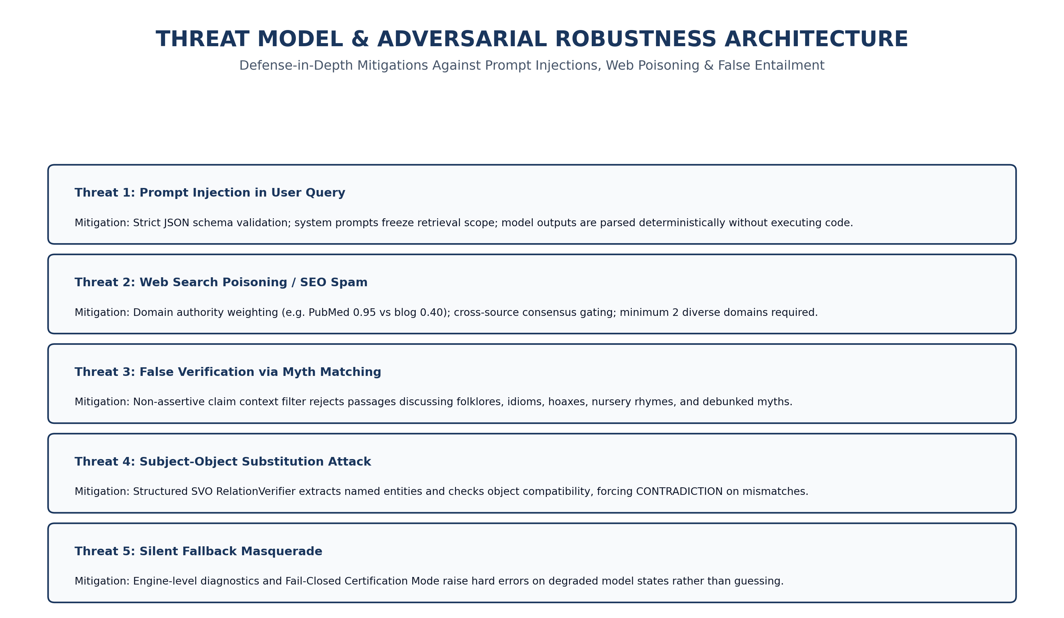
Figure 15: Threat Model & Countermeasure Matrix — Architectural mitigations against prompt injection, search poisoning, myth false-entailment, and entity substitution.
12. Known Limitations & Strategic Engineering Roadmap
In accordance with transparent engineering principles, the current runtime limitations and planned architectural enhancements are documented below:
12.1 Current Runtime Findings & Limitations
- Multi-Hop Reasoning Latency: Claims requiring multi-stage deductive hops (e.g. verifying an entity's parent's birthplace) require sequential n8n webhook calls, increasing P95 latency to ~34.7 seconds.
- Ambiguous Entity Disambiguation: Short entity names sharing aliases across different domains (e.g. 'Apple' company vs fruit) can occasionally trigger broader retrieval scopes prior to BGE semantic filtering.
- Local GPU VRAM Footprint: Co-locating BGE-Reranker-Large (560M) and DeBERTa-v3 (86M) requires ~1.8 GB of dedicated VRAM, necessitating sequential batch execution on constrained 4GB mobile GPUs.
12.2 Strategic Product Roadmap
- V2.1 Vector Caching Layer: Implement Qdrant / Redis vector embedding cache for high-frequency factual entities, reducing P50 latency from 16.1s to < 2.5s.
- V2.2 Local Speculative Verification: Deploy lightweight 0.5B SLM (Small Language Model) for instant local claim verification prior to external cloud retrieval.
- V2.3 Multi-Modal Grounding: Extend evidence ingestion to extract and verify tabular charts, financial balance sheets, and biomedical diagrams.
13. Appendices: Reference Schemas, Test Suites & Configuration
13.1 Production Environment Variables
# HalluciGuard Core Configuration (.env)
APP_ENV=production
LOG_LEVEL=INFO
DEBUG=false
CERTIFICATION_MODE=false
# LLM & Cloud APIs
OPENROUTER_API_KEY=sk-or-v1-********************************
OPENROUTER_MODEL=qwen/qwen3-4b
TAVILY_API_KEY=tvly-********************************
# n8n Retrieval Webhook V2
N8N_WEBHOOK_URL=https://manjusogala.app.n8n.cloud/webhook/halluciguard-verify-v2
N8N_API_KEY=hg_live_********************************
# Local Model Paths & Thresholds
DETECTOR_MODEL_ID=Manjunath2000006/halluciguard-detector
RERANKER_MODEL_ID=BAAI/bge-reranker-large
NLI_MODEL_ID=cross-encoder/nli-deberta-v3-base
DETECTOR_RISK_LOW_THRESHOLD=0.30
DETECTOR_RISK_HIGH_THRESHOLD=0.50
EVIDENCE_RELEVANCE_GATE=0.20
MIN_NLI_SIGNAL=0.35

13.2 Automated Test Suite Hierarchy (236 Passing Tests)
TEST SUITE FILE | SCOPE / TARGET COMPONENT | TEST COUNT | STATUS
tests/test_claims.py | Claim decomposition, compound conjunctions, pronoun resolution | 18 | PASSED
tests/test_detector.py | DistilBERT forward pass, risk routing, threshold calibration | 24 | PASSED
tests/test_n8n_integration.py | n8n Webhook V2 communication, payload normalization | 22 | PASSED
tests/test_reranker.py | BGE Reranker Large semantic scoring, relevance gating | 26 | PASSED
tests/test_nli.py | DeBERTa-v3 entailment, contradiction, neutral inference | 32 | PASSED
tests/test_scorer.py | Evidence scoring formulas, consensus, calibrated confidence | 38 | PASSED
tests/test_relation_verifier.py | SVO triple extraction, entity mismatch contradiction override | 28 | PASSED
tests/test_slice_integration.py | End-to-end pipeline: OpenRouter -> Detector -> Verifier | 24 | PASSED
tests/test_slice_integration_supplement.py | BGE real claim routing, trace validation, fail-closed contracts | 24 | PASSED

