Template for PSQ Indicators

This template is designed to help hospital track and monitor Patient Safety and Quality (PSQ) indicators within their healthcare facility. It provides a structured format to collect data on key performance metrics related to patient safety, clinical outcomes, and quality improvement efforts.

The template allows hospitals to assess compliance, identify trends, measure progress, and ensure alignment with NABH standards. It serves as a critical tool for ongoing evaluation and strategic planning to enhance patient care and safety.

SHCO Patient Safety and Quality Indicators Template

Name of the Hospital:
Date:
SHCO – The Quality Indicators
Process Indicators | Outcome Indicators |  | Managerial Indicators
▪ Time taken for discharge  ▪ Tame taken for Initial Assessment for IP patients  ▪ Waiting time for diagnostics  ▪ Percentage of transfusion reactions ▪ Standardized Mortality Ratio for ICU ▪ Compliance to Hand hygiene practice  ▪ Percentage of cases who received appropriate prophylactic antibiotics within the specified timeframe | ▪ Patient Fall  ▪ Needle Stick Injuries  ▪ Hospital Acquired Pressure Ulcers  ▪ Central Line associated blood stream infection rate  ▪ Catheter Associated Urinary Tract Infection rate  ▪ Surgical Site Infection rate – Superficial and Deep  ▪ Ventilator associated Pneumonia rate ▪ Incidence of medication errors  ▪ Patient Satisfaction |  | ▪ Employee Attrition Rate (Category wise – Doctors, Nurses, others, etc.)  ▪ Employee absenteeism rate ▪ Employee satisfaction  ▪ Percentage of employees aware of employee rights and responsibilities

** Please select minimum five quality indicators (mix of Clinical & Managerial indicators) for your organization.

Name of the Quality Indicator (e.g., Patient Fall)

Numerator

Denominator

Number of total Falls
Formula -------------------------------------- x 1000 Total Patient Days*

*Total patient days is the total number of days a patient spends in a hospital during a specific period of time, from the day of admission to the day of discharge, but not including the day of discharge.

Patient Fall in the Hospital

Month | Apr ’24 | May ’24 | Jun 24 | Jul ’24 | Aug ’24 | Sep ’24 | Oct ’24 | Nov ’24 | Dec ’24 | Jan ’24 | Feb ’24 | Mar ’24 | Total
No. of Falls
Patient Days
Fall Rate

Graphical Representation of the Indicator

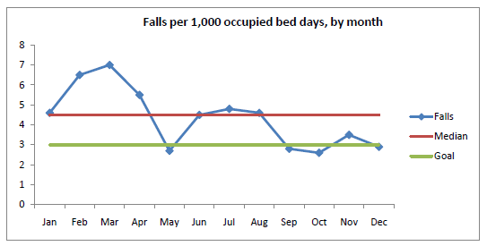

Patient Fall in the Hospital – Analysis & Interpretation

Analysis

Corrective Actions

Preventive Actions

(possible causes, process deviations, etc.)

A process that helps organizations investigate the cause of an incident, determine its impact, and identify strategies to prevent similar occurrences in the future.

A Corrective Action is a measure implemented in a workplace to combat the reoccurrence of incidents that may lead to injuries, destruction, and ruining the public image. It eliminates the root causes of problems that have already occurred.

Preventive action is a system to eliminate any cause(s) that would create a potential hazard or undesirable situation.

The steps of analysis may include:
o Ascertaining that a serious clinical incident has occurred o Triggering the investigation procedure
o Establishing the circumstances as they initially appear o Structured interviews of staff
o Collating interviews and assembling composite analysis o Compiling report of events
o Submitting report to senior clinicians and management o Implementing actions arising from report

Disclaimer

The contents are sample references to aid understanding of the Standards and are not prescribed by NABH as mandatory practices. Healthcare organizations are encouraged to modify them as per their scope and practices. NABH is not liable for misinterpretation, erroneous use, or non-conformities during assessment due to unmodified use of these contents.

