Hospital Signage Checklist

This document provides a list of essential signages and pictograms that hospitals must display in various locations to ensure safety, effective communication, and compliance with regulatory requirements. These signages are crucial for guiding patients, visitors, and staff.

Sr. No. | Requirements | Signage Reference | Yes | No
1 | Radiation Hazard | 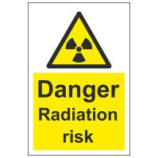
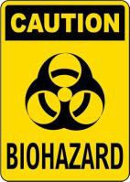    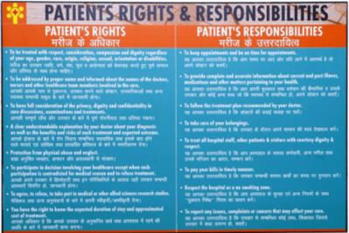  2 | Declaration under PC PNDT Act | 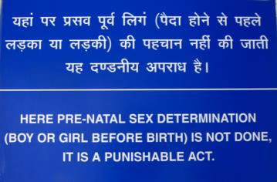
3 | Bio Hazard - including bio medical waste authorized signages
4 | Fire Exit Signage
5 | Patient Rights & Responsibility

6 | Scope of Services
7 | Department Direction
8 | Name of the Hospital (Bilingual Language)

Disclaimer
The contents are sample references to aid understanding of the Standards and are not prescribed by NABH as mandatory practices. Healthcare organizations are encouraged to modify them as per their scope and practices. NABH is not liable for misinterpretation, erroneous use, or non-conformities during assessment due to unmodified use of these contents.

