An Autonomous Multi-Parameter Aquatic Robotic System for Real-Time Chemical Gradient Mapping, Contamination Source Localization, and Adaptive Remediation.

Phase 1: Patrolling Mode
Patrolling Mode is the default autonomous operational state of the Aqua Bot in which it continuously navigates the water body while collecting baseline chemical and physical data to detect early anomalies.
Core Functions:
- Sensor Initialization & Calibration
  - pH sensor (temperature compensated)
  - Turbidity sensor
  - Salinity sensor
  - GPS and depth sensors
- Periodic Data Sampling
  - Records pH, turbidity (NTU), Salinity, temperature, and location at fixed intervals.
  - Builds a time-series dataset.
- Baseline Establishment
  - Calculates rolling mean and standard deviation. (recent 50 datapoints)
  - Defines normal lake conditions.
- Anomaly Monitoring
  - Compares real-time readings with baseline values.
  - Detects abnormal deviations using threshold logic.
  - Estimates preliminary spatial gradients.
If the bot moves 5 meters east and:
pH changes from 7.2 → 6.8
Then:
$$\text{Gradient}=\frac{6.8-7.2}{5}=-0.08\text{ pH per meter}$$
Negative means pH decreasing.
That suggests we are moving toward an acidic region.

- Controlled Navigation
  - Moves in a predefined or adaptive grid path.
  - Maintains moderate speed for efficient coverage.
- Energy Optimization
  - Runs non-essential systems at low power.
  - Remains in monitoring state unless anomaly detected.
Sample dataset
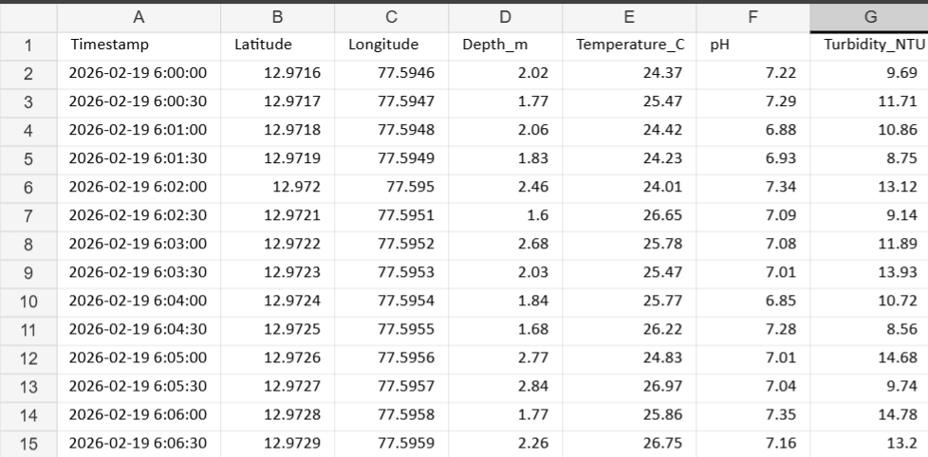

Phase 2: ANOMALY DETECTION (Investigation Trigger Layer)

Phase 2 answers: “Is the deviation statistically significant and spatially meaningful?”
It has 4 layers:
- Statistical deviation detection
- Multi-parameter validation (pH + turbidity)
- Temporal persistence check
- Spatial gradient confirmation
Only if all pass → switch to Investigation Mode.
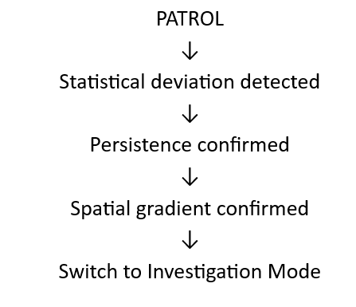
STEP 1: Statistical Deviation Detection
From Phase 1 we have: $\overset{ˉ}{pH},σ_{pH}$
At time $t$, new reading: $pH_{t}$
Compute deviation score: $Z_{pH}=\frac{pH_{t}-\overset{ˉ}{pH}}{σ_{pH}}$
This is a Z-score.
Interpretation:
- |Z| < 2 → normal fluctuation
- 2 < |Z| < 3 → suspicious
- |Z| > 3 → statistically abnormal

Same calculation for turbidity:
$$Z_{NTU}=\frac{NTU_{t}-\overset{ˉ}{NTU}}{σ_{NTU}}$$

STEP 2: Multi-Parameter Validation
Single parameter anomaly may be noise.
So, we create composite anomaly index: $A=w_{1}∣Z_{pH}∣+w_{2}∣Z_{NTU}∣$
Where:
- $w_{1},w_{2}$= weights

Example:
If pH more critical → $w_{1}=0.6$, $w_{2}=0.4$
If: $A>Threshold_{A}$
Flag as anomaly candidate.

STEP 3: Temporal Persistence Check
Temporal Persistence Check = verifying that an abnormal signal persists over several time samples before confirming an anomaly.
One abnormal reading is not enough.
Define persistence window:

Example: 5 consecutive samples.
If: $∣Z_{pH}∣>2 \text{for 5 consecutive readings}$
Then confirm anomaly.
This prevents:
- Sensor spikes
- Electrical noise
- Temporary turbulence
We are implementing a time-domain validation filter:
- Spatial check → how abnormal? (Z-score)
- Temporal check → how long abnormal?
Both together reduce false positives.

STEP 4: Preliminary Spatial Gradient Confirmation
Now we check direction.
Compute gradient: $∇pH≈\frac{pH_{t}-pH_{t-1}}{distance}$
If gradient magnitude increasing consistently: $∣∇pH_{t}∣ > ∣∇pH_{t-1}∣$
Then pollution likely directional.
If deviation exists but no gradient → maybe local mixing.
- The pH is abnormal
- But the abnormality is not changing directionally across space
- Therefore, it is probably caused by local turbulence or mixing, not a pollution plume. (A pollution plume means: A region of contaminated water moving away from a pollution source in a flow direction. )

STEP 5: Confidence Score
Define anomaly confidence: $C=αA+β∣∇pH∣$
If: $C>C_{threshold}$
System switches to: INVESTIGATION MODE

Why Multi-Layer Approach?
Because lakes are noisy environments.
we must avoid:
- False positives
- False gradient detection
- Temperature-induced errors
- Mechanical vibration effects
This layered filtering makes system robust.

Phase 3: Investigation & Source Localization Phase
Phase 3 answers:
- Where is the source?
- Is it spreading?
- How strong is it?
- Is it stationary or dynamic?
This phase converts:
“Anomaly detected” → “Source localized at (x, y) with confidence x%”

STEP 1: Trigger Condition
Phase 3 begins if: $∣pH_{t}-μ_{baseline}∣>kσ$
AND
$$∣\frac{dpH}{ds}∣>ϵ$$
Meaning:
- Abnormal value
- Non-zero spatial slope
If slope ≈ 0 → random noise
If slope significant → directional contamination

STEP 2: Mathematical Objective

We want to estimate: $\left(x_{s} , y_{s}\right)$
Where:
$$∣∇pH∣\text{ is maximum}$$OR
$$\text{Minimum pH (if acidic source)}$$
This is an optimization problem.

STEP 3: Local Gradient Estimation (True 2D)
Now we move beyond 1D derivative.
Robot performs small controlled movements:
Move Δx → measure pH
Move Δy → measure pH
Approximate:
$$\frac{∂pH}{∂x}≈\frac{pH(x+Δx,y)-pH(x,y)}{Δx} \\ \frac{∂pH}{∂y}≈\frac{pH(x,y+Δy)-pH(x,y)}{Δy}$$
Then compute:
$$∇pH=\left(\frac{∂pH}{∂x} , \frac{∂pH}{∂y}\right)$$
Now we have direction vector.

STEP 4: Navigation Strategy (Gradient Descent)
If acidic plume:
Move in direction of negative gradient:
$$\text{New Position}=\text{Current Position}-α∇pH$$
Where:
- α = step size
- Controls stability
Too large α → oscillation
Too small α → slow response
This is literally environmental gradient descent.

Analogy:
Case 1: Acid Source
Suppose:
- Normal lake pH = 7.2
- Near contamination = 6.8
- At source = 6.3
So, as you move toward source:
pH decreases.
If we visualize this surface:
It slopes downward toward the source.
That downward bowl shape is like a valley.
Lowest point = most acidic location.
“valley” means: pH gets lower and lower as you approach the source.

Case 2: Alkaline Source
Now suppose:
- Normal pH = 7.2
- Near contamination = 7.8
- At source = 8.4
Now pH increases toward source.
The surface slopes upward.
That forms a hill.
Highest point = alkaline source.

STEP 5: Confidence Validation
We must validate before declaring source.
Conditions:
- Gradient magnitude increasing
- pH magnitude decreasing consistently
- Turbidity increasing (if correlated)
- No sudden random reversals
If: $∣∇pH∣→0$
We reached flat region (possible center).

STEP 6: Multi-Parameter Gradient Fusion
Define composite field:
$$F(x,y)=w_{1}⋅pH+w_{2}⋅NTU$$
Then compute:
$$∇F=w_{1}∇pH+w_{2}∇NTU$$
This increases reliability.
Because:
- pH may drift slowly
- Turbidity may spike faster
Combined signal is stronger.

STEP 7: Source Confirmation Logic
Declare source if:
- Local minimum pH reached
- Gradient magnitude ≈ 0
- Surrounding values higher
- Turbidity locally maximum
Mathematically:
$$∇pH=0$$
AND
$$∇^{2}pH>0$$
That is second derivative positive (local minimum).
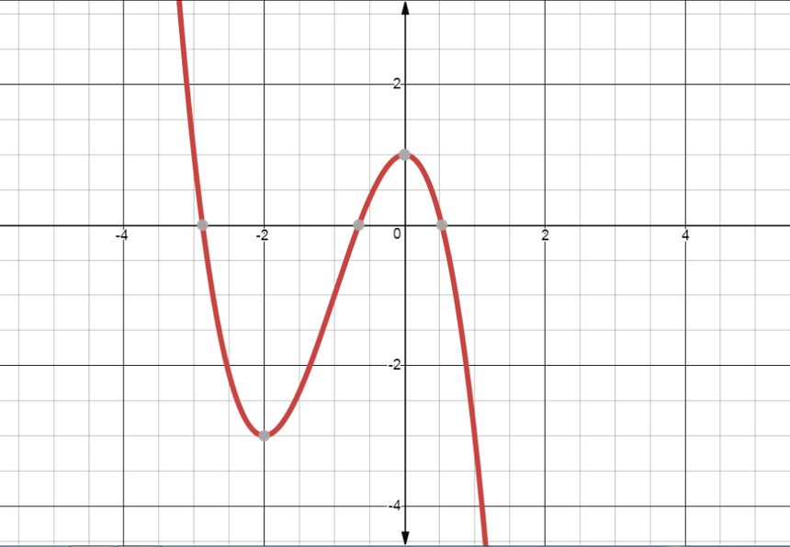

STEP 8: Real-World Complications
You must account for:
- Wind-driven surface currents
- Thermal stratification
- Sensor delay
- Plume diffusion
- Multiple pollution sources
Which means:
Gradient may shift over time.
Your bot must:
Continuously re-evaluate.

STEP 9: Cleaning Integration
Once source localized:
Robot switches to:
Cleaning Mode.
For example:
- Activate suction pump
- Deploy neutralizing agent
- Deploy ferrous collection mechanism
Cleaning radius defined by:
$$r=\frac{1}{∣∇pH∣}$$
Steeper gradient → smaller, concentrated source
Shallow gradient → widespread plume

Understanding formula
The gradient magnitude is:
$$∣∇pH∣=\sqrt{{\left(\frac{∂pH}{∂x}\right)}^{2}+{\left(\frac{∂pH}{∂y}\right)}^{2}}$$
It measures:
How steep the pH field is at that location.
Units:
pH per meter.
Example:
If pH changes 0.5 units over 1 meter:
$$∣∇pH∣=0.5\text{ pH/m}$$
If it changes 0.05 over 1 meter:
$$∣∇pH∣=0.05\text{ pH/m}$$
So larger gradient = steeper change.

What Does Taking 1 / Gradient Mean?
$$\frac{1}{∣∇pH∣}$$
This inverts steepness.
If gradient is large → result small.
If gradient is small → result large.

Physical Meaning in Lake
Near contamination source:
- pH changes very sharply.
- Gradient is large.
So:
$$∣∇pH∣\text{ large}⇒\frac{1}{∣∇pH∣}\text{ small}$$
Meaning:
The plume is concentrated in small area.

Far from source:
- pH changes slowly.
- Gradient small.
So:
$$∣∇pH∣\text{ small}⇒\frac{1}{∣∇pH∣}\text{ large}$$
Meaning:
Pollution is diffused over wide area.

Why Interpret It as Radius?
Because in diffusion physics:
Concentration roughly follows a bell-shaped curve.
Near center:
Slope steep.
Far from center:
Slope shallow.
The inverse gradient gives a rough measure of how wide the plume is.
It is not exact radius — it is a proportional indicator.

Dimensional Analysis
Gradient unit:
pH per meter.
So:
$$\frac{1}{∣∇pH∣}$$
Unit:
meter per pH.
So technically:
It’s not directly meters.
To make it practical, you scale it:
$$r=\frac{k}{∣∇pH∣}$$
Where:
k = tuning constant.
Then r approximates influence radius.

Why This Makes Sense Physically
If gradient is very steep:
Pollution is localized.
Cleaning should be tight and concentrated.
If gradient is shallow:
Pollution is widespread.
Cleaning area should be larger.
So:
Inverse gradient controls cleaning radius.

What does $∣∇pH∣$mean?
$$∣∇pH∣$$
= magnitude of the pH gradient
It tells you:
How fast pH changes over distance
$$∣∇pH∣≈\frac{\text{change in pH}}{\text{distance}}$$
Units example:
$$\text{pH change per meter}$$

Meaning of “large” gradient
A large gradient means:
pH changes quickly over a short distance.
Example
Distance | pH
0 m | 7.0
1 m | 5.0
Gradient:
$$∣∇pH∣=\frac{2}{1}=2$$
This is large because pH changed a lot in little space.
Strong spatial variation → likely plume edge.

Meaning of “small” gradient
A small gradient means:
pH changes slowly across space.
Example
Distance | pH
0 m | 7.0
10 m | 6.9
Gradient:
$$∣∇pH∣=\frac{0.1}{10}=0.01$$
Very small change → nearly uniform water.

Why $\frac{1}{∣∇pH∣}$becomes small
You wrote:
$$∣∇pH∣\text{ large }⇒\frac{1}{∣∇pH∣}\text{ small}$$
This is just inverse relationship.
Simple numbers
| Gradient $∣∇pH∣$| Reciprocal $1/∣∇pH∣$|
| 0.1 | (small) | 10 (large) |
| 1 | 1 |
| 5 (large) | 0.2 (small) |
So:
- Large gradient → inverse becomes small
- Small gradient → inverse becomes large

5️⃣ Physical intuition (VERY important)
Think:
Large gradient
pH changes sharply → pollution boundary is tight
7.0 → 6.0 → 5.0 (fast change)
Distance needed for change = SMALL.
So:
$$\frac{1}{∣∇pH∣}≈\text{characteristic length scale}$$
👉 small value = sharp transition.

Small gradient
pH changes slowly:
7.0 → 6.9 → 6.8 → 6.7
Distance needed = LARGE.
So inverse becomes large.

6️⃣ What “large” and “small” actually mean in practice
They are relative to a threshold you define.
Example:
| $∣∇pH∣$| Interpretation |
|---|---|
| < 0.05 | small gradient (mixing) |
| 0.05–0.5 | moderate |
| > 0.5 | large gradient (plume edge) |
Engineers always choose thresholds experimentally.

One-line intuition
Large gradient = rapid spatial change.
Small gradient = slow spatial change.
and
Taking reciprocal flips large ↔ small.

