Jenkins Scripted pipeline example project: ci-cd tools
Git -----> jenkins ----->tomcat8----> webapps / deploy war file
Git Jenkins ------>docker image create > push to docker hub

node{
stage('SCM Checkout'){
git credentialsId: 'GIt-Hub', url: 'https://github.com/modugulakrishna/myweb.git'

}
stage('MVN Compile')

def mvnHome = tool name: 'Maven', type: 'maven'
def mvnCMD = "${mvnHome}/bin/mvn"
sh "${mvnCMD} clean package"

stage('Deploye in tomcat'){
sshagent(['devops-tomcat']) {
sh 'scp -o StrictHostKeyChecking=no target/*.war jenkins@192.168.43.108:/var/lib/tomcat8/webapps/'
}
stage('Build Docker image'){
sh 'docker build . -t modugulakrishna99/sindhu:1.0'
}

stage('Push to DockerHUb'){
withCredentials([string(credentialsId: 'DockerHubPwd', variable: 'DockerHubPwd')]) {
sh "docker login -u modugulakrishna99 -p ${DockerHubPwd}"
}
sh 'docker push modugulakrishna99/sindhu:1.0'
}

stage('Run container on Dev-server'){
def dockerRun = 'docker run -p 9090:8080 -d --name krishna modugulakrishna99/sindhu:1.0'
sshagent(['devops-kubectl']) {
sh "ssh -o StrictHostKeyChecking=no jenkins@devops-kubectl ${dockerRun}"
}
}
}
}

Step :1 screen-shots

node{
stage('SCM Checkout'){
git credentialsId: 'GIt-Hub', url: 'https://github.com/modugulakrishna/myweb.git'

}
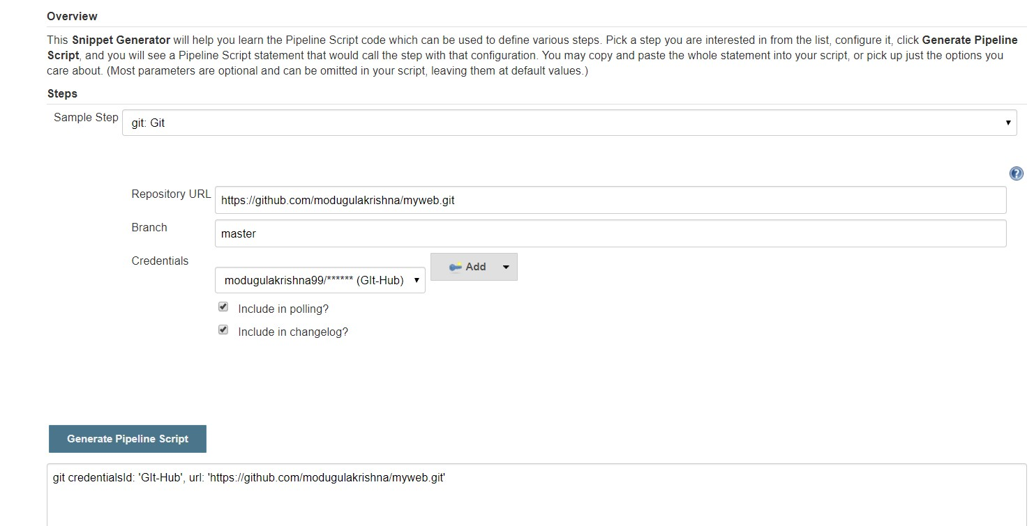

Step -2
stage('MVN Compile')

def mvnHome = tool name: 'Maven', type: 'maven'
def mvnCMD = "${mvnHome}/bin/mvn"
sh "${mvnCMD} clean package"

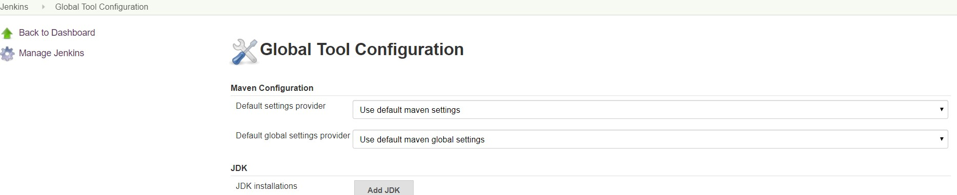

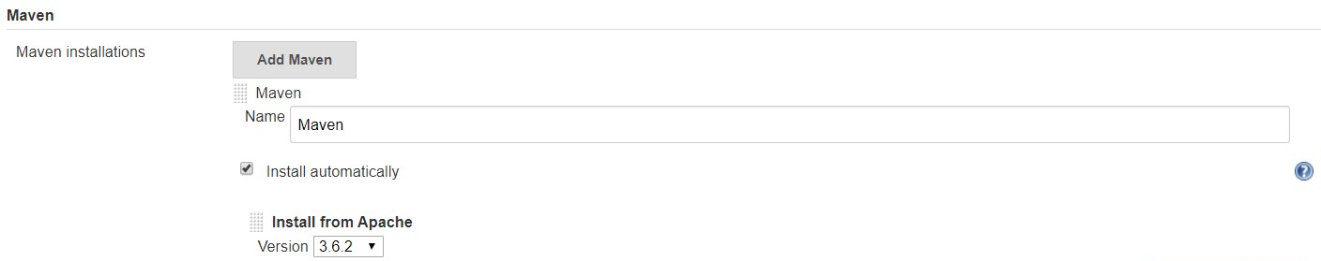

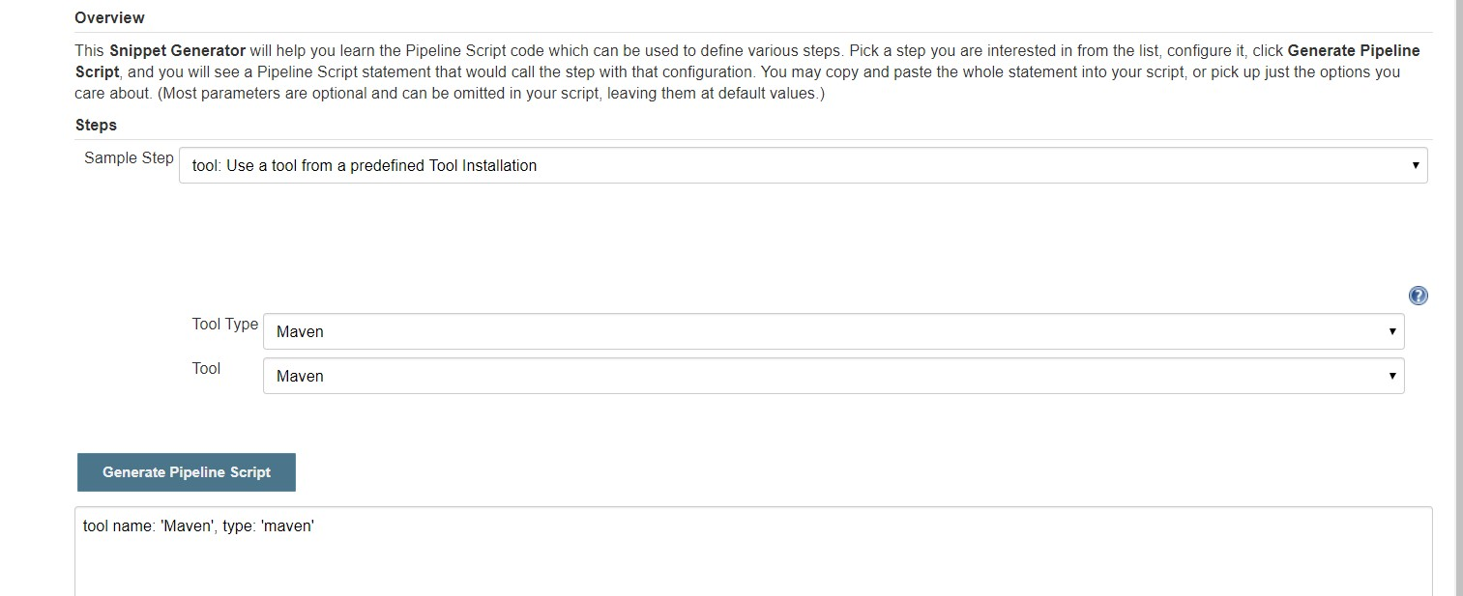
Step -3
stage('Deploye in tomcat'){
sshagent(['devops-tomcat']) {
sh 'scp -o StrictHostKeyChecking=no target/*.war jenkins@192.168.43.108:/var/lib/tomcat8/webapps/'
}

(note: 1) add devops-tomcat: jenkins user private key in jenkins(devops-jenkins) credentials provider
- Passwordless authentication jenkins(devops-jenkins) to >>>> devops-tomcat

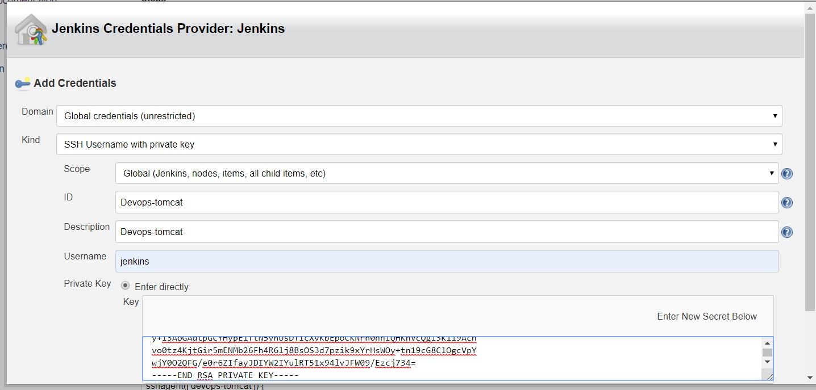

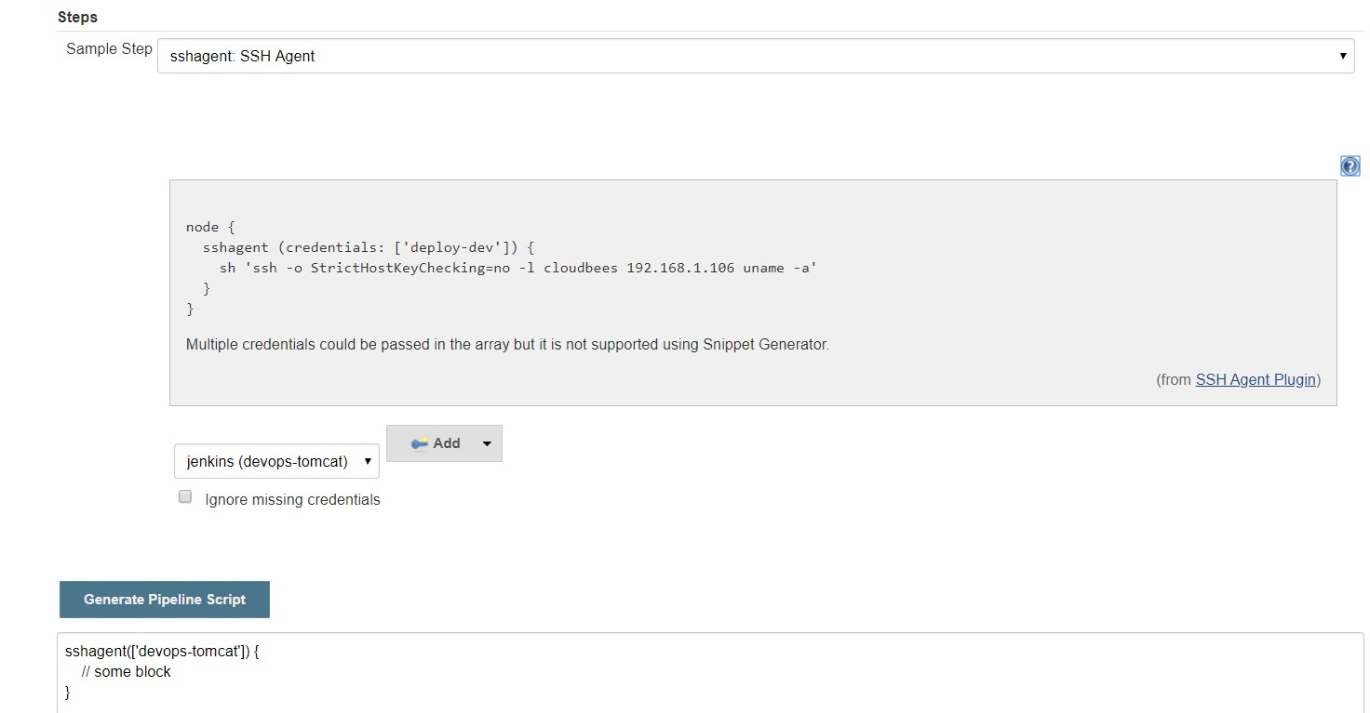
Step -4
stage('Build Docker image'){
sh 'docker build . -t modugulakrishna99/sindhu:1.0'
}

Step - 5
stage('Push to DockerHUb'){
withCredentials([string(credentialsId: 'DockerHubPwd', variable: 'DockerHubPwd')]) {
sh "docker login -u modugulakrishna99 -p ${DockerHubPwd}"
}
sh 'docker push modugulakrishna99/sindhu:1.0'
}

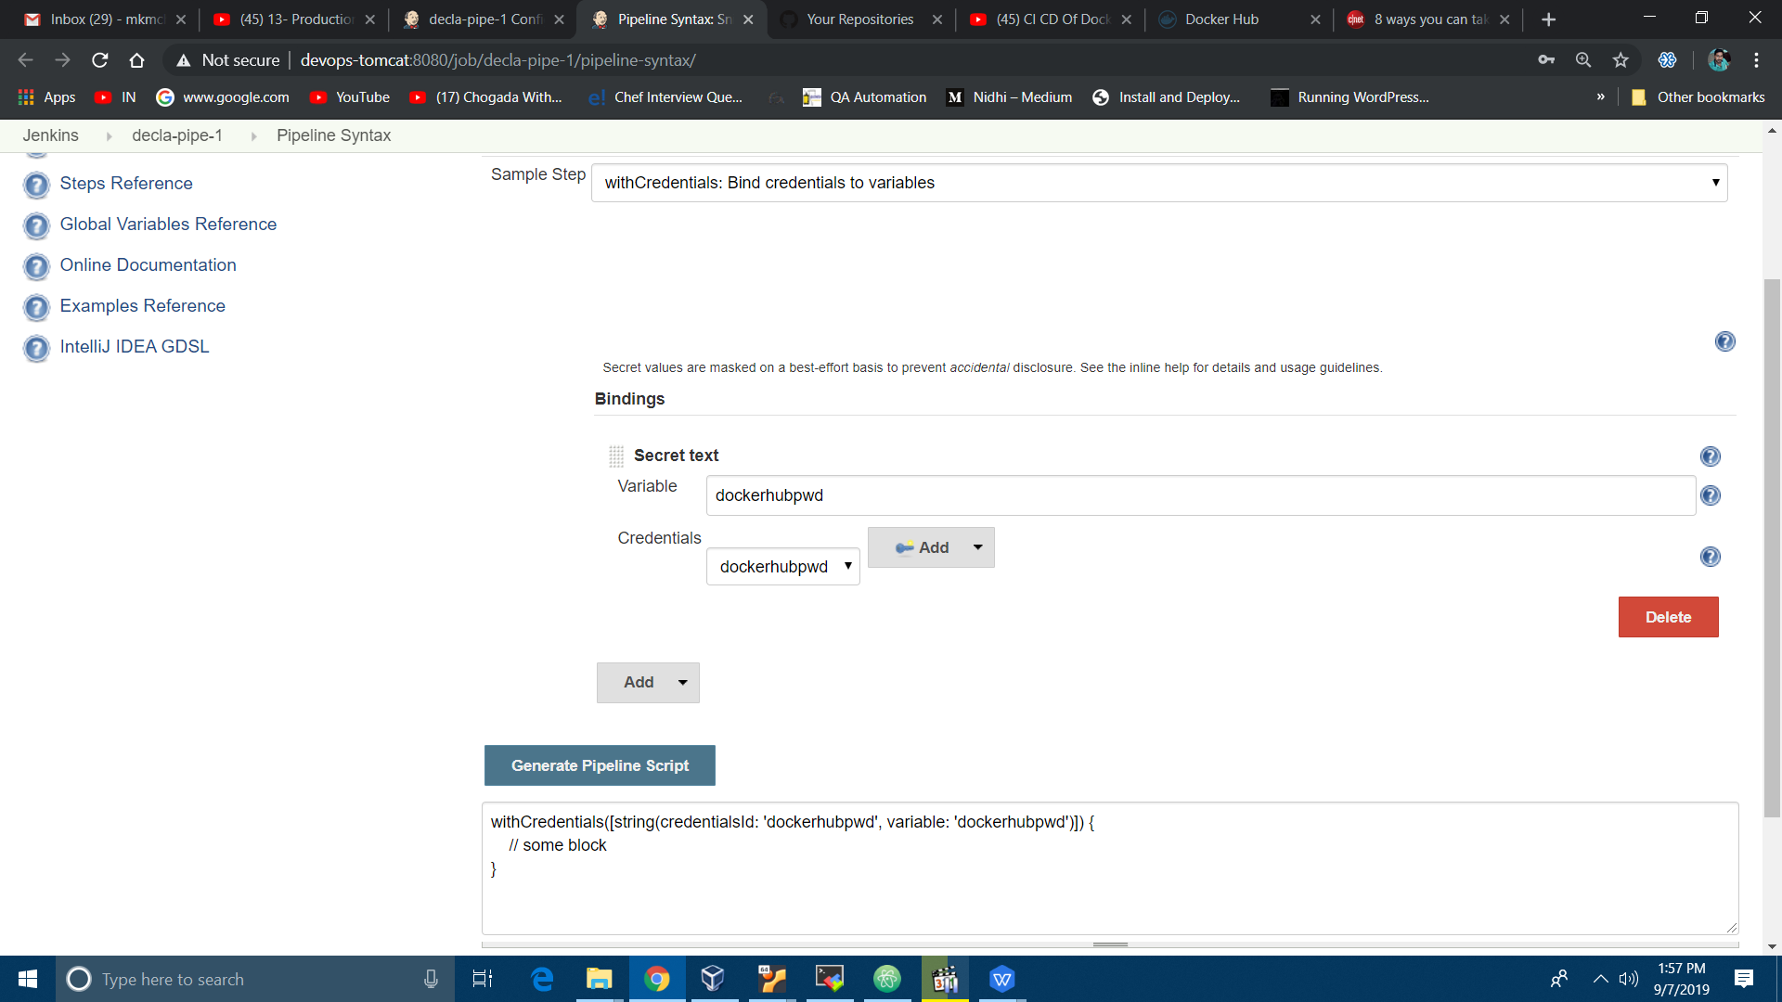

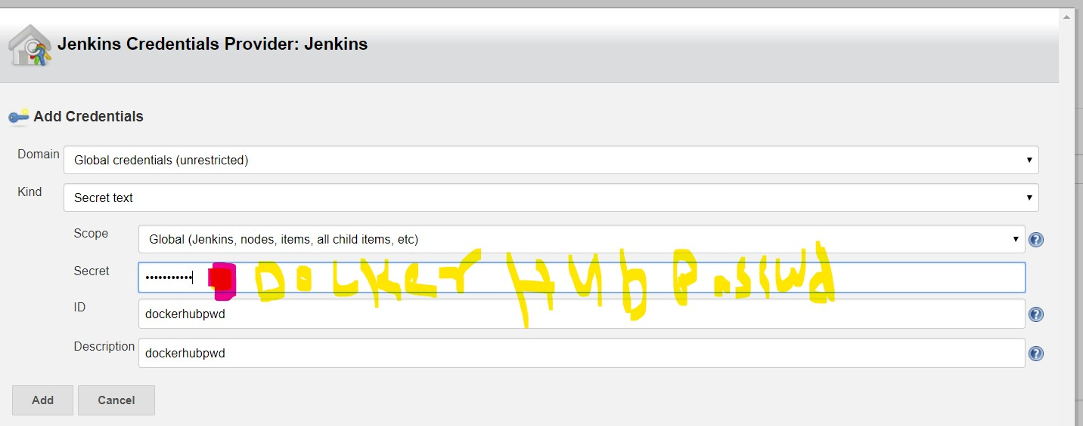

Step 6

stage('Run container on Dev-server'){
def dockerRun = 'docker run -p 9090:8080 -d --name krishna modugulakrishna99/sindhu:1.0'
sshagent(['devops-kubectl']) {
sh "ssh -o StrictHostKeyChecking=no jenkins@devops-kubectl ${dockerRun}"
}
}
}
}

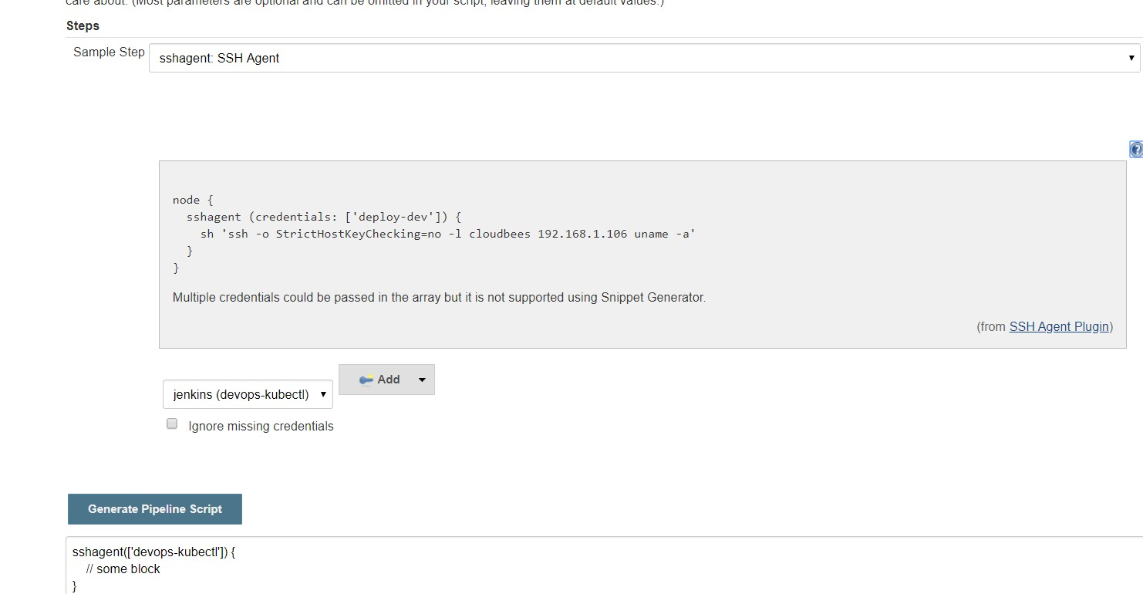

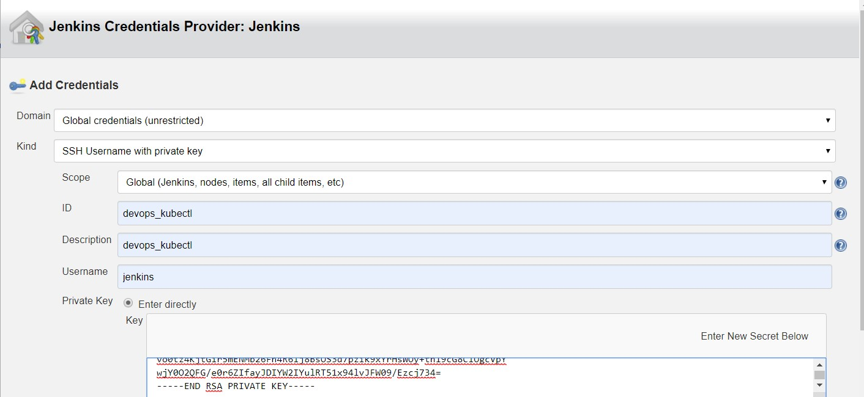

(note: 1) add devops-kubectl: jenkins user private key in jenkins(devops-jenkins) credentials provider
- Passwordless authentication jenkins(devops-jenkins) to >>>> devops-kubectl

Step7 go to devops-kubectl
Check docker ps >>>>> our container running
Check webpage:localhost:9090/mkm/
It’s contains total
….…………………
>>>>>>>>>>>>>>>>>>>>>>>>>>>>>>>>>>>>>>>>>>>>>>>>>>>>>>>>>>>>>>>>>>
The end

Project errors:
Jenkins user in docker group (in single server jenkins, tomcat, docker in one server)

** Message: 17:16:26.411: Remote error from secret service: org.freedesktop.DBus.Error.UnknownMethod: No such interface 'org.freedesktop.Secret.Collection' on object at path /org/freedesktop/secrets/collection/login
Error saving credentials: error storing credentials - err: exit status 1, out: `No such interface 'org.freedesktop.Secret.Collection' on object at path /org/freedesktop/secrets/collection/login`

This error you need to install : sudo apt install gnupg2 pass

