**OCEAN – World at one Place**



***- A simulation project submitted by Manju Penumarthi and Saiteja Nadella***

**Executive summary**:

The goal of this project is to implement a most efficient queuing system for a hypermarket through a computer simulation model using Discrete Event Simulation (DES) method. Arena Simulation Software is used to develop the model to replicate the actual system. The model aims to improve the service performance by reducing the waiting time at the queuing system in the hypermarket. It helps the management to improve the level of customer satisfaction against the service provided without high costs. The data was collected during the peak hours (8 AM – 8 PM), which include the number of customers entering the queuing system, number of checkout systems available, queue times, and service times. The simulation is run with the provision of 1 time of replication with a length of time of replication for 12 hours. The queuing system was identified based on the scenario analysis, and the recommendation is made for the management to decide on improving the queuing system.

**Problem Statement:**

Like most of the other hypermarkets, ‘Ocean –hypermarket’ has a lot of customers shopping every day for all their household and general needs. Weekends are busy days as customers have time off from their jobs. But, during the weekends, the customer satisfaction levels are low and from the data collected, it was noted that at least 4% of customers leave empty-handed due to long waiting queues. This creates the need for our simulation model to develop a practical solution on how to engage/address more customers at a lesser time and improve customer satisfaction levels.

**Queuing Concept:**

Queues are common before receiving the service at busy business places. The line of individuals or items waiting to be operated is referred to as a queue. The management typically concentrates on offering service to customers with the shortest wait time to attract customers. Operation managers need a quick checkout process rather than forcing customers to leave without making a purchase to ensure high customer satisfaction. The cost of waiting time will decrease as service quality improves. Costs associated with waiting are thought to be an indicator of how effectively operations are run. The queue is analyzed in terms of the length of the waiting line, average waiting time, and another factor that used to understand the service system. Multi queue-multi server model is the design for hypermarket systems.

**Simulation:**

Simulation is a technique for assessing the model's behaviour in various situations, helping the management in decision-making. Post-simulation model, the real effects of each alternative model will be identified. Simulations are of great use as these can avoid the negative impacts of changes on real systems. Working on simulations will help to know the effects without disturbing the real systems, processes and information flow in the systems.

Discrete Event Simulation (DES) models the operation of a system as a discrete sequence of events in time. Each event appears at a particular present in time and marks a change of state in the system. Effects in DES will not affect the actual system. DES offers a user-friendly and adaptable tool for the computer-based modelling of complex systems. DES is a versatile modelling technique that can represent complex behaviour within and interactions between individuals, populations, and their environments, among other things. Only DES offers discrete sequences of the event in time among simulation techniques.

**Simulation studies for queuing problem:**

Simulation is being used as a tool to increase the effectiveness of operations at the hypermarket. The better decision can be made for improving the queuing system if using simulation software. Moreover, there are complex decisions in the service industry since it will involve randomly in customer arrival and time of services.

The variables were based on the time of day, customer arrival rate, service times and different checkout systems. The model would serve as a guide for the decision-making process, according to this project. Developing a simulation model is needed to make a confirmation against the queuing theory.

This project requires calculating all the data using a mathematical model. The results of this project might be inaccurate because the data involves assumptions.

The model was developed with details that include waiting for a time length of the queue, and the number of customers in waiting lines.

**Methodology:**

The simulation model requires data to complete the study. The information gathered consists of the volume of customer queuing, and the time taken for each customer to finish the buying process at the checkout system.

A simulation model was created using Arena simulation software to watch the actual performance. Additionally, the software uses the data gathered to analyse the effectiveness of the current system. This simulation is run for 12 hours, a regular work shift at the Ocean Hypermarket. The model was simulated 1 time, which is 1 replication. Statistical results are collected and recorded to analyze the data, after running the simulation model. The statistical data produced is in term of the waiting time, the number waiting, and number busy.

**Assumptions:**

The following assumptions held true throughout the entire simulation period:

1. The hypermarket has six checkout system including the express counter.
2. The checkout counter for the hypermarket normally open for four checkout system with three checkout system operate as normal counters, and one checkout system operates as an express counter.
3. The hypermarket is open 12 hours a day from 8 AM – 8 PM.

**Test Case Scenarios:**

‘what if’ analysis was implemented to came out with several scenarios for improving the queuing system.

* Scenario 1: Open fifth checkout system with infinite number of maximum customer arrivals
* Scenario 2: Open sixth checkout system with infinite number of maximum customer arrivals
* Scenario 3: Make one of the three open normal checkout systems as express counter

**Numerical Data:**

|  |  |  |  |
| --- | --- | --- | --- |
| **Operation** | **Resource** | **Time (Minutes)** | **Item** |
| Arrival | Customer | 0.5 + 5 * BETA (1.21, 1.25) |  |
| Choose Checkout Counter 1 | Customer |  | 25% of Cashier 1 |
| Choose Checkout Counter 2 | Customer |  | 23% of Cashier 2 |
| Choose Checkout Counter 3 - Express | Customer |  | 26% of Cashier 3 |
| Choose Checkout Counter 4 | Customer |  | 22% of Cashier 4 |
| Service in Checkout System 1 | Cashier 1 | 0.5 + 10*BETA (0.795, 0.94) |  |
| Service in Checkout System 2 | Cashier 2 | 1.5 + 9*BETA (1.02, 0.852) |  |
| Service in Checkout System 3 | Cashier 3 | 0.55 + 5*BETA (0.8, 0.755) |  |
| Service in Checkout System 4 | Cashier 4 | 0.68 + 8*BETA (0.99, 0.65) |  |
| Service in Checkout System 5 | Cashier 5 | 0.7 + 9*BETA (0.65, 0.74) |  |
| Service in Checkout System 6 | Cashier 6 | 0.4 + 6*BETA (0.65, 0.74) |  |

**Arena Model:** The steps involved in the arena model are as follows:

1. Customer enters the queuing system

2. Customer chooses the queue to complete the billing process

3. Customer waits in the checkout system queue to receive the service

4. Customer receives the service

5. Customer leaves the checkout system

The Arena modules used in this model include Create, Decide, station, Process, and Dispose.

One cannot determine how many customers arrive at a hypermarket. Next, the arrival pattern at the system is either random or scheduled. Based on the quantity of arrivals, the pattern of arrival is evaluated. The hypermarket pattern is truly arbitrary. The customers in the queues were served based on the FIFO (First Come First Out) queuing rule. This rule shows that the first customers in the line will be the first people to receive the services.

The customers arriving, and the cashiers at the checkout systems are the resources in this model. The data is from busy days – the weekends. From the data collected, it was noted that at least 4% of customers leave empty-handed due to long waiting queues. The customer arrival and service times are random events, so beta distribution which is used to model the uncertainty about the probability of success of a random experiment is used. The checkout counters are shown using ‘Station’ module, which defines a physical or logical location where processing occurs.

The above mentioned three scenarios were tested and then we compared each test case result with the base model to help the Ocean hypermarkets management select the best queuing system. The values compared include number of customers entered the system, left the system, average wait time, queue or wait time in each checkout system queue.

**Results:**

**Base Model:**

The base model is constructed using 4 checkout systems, out of which the counter 3 is considered as a express counter where the process for a single customer takes less time when compared to the process at other normal counters available. This alone will not resolve the queuing problem at the hyper market, so we tested three other sceneries which we thought might help the management to decide on which queuing solution is better for their problem.

**Queue – Basic Process:**

**Resource – Basic Process:**

**Scenario 1:** Adding a fifth checkout system

As a first scenario, we considered adding an additional checkout system which might reduce the queue at other system and result in faster billing. The maximum number of customer arrivals is taken as infinite and for the billing process at checkout system 5, the beta distribution value is used.

By considering the resource utilization as 15% of Cashier 1, 15% of Cashier 2, 26% of Cashier 3, 20% of Cashier 4, and 20% of Cashier 5, we obtained the below output.

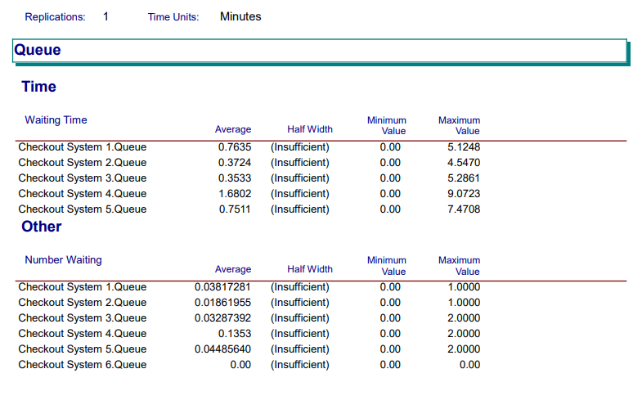

**Scenario 2:** Adding a sixth checkout system

As a second scenario, we considered adding two additional checkout systems i.e., opening all the 6-checkout system available by keeping in mind the number of customer arrivals and the average waiting time in all the queues. This might reduce the queuing problem to some more extent. The maximum number of customer arrivals is taken as infinite and for the billing process at checkout system 6, the beta distribution value is used.

By considering the resource utilization as 10% of Cashier 1, 10% of Cashier 2 , 26% of Cashier 3, 20% of Cashier 4, 10% of Cashier 5, and 20% of Cashier 6, we obtained the below output.

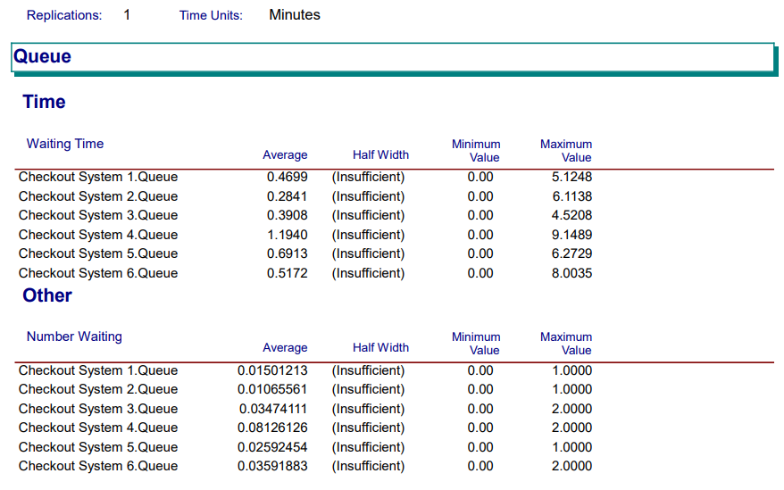

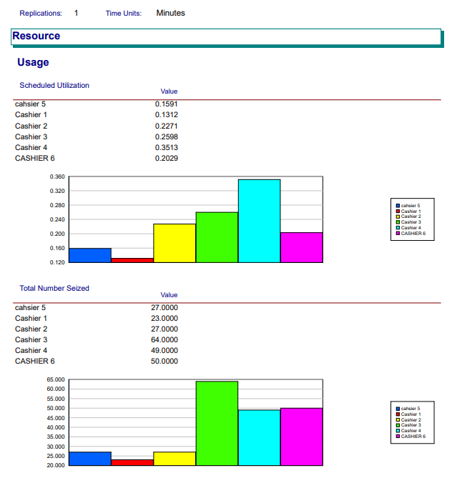

**Scenario 3:** Adding one additional express counter - Making the checkout 1 as an express counter

In this scenario, we tested the possibility of resolving the queuing problem with only four checkout systems taken from the base model. But as an additional change we considered updating one of the three normal counters available as an express counter making a total of 2 normal and 2 express checkouts at the hypermarket. The same beta distribution is used for customer arrival rate and service rates.

By using the same service time as of express counter 3 for checkout system 1, below are the results:

**Comparison of above models:**

On running the simulation model for 12 hours with 1 replication, the average number of entities (customers) In each scenario are as follows:

|  |  |  |  |  |
| --- | --- | --- | --- | --- |
|  | **Base Case** | **Scenario 1** | **Scenario 2** | **Scenario 3** |
| **Customers In** | 242 | 252 | 247 | 242 |
| **Customers Out** | 240 | 250 | 247 | 239 |
| **Average Waiting Time (Minutes)** | 1.1059 | 0.7772 | 0.5932 | 1.086 |

|  |  |  |  |  |
| --- | --- | --- | --- | --- |
|  | **Average Waiting Time (Minutes)** | | | |
| **Checkout System** | **Base Case** | **Scenario 1** | **Scenario 2** | **Scenario 3** |
| **1** | 0.6991 | 0.7635 | 0.4699 | 0.5631 |
| **2** | 2.096 | 0.3724 | 0.2841 | 2.2089 |
| **3** | 0.3879 | 0.3533 | 0.3908 | 0.3618 |
| **4** | 1.6831 | 1.6802 | 1.194 | 1.9711 |
| **5** |  | 0.7511 | 0.6913 |  |
| **6** |  |  | 0.5172 |  |

**Interpretation and Recommendations:**

The scenario 1 (opening one additional or fifth checkout system) performed better by serving high number of customers 252 out of 250 with a queue time of 0.7772 minutes. This model increased the number of customers being served and the queue time is less compared to the base model. This model must emphasize resource utilization as the first two cashiers were not being used effectively. If the resource utilization is corrected, the number of customers being served will be automatically improved.

From the above results, the model in the scenario 2 (opening all the 6 checkout systems) performed well. The average waiting time was reduced to a great extent from 1.1059 minutes to 0.5932 with 247 out of 247 entities or customers served. This model helped to serve all the customers who entered the system and to reduce the queuing time. If the cashiers were utilized in equal time, the model’s accuracy can be further improved. Therefore, this is a great option to consider.

However, the queue time is less in both the above scenarios, the hypermarkets management should think of the additional costs and the value of the outcome before deciding on which method to implement. But as per the problem statement, I suggest that the scenario 2 is the best option to choose, as all the customers were leaving the system with their products without showing any dissatisfaction due to long waiting times in the queues.

The scenario 3, making one of the available normal counters as an express counter didn’t show much change in the average waiting time and the total number of customers served. Hence, this is not a good option to consider.

**Conclusion:**

We wanted to address the queuing problem which caused high levels of customer dissatisfaction at the Ocean hypermarket. We gathered information about the peak periods from the Ocean hypermarket and used Arena software to mimic the activities to be able to examine the workflow. During peak hours, it was noticed that the total customer time was too high, which could result in clientele loss and have a negative impact on the bottom line of the company. This issue was addressed by introducing additional checkout systems in a new model. The new model simulation report demonstrated that it had decreased the system's average customer wait time and increased the number of clients served. Consequently, these adjustments may result in an increase in the revenue.

**References:**

https://knepublishing.com/index.php/KneSocial/article/view/5059/10154#figures/figure_5https://knepublishing.com/index.php/Kne-Social/article/view/5059/10154#figures/figure_5