Movie Rental Database Design

Description and its Unnormalized Data:

UNNORMALIZED TABLE 1:

MOVIE_ID | MOVIE_TITLE | MOVIE_VALUE | MOVIE_QTY | MOVIE_CAT_ID | MOVIE_CATEGORY
1 | Alien | 10 | 5 | 1 | SciFi
2 | Bladerunner | 8 | 3 | 1 | SciFi
3 | Star Wars | 15 | 11 | 1 | SciFi
4 | Texas Chainsaw Masacre | 7 | 2 | 2 | Horror
5 | Jaws | 7 | 1 | 2 | Horror
6 | The good, the bad and the ugly | 7 | 2 | 3 | Western
7 | Silverado | 7 | 1 | 3 | Western
8 | Duck Soup | 5 | 1 | 4 | Comedy
9 | Planes, trains and automobiles | 5 | 3 | 4 | Comedy
10 | Waking Ned Devine | 12 | 4 | 4 | Comedy
11 | Deep Blue Sea | 14 | 3 | 5 | Drama
12 | The Fifth Element | 15 | 5 | 5 | Drama

Columns Descriptions
------------- -----------------------------------------
movie_id Movie ID
movie_title Movie Title
movie_value The value (cost) of each movie
movie_qty The number of copies available for each movie
movie_cat_id Movie Category ID
movie_category The category for each movie

UNNORMALIZED TABLE 2:

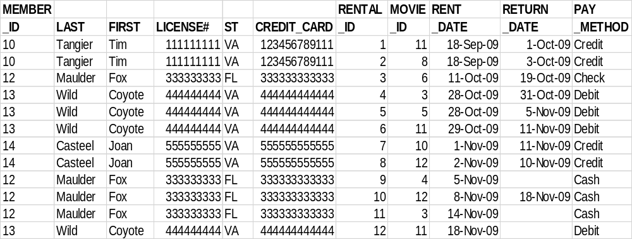

Columns Descriptions
--------- ----------------------------------------
Member_id Member's ID
Last Member's last name
First Member's first name
License# Member's driver license number
St Member's driver license issuing state
Credit_card Member's credit card number
Rental_id Rental transaction ID
Rent_date Movie rent date
Return_date Movie return date
Pay_method Member's payment method for each rental transaction

Part I: Database Design

1. Drawing the Entity-Relationship Diagram for the database below

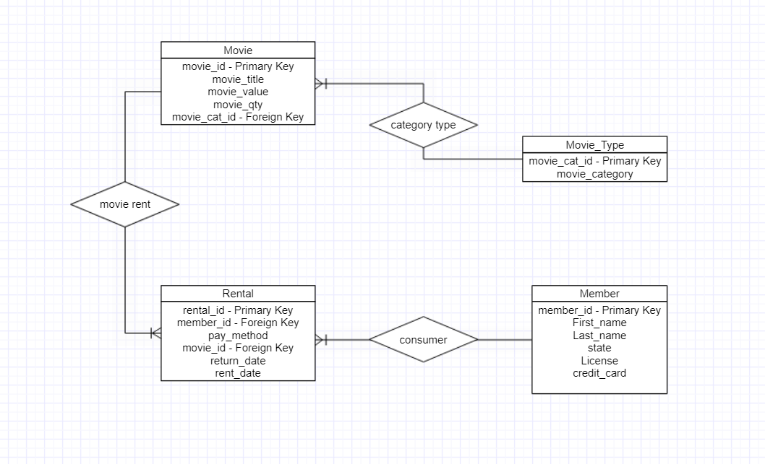

Every member will have many rentals but, each rental will have only one member.

Each rental will only contain one movie; however, each movie will have numerous rentals.

There will be several movies in each category, but there will only be one category for each movie.
2. Creating the database in the SQL account based upon the above ER diagram and normalized data. Displaying the content (SELECT * FROM table_name) and structure (DESCRIBE table_name) of the 4 tables (movie, movie_type, rental, and member) in the database.

Table Name | Table Content | Table Structure
movie | CREATE TABLE movie (  movie_id INT NOT NULL,  movie_title VARCHAR (50) NOT NULL,  movie_value INT NOT NULL,  movie_qty INT NOT NULL,  movie_cat_id INT NOT NULL,  PRIMARY KEY (movie_id)  );  INSERT INTO movie VALUES (1,'Alien',10,5,1);  INSERT INTO movie VALUES (2,'Bladerunner',8,3,1);  INSERT INTO movie VALUES (3,'Star Wars',15,11,1);  INSERT INTO movie VALUES (4,'Texas Chainsaw Masacre',7,2,2);  INSERT INTO movie VALUES (5,'Jaws',7,1,2);  INSERT INTO movie VALUES (6,'The good, the bad and the ugly',7,2,3);  INSERT INTO movie VALUES (7,'Silverado',7,1,3);  INSERT INTO movie VALUES (8,'Duck Soup',5,1,4);  INSERT INTO movie VALUES (9,'Planes, trains and automobiles',5,3,4);  INSERT INTO movie VALUES (10,'Waking Ned Devine',12,4,4);  INSERT INTO movie VALUES (11,'Deep Blue Sea',14,3,5);  INSERT INTO movie VALUES (12,'The Fifth Element',15,5,5);  Select * from movie  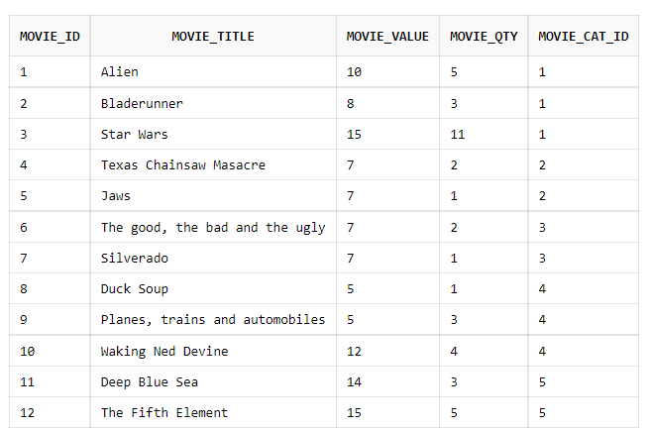 | dESC movie;  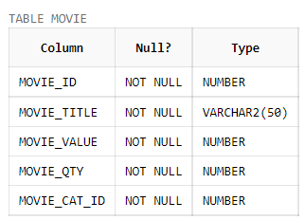
movie_type | CREATE TABLE movie_type (  movie_category_id INT NOT NULL,  movie_catEGory VARCHAR (50) NOT NULL,  PRIMARY KEY (movie_category_id)  );  INSERT INTO movie_type VALUES (1,'SciFi');  INSERT INTO movie_type VALUES (2, 'Horror');  INSERT INTO movie_type VALUES (3, 'Western');  INSERT INTO movie_type VALUES (4, 'Comedy');  INSERT INTO movie_type VALUES (5, 'Drama');  SELECT * FROM MOVIE_TYPE;  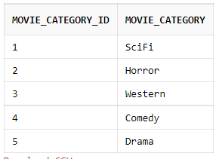 | DESC MOVIE_TYPE;  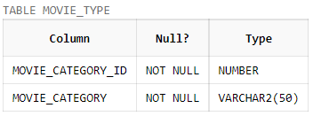
rental | CREATE TABLE rental (  rental_id INT NOT NULL,  member_id INT NOT NULL,  pay_method VARCHAR (50) NOT NULL,  movie_id INT NOT NULL,  return_date DATE,  rent_date DATE,  PRIMARY KEY (rental_id)  );  INSERT INTO RENTAL VALUES (1,10,'Credit',11,'1-Oct-09','18-Sep-09');  INSERT INTO RENTAL VALUES (2,10,'Credit',8,'3-Oct-09','18-Sep-09');  INSERT INTO RENTAL VALUES (3,12,'Check',6,'19-Oct-09','11-Oct-09');  INSERT INTO RENTAL VALUES (4,13,'Debit',3,'31-Oct-09','28-Oct-09');  INSERT INTO RENTAL VALUES (5,13,'Debit',5,'5-Nov-09','28-Oct-09');  INSERT INTO RENTAL VALUES (6,13,'Debit',11,'11-Nov-09','29-Oct-09');  INSERT INTO RENTAL VALUES (7,14,'Credit',10,'11-Nov-09','1-Nov-09');  INSERT INTO RENTAL VALUES (8,14,'Credit',12,'10-Nov-09','2-Nov-09');  INSERT INTO RENTAL VALUES (9,12,'Cash',4, NULL,'5-Nov-09');  INSERT INTO RENTAL VALUES (10,12,'Cash',12,'18-Nov-09','8-Nov-09');  INSERT INTO RENTAL VALUES (11,12,'Cash',3, NULL,'14-Nov-09');  INSERT INTO RENTAL VALUES (12, 13,'Debit',11, NULL,'18-Nov-09');  SELECT * FROM RENTAL;  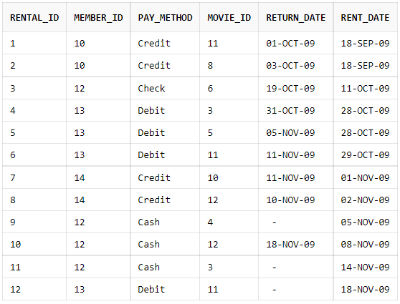 | DESC RENTAL;  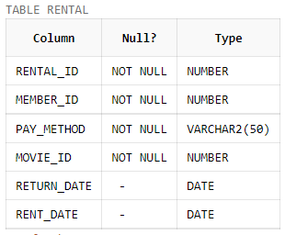
member | CREATE TABLE member (  member_id INT NOT NULL,  First_name VARCHAR (50) NOT NULL,  Last_name VARCHAR (50) NOT NULL,  License INT NOT NULL,  state VARCHAR (50) NOT NULL,  credit_card INT NOT NULL,  PRIMARY KEY (member_id)  );  INSERT INTO member VALUES (10, 'Tangier', 'Tim', 11111111, 'VA', 123456789111);  INSERT INTO member VALUES (12, 'Maulder', 'Fox', 333333333, 'FL', 333333333333);  INSERT INTO member VALUES (13, 'Wild', 'Coyote', 444444444, 'VA', 444444444444);  INSERT INTO member VALUES (14, 'Casteel', 'Joan', 555555555, 'VA', 555555555555);  SELECT * FROM MEMBER;  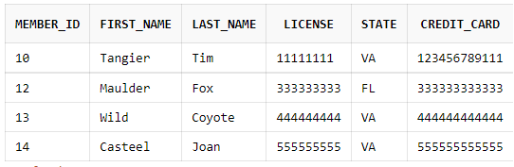 | DESC MEMBER;  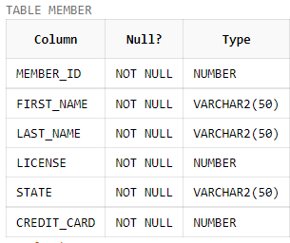

Part II: SQL and PL/SQL

1. Displaying the ID, lastname and firstname of those members who have not returned the movies they rented.

SQL Statement:

SELECT member_id, last_name, first_name FROM member WHERE member_id IN (SELECT member_id FROM rental WHERE return_date IS NULL);

Query Result Generated By ORACLE:

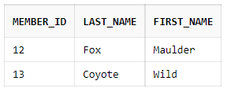

2. Displaying the title, value (cost) and category of those movies whose titles contain "and".

SQL Statement:

SELECT a.movie_title, b.movie_category, a.movie_value from movie a
JOIN movie_type b
ON a.movie_cat_id=b.movie_category_id
WHERE a.movie_title LIKE '%and%';

Query Result Generated By ORACLE:

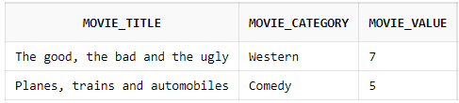

3. Displaying the rental transaction ID, member ID, the number of weeks between the movie rent date and return date (call this column "Delay_weeks", use "December 1, 2009" as the return date if a movie's return date is not yet available). Rounded the values in the "Delay_weeks" column to integers. Adding another new column with the name "Status" that shows whether the movie in each rental transaction was "Returned" or "Not Returned".

SQL Statement:

SELECT rental_id,member_id,round(((to_date(NVL(return_date, '01-DEC-09'))-to_date(rent_date))/7)) "DELAY WEEKS",NVL2(return_date, 'RETURNED', 'NOT RETURNED') "STATUS" FROM rental;

Query Result Generated By ORACLE:

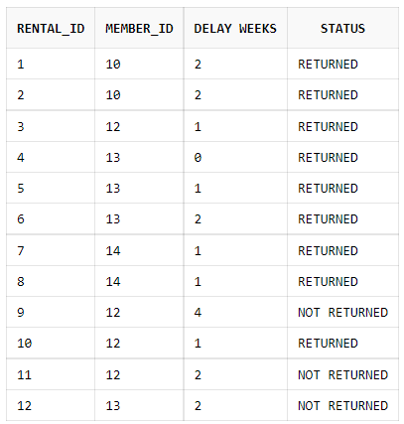
4. Displaying the movie category that generated more rental transactions than any other movie categories, and the number of rental transactions generated by this category.

SQL Statement:

SELECT movie_category,COUNT(rental_id) "RENTAL TRANSACTIONS" FROM movie a
JOIN movie_type b
ON a.movie_cat_id=b.movie_category_id
JOIN rental c
ON a.movie_id=c.movie_id
GROUP BY movie_category
HAVING COUNT (rental_id)=(SELECT MAX(COUNT(rental_id)) FROM movie a
JOIN movie_type b
ON a.movie_cat_id=b.movie_category_id
JOIN rental c
ON a.movie_id=c.movie_id
GROUP BY movie_category)

Query Result Generated By ORACLE:

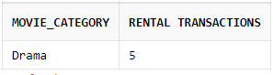

5. Displaying the title, category, movie_qty and the average movie_value of those movies that were rented by customers using cash as payment.

SQL Statement:

SELECT movie_title,movie_category,movie_value,((movie_qty*movie_value)/movie_qty) "Average_value" from movie a
JOIN movie_type b ON a.movie_cat_id=b.movie_category_id
JOIN rental c ON a.movie_id=c.movie_id AND c.pay_method='Cash';

Query Result Generated By ORACLE:

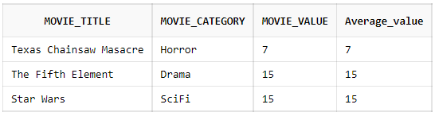

6. Creating an anonymous PL/SQL block containing a WHILE loop to display the top four movies with the greatest number of copies available (movie_qty). Displaying all fields from the movies table in the output.

Anonymous PL/SQL block:

DECLARE
movie_id number(10);
movie_title varchar(50);
movie_value decimal(5,2);
movie_qty number(10);
movie_cat_id number(10);
CURSOR moviecursor is SELECT * from movie order by movie_qty desc;
BEGIN
Open moviecursor;
Fetch moviecursor into movie_id, movie_title, movie_value, movie_qty, movie_cat_id;
While moviecursor%found and moviecursor%rowcount <=4
Loop dbms_output.put_line('Movie_Id :' || movie_id || ' Movie_Title: '|| movie_title || ' Movie_Qty:' || movie_qty || ' Movie_Value : '||movie_value ||' Movie_Cat_id: '||movie_cat_id);
Fetch moviecursor into movie_id, movie_title, movie_value, movie_qty, movie_cat_id;
End loop;
Close moviecursor;
End;

Output of the PL/SQL block:

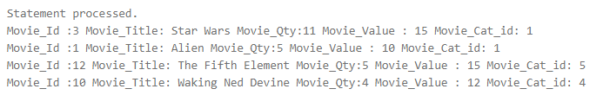

7. Creating an anonymous PL/SQL block updating the pay_method of a member (whose member_id is 30) to “Credit”. However, no such a member exists in the database. Using a user-defined exception to trap this error and returning the message “This is an invalid member ID” as the output of this anonymous block.

Anonymous PL/SQL block:

DECLARE
Invalid_member_Id EXCEPTION;
BEGIN
UPDATE rental SET pay_method='credit' WHERE member_id='30';
IF SQL% NOTFOUND THEN
RAISE Invalid_member_Id;
END IF;
EXCEPTION
WHEN Invalid_member_Id THEN DBMS_OUTPUT.PUT_LINE('This is an invalid member ID');
END;

Output of the PL/SQL block:

