**SQL Coding Challenge**

Use CarRentalService

Create table Vehicle

(

vehicleID int primary key,

make varchar(50),

model varchar(50),

year int,

dailyrate decimal(10, 2),

status int check (status in (0,1)),

passengercapacity int,

enginecapacity int

)

Create table Customer

(

customerID int primary key,

firstname varchar(50),

lastname varchar(50),

email varchar(100),

phonenumber varchar(15) unique

)

Create table Lease

(

leaseID int primary key,

vehicleID int,

customerID int,

startdate date,

enddate date,

type varchar(20) check (type in ('Daily', 'Monthly')),

foreign key (vehicleID) references Vehicle(vehicleID) on delete cascade on update cascade,

foreign key (customerID) references Customer(customerID) on delete cascade on update cascade

)

Create table Payment

(

paymentID int primary key,

leaseID int,

paymentdate date,

amount decimal(10, 2),

foreign key (leaseID) references Lease(leaseID) on delete cascade on update cascade

)

Insert into Vehicle

values

(1, 'Toyota', 'Camry', 2022, 50.00, 1, 4, 1450),

(2, 'Honda', 'Civic', 2023, 45.00, 1, 7, 1500),

(3, 'Ford', 'Focus', 2022, 48.00, 0, 4, 1400),

(4, 'Nissan', 'Altima', 2023, 52.00, 1, 7, 1200),

(5, 'Chevrolet', 'Malibu', 2022, 47.00, 1, 4, 1800),

(6, 'Hyundai', 'Sonata', 2023, 49.00, 0, 7, 1400),

(7, 'BMW', '3 Series', 2023, 60.00, 1, 7, 2499),

(8, 'Mercedes', 'C-Class', 2022, 58.00, 1, 8, 2599),

(9, 'Audi', 'A4', 2022, 55.00, 0, 4, 2500),

(10, 'Lexus', 'ES', 2023, 54.00, 1, 4, 2500)

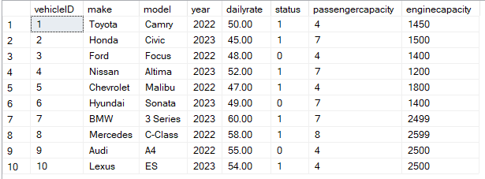

Insert into Customer

values

(1, 'John', 'Doe', 'johndoe@example.com', '555-555-5555'),

(2, 'Jane', 'Smith', 'janesmith@example.com', '555-123-4567'),

(3, 'Robert', 'Johnson', 'robert@example.com', '555-789-1234'),

(4, 'Sarah', 'Brown', 'sarah@example.com', '555-456-7890'),

(5, 'David', 'Lee', 'david@example.com', '555-987-6543'),

(6, 'Laura', 'Hall', 'laura@example.com', '555-234-5678'),

(7, 'Michael', 'Davis', 'michael@example.com', '555-876-5432'),

(8, 'Emma', 'Wilson', 'emma@example.com', '555-432-1098'),

(9, 'William', 'Taylor', 'william@example.com', '555-321-6547'),

(10, 'Olivia', 'Adams', 'olivia@example.com', '555-765-4321')

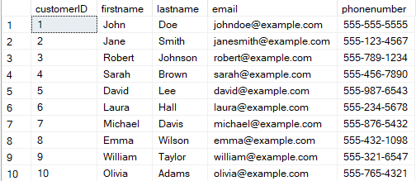

Insert into Lease

values

(1, 1, 1, '2023-01-01', '2023-01-05', 'Daily'),

(2, 2, 2, '2023-02-15', '2023-02-28', 'Monthly'),

(3, 3, 3, '2023-03-10', '2023-03-15', 'Daily'),

(4, 4, 4, '2023-04-20', '2023-04-30', 'Monthly'),

(5, 5, 5, '2023-05-05', '2023-05-10', 'Daily'),

(6, 4, 3, '2023-06-15', '2023-06-30', 'Monthly'),

(7, 7, 7, '2023-07-01', '2023-07-10', 'Daily'),

(8, 8, 8, '2023-08-12', '2023-08-15', 'Monthly'),

(9, 3, 3, '2023-09-07', '2023-09-10', 'Daily'),

(10, 10, 10, '2023-10-10', '2023-10-31', 'Monthly')

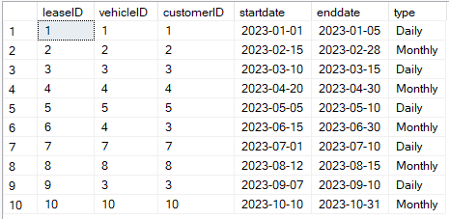

Insert into Payment

values

(1, 1, '2023-01-03', 200.00),

(2, 2, '2023-02-20', 1000.00),

(3, 3, '2023-03-12', 75.00),

(4, 4, '2023-04-25', 900.00),

(5, 5, '2023-05-07', 60.00),

(6, 6, '2023-06-18', 1200.00),

(7, 7, '2023-07-03', 40.00),

(8, 8, '2023-08-14', 1100.00),

(9, 9, '2023-09-09', 80.00),

(10, 10, '2023-10-25', 1500.00)

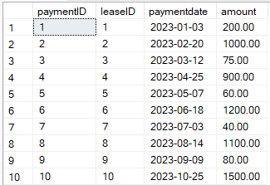

1. Update the daily rate for a Mercedes car to 68.

Update Vehicle set dailyrate = 68.00

where make = 'Mercedes'

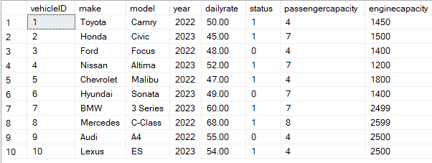

2. Delete a specific customer and all associated leases and payments.

Delete from Customer

where customerID = 3

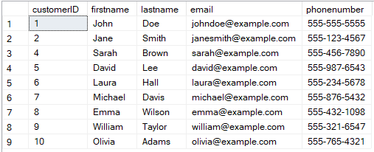

3. Rename the "paymentDate" column in the Payment table to "transactionDate".

Exec sp_rename 'Payment.paymentdate','transactiondate','column'

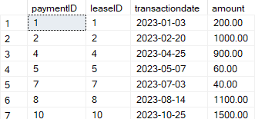

4. Find a specific customer by email.

Select * from Customer

where email = 'david@example.com'



5. Get active leases for a specific customer.

Select * from Lease

where customerID = 4 and enddate >= getdate()



6. Find all payments made by a customer with a specific phone number.

Select paymentID,amount, Customer.firstname, Customer.lastname from Payment

inner join Lease on Lease.leaseID = Payment.leaseID

inner join Customer on Customer.customerID = Lease.customerID

where Customer.phonenumber = '555-765-4321'



7. Calculate the average daily rate of all available cars.

Select avg(dailyrate) as AvgDailyRate from Vehicle



8. Find the car with the highest daily rate.

Select top 1 vehicleID,make,model,dailyrate

from Vehicle

order by dailyrate desc



9. Retrieve all cars leased by a specific customer.

Select Lease.vehicleID, Vehicle.make, Lease.customerID, Customer.firstname, Customer.lastname

from Lease

inner join Vehicle on Vehicle.vehicleID = Lease.vehicleID

inner join Customer on Customer.customerID = Lease.customerID

where Customer.customerID = 7



10. Find the details of the most recent lease.

Select top 1 * from Lease

order by startdate desc



11. List all payments made in the year 2023.

Select * from payment

where transactiondate like '2023%'

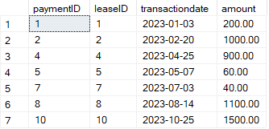

12. Retrieve customers who have not made any payments.

Select Customer.customerID,firstname,lastname,email from Customer

left join Lease on Lease.customerID = Customer.customerID

left join Payment on Payment.leaseID = Lease.leaseID

where Payment.paymentID is null



13. Retrieve Car Details and Their Total Payments.

Select Vehicle.vehicleID,make,model,year,dailyrate,status,passengercapacity,enginecapacity,sum(Payment.amount) as TotalPayment

from Vehicle

left join Lease on Lease.vehicleID = Vehicle.vehicleID

left join Payment on Payment.leaseID = Lease.leaseID

group by Vehicle.vehicleID,make,model,year,dailyrate,status,passengercapacity,enginecapacity

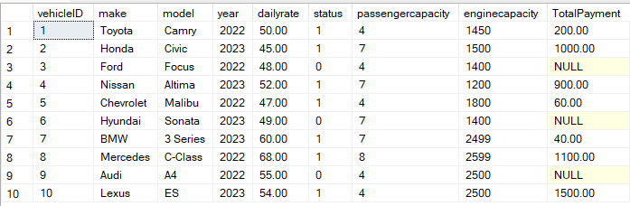

14. Calculate Total Payments for Each Customer.

Select Customer.customerID,firstname,lastname, sum(Payment.amount) as TotalPayment

from Customer

left join Lease on Lease.customerID = Customer.customerID

left join Payment on Payment.leaseID = Lease.leaseID

group by Customer.customerID,firstname,lastname

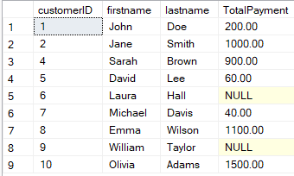

15. List Car Details for Each Lease.

Select Vehicle.vehicleID,make,model,year,dailyrate,status,passengercapacity,enginecapacity,leaseID

from Vehicle

inner join Lease on Lease.vehicleID = Vehicle.vehicleID

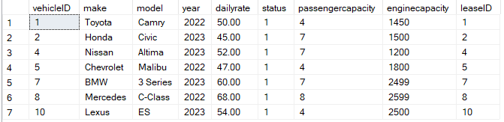

16. Retrieve Details of Active Leases with Customer and Car Information.

Select *

from Customer

inner join Lease on Lease.customerID = Customer.customerID

inner join Vehicle on Vehicle.vehicleID = Lease.vehicleID

where enddate >= getdate()



17. Find the Customer Who Has Spent the Most on Leases.

Select top 1 Customer.customerID,firstname,lastname,sum(Payment.amount) as MoneySpent

from Customer

inner join Lease on Lease.customerID = Customer.customerID

inner join Payment on Payment.leaseID = Lease.leaseID

group by Customer.customerID,firstname,lastname

order by MoneySpent desc



18. List All Cars with Their Current Lease Information.

Select *

from Vehicle

left join Lease on Lease.vehicleID = Vehicle.vehicleID

