ABC Diagnostic Imaging Center (Simulated)
(For Academic & Research Demonstration Only)
Patient Details
- Patient ID: PREG_001
- Age: 26 years
- Gender: Female
- Gestational Age: Second Trimester
Scan Information
- Scan Type: Obstetric Ultrasound (2D)
- Date of Scan: 2026-01-03
🖼️ Ultrasound Image
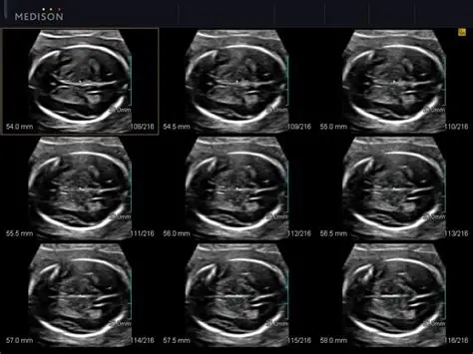
Findings
- Standard fetal planes are adequately visualized
- Fetal brain anatomy appears normal
- No evidence of ventriculomegaly or structural abnormality
- Amniotic fluid volume appears within normal limits
Impression
Normal obstetric ultrasound findings.
No abnormality detected at the time of examination.
Recommendation
- Continue routine antenatal care
- Follow-up scans as per standard antenatal schedule
Remarks
This is a simulated ultrasound report created for demonstrating a
Doctor-in-the-Loop AI-based clinical reporting system.
No real patient data is used.

Radiologist: Dr. XYZ (Simulated)
Signature: ____________________
Date: 2026-01-03

