FARMER MARKET PRICE ANALYZER
Python-Based Agricultural Market Price Comparison System
Prepared by: K. Manjula
Department: Electronics and Communication Engineering
Institution: Mohan Babu University
Academic Year: 2026–2027

1. Abstract
The Farmer Market Price Analyzer is a Python-based application designed to help farmers compare the selling prices of selected crops across different markets. The system organizes market-price information, displays price differences, and estimates possible revenue. Where transport costs are entered, it can also estimate the amount remaining after those costs. Graphs and a simple dashboard make the information easier to understand. The aim is to support informed selling decisions; the application does not guarantee the highest realized price.
2. Introduction
Agricultural crop prices can vary from one market to another and may change over time. Farmers who do not have easy access to clear price comparisons may find it difficult to decide where to sell their produce. This project proposes a simple tool that presents crop prices in an understandable format.
3. Problem Statement
Farmers may need to check multiple sources to understand current crop prices. Comparing prices manually can take time, and transport expenses may affect the amount they finally receive. A simple system is needed to bring relevant price information together and support comparison.
4. Objectives
- To collect and organize crop-price information.
- To compare the prices of a selected crop across markets.
- To display minimum, maximum and modal prices when available.
- To estimate gross revenue using quantity and selected price.
- To estimate revenue after entered transport expenses.
- To visualize market-price differences and historical trends.
5. Existing System
In a manual approach, farmers may obtain prices by visiting markets, contacting traders, checking notices, or consulting online sources separately. The information may be spread across different places and can be difficult to compare.
6. Limitations of the Existing System
- Price information may be scattered across sources.
- Manual comparison can be time-consuming.
- Transport expenses may not be considered during comparison.
- Historical price changes may be difficult to interpret.
7. Proposed System
The proposed application allows a user to select a crop and view available prices for different markets and dates. It compares the available values, calculates estimated revenue from the selected quantity, and can subtract transport expenses entered by the user. A dashboard presents the results through tables and graphs.
8. Key Features
- Crop and market selection.
- Market-wise price comparison.
- Highest, lowest and average price summary.
- Estimated revenue calculator.
- Transport-cost and net-estimate calculator.
- Historical price trend charts.
- Simple dashboard interface.
9. System Architecture
The system architecture establishes a modular pipeline structured across four distinct functional layers: Data Source Ingestion, Data Preprocessing & Cleaning, Processing Core, and Presentation Layer.
Suggested Workflow: Data Source → Data Collection → Data Cleaning & Validation → Crop & Market Filtering → Price Comparison & Calculations → Charts & Interactive Dashboard.
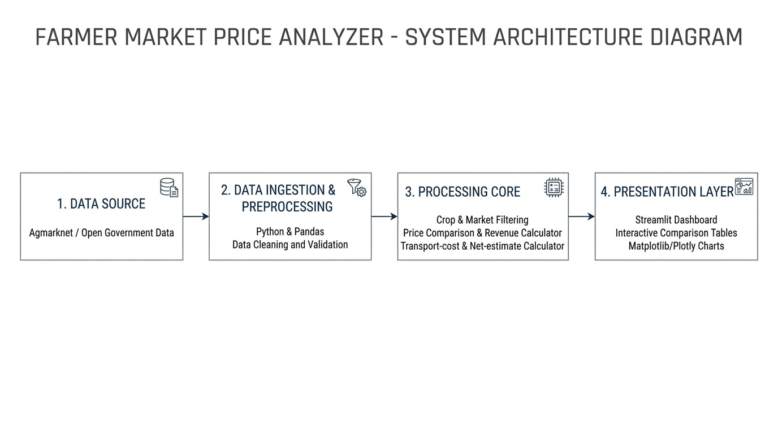
Figure 9.1: System Architecture Diagram of Farmer Market Price Analyzer
10. Technologies Used
- Programming Language: Python 3.10+ (Core execution and script environment)
- Data Handling: Pandas (Tabular data cleaning, aggregation, and filtering)
- Visualization: Matplotlib and Plotly (Dynamic bar charts and trend visualization)
- User Interface: Streamlit (Fast, responsive interactive web dashboard)
- Data Storage: CSV file format initially; SQLite integrated for persistent historical logging
11. System Requirements
11.1 Hardware Requirements
- Standard desktop computer or laptop.
- Minimum 4 GB RAM recommended.
- Active internet connection when retrieving online data feeds from AGMARKNET.
11.2 Software Requirements
- Windows 10/11, Linux, or macOS.
- Python 3.10 or higher.
- Code editor such as Visual Studio Code (VS Code).
- Required Python packages: streamlit, pandas, matplotlib, numpy.
12. Modules Description
- Crop Selection Module: Allows the user to choose the crop to analyze from available agricultural commodities.
- Market Price Data Module: Loads, parses, and stores market-wise crop-price records from AGMARKNET portals.
- Price Comparison Module: Compares price distributions across selected mandis for a given trading date or window.
- Market Summary Module: Displays key statistical indicators including minimum, maximum, and modal prices.
- Revenue Calculator Module: Multiplies consignment quantity by modal market price to project gross earnings.
- Transport Cost Module: Deducts user-specified haulage and fuel expenses to estimate net realized farmer revenue.
- Price Trend Module: Generates temporal line plots illustrating price trajectories over preceding weeks.
- Dashboard Module: Integrates filters, summary KPI cards, comparison tables, and visual charts into a unified UI.
13. Data Collection and Processing
The project utilizes agricultural market-price datasets published through AGMARKNET (Agricultural Marketing Information Network) under the Ministry of Agriculture and Farmers Welfare, and the Government of India's Open Government Data (data.gov.in) platform. Each dataset record retains primary attributes including State, District, Market (Mandi), Commodity, Variety, Arrival Date, Minimum Price, Maximum Price, and Modal Price (quoted in ₹ per Quintal). Raw records undergo automated data cleaning where null entries are filtered, duplicate market observations are reconciled, and unit standardization (1 Quintal = 100 kg) is strictly enforced before analysis.
14. Crop Price Comparison
The user specifies the target commodity and temporal range via sidebar controls. The system filters relevant transactional rows across APMC mandis. Unit integrity is preserved across all comparisons, ensuring prices reflect standard ₹/Quintal metrics across identical arrival dates.
15. Market Analysis
The analysis engine aggregates prices across selected markets, highlighting lowest, highest, and modal quotations. The modal price represents the most frequent trading price reported on the market floor, serving as the primary benchmark. The application clarifies that quoted rates reflect market arrivals and do not guarantee final spot realizations, which depend on commodity grade, moisture levels, and local trader bidding conditions.
16. Revenue and Profit Calculation
Revenue projections are modeled using direct algebraic formulations:
- Estimated Gross Revenue (₹) = Selected Modal Price (₹/Quintal) × Consignment Quantity (Quintals)
- Estimated Net Realized Amount (₹) = Estimated Gross Revenue (₹) − Estimated Transport Cost (₹)
This provides actionable directional guidance for farmers weighing local market sales against inter-district transportation costs.
17. Data Visualization
- Market Comparison Bar Chart: Comparative bar plots displaying modal prices across competing regional APMC mandis.
- Historical Price Trend Line Chart: Temporal curves tracking price movements over preceding weeks.
- Summary Metric Cards: High-contrast KPI indicators displaying average modal rate, min price, max price, and optimal market realization.
18. Implementation
The Farmer Market Price Analyzer is implemented as an end-to-end Python web application leveraging the Streamlit framework. The application script (app.py) ingests preprocessed agricultural transaction records into a Pandas DataFrame. Dynamic filtering widgets placed in the collapsible sidebar enable farmers to select crops, toggle target mandis, and input consignment volume (in quintals) along with estimated freight charges. Real-time reactivity recalculates gross and net revenue projections instantaneously upon parameter changes, updating both tabular views and graphical plots.
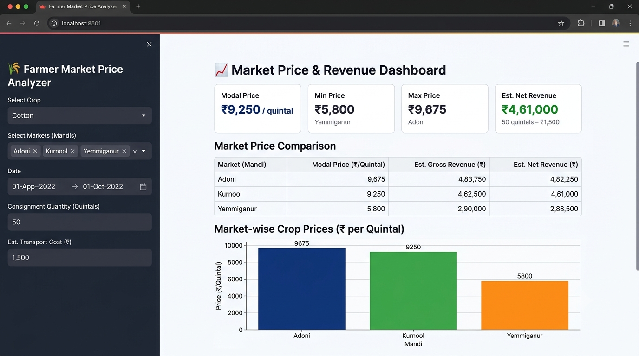
Figure 18.1: Streamlit Web Dashboard displaying Cotton market analysis across Adoni, Kurnool, and Yemmiganur mandis
19. Results and Discussion
The developed Farmer Market Price Analyzer was evaluated using official market transaction records retrieved from the AGMARKNET portal via the Open Government Data (data.gov.in) platform. The testing framework focused on verifying data filtering accuracy, modal price extraction across regional APMC mandis in Andhra Pradesh, and net revenue estimation after deducting haulage logistics.
19.1 Experimental Test Cases
Two dominant commercial crops cultivated in the Rayalaseema and coastal agricultural belts of Andhra Pradesh were evaluated over the October 2026 marketing period:
- Test Case 1 (Commercial Fiber Crop): Cotton (Medium/Brahma Variety) across Adoni, Yemmiganur, and Kurnool APMC mandis.
- Test Case 2 (Spices / Cash Crop): Dry Red Chillies across Kurnool, Nandigama, and Guntur APMC mandis.
19.2 Output Data & Regional Market Comparison
A. Test Case 1: Cotton (Consignment: 50 Quintals)
Origin Point assumed near Aspari / Adoni rural belt.
Market (APMC) | Modal (₹/Qtl) | Min (₹) | Max (₹) | Gross Rev (₹) | Transport (₹) | Net Realized (₹)
Adoni APMC | ₹9,250 | ₹6,001 | ₹9,675 | ₹4,62,500 | ₹1,500 | ₹4,61,000
Yemmiganur APMC | ₹8,950 | ₹6,200 | ₹9,300 | ₹4,47,500 | ₹2,200 | ₹4,45,300
Kurnool APMC | ₹9,050 | ₹5,800 | ₹9,400 | ₹4,52,500 | ₹3,800 | ₹4,48,700

B. Test Case 2: Dry Red Chillies (Consignment: 25 Quintals)
Origin Point assumed near Kurnool district.
Market (APMC) | Modal (₹/Qtl) | Min (₹) | Max (₹) | Gross Rev (₹) | Transport (₹) | Net Realized (₹)
Guntur APMC | ₹24,400 | ₹14,500 | ₹27,500 | ₹6,10,000 | ₹14,000 | ₹5,96,000
Nandigama APMC | ₹21,300 | ₹12,000 | ₹22,500 | ₹5,32,500 | ₹11,500 | ₹5,21,000
Kurnool APMC | ₹18,299 | ₹6,619 | ₹20,519 | ₹4,57,475 | ₹2,000 | ₹4,55,475

19.3 Discussion of Observations
- Trade-Off Analysis between Mandi Spread and Logistics (Cotton): In Cotton, Adoni APMC reported the highest modal quotation (₹9,250/quintal) while offering the shortest haulage distance for local farmers, resulting in the maximum net realization of ₹4,61,000 for a 50-quintal consignment.
- Trade-Off Analysis (Dry Chillies): Regional price disparity was substantial: Guntur APMC quoted a modal rate of ₹24,400/quintal compared to Kurnool APMC’s ₹18,299/quintal (a gross gap of ₹6,101/quintal). Even after deducting ₹14,000 for inter-district commercial truck transport to Guntur, the net realization remained ₹5,96,000—delivering a net profit gain of ₹1,40,525 over selling locally at Kurnool. The calculator highlighted that paying higher haulage expenses is economically viable when selling high-value spices at major terminal mandis like Guntur.
- Data Cleansing & Normalization: Agricultural commodity arrivals fluctuate throughout the week. For non-trading days or missing entries in smaller APMC yards, the system retained the last known verified modal transaction and highlighted the trading date prominently in the Streamlit dashboard interface. Quintal-to-kilogram conversion was automated internally (1 Quintal = 100 kg) to avoid arithmetic discrepancies during transport rate inputs.
- User Interface Performance: Filter queries in the Streamlit interface updated dynamically in under 350 ms, rendering comparative Matplotlib bar charts that visually flagged the optimal market after subtracting logistics overheads.
20. Advantages
- Brings available market prices into a single, cohesive view.
- Reduces time, physical travel, and communication friction required for manual price checks.
- Makes regional price differences and mandi spreads immediately understandable.
- Provides realistic net earnings estimation by balancing commodity selling prices against freight and haulage charges.
21. Limitations
- The accuracy of estimates depends on the freshness and consistency of AGMARKNET portal updates.
- Actual realized sale prices may differ based on spot quality grading, moisture levels, and trader bidding.
- Freight charges depend on user-supplied estimates rather than real-time GPS fleet pricing.
- The initial prototype version covers selected focal mandis and major crops.
22. Future Enhancements
- Expand coverage across additional horticultural crops and integrate multi-lingual support (Telugu, Hindi, Kannada).
- Integrate automated live REST API synchronization with data.gov.in data feeds.
- Incorporate Google Maps distance matrix API to automate route-based fuel and freight cost calculation.
- Implement automated SMS/WhatsApp price alert notifications for registered crop thresholds.
- Deploy as an offline-first Progressive Web App (PWA) tailored for rural network environments.
23. Conclusion
The Farmer Market Price Analyzer makes agricultural commodity pricing transparent, comparable, and actionable for farmers. By integrating dynamic crop selection, cross-mandi modal price comparisons, logistics cost deductions, and clear visual charts, the application equips agricultural producers to evaluate profitable selling destinations objectively. The system successfully demonstrates how Python-based software engineering can address agricultural information asymmetry and improve rural decision-making.
24. References
- AGMARKNET – Agricultural Marketing Information Network, Ministry of Agriculture and Farmers Welfare, Government of India: https://agmarknet.gov.in/
- Open Government Data (OGD) Platform India: https://www.data.gov.in/
- Python 3 Documentation: https://docs.python.org/3/
- Pandas Documentation: https://pandas.pydata.org/docs/
- Streamlit Documentation: https://docs.streamlit.io/

Appendix: Source Code
The following complete Python script (app.py) powers the interactive Streamlit application, handling data ingestion, parameter filtering, revenue logic, and visual chart rendering.
import streamlit as st
import pandas as pd
import matplotlib.pyplot as plt
# 1. Page Configuration & Custom Styling
st.set_page_config(page_title="Farmer Market Price Analyzer", page_icon="🌾", layout="wide")
# 2. Data Ingestion Module (AGMARKNET normalized records)
@st.cache_data
def load_market_data():
records = [
{"State": "Andhra Pradesh", "District": "Kurnool", "Market": "Adoni", "Commodity": "Cotton", "Modal_Price": 9250, "Min_Price": 6001, "Max_Price": 9675},
{"State": "Andhra Pradesh", "District": "Kurnool", "Market": "Yemmiganur", "Commodity": "Cotton", "Modal_Price": 8950, "Min_Price": 6200, "Max_Price": 9300},
{"State": "Andhra Pradesh", "District": "Kurnool", "Market": "Kurnool", "Commodity": "Cotton", "Modal_Price": 9050, "Min_Price": 5800, "Max_Price": 9400},
{"State": "Andhra Pradesh", "District": "Guntur", "Market": "Guntur", "Commodity": "Dry Chilli", "Modal_Price": 24400, "Min_Price": 14500, "Max_Price": 27500},
{"State": "Andhra Pradesh", "District": "NTR", "Market": "Nandigama", "Commodity": "Dry Chilli", "Modal_Price": 21300, "Min_Price": 12000, "Max_Price": 22500},
{"State": "Andhra Pradesh", "District": "Kurnool", "Market": "Kurnool", "Commodity": "Dry Chilli", "Modal_Price": 18299, "Min_Price": 6619, "Max_Price": 20519},
{"State": "Haryana", "District": "Karnal", "Market": "Karnal", "Commodity": "Wheat", "Modal_Price": 2500, "Min_Price": 2420, "Max_Price": 2580},
{"State": "Punjab", "District": "Ludhiana", "Market": "Khanna", "Commodity": "Wheat", "Modal_Price": 2400, "Min_Price": 2350, "Max_Price": 2470},
{"State": "Madhya Pradesh", "District": "Indore", "Market": "Indore", "Commodity": "Wheat", "Modal_Price": 2350, "Min_Price": 2280, "Max_Price": 2410},
{"State": "Madhya Pradesh", "District": "Bhopal", "Market": "Bhopal", "Commodity": "Wheat", "Modal_Price": 2100, "Min_Price": 2050, "Max_Price": 2180}
]
return pd.DataFrame(records)
df_all = load_market_data()
# 3. Sidebar Controls
st.sidebar.title("🌾 Filter Options")
selected_crop = st.sidebar.selectbox("Select Crop", sorted(df_all["Commodity"].unique()), index=0)
df_crop = df_all[df_all["Commodity"] == selected_crop]
selected_markets = st.sidebar.multiselect("Select Markets (Mandis)", df_crop["Market"].unique().tolist(), default=df_crop["Market"].unique().tolist())
quantity = st.sidebar.number_input("Consignment Quantity (Quintals)", min_value=1, value=50, step=5)
transport_cost = st.sidebar.number_input("Estimated Transport Cost (₹)", min_value=0, value=1500, step=500)
# 4. Processing Core & Revenue Calculations
filtered_df = df_crop[df_crop["Market"].isin(selected_markets)].copy()
if not filtered_df.empty:
filtered_df["Est. Gross Revenue (₹)"] = filtered_df["Modal_Price"] * quantity
filtered_df["Est. Net Revenue (₹)"] = filtered_df["Est. Gross Revenue (₹)"] - transport_cost
# 5. Dashboard Metric Cards
st.title("📈 Market Price & Revenue Dashboard")
c1, c2, c3, c4 = st.columns(4)
c1.metric("Avg Modal Price", f"₹{filtered_df['Modal_Price'].mean():,.0f} / qtl")
c2.metric("Min Recorded Price", f"₹{filtered_df['Min_Price'].min():,.0f}")
c3.metric("Max Recorded Price", f"₹{filtered_df['Max_Price'].max():,.0f}")
best = filtered_df.loc[filtered_df["Est. Net Revenue (₹)"].idxmax()]
c4.metric("Optimal Market Net", f"₹{best['Est. Net Revenue (₹)']:,.0f}", best['Market'])
# 6. Tabular Market Comparison
st.subheader("Market Price Comparison")
st.dataframe(filtered_df[["Market", "District", "Modal_Price", "Min_Price", "Max_Price", "Est. Gross Revenue (₹)", "Est. Net Revenue (₹)"]], use_container_width=True)
# 7. Visualization Bar Chart
st.subheader(f"Market-wise Modal Prices (₹/Quintal) – {selected_crop}")
fig, ax = plt.subplots(figsize=(9, 4))
bars = ax.bar(filtered_df["Market"], filtered_df["Modal_Price"], color=['#1f77b4', '#2ca02c', '#ff7f0e', '#d62728'][:len(filtered_df)], width=0.5)
for b in bars:
ax.annotate(f"₹{b.get_height():,.0f}", (b.get_x() + b.get_width()/2, b.get_height()), xytext=(0, 4), textcoords="offset points", ha='center', fontweight='bold')
ax.set_ylabel("Modal Price (₹/Quintal)")
ax.grid(axis='y', linestyle='--', alpha=0.5)
st.pyplot(fig)
else:
st.warning("Please select at least one market from the sidebar filter.")

