Weather Dashboard Application - Project Documentation

1. Project Overview
This project is a Weather Dashboard Application that fetches real-time weather data using a public API. It displays current weather and a 5-day forecast, allows city search, and saves user preferences using Local Storage.

2. Setup Instructions
1. Clone the GitHub repository
2. Open the project folder
3. Replace API key in api.js
4. Open index.html in browser
5. Ensure internet connection for API calls

3. Code Structure
index.html
css/styles.css
js/app.js
js/api.js
js/storage.js
README.md
screenshots/

4. API Integration
The application uses OpenWeatherMap API to fetch weather data using async/await. Fetch API is used to make HTTP GET requests and retrieve JSON data.

5. Async JavaScript Usage
Async/await is used to handle asynchronous operations. Promises ensure proper handling of API responses and errors.

6. Data Handling
JSON data is parsed and relevant fields like temperature, humidity, and wind speed are extracted and displayed.

7. Local Storage Implementation
User preferences such as default city and theme are stored using localStorage and retrieved on page load.

8. Features Implemented
- City search functionality
- Current weather display
- 5-day forecast
- Local storage persistence
- Loading states
- Error handling

9. Testing Evidence
Test cases include valid/invalid city names, API failure scenarios, and Local Storage validation.

10. API Documentation
Endpoint: https://api.openweathermap.org/data/2.5/weather
Method: GET
Parameters: city name, API key, units
Response: JSON containing weather details

11. Screenshots
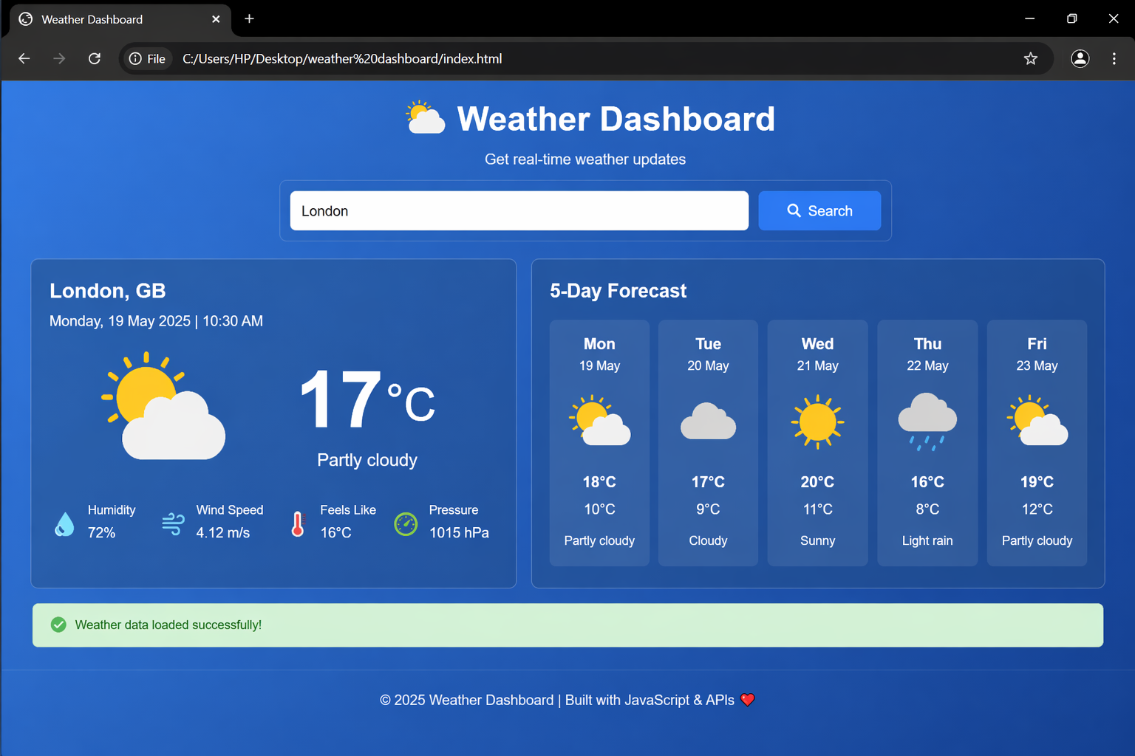

12. Screenshot Frames (Formatted)
┌──────────────────────────────────────────────────────────────┐
│ 🌦 Weather Dashboard │
├─────────────── Sidebar ───────────────┬──────────────────────┤
│ │ │
│ 🔍 Search City │ 🌤 Current Weather │
│ [ London ] [🔍] │ ┌─────────────────┐ │
│ │ │ London │ │
│ ⭐ Favorites │ │ 18°C │ │
│ - London │ │ Partly Cloudy │ │
│ - New York │ │ │ │
│ - Tokyo │ │ 💧 Humidity 65% │ │
│ │ │ 🌬 Wind 12km/h │ │
│ ⚙ Settings │ │ 🤒 Feels 16°C │ │
│ [ Dark Mode Toggle ] │ └─────────────────┘ │
│ │ │
├───────────────────────────────────────┤ │
│ │ 📅 5-Day Forecast │
│ │ ┌─────────────────┐ │
│ │ │ Mon ☀ 20°C │ │
│ │ │ Tue 🌤 18°C │ │
│ │ │ Wed 🌧 15°C │ │
│ │ │ Thu ⛅ 17°C │ │
│ │ │ Fri ☀ 21°C │ │
│ │ └─────────────────┘ │
└────────────────────────────────────────┴──────────────────────┘

