Personal Portfolio Website - Internship Project Documentation

1. Project Overview
This project is a basic Personal Portfolio Website developed using HTML5. The purpose of the project is to demonstrate understanding of web page structure, semantic HTML elements, forms, navigation links, and image handling. The website contains three main sections: About, Skills, and Contact.

2. Setup Instructions
Step 1: Install Visual Studio Code.
Step 2: Create a project folder named 'portfolio-website'.
Step 3: Inside the folder create: index.html, README.md, and images/ folder.
Step 4: Open the folder in VS Code and start editing index.html.
Step 5: Run the file in a web browser by double clicking index.html.

3. Code Structure
Project folder structure:
portfolio-website/
│── index.html
│── README.md
└── images/
└── profile.jpg

4. Visual Documentation (Screenshots)
Expected screenshot
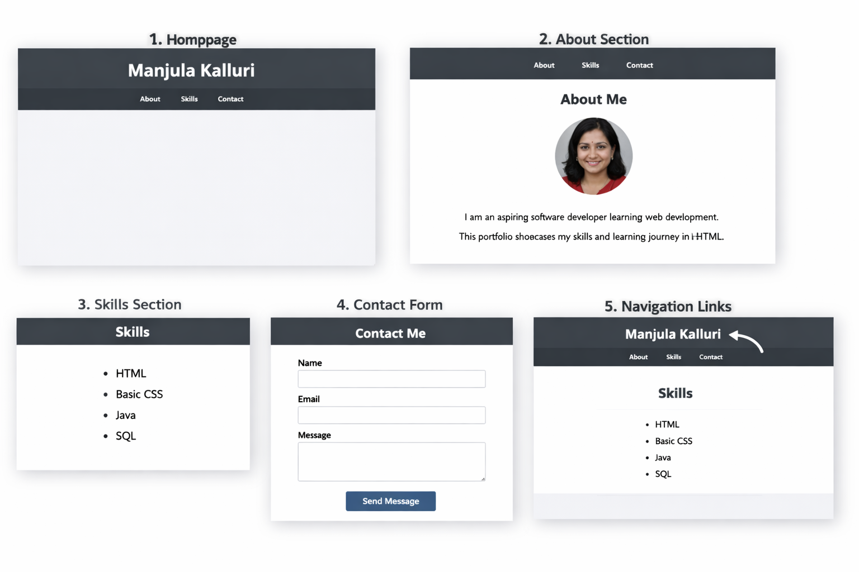

Screenshot 1: Homepage with header and navigation menu.
Screenshot 2: About section displaying personal information.
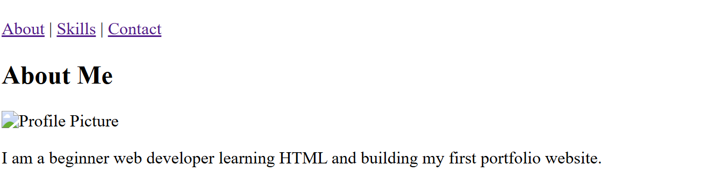
Screenshot 3: Skills section showing list of skills.
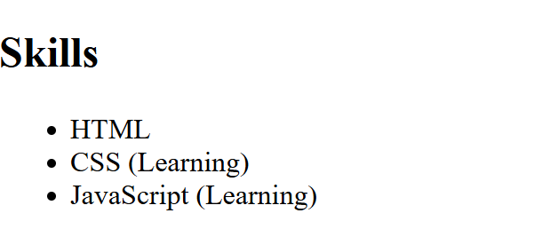
Screenshot 4: Contact form with name, email, and message fields.
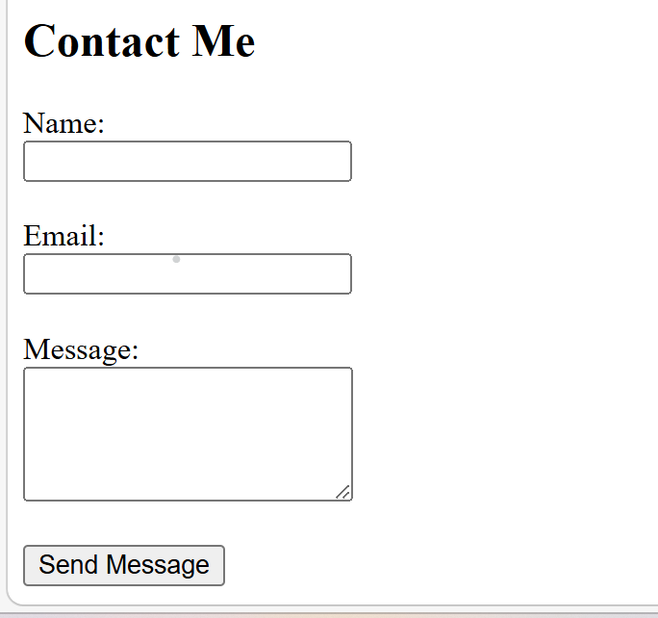

Screenshot 5: Working navigation links between sections.
Navigation link for About information in my first portfolio website.
file:///C:/Users/manju/Downloads/index.html?name=Manjula+Kalluri&email=manjulakalluri21%40gmail.com&message=My+First+Website#about
Navigation link for Skills information in my first portfolio website.
file:///C:/Users/manju/Downloads/index.html?name=Manjula+Kalluri&email=manjulakalluri21%40gmail.com&message=My+First+Website#skills
Navigation link for contact information in my first portfolio website.
file:///C:/Users/manju/Downloads/index.html?name=Manjula+Kalluri&email=manjulakalluri21%40gmail.com&message=My+First+Website#contact
Insert screenshots captured from the browser while running the project.
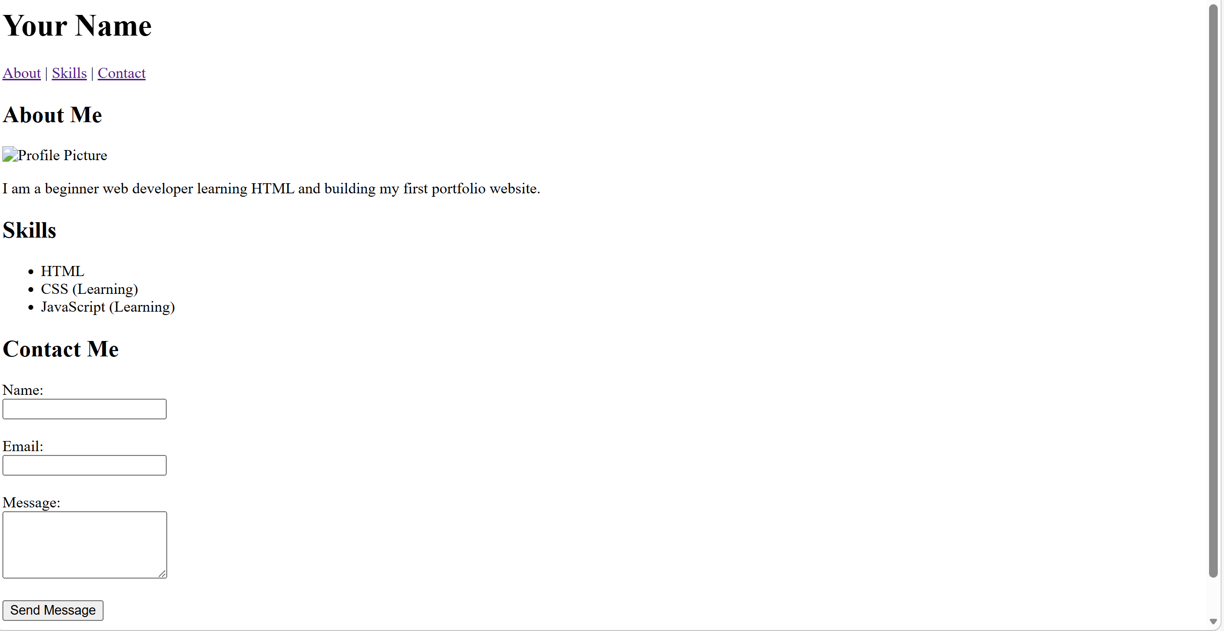

5. Technical Details
Technology Used: HTML5
Key Concepts Implemented:
- HTML document structure (DOCTYPE, html, head, body)
During the development of this portfolio website, several HTML concepts were learned and applied.
HTML Document Structure
Every HTML page begins with a basic structure that includes:
<!DOCTYPE html>
<html>
<head>
<title>Page Title</title>
</head>
<body>
</body>
</html>
This structure defines the webpage and ensures proper rendering in browsers.
HTML Tags and Elements
HTML uses tags to structure webpage content.
Examples include:
- <h1> to <h6> for headings
- <p> for paragraphs
- <a> for hyperlinks
- <img> for images
- <form> for forms
These tags help organize and display information properly.

HTML Attributes
Attributes provide additional information about HTML elements.
Examples used in the project include:
- href for links
- src for images
- alt for alternative image text
- id for linking navigation sections
- required for form validation

- Semantic HTML elements such as header, nav, section, and footer
Semantic HTML
Semantic HTML elements help structure content in a meaningful way.
Examples used in the portfolio:
- <header> – contains the website title and navigation menu
- <nav> – holds navigation links
- <main> – contains the main content of the page
- <section> – divides the webpage into sections
- <footer> – contains copyright information
These elements improve readability and accessibility.
- Internal navigation using anchor links
The portfolio website is designed as a single-page application with multiple sections.
Header
Displays the developer's name and navigation menu.
Navigation
Contains links that allow users to jump to different sections of the page.
Example:
<a href="#about">About</a>
<a href="#skills">Skills</a>
<a href="#contact">Contact</a>
- Forms using input fields, textarea, and button
About Section
Provides a brief introduction about the developer and includes a profile picture.

Skills Section
Lists the developer's technical skills using unordered lists.
Example:
<ul>
<li>HTML</li>
<li>CSS</li>
<li>Java</li>
</ul>

Contact Section
Includes a contact form that allows users to enter:
- Name
- Email
- Message
HTML form validation is implemented using the required attribute.
- Image embedding with alt text
Footer
The footer contains copyright information.
Example:
© 2026 Manjula Kalluri

6. Architecture Explanation
The portfolio website follows a simple single-page architecture where different sections are organized within the same HTML document. Navigation links use anchor tags that point to section IDs, allowing users to jump to different sections without loading a new page.

7. Algorithms and Data Structures
This project primarily focuses on front-end HTML structure and does not use complex algorithms or data structures. However, structured lists (ordered and unordered lists) are used to organize skill information.

8. Testing Evidence
Test Case 1: Page loads correctly in browser.
Test Case 2: Navigation links move to correct sections.
Test Case 3: Images display properly with alt text.
Test Case 4: Contact form accepts user input.
Test Case 5: HTML validation passes using W3C validator.
The following test cases were executed to verify that the portfolio website works correctly and meets the project requirements.

9. Conclusion
The project demonstrates the fundamentals of HTML including page structure, navigation, images, and forms. It provides a foundation for future enhancements using CSS and JavaScript.

