1. Executive Summary
This report analyzes 300,000 transactions and 107,658 user records from the PhonePe digital payments platform to evaluate transaction performance, service-level contribution, and user engagement over the reporting period. The objective is to surface actionable insights that inform product, risk, and growth decisions.
Overall platform health is strong: a 96% transaction success rate, steady month-over-month value throughput, and consistent user acquisition. However, the data also reveals concentration risk in high-value Loan transactions and a persistent, largely unexplained transaction failure category that merits further investigation.
300,000  Total Transactions | ₹3.47B  Total Value Processed | 96.0%  Success Rate | 107,658  Registered Users

2. Objective
The objective of this analysis is to:
- Quantify overall transaction volume, value, and success rate across the platform.
- Compare performance across service categories — Money Transfer, Recharge & Bill Payments, Loans, and Insurance.
- Identify the primary drivers of transaction failure.
- Assess user growth trends and demographic composition.
- Translate these findings into concrete, prioritized recommendations for management.

3. Scope & Data Source
Data Source: Phonepe_Dataset.xlsx (All_Users and All_Transactions tables)
Transaction Records: 300,000, spanning January–December 2024
User Records: 107,658, onboarded from August 2023 through August 2025
Analysis Tools: Power BI (interactive dashboard & DAX measures), Python/pandas (verification & summary statistics)
All figures in this report are computed directly from the raw dataset; none are estimated or extrapolated.

4. Key Insights

4.1 Value is concentrated in Loans, not Money Transfer
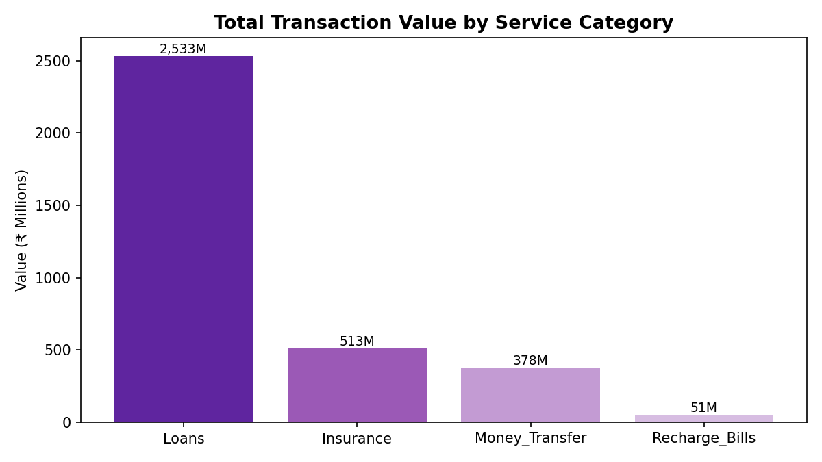
Service | Transactions | Value | % of Value
Loans | 50,000 | ₹2,532.5M | 72.9%
Insurance | 50,000 | ₹512.9M | 14.8%
Money Transfer | 150,000 | ₹378.2M | 10.9%
Recharge & Bills | 50,000 | ₹50.7M | 1.5%

Insight:
Loans represent only ~17% of transaction volume but nearly 73% of total value processed. Money Transfer is the highest-frequency service but contributes the smallest average ticket size. Platform risk and liquidity planning should weight Loans disproportionately relative to their transaction count.

4.2 Lending & investment products dominate the top sub-categories
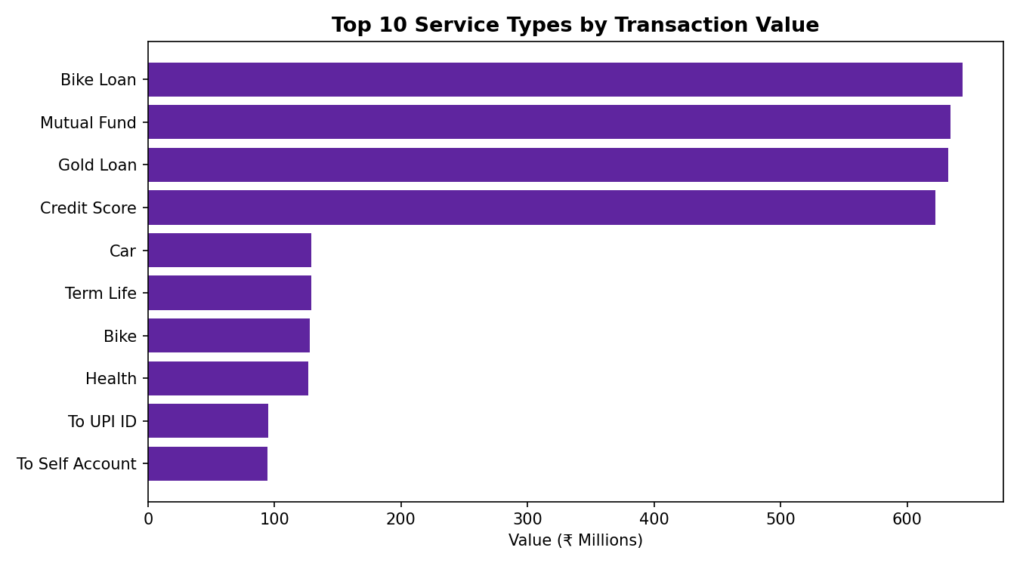
Insight:
Bike Loan, Mutual Fund, Gold Loan, and Credit Score products each exceed ₹600M in value — well ahead of any Recharge or Bill Payment sub-type. This suggests the platform's financial-services vertical (lending, investing) is a more significant value driver than its utility-payment vertical.

4.3 Transaction value is stable, with no strong seasonal trend
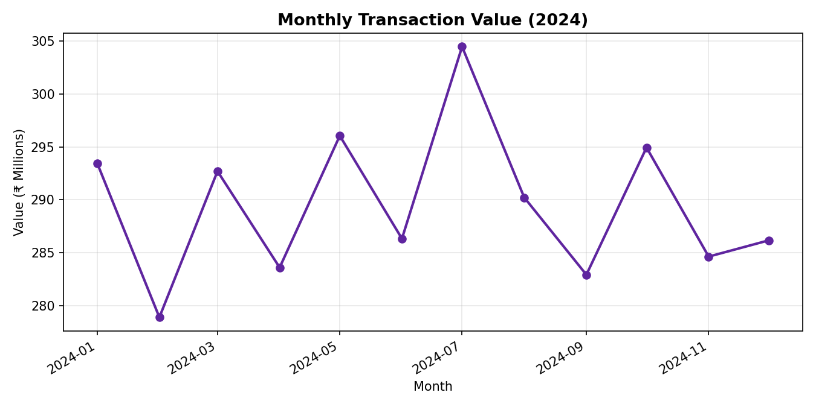
Insight:
Monthly transaction value stayed within a narrow ₹279M–₹305M band throughout 2024, with a mild peak in July. The absence of sharp seasonality suggests demand is driven more by steady utility/lending needs than by festival or promotional cycles — useful context when planning campaigns intended to lift volume.

4.4 96% success rate, but failures lack a clear root cause
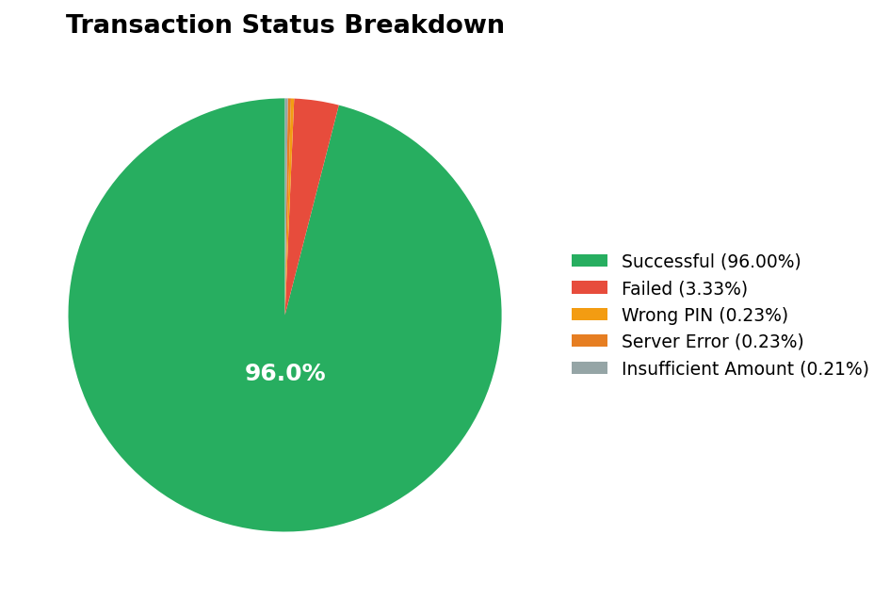
Status | Count | % of Total
Successful | 287,993 | 96.00%
Failed | 9,980 | 3.33%
Wrong PIN | 700 | 0.23%
Server Error | 692 | 0.23%
Insufficient Amount | 635 | 0.21%

Insight:
Of the 4% non-successful transactions, the overwhelming majority (83% of failures) fall under a generic “Failed” status rather than Wrong PIN (user error) or Server Error (platform-side issue). This points toward bank/network-side declines rather than app defects, but the lack of a granular reason code limits root-cause analysis.

4.5 Consistent user acquisition; no single age group dominates
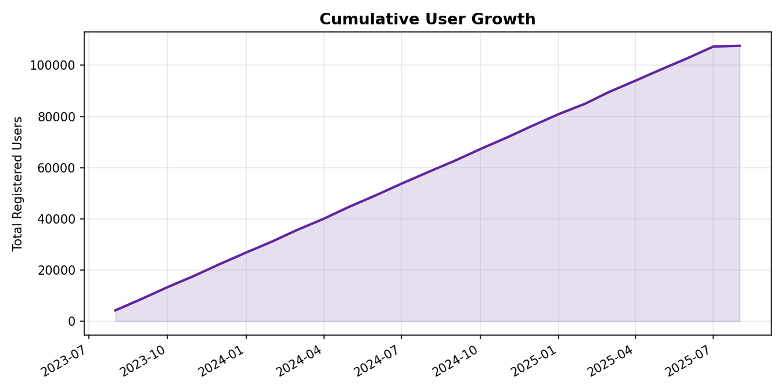
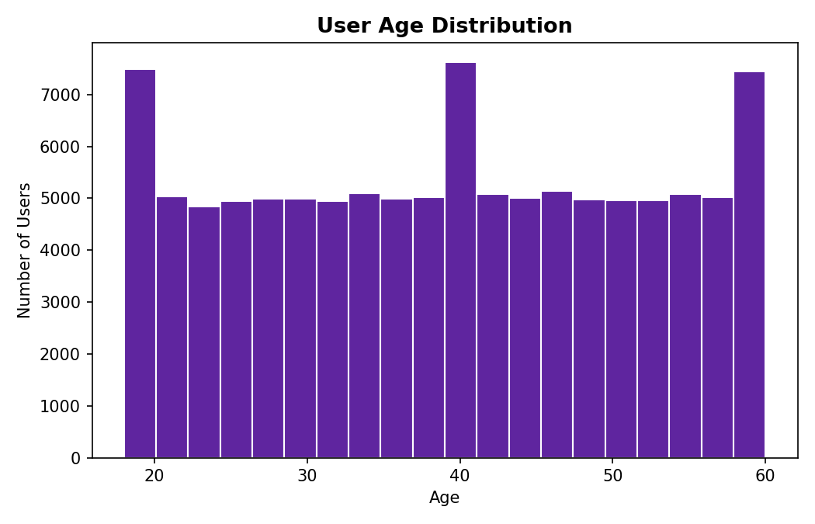
Insight:
The platform has added a steady 4,300–4,700 new users per month since mid-2023, with no visible growth spikes or slowdowns. Users are broadly distributed across the 18–64 age range (average age 39), indicating a mainstream adult user base rather than a niche younger or older segment.

5. Recommendations

5.1 Strengthen monitoring and controls around Loan transactions
Given that Loans drive ~73% of transaction value from just 17% of volume, establish dedicated monitoring, fraud checks, and capital/liquidity forecasting specific to this category rather than relying on platform-wide averages.

5.2 Investigate the root cause of generic “Failed” transactions
Work with payment/banking partners to introduce granular decline-reason codes. Even reducing the unexplained “Failed” bucket by 20–30% (via better diagnostics) could materially improve the realized success rate and reduce user friction.

5.3 Prioritize product investment in lending & investment sub-categories
Bike Loan, Gold Loan, Mutual Fund, and Credit Score products are the highest-value sub-categories. Consider expanding features, credit limits, or partner integrations in these areas, where incremental improvements have outsized value impact.

5.4 Use Money Transfer's high frequency for cross-sell, not standalone growth
Money Transfer generates the most transactions but the least value per transaction. Its high engagement frequency makes it a strong channel for cross-selling Insurance and Loan products rather than a primary revenue lever on its own.

5.5 Maintain current acquisition pace while monitoring retention
User growth is steady but this report does not measure retention or churn. Recommend a follow-up cohort-retention study (see Next Steps) before increasing acquisition spend, to confirm growth is translating into active, transacting users.

6. Next Steps
- Conduct cohort-based retention analysis by user sign-up month.
- Segment failure rates by service type to identify whether Loans/Insurance transactions fail more often than Recharges.
- Introduce a geographic dimension (state/city) once location data is available, to identify regional opportunity or risk concentration.
- Layer in per-user lifetime value (LTV) analysis to complement the platform-level totals in this report.
- Request granular decline-reason codes from payment partners to close the root-cause gap identified in Section 4.4.

7. Conclusion
The PhonePe platform shows healthy overall performance — high success rates, stable transaction throughput, and consistent user growth. The most significant opportunities lie in (1) tightening controls around the high-value Loans category, (2) closing the diagnostic gap on failed transactions, and (3) using cross-sell strategies to convert Money Transfer's high engagement into higher-value product adoption. These recommendations are intended to guide the next planning cycle and are supported by the full interactive Power BI report accompanying this document.

