





A Project Report
On

FETAL MOVEMENT RECOGNITION APPROACHES USING MACHINE LEARNING AND BAYESIAN OPTIMIZATION
Submitted in partial fulfillment for the award of the degree of
Bachelor of Technology in
Electronics and Communications Engineering

by
P U MANJULA 21F61A04B2
SIDDU LIKHITHA 22F65A0411
PALA PRIYA 21F61A04F2
THALARI RAKESH 21F61A04F5 KUNCHAPU PAVAN KUMAR 21F61A04D7
Under the esteemed guidance of
Dr.C.PRIYA, M.E., Ph.D
Professor & Deputy Dean, Department of ECE

Department of Electronics and Communications Engineering

SIDDHARTH INSTITUTE OF ENGINEERING & TECHNOLOGY
(AUTONOMOUS)
(Approved by AICTE & Affiliated to JNTUA, Ananthapuramu) (Accredited by NBA for Civil, EEE, ECE, MECH and CSE, New Delhi)
(Accredited by NAAC with ‘A+’ Grade, an ISO 9001:2008 Certified Institution) Siddharth Nagar, Narayanavanam road, Puttur-517583, A.P
2025







SIDDHARTH INSTITUTE OF ENGINEERING & TECHNOLOGY
(AUTONOMOUS)
(Approved by AICTE & Affiliated to JNTUA, Ananthapuramu) (Accredited by NBA for Civil, EEE, ECE, MECH and CSE, New Delhi)
(Accredited by NAAC with ‘A+’ Grade, an ISO 9001:2008 Certified Institution) Siddharth Nagar, Narayanavanam road, Puttur-517583, A.P

DEPARTMENT OF ELECTRONICS AND COMMUNICATIONS ENGINEERING

CERTIFICATE
This is to certify that the Project entitled “ FETAL MOVEMENT RECOGNITION APPROACHES USING MACHINE LEARNING AND
BAYESIAN OPTIMIZATION ”that is being submitted by
P U MANJULA 21F61A04B2
SIDDU LIKHITHA 22F65A0411
PALA PRIYA 21F61A04F2
THALARI RAKESH 21F61A04F5 KUNCHAPU PAVAN KUMAR 21F61A04D7
is in partial fulfillment of the requirements for the award of BACHELOR OF
TECHNOLOGY in ELECTRONICS AND COMMUNICATIONS
ENGINEERING to JNTUA , ANANTHAPURAMU. The results embodied in this Project report have not been submitted to any other University or Institute for the award of any degree.
Internal Guide Head of the Department Dr.C.PRIYA, M.E., Ph.D., Dr.P.RATNA KAMALA, M.Tech., Ph.D.,
Professor, Deputy Dean( R & D), Head of the Department,
Department of ECE, Department of ECE,
SIETK. SIETK.
Submitted for the project viva-voce examination held on

Internal Examiner External Examiner

Acknowledgement
We wish to express our profound and sincere gratitude to Dr. C. Priya, Professor & Deputy Dean, Research & Development , Siddharth Institute of Engineering & Technology, Puttur, who guided us into the intricacies of this project with utmost clarity.

We would also like to extend our gratitude to Dr. P Ratna Kamala, Head of the Department of Electronics and Communications Engineering for her encouragement and for providing the facilities to carry out the work in a successful manner.
We are thankful to Dr. K. Chandrasekhar Reddy, Principal for his encouragement and support.

We wish to express our sincere thanks to Dr. K. Indira Veni, Vice-Chairman, and Dr. K. Ashok Raju, Chairman of Siddharth Group of Institutions, Puttur, for providing ample facilities to complete the project work.

We would also like to thank all the faculty and staff of the Electronics and Communications Engineering Department, for helping us to complete the project work.

Very importantly, we would like to place on record our profound indebtedness to our parents and families for their substantial moral support and encouragement given throughout our studies.

TABLE OF CONTENTS

CHAPTER NO. | NAME | PAGE NO.
 | ABSTRACT | i
 | LIST OF FIGURES | ii
 | LIST OF TABLES | iii
 | SYMBOLS & ABBREVIATIONS | iv
CHAPTER 1 | INTRODUCTION | 1-3
 | 1.1 Fetal Development & Analysis | 1
 | 1.1.1. Expected Delivery Date Calculation
 | 1.2 Fetal Development Phases | 1-2
 | 1.2.1. First Trimester (Week 1-13):
 | 1.2 2 Second Trimester (Week 14-27):
 | 1.2.3 Third Trimester (Week 28-Birth):
 | 1.3 Imaging Modalities for Fetal Screening | 2-3
 | 1.4 Fetal Echocardiography | 3
 | 1.5 Fetal MRI (Magnetic Resonance Imaging) | 3
CHAPTER 2 | LITERATURE SURVEY | 4-10
CHAPTER 3 | PROPOSED SYSTEM | 11-18
 | 3.1 Module | 12-13
 | 3.1.1 Sensor Data Acquisition Module
 | 3.1.2 Preprocessing Module
 | 3.1.3 Feature Extraction Module
 | 3.2 Classification Module | 13-16
 | 3.2.1 Multi-Layer Perceptron Architecture

 | 3.2.2 MLP Classifier with its Parameters
 | 3.3 Algorithm | 16-18
CHAPTER 4 | HARDWARE DESCRIPTION | 19-23
 | 4.1 Arduino micro controller | 19-20
 | 4.2 Lithium-ion (Li-ion) battery | 20-21
 | 4.3 MPU6050 Module | 21-22
 | 4.3.1 MPU6050 Module configuration | 23
 | 4.4 LCD | 23
CHAPTER 5 | SOFTWARE DESCRIPTION | 24-25
 | 5.1 Python | 24-25
 | 5.1.1Python Application | 25
CHAPTER 6 | APPLICATIONS | 26
CHAPTER 7 | RESULTS & DISCUSSION | 27-40
 | 7.1 Data Set Details | 27
 | 7.2 Confusion Matrix | 27-34
 | 7.2.1 Key components of the confusion
 | 7.2.2 Interpretation
 | 7.3 Summary | 35-41
CHAPTER 8 | CONCLUSION AND FUTURE SCOPE | 42
 | REFERENCES | 43-46
ANNEXURE – A | Source Code | 1-6
ANNEXURE – B | Project Budget | 7-8
ANNEXURE – C | Journal Certifications | 9-14

Focusing on the processing and classification of fetal abdominal movement signals, the study utilizes an advanced machine learning approach to support infant health monitoring. A robust system is developed to accurately identify various types of fetal movements, which can be critical for assessing the well-being of the fetus. To build the dataset, ADXL accelerometer and gyroscope sensors are used to capture detailed abdominal movement data. The collected raw signals undergo preprocessing steps such as noise reduction, normalization, and feature extraction to enhance the quality and relevance of features used for classification.
We utilized a Multi-Layer Perceptron (MLP) classifier, a type of artificial neural network, to model the complex relationships within the preprocessed sensor data. The MLP classifier was trained and validated on the dataset, demonstrating its capability to accurately distinguish between various movement patterns. Our experimental results highlight the effectiveness of the MLP classifier in handling the intricacies of abdominal signal data, providing high classification accuracy and reliability. This work underscores the potential of integrating advanced machine learning techniques with sensor technology for the real- time monitoring of baby movements. Such a system could serve as an essential tool for parents and healthcare providers, offering valuable insights into infant activity and potential health issues.
Keywords: Cardiotocography, Fetal heart rate (FHR), MLP Classifier (Multi Layer Percerptron Classifier).

FIGURE NO. | FIGURE NAME | PAGE NO.
Figure 3.1 | Block Diagram of Proposed System | 11
Figure 3.2 | Implementation of the flow chart | 17
Figure 4.1 | Architecture of Arduino micro controller | 19
Figure 4.2 | Lithium-ion (Li-ion) battery | 20
Figure 4.3  Figure 4.4 | Architecture of MPU6050 Pinout Configuration  LCD Display | 21  23
Figure 7.1 | Acceleration value of X | 30
Figure 7.2 | Acceleration value Y | 30
Figure 7.3 | Acceleration value Z | 30
Figure 7.4 | Gyroscope value of X | 31
Figure 7.5 | Gyroscope value of Y | 31
Figure 7.6 | Gyroscope value of Z | 31
Figure 7.7 | Input signal plot | 32
Figure 7.8 | Training and validation curve | 32
Figure 7.9 | Confusion matrix | 33
Figure 7.10 | Performance analysis | 36
Figure 7.11 | Implementation protype | 37
Figure 7.12 | Thing Speak view | 38

TABLE NO. | TABLE NAME | PAGE NO.
Table 1.1  Table 4.3.1 | Screening Trimesters  MPU6050 Pinout Configuration | 2  22
Table 7.1 | Confusion Matrix | 27
Table 7.2 | Data set visualization | 29
Table 7.3 | Comparison of models | 35
Table 7.4 | Impact of Normalization ICA | 39

ACRONYM | ABBREVIATION
EDD | Expected Delivery Date
LMP | Last Menstrual Period
CNN | Convolutional Neural Networks
CVS | Chorionic Villus Sampling (CVS)
MRI | Magnetic Resonance Imaging
ADXL | Analog Devices' 3-axis accelerometer
MLP | Multi-Layer Perceptron
IDE | Integrated development environment
MEMS | Micro Electro-Mechanical Systems
POA | Period of Amenorrhea
SVM | Support Vector Machine
LSTM | Long Short-Term Memory
GRU | Gated Recurrent Unit
ICA | Independent Component Analysis

CHAPTER-1 INTRODUCTION
Fetal development monitoring plays a critical role in ensuring the health of both the mother and the baby during pregnancy. Regular screenings help track the baby's growth, detect any abnormalities, and estimate important milestones. One of the key factors in monitoring is determining the Expected Delivery Date (EDD), which is usually estimated based on the Last Menstrual Period (LMP). The LMP method assumes a standard 28-day menstrual cycle and calculates the due date as 40 weeks (or approximately 280 days) from the first day of the last period.

Fetal Development & Analysis
Pregnancy is divided into three trimesters, and fetal development progresses through various stages. Each trimester brings significant changes in the baby's growth, organ formation, and overall development. By conducting periodic screenings, healthcare providers can assess whether the baby is developing normally and detect potential complications early.
    - Expected Delivery Date (EDD) Calculation
      - LMP Method: The most commonly used method, based on the first day of the mother’s last menstrual period.
      - Ultrasound Method: If the LMP is unknown, an ultrasound scan (typically done between 8-14 weeks) helps determine the gestational age and estimate the due date more accurately. Regular screenings not only track fetal growth but also help identify congenital disorders, genetic abnormalities, and potential pregnancy risks.

Fetal Development Phases
Fetal development occurs in three key phases, corresponding to the three trimesters of pregnancy:
    - First Trimester (Week 1-13):
      - The zygote (fertilized egg) undergoes rapid cell division and implants into the uterine wall. • By the 4th week, the neural tube (which develops into the brain and spinal cord) begins to form. • The heart starts beating around week 5-6 and can be detected by ultrasound.
      - By the end of week 12, major organs (heart, lungs, liver, kidneys, etc.) have started forming.
      - The embryo transitions into a fetus at the end of the first trimester.

1.2.2 Second Trimester (Week 14-27):
- The fetus grows rapidly, Zand its movements become more noticeable.
- Facial features develop, and the baby can make facial expressions.
- The nervous system matures, allowing better muscle control.
- By week 20, the fetus can hear sounds from the external environment.
- The skin starts developing a waxy coating called vernix caseosa, which protects it from amniotic fluid.
1.2.3 Third Trimester (Week 28-Birth):
- The fetus gains significant weight, and its lungs mature in preparation for breathing.
- The brain develops rapidly, improving reflexes and movement coordination.
- By week 32, the baby starts moving into the head down position for birth.
- By week 37-40, the baby is considered full-term and ready for delivery.
Each trimester is a critical phase, and any developmental delays or abnormalities are carefully monitored using advanced imaging techniques.

Table 1.1 Screening Trimesters

First Trimester | Second Trimester | Third Trimester
To calculate the date of Pregnancy | For Pregnancy Conformation | To investigate  biophysical  profile
To recognize the placental  structures | To access the amniotic fluid  level | To verify the placenta
To find fetal Abnormalities | To access the fetal biometric | To access the position of  placenta
 | To monitor the growth

  - Imaging Modalities for Fetal Screening
Fetal development monitoring relies on various medical imaging techniques to assess growth, detect abnormalities, and ensure the baby is developing healthily. Below are the most commonly used imaging modalities for fetal screening:
- Ultrasound (US)
- The most widely used and non-invasive method for fetal imaging.
- Uses high-frequency sound waves to create real time images of the fetus inside the womb.

- Helps assess fetal growth, organ formation, amniotic fluid levels, and placental health.
- Conducted at multiple stages of pregnancy to monitor fetal well-being.
- Chorionic Villus Sampling (CVS)
- A diagnostic test performed between 10-13 weeks of pregnancy.
- Involves collecting a small sample of placental tissue (chorionic villi) to detect genetic disorders such as Down syndrome and cystic fibrosis.
- Recommended for women with a high risk of genetic conditions.
- Amniocentesis
- Typically performed between 15-20 weeks of pregnancy
- A small amount of amniotic fluid is extracted using a thin needle to analyze chromosomal abnormalities and genetic disorders.
- Can also detect neural tube defects such as spina bifida.
- Generally offered to women over 35 years of age or those with a family history of genetic disorders.

Fetal Echocardiography
- A specialized ultrasound scan of the baby’s heart to detect congenital heart defects.
- Performed if there is a family history of heart disease, abnormal findings in routine ultrasounds, or if the mother has diabetes.

Fetal MRI (Magnetic Resonance Imaging)
- An advanced imaging technique used when ultrasound results are inconclusive.
- Provides detailed images of the fetal brain, spine, and other organs to detect abnormalities like neural tube defects and brain malformations.
- Safe for both mother and baby, as it does not use radiation.

CHAPTER-2 LITERATURE SURVEY
- M. Moutaib, et al 2024 compare the RF-based approach to traditional machine- learning techniques such as Artificial Neural Network, Support Vector Machines, and Recurrent Neural Network. The comparison shows that this method outperforms others in terms of accuracy, robustness, and reliability. The paper meticulously describes the methodology, algorithm implementation, and comparative results. It emphasizes Random Forest's benefits for fetal ECG analysis as well as its future clinical utility. Random Forest has emerged as a promising approach for fetal ECG analysis, with the potential to improve clinical practice and fetal well-being.
- Goel, et al 2024 classified a dataset into three fetal states: normal, suspicious, and pathological. Random forest classifiers achieved an outstanding 98.49% accuracy, followed by gradient boosting classifiers at 97.89%, demonstrating their dependability for precise fetal health classification. Beyond CTG, our research aims to predict fetal health throughout pregnancy, providing valuable support to obstetricians and gynecologists in improving prenatal care, demonstrating efficiency and integrability into automated decision support systems, and promising better maternal and fetal health outcomes.
- B. Jansi, et al 2024 studied the classification accuracy of CTG datasets with all features, without considering classifier computing time. We introduce the Improved Gaussian Grasshopper Optimization Algorithm (IGGOA) and Deep Belief Network (DBN) to Categorize the CTG data. Several factors contribute to the implementation of IGGOA in feature selection: 1) Because of its fragile tail, Gaussian Mutation (GM) is used to create a new offspring that is closer to the original feature. 2) Because grasshoppers have more vital attraction forces, the development of Levy Flight (LF) has made it easier to solve the local optimum. 3) OBL has been used to update the current population, and GOA capability is used to determine the FHR classification. The DBN classifier classifies CTG samples. S. P. Shetty et al [15] 2024's focus on both fetal health classification and birth weight prediction enables this work to use a variety of algorithms—Support Vector Classifier, Random Forest, AdaBoost, and Decision Tree—while seamlessly integrating them via a refined ensemble approach.

This strategic fusion prioritizes precision in categorizing fetal health as "NORMAL," "SUSPECT," or "PATHOLOGICAL," demonstrating steadfast commitment to accurate identification, particularly in critical health conditions. Rigorous evaluation metrics, particularly the macro recall score, highlight the importance of conducting thorough assessments when dealing with the multifaceted nature of preterm birth risks. Simultaneously, the birth weight prediction component uses a combination of AdaBoost and Random Forest regressors, which improves estimation accuracy.
- V. Yerande, et al 2024 suggest an optimized CNN-LSTM deep learning structure for predicting fetal cardiac disease from the abdomen. ECG recording on a 1D time series dataset. The CNN excels at recognizing spatial features, whereas the LSTM excels at learning temporal features. An open-source, non-invasive fetal ECG arrhythmia database is used to obtain multichannel abdominal ECG recordings. Wavelet transforms and median filtering are used to preprocess and filter abdominal signals. CNN, LSTM, and a hybrid CNN LSTM model are used to predict fetal cardiac events. The hybrid CNN LSTM model performed well, with 98% accuracy, 97.2% precision, 98% recall, and 98% F1-score. The proposed hybrid deep learning 1D CNN LSTM architecture outperforms the current state-of-the-art.
- M. F. Ukrit, et al 2024 use machine learning, deep learning, and ensemble techniques to create predictive models for identifying fetal health risks (normal, suspect, or pathological) and predicting visceral fat levels. The most accurate models for each prediction category are identified after extensive experimentation with various machine learning and deep learning methodologies. The significance of this work stems from its potential to improve prenatal care by providing timely assessments of fetal health risks and enabling proactive interventions. Furthermore, predicting visceral fat levels helps with maternal health management, reducing the risk of complications like gestational diabetes and hypertension. Finally, this study presents a comprehensive approach to maternal-fetal health monitoring that promises better outcomes for both mother and child.
- Swain, et al 2024 used a voting ensemble method that included Decision Trees (DT), Support Vector Machines (SVM), and Naïve Bayes (NB) after successfully constructing predictive models, resulting in significant accuracies of 92.28%, 83.89%, and 82.22%. These findings demonstrate the efficacy of these models in predicting

fetal health. 00 The outcomes are based on the comprehensive dataset. To improve model performance, a meticulous GridSearchCV approach thoroughly investigated optimal parameter values within predefined parameter grids, significantly improving predictive capabilities. Additionally, using a bagging method, specifically Random Forest (RF), Logistic Regression (LR), and Gradient Boosting, improved predictive accuracy. These bagging models achieved exceptional accuracy of 94.02%, 93.22%, and 92.28%. The systematic approach that included clustering, dimensionality reduction, ensemble learning, and parameter optimization resulted in highly accurate predictive models.
- S. K. Sunori, et al 2024 focusing on the designing and comparison of classification models to assess the heart health of humans. Two different techniques are explored. The first one is a simple competitive neural network based on unsupervised learning, while the second is a supervised neural network based on SCG (Scaled Conjugate Gradient) algorithm. The primary objective of this research work is to compare the accuracy of these two developed models in assessment of health of human heart. All simulations have been conducted in MATLAB.
- R. Nagavibha, et al 2024 focuses on developing a machine learning-driven system for accurate fetal health classification. The dataset comprises detailed information on the signs and symptoms of pregnant individuals, particularly those at risk or with emerging fetal health issues. Employing a set of ten machine learning models namely Naïve Bayes, Logistic Regression, Decision Tree, Random Forest, KNN, SVM, Gradient Boosting, Linear Discriminant Analysis, Quadratic Discriminant Analysis Light Gradient Boosting Machine (LGBM) along with ensemble-based processes, the Light Gradient Boosting Machine (LGBM) has been identified as a standout performer, accomplishing an accuracy of 96.9%. Furthermore, our exploration demonstrates overall performance like character fashions, signaling promising prospects for sturdy and correct fetal fitness class systems. This study highlights the power of machine learning that could revolutionize prenatal care by identifying fetal health problems early.
- M. F. Sefidi, et al 2024 an optimized SVM classification method is proposed, which was used to classify UCI fetal health data. The optimization process

was based on the genetic algorithm and the FDR relationship, in which the importance of all the features was obtained in the form of coefficients. By applying these coefficients to the feature vector of the data set, the separation of data into different classes is improved. First, the support vector machine (SVM) algorithm was used without optimization for data classification, and the correct classification rate (CCR) was 88.28. Then, by normalizing, whitening and removing outlier data in the pre- processing stage, the accuracy increased to 90.30. By applying the feature value coefficients to the input of the class band model with the aim of optimizing the feature vector, the classification accuracy increased to 93.98.
- Y. Salini, et al 2024 addresses the imperative for advanced fetal health classification through the application of machine learning (ML) techniques. The objective is to explore, develop, and analyze ML models capable of accurately classifying fetal health based on CTG data. The overarching goal is to enhance diagnostic precision and facilitate timely interventions. Utilizing a freely available cardiotocography data set, despite its relatively small size, the research acknowledges its rich characteristics. Various ML models, including Random Forests, Logistic Regression, Decision Trees, Support Vector Classifiers, Voting Classes, and K- Nearest Neighbors, are deployed on the data set. The analysis involves rigorous training and testing of these models to assess their efficacy in classifying fetal health. The study yields promising outcomes, with the implemented ML models achieving a notable accuracy level of 93%, surpassing previous methods. This underscores the effectiveness of the proposed models in elevating the precision of fetal health classification based on CTG data. The findings advocate for the integration of ML models into routine clinical practices, streamlining fetal health assessments. The study not only underscores the significance of early complication detection but also demonstrates the potential of ML in optimizing medical resource allocation and time efficiency. Further research is warranted to refine and expand ML applications in the context of fetal health assessment, promising advancements in prenatal care.
- Reddy, et al 2023 improve the Fetal Health Prediction using the XGB Classifier and in comparison, with K- Nearest Neighbor. Prenatal diagnostics, which includes screening and diagnostic testing, can give important details about the fetus's health and help people comprehend the risk. This study aims to offer clinicians and

expectant mothers convenient services by gathering secondary data from diverse sources. In this study, a total of 3200 data points was utilized for our research purposes. Out of these, 2560 data points were allocated for training, while the remaining 640 data points were set aside for testing. The entire process was iterated 10 times for robustness. The study involved two distinct groups, with each group consisting of 10 samples. The K-Nearest Neighbor (KNN) Algorithm was categorized under Group 2, while the XGB Classifier Algorithm was assigned to Group 1. The statistical power of our analysis was set at 80%. The XGB Classifier Algorithm demonstrated a notably higher accuracy rate of 95.96% compared to the KNN Algorithm, which achieved an accuracy of 87.74%. The calculated significance value was 0.001 (p < 0.05), indicating that there is a statistically significant difference between the two algorithms considered for the development of the Novel Fetal Health Prediction System. In conclusion, our findings highlight that the XGB Classifier Algorithm outperforms the K-Nearest Neighbor Algorithm with an impressive accuracy rate of 95.96%, which is significantly higher than the 87.74% accuracy achieved by the latter. This underscores the potential superiority of the XGB Classifier Algorithm for the task at hand in the context of fetal health prediction.
- T. Gaddam, et al 2023 presents a novel approach to fetal health classification using machine learning models. Three classes—Normal, Suspect, and Pathological— are created by selecting pertinent features from the Cardiotocography (CTG) dataset. Predictive models are created using machine learning (ML) techniques, such as XGBoost, Voting Classifier, Random Forest (RF), Decision Tree (DT), Support Vector Machine (SVM), and Logistic Regression (LR). XGBoost model has performed well and attained an accuracy-94%. RF model gave the highest precision and recall for classifying normal and suspect classes. Furthermore, this work also uses Explainable AI (XAI) tool called SHAP (Shapley Additive explanations) to know/interpret how RF model produces the outcome for test data. ML embedded with XAI supports healthcare providers to trust the model as well as timely intervention of doctors leads to better pregnancy outcomes and maternal-infant health.
- K. S. Gill, et al 2023 suggested a deep learning-based method for detecting fetal brain abnormalities from ultrasound images. Leveraging the power of convolutional neural networks (CNNs), the selected pre-trained CNN models are

extended with 100 additional layers and fine- tuned to enhance their performance for fetal brain anomaly classification. Transfer learning model such as MobileNetV2 with 88 layers, VGG16 with 16 layers, ResNet50 with 50 layers and InceptionV3 with 159 layers are trained using a combination of two publicly accessible datasets comprising ultrasound images of fetal brains. The results demonstrate that us approach, particularly employing the MobileNetV2 architecture, achieves a remarkable classification accuracy of 90% for fetal brain disorders, surpassing VGG16, ResNet50, and InceptionV3.This encouraging result highlights the utilization of deep learning in early identification and treatment, improving the long-term prognosis of infants with fetal brain abnormalities and thus enhancing prenatal care.
- F. Francis, et al 2023 proposed using Apgar scores as the surrogate benchmark of babies' ability to recover from birth. Apgar scores measure newborns' ability to recover from active uterine contraction, which measures appearance, pulse, grimace, activity and respiration. The higher the Apgar score, the healthier the baby is, we employ signal processing methods to pre-process and extract validated features of
552 raw CTG. We also included CTG-specific characteristics as outlined in the NICE guidelines. We employed ML techniques using 22 features and measured performances between ML classifiers. While we found that ML can distinguish CTG with low Apgar scores, results for the lowest Apgar scores, which are rare in the dataset we used, would benefit from more CTG data for better performance. We need an external dataset to validate our model for generalizability to ensure that it does not overfit a specific population. Clinical Relevance— This study demonstrated the potential of using a clinically relevant benchmark for classifying CTG to allow automatic early detection of hypoxia to reduce decision-making time in maternity units.
- T. Ouypornkochagorn, et al 2023 an acoustic device was proposed for detecting fetal movement. The device’s dish was large, i.e., 31 mm, and therefore, a single device was sufficient for detection. Power spectral density (PSD) was used for creating the spectrogram of the moving signal. Four classifiers were used to identify fetal and non- fetal movements. The experiment was conducted on 12 pregnant women at their homes or workplaces, where body movement was allowed. The device was attached to the abdomen and recorded using a smartphone connected via Bluetooth.

The total recorded time was 50.5 h. The signal amplitude of the fetal movement was
8.5 dB higher than that of the nonfetal movement. The detectivity of the device was 67.2%–75.2%. Lower detectivity was observed in subjects with small and very large abdominal circumferences. Gestation showed a negative correlation with maternal perception but no correlation with the device’s detection rate. The convolutional neural network classifier exhibited the highest performance, with a F1 -score of 95.2% and an accuracy of 94.9%.

CHAPTER-3 PROPOSED METHOD
The proposed system aims to provide a comprehensive solution for monitoring infant movements through the integration of sensor technology and advanced machine learning algorithms. Central to this system is the use of an ADXL accelerometer and gyroscope sensors, which are strategically positioned to capture detailed abdominal movements of the infant. The sensor data is then subjected to a rigorous preprocessing pipeline, including noise reduction techniques to eliminate irrelevant signals, normalization to ensure consistency across data samples, and feature extraction to identify key movement patterns.

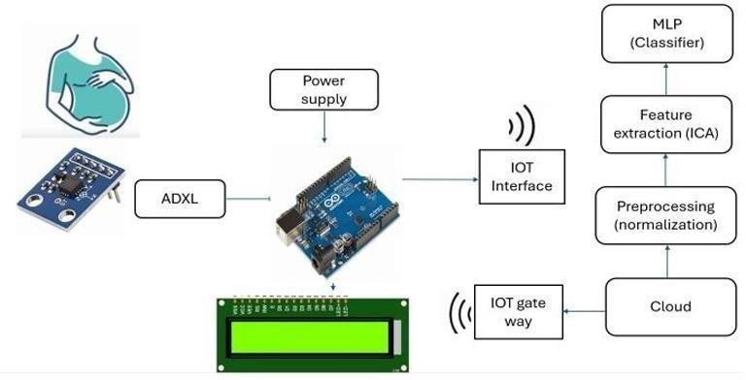

Figure 3.1 Block Diagram of Proposed System

These steps are crucial for enhancing the quality and relevance of the data, ensuring that the subsequent classification process is both accurate and reliable. For the classification of the processed data, the system employs a Multi-Layer Perceptron (MLP) classifier, a robust type of artificial neural network known for its ability to model complex, non-linear relationships within data. The MLP is meticulously trained and validated on the preprocessed dataset, allowing it to distinguish between various infant movement patterns with high

precision. The effectiveness of the MLP classifier is demonstrated through its high classification accuracy, making it a reliable tool for real-time monitoring.
This system has significant potential applications, particularly in providing continuous, non-invasive monitoring of infant activity. By accurately classifying different movement types, it can offer valuable insights into the infant's health and well-being, enabling early detection of potential issues. This capability is especially useful for parents and healthcare providers, who can use the system as a proactive tool for ensuring infant safety and addressing health concerns promptly.

Module

Sensor Data Acquisition Module
The Sensor Data Acquisition Module is the foundational component of the system, responsible for collecting real-time data from the infant's movements. This module utilizes an ADXL accelerometer and gyroscope sensors, which are strategically placed to capture the dynamic movements of the infant's abdomen. The accelerometer measures the linear acceleration of the abdomen in multiple axes, while the gyroscope records the angular velocity, providing a comprehensive dataset that reflects the infant's activity. The sensors are designed to be sensitive enough to detect even the slightest movements, ensuring that the data collected is detailed and accurate. This raw data serves as the primary input for the subsequent modules, making this module critical for the overall functionality of the system.

Preprocessing Module
The Preprocessing Module is essential for preparing the raw sensor data for the classification model. Initially, noise reduction is applied to remove irrelevant or extraneous signals from the sensor data, preventing distortions during analysis. In proposed work, this preprocessing begins with loading the sensor data from a CSV file, followed by the separation of features (e.g., Ax, Ay, Az, Gx, Gy, Gz) and labels.
A crucial preprocessing step is normalization, which ensures that all features are scaled to a common range without distorting their original relationships. This is achieved using StandardScaler from the sklearn library. Standardizing the data before further analysis

ensures that features like acceleration and gyroscope readings, which may be on different scales, are treated uniformly. The scaled data ensures consistency during feature extraction and improves the model's ability to converge during training. Additionally, the data is split into training and testing sets to facilitate both model training and evaluation.

Feature Extraction Module

The Feature Extraction Module extracts the most relevant and informative features from the preprocessed data. Here, Independent Component Analysis (ICA) is employed for feature extraction. ICA is a technique used to separate a multivariate signal into additive, independent non-Gaussian signals. This allows the system to uncover latent structures within the sensor data that may correspond to specific infant movements. In the proposed work, the data is reduced to 3 independent components using the Fast ICA algorithm. These components represent key features that encapsulate critical movement patterns from the original sensor readings. This dimensionality reduction not only improves the efficiency of the classification algorithm but also helps in removing potential multicollinearity and noise that may not contribute to movement classification.

Classification Module
The Classification Module is the core analytical engine of the system, responsible for categorizing the extracted features into predefined classes of infant movements. This module employs a Multi-Layer Perceptron (MLP) classifier, an advanced type of artificial neural network known for its ability to model complex relationships within data. The MLP classifier consists of multiple layers of neurons, each layer processing the input data and passing it on to the next layer. During the training phase, the classifier learns the intricate patterns associated with each movement type, adjusting its weights and biases to minimize the classification error. Once trained, the MLP is capable of accurately classifying new, unseen data, making it a powerful tool for real-time monitoring of infant movements.

Multi-Layer Perceptron Architecture
MLP (Multi-Layer Perceptron) is a type of neural network with an architecture consisting of input, hidden, and output layers of interconnected neurons. It is capable of

learning complex patterns and performing tasks such as classification and regression by adjusting its parameters through training. Let’s explore the architecture of an MLP in detail:
      - INPUT LAYER: The input layer is where the MLP and dataset first engage with one another. A feature in the incoming data is matched to each neuron in this layer. For instance, each neuron might represent the intensity value of a pixel in picture categorization. These unprocessed input values are to be distributed to the neurons in the next hidden layers by the input layer.
      - HIDDEN LAYERS: MLPs have a hidden layer or layers that are present between the input and output layers. The main computations happen at these layers. Every neuron in a hidden layer analyzes the data that comes from the neurons in the layer above it. In the same buried layer, neurons do not interact directly with one another but rather indirectly via weighted connections. The hidden layer transformation allows the network to learn intricate links and representations in the data. The intricacy of the task might affect the depth (number of hidden layers) and width (number of neurons in each layer).
      - OUTPUT LAYER: The MLP’s neurons in the output layer, the last layer, generate the model’s predictions. The structure of this layer is determined by the particular task at hand. The probability score for binary classification may be generated by a single neuron with a sigmoid activation function. Multiple neurons, often with SoftMax activation, can give probabilities to each class in a multi-class classification system. When doing regression tasks, the output layer frequently just has a single neuron that can forecast a continuous value.
Each neuron applies an activation function to the weighted total of its inputs, whether it is in the input, hidden, or output layer. The sigmoid, hyperbolic tangent (tanh), and rectified linear unit (ReLU) are often used activation functions. The MLP modifies connection (synapse) weights during training using backpropagation and optimization methods like gradient descent. In order to reduce the discrepancy between projected and actual outputs, this method aids the network in learning and fine-tuning its parameters. MLPs are appropriate for a variety of machine learning and deep learning problems, from straightforward to extremely complicated, due to their flexibility in terms of the number of hidden layers, neurons per layer, and choice of activation functions.

MLP Classifier With Its Parameters
The MLP Classifier, short for Multi-Layer Perceptron Classifier, is a neural network- based classification algorithm provided by the Scikit-Learn library. It’s a type of feedforward neural network, where information moves in only one direction: forward through the layers. Here’s a detailed explanation of the MLP Classifier and its parameters, which in return collectively define the architecture and behavior of the MLP Classifier:
HIDDEN LAYER SIZES [PARAMETER: HIDDEN_LAYER_SIZES]: An MLP neural
network’s hidden_layer_sizes parameter is a crucial structural element. It describes how the network’s hidden layers are structured. Each element of the tuple that this parameter accepts represents the number of neurons in a certain hidden layer. The network contains two hidden layers, with the first having 64 neurons and the second having 32 neurons, for
instance, if hidden_layer_sizes is set to (64, 32). The network’s ability to recognize complex patterns and correlations in the data is greatly influenced by the choice of the number of neurons and hidden layers. In order to model complex data, deeper networks with more neurons may be more susceptible to overfitting.

ACTIVATION FUNCTION [PARAMETER: ACTIVATION]: Each neuron in the MLP’s
hidden layers is activated using a different activation function, which is determined by the activation parameter. The network can model intricate input- to-output mappings thanks to the non-linearity introduced by activation functions. There are numerous activation functions, each with their own special qualities. One well-liked option is “relu” (Rectified Linear Unit), which is both computationally effective and successful in reducing the vanishing gradient problem. Both “tanh” (Hyperbolic Tangent) and “logistic” (Logistic Sigmoid) are frequently used and have various uses.

SOLVER FOR WEIGHT OPTIMIZATION [PARAMETER: SOLVER]: The neural
network’s weights are updated during training using an optimization technique, which is determined by the solver parameter. To reduce the loss function of the network, several solvers use various methods. The “adam” algorithm, which combines ideas from RMSprop and Momentum, works well with large datasets and intricate models. The limited-memory Broyden- Fletcher- Goldfarb-Shanno optimization algorithm is used by “lbfgs,” which is best

for smaller datasets. The stochastic gradient descent algorithm, known as “sgd,” adjusts weights based on random selections (mini- batches) of the training data at each iteration.
LEARNING RATE [PARAMETER: LEARNING_RATE]: Each training iteration’s weight updates are controlled by the learning rate parameter. It is essential in establishing the training process’s stability and rate of convergence. The learning rate might be “constant,” “in scaling,” or “adaptive,” which can all have an impact on how it changes over time. It is crucial to choose the right learning rate since an extremely high rate might cause divergence or slow convergence, while a rate that is too low can cause very slow convergence.
MAXIMUM ITERATIONS [PARAMETER: MAX_ITER]: The mix_iter parameter restricts how many iterations can be made before the solver converges during training. Convergence is the condition at which further iterations of the network’s weights do not appreciably lower the loss. The solution quits and returns the current findings, which might not be ideal, if it cannot converge within the predetermined limit. When max_iter is chosen appropriately, the training process is neither abruptly stopped nor overly prolonged, allowing the model to converge to the desired level.

  - Algorithm

- Start
The system initializes and prepares for data collection. The necessary hardware components, including ADXL accelerometer and gyroscope sensors, are activated. The system verifies connectivity to ensure seamless data transmission.
- Data Collection
Sensors are placed on the abdomen to record fetal movements. Accelerometer data records linear movements, while gyroscope data captures angular velocity. The system continuously logs raw movement data for further processing.
- Preprocessing Noise Reduction:
Unwanted disturbances in the signals, such as maternal movements and environmental noise, are filtered out using bandpass filters and adaptive noise cancellation techniques.

Normalization: Data is normalized using min-max scaling to ensure uniformity across different samples and subjects. Feature Extraction: Independent Component Analysis (ICA) is applied to separate meaningful fetal movement patterns from irrelevant signals.
- Feature Extraction
The system extracts key motion-based features, including: Mean and variance of acceleration and angular velocity. Time-domain features such as movement duration and frequency. Frequency-domain features obtained via spectral analysis to assess periodic movements. These features serve as critical inputs for the classification model.
- Classification using Multi-Layer Perceptron (MLP) Classifier:
The extracted features are fed into a Multi-Layer Perceptron (MLP) classifier, which comprises:
Input Layer: Accepts the sensor features as input. Hidden Layers: Processes the movement patterns and learns meaningful representations. Output Layer: Classifies fetal movement as normal or abnormal. The model is trained using labelled datasets to ensure high accuracy in classification.

Implementation:

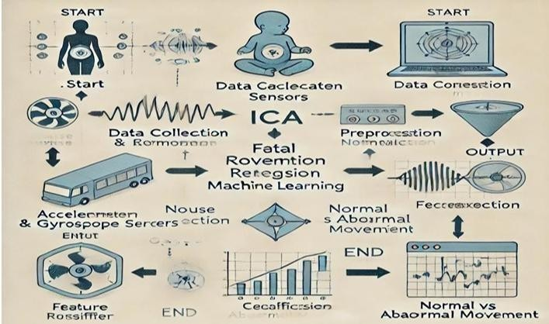

Figure 3.2 Implementation of the flow chart

- Decision Making:
Based on the classification output: If the movement is normal → The system continues real- time monitoring. If abnormal movement is detected → The system triggers an alert for immediate attention. Alerts can be sent to healthcare providers via mobile notifications, email alerts, or IoT-based dashboards.
- Output Display and Monitoring:
The system updates the real-time fetal movement status on a monitoring interface

CHAPTER-4 HARDWARE SPECIFICATION

Arduino Micro controller

Arduino is an open-source computer hardware and software company, project and user community that designs and manufactures microcontroller-based kits for building digital devices and interactive objects that can sense and control objects in the physical world.

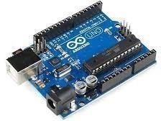

Figure 4.1 Architecture of Arduino micro controller

The project is based on microcontroller board designs, manufactured by several vendors, using various microcontrollers. These systems provide sets of digital and analog I/O pins that can be interfaced to various expansion boards ("shields") and other circuits. The boards feature serial communications interfaces, including USB on some models, for loading programs from personal computers. For programming the microcontrollers, the Arduino project provides an integrated development environment (IDE) based on the Processing project, which includes support for the C and C++ programming languages.
The first Arduino was introduced in 2005, aiming to provide an inexpensive and easy way for novices and professionals to create devices that interact with their environment using sensors and actuators. Common examples of such devices intended for beginner hobbyists include simple robots, thermostats, and motion detectors.

Arduino boards are available commercially in preassembled form, or as do-it-yourself kits. The hardware design specifications are openly available, allowing the Arduino boards to be manufactured by anyone. Adafruit Industries estimated in mid-2011 that over 300,000 official Arduinos had been commercially produced, and in 2013 that 700,000 official boards were in users' hands.

Lithium-ion (Li-ion) battery

A lithium-ion (Li-ion) battery is an advanced battery technology that uses lithium ions as a key component of its electrochemistry. During a discharge cycle, lithium atoms in the anode are ionized and separated from their electrons. The lithium ions move from the anode and pass through the electrolyte until they reach the cathode, where they recombine with their electrons and electrically neutralize. The lithium ions are small enough to be able to move through a micro-permeable separator between the anode and cathode. In part because of lithium’s small size (third only to hydrogen and helium), Li-ion batteries are capable of having a very high voltage and charge storage per unit mass and unit volume.
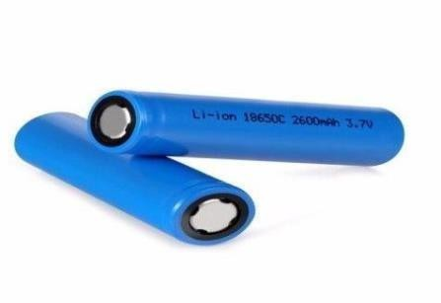

Figure 4.2 Lithium-ion (Li-ion) battery

Li-ion batteries can use a number of different materials as electrodes. The most common combination is that of lithium cobalt oxide (cathode) and graphite (anode), which is most commonly found in portable electronic devices such as cellphones and laptops. Other cathode materials include lithium manganese oxide (used in hybrid electric and electric automobiles) and lithium iron phosphate. Li-ion batteries typically use ether (a class of organic compounds) as an electrolyte. Compared to the other high-quality rechargeable battery technologies (nickel- cadmium or nickel-metal-hydride), Li-ion batteries have a number of advantages. They have one of the highest energy densities of any battery

technology today (100-265 Wh/kg or 250-670 Wh/L). In addition, Li-ion battery cells can deliver up to 3.6 Volts, 3 times higher than technologies such as Ni-Cd or Ni-MH. This means that they can deliver large amounts of current for high-power applications, which has Li-ion batteries are also comparatively low maintenance, and do not require scheduled cycling to maintain their battery life. Li-ion batteries have no memory effect, a detrimental process where repeated partial discharge/charge cycles can cause a battery to ‘remember’ a lower capacity. This is an advantage over both Ni-Cd and Ni-MH, which display this effect. Li-ion batteries also have low self-discharge rate of around 1.5-2% per month. They do not contain toxic cadmium, which makes them easier to dispose of than Ni-Cd batteries.
Due to these advantages, Li-ion batteries have displaced Ni-Cd batteries as the market leader in portable electronic devices (such as smartphones and laptops). Li-ion batteries are also used to power electrical systems for some aerospace applications, notable in the new and more environmentally friendly Boeing 787, where weight is a significant cost factor. From a clean energy perspective, much of the promise of Li-ion technology comes from their potential applications in battery-powered cars. Currently, the bestselling electric cars, the Nissan Leaf and the Tesla Model S, both use Li-ion batteries as their primary fuel source.

MPU6050 Accelerometer and Gyroscope Module

The MPU6050 module is a Micro Electro-Mechanical Systems (MEMS) which consists of a 3-axis Accelerometer and 3-axis Gyroscope inside it. This helps us to measure acceleration, velocity, orientation, displacement and many other motions related parameter of a system or object.
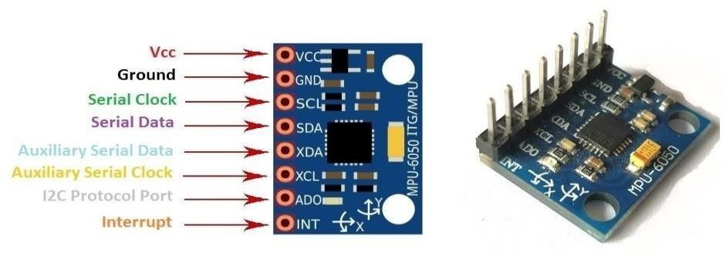

Figure 4.3 Architecture of MPU6050 Pinout Configuration

Table 4.3.1: MPU6050 Pinout Configuration

Pin Number | Pin Name | Description
1 | Vcc | Provides power for the module, can be  +3V to +5V. Typically +5V is used
2 | Ground | Connected to Ground of system
3 | Serial Clock (SCL) | Used for providing clock pulse for I2C Communication
4 | Serial Data (SDA) | Used for transferring Data through I2C communication
5 | Auxiliary Serial Data (XDA) | Can be used to interface other I2C modules with MPU6050. It is optional
6 | Auxiliary Serial Clock (XCL) | Can be used to interface other I2C modules with MPU6050. It is optional
7 | AD0 | If more than one MPU6050 is used a single MCU, then this pin can be used to vary the address
8 | Interrupt (INT) | Interrupt pin to indicate that data is available for MCU to read.

LCD Display

Can be integrated with an LCD screen or mobile app. Alerts caregivers and healthcare providers in case of abnormal fetal movements.
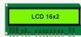

Figure 4.4 LCD Display

Wireless Communication Module (Bluetooth/Wi-Fi)

Enables real-time data transmission to a monitoring device. Facilitates remote fetal movement analysis and alerts.

CHAPTER-5 SOFTWARE SPECIFICATION

SOFTWARE REQUIRED:

    - IDLE 1.7
    - PYTHON 1.7.6

HARDWARE REQUIRED:

    - System : Windows Xp Professional Service Pack 2
    - Processor : Up to 1.5 GHz
    - Memory : Up to 512 MB RAM

Python
The Python language had a humble beginning in the late 1980s when a Dutchman Guido Von Rossum started working on a fun project, which would be a successor to ABC language with better exception handling and capability to interface with OS Amoeba at Centrum Wiskunde and Informatica. It first appeared in 1991. Python 2.0 was released in the year 2000 and Python 3.0 was released in the year 2008. The language was named Python after the famous British television comedy show Monty Python's Flying Circus, which was one of Guido's favorite television programs. Here we will see why Python has suddenly influenced our lives and the various applications that use Python and its implementations.
Some key features of the language are:

- Python programs can run on any platform, you can carry code created in Windows machine and run it on Mac or Linux.
- Python has inbuilt large library with prebuilt and portable functionality, also known as the standard library.
- Python is an expressive language.
- Python is free and open source.
- Python code is about one third of the size of equivalent C++ and Java code.

- Python can be both dynamically and strongly typed--dynamically typed means it is a type of variable that is interpreted at runtime, which means, in Python, there is no need to define the type (int or float) of the variable.

Python Application
One of the most famous platforms where Python is extensively used is YouTube. The other places where you will find Python being extensively used are the special effects in Hollywood movies, drug evolution and discovery, traffic control systems, ERP systems, cloud hosting, e- commerce platform, CRM systems, and whatever field you can think of.

Version

At the time of writing this book, two main versions of the Python programming language were available in the market, which are Python
2.x and Python 3.x. The stable release as of writing the book were Python

2.7.13 and Python 3.6.0.

Implementation of Python
Major implementations include CPython, Jython, Iron Python, MicroPython, and PyPy.

CHAPTER – 6 APPLICATIONS

Fetal MRI proves invaluable in situations that demand a deeper understanding of fetal health:
- Complex Anomalies: When traditional ultrasound detects intricate abnormalities that require further exploration, fetal MRI is employed for comprehensive assessment.
- Nervous System Evaluation: Fetal MRI excels in capturing detailed images of the brain and spinal cord, assisting in the detection of potential neurological issues.
- In-Depth Organ Examination: For cases involving suspected anatomical deviations or abnormalities, fetal MRI provides precise and detailed insights into the condition of internal organs

CHAPTER-7 RESULTS AND DISCUSSION
  - DATA SET DETAILS
The dataset contains tri-axial accelerometer and tri-axial gyroscope readings from the four IMUs and labels. There are three sub-datasets, which have different ground-truth labelling configurations, included in this dataset. Please note that the labelling is subjective to the mother's perception. The dataset, as a whole, contains recordings spanning 14 weeks from 26th week to 39th week and in total, about 71 hours of recordings.
The three sub-datasets included are: Sub-dataset One: In this sub-dataset, only the occurrence of the particular type of fetal movement known as the fetal kick is considered for ground-truth labelling. Sub-dataset Two: All types of fetal movement felt by the mother -- including trunk movement, isolated limb movement, and general body movement -- were considered for ground truth- labelling as fetal movements in this sub-dataset.
Sub-dataset Three: In this sub-dataset, the emphasis was given to the classification of different types of fetal movements. Three types of fetal movements are labelled: trunk movement, isolated limb movement, and general body movement. Additional data are provided in three additional 'csv' files, which contains the record number, the Period of Amenorrhea (POA), start time, and end time of each recording. Also, additional details about the mother and the baby are provided in the README file.
  - CONFUSION MATRIX
Confusion Matrix as the name suggests gives us a matrix as output and describes the complete performance of the model.

Table 7.1: Confusion Matrix
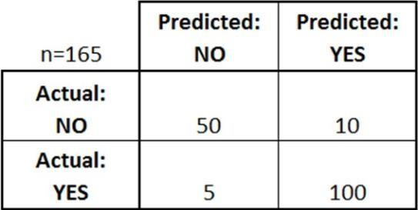

There are 4 important terms:
- True Positives: The cases in which we predicted YES and the actual output was also YES.
- True Negatives: The cases in which we predicted NO and the actual output was NO.
- False Positives: The cases in which we predicted YES and the actual output was NO.
- False Negatives: The cases in which we predicted NO and the actual output was YES.
Accuracy for the matrix can be calculated by taking average of the values lying across the “main diagonal” i.e.

Confusion Matrix forms the basis for the other types of metrics.
The proposed model is compared to other models in terms of Accuracy, Specificity, Recall and Precision rate measurements. These measurements can be defined as:
Accuracy = (TP + TN) / (TP + TN+FP +FN)

Specificity = (TN) / (TN + FP) Recall = (TP) / (TP + FN) Precision=TP/(TP+FP) Where,
FP is the False Positive FN is the False Negative TP is the True Positive TN is the True Negative

Table 7.2: Data set visualization
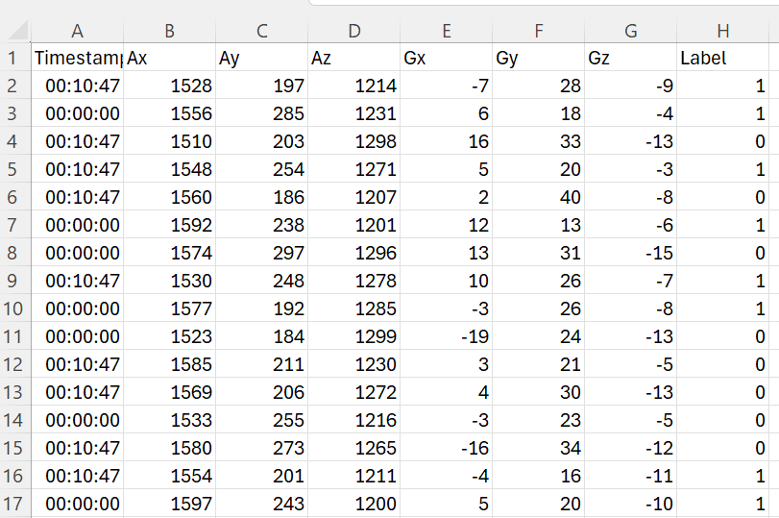

The above figure shows the input image for classification. The columns are labeled as follows:
- TIMESTAMP: Likely represents the time at which each event or measurement occurred.
- AX, AY, AZ: These might be acceleration values in the x, y, and z directions, possibly measured by an accelerometer.
- GX, GY, GZ: These could be gyroscope values representing rotational velocity around the x, y, and z axes.
- LABEL: This column likely contains a categorical label or classification associated with each event or measurement.

ACCELELERATION:
Accelerations are short-term rises in the heart rate of at least 15 beats per minute, lasting at least 15 seconds. Accelerations are normal and healthy. They tell the doctor that the baby has an adequate oxygen supply, which is critical.
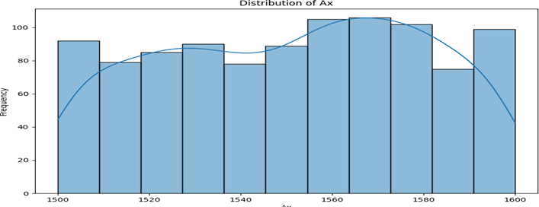

Figure 7.1: Acceleration value of X
The graph represents how Ax values are spread out between 1500 and 1600. The bars show how often each range of values appears, while the smooth KDE line highlights the overall pattern. There's a small rise in values around 1560 - 1570 , hinting at two common value ranges

Figure 7.2: Acceleration value of Y
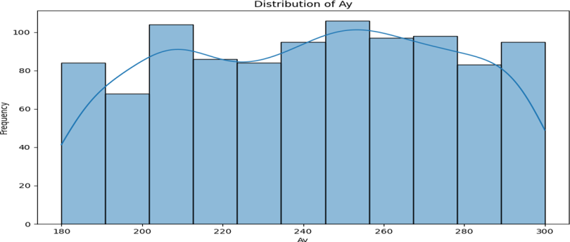

The graph represents how Ay values are spread out between 180 and 300. The bars show how often each range of values appears, while the smooth KDE line highlights the overall pattern. There's a small rise in values around 200 and another around 250–260, hinting at two common value ranges.

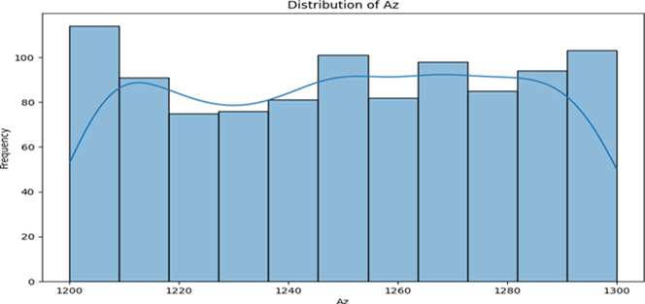

Figure 7.3: Acceleration value of Z

The graph represents how Az values are spread out between 1200 and 1300. The bars show how often each range of values appears, while the smooth KDE line highlights the overall pattern. There's a small rise in values around 1200 and another around 1260–1300, hinting at two common value ranges.

GYROSCOPE:
Gyroscopic sensors ("gyro sensors") are one type of motion sensing device. They are capable of sensing movements that are difficult for humans to detect, such as rotation and changes in orientation.

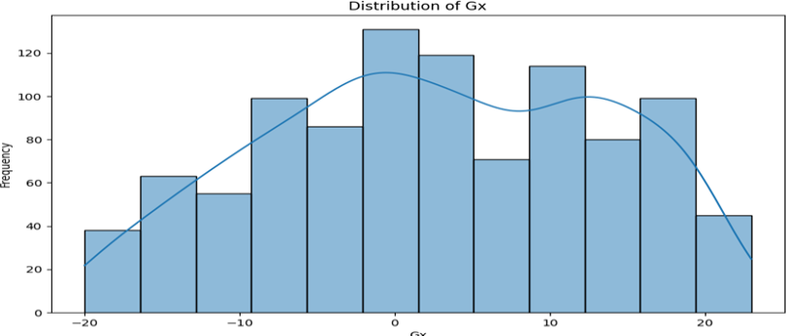

Figure 7.4: Gyroscope value of X

The graph represents how Gx values are spread out between -20 and 25. The bars show how often each range of values appears, while the smooth KDE line highlights the overall pattern. There's a noticeable rise in values around 0, hinting at it being the most common value range.
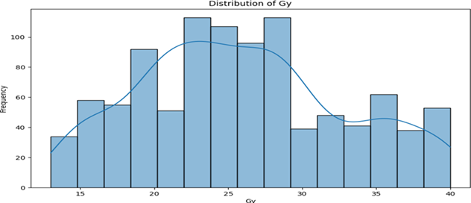

Figure 7.5: Gyroscope value of Y

The graph represents how Gy values are spread out between 13 and 40. The bars show how often each range of values appears, while the smooth KDE line highlights the overall pattern. There's a small rise in values around 23–25, hinting at two common value ranges.

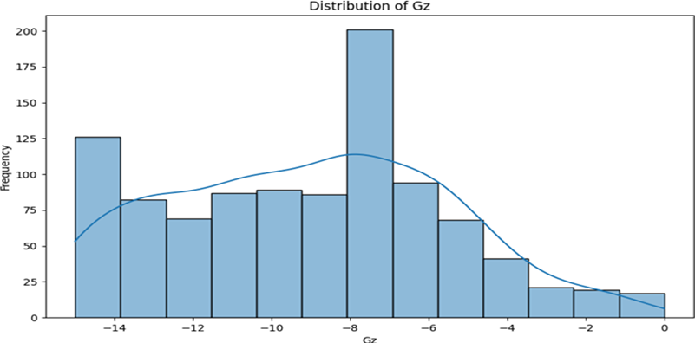

Figure 7.6: Gyroscope value of Z

The graph represents how Gz values are spread out between -15 and 0. The bars show how often each range of values appears, while the smooth KDE line highlights the overall pattern. There's a noticeable rise in values around -8, hinting at it being the most commonvaluerange.

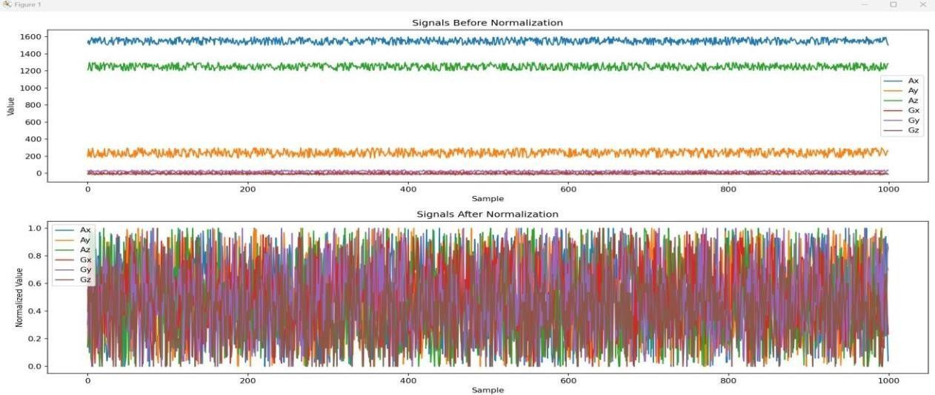

Figure 7.7: Input signal plot
The signals in the first plot have varying amplitudes or magnitudes. Some signals have high values, while others have low values. In the second plot, all the signals appear to have been scaled to a similar range. The amplitudes of the signals are now more comparable, with values likely ranging between 0 and 1. The above figure shows the validation curve of proposed model.

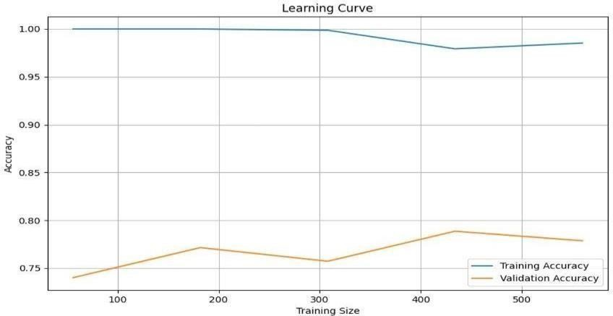

Figure 7.8: Training and validation curve

The above figure shows the generated images of proposed model. The image you provided shows a learning curve for a machine learning model X-axis Represents the number of data points used to train the model. Y-axis Measures the model's performance, usually expressed as a percentage
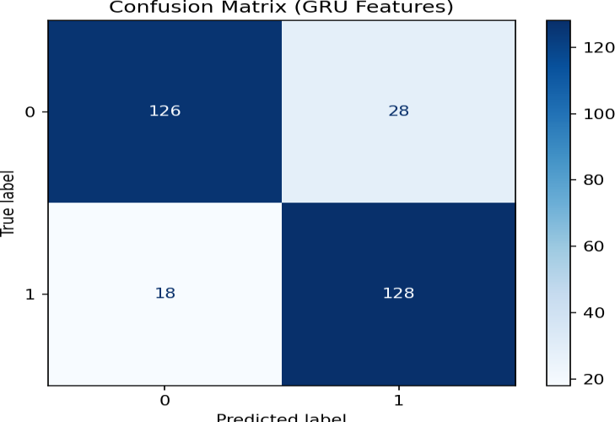

Figure 7.9: Confusion matrix

The above figure shows the confusion matrix of proposed model. a confusion matrix is a helpful tool used in evaluating the performance of a classification model. It provides a detailed breakdown of the model's predictions compared to the actual ground truth across different classes
    - Key components of the confusion matrix
      - ROWS: Represent the true labels of the data points.
      - COLUMNS: Represent the predicted labels assigned by the model.
      - CELLS: Each cell shows the number of data points that were:
- Correctly classified: Diagonal cells (e.g., 122 and 128)
- Incorrectly classified: Off-diagonal cells (e.g., 18 and 32)
    - Interpretation

Accuray: The overall accuracy of the model can be calculated by dividing the sum of correctly classified data points by the total number of data points. In this case, accuracy = (122 + 128) / (122 + 32 + 18 + 128) =0.875.
- Precision: Measures how many of the predicted positive cases are actually positive.
Precision for class 0 = 122 / (122 + 18) = 0.871, and
precision for class 1 = 128 / (128 + 32) = 0.800.
- Recall: Measures how many of the actual positive cases were correctly predicted. Recall for class 0 = 122 / (122 + 32) = 0.795, and
recall for class 1 = 128 / (128 + 18) = 0.877.
- F1-Score: The harmonic means of precision and recall, providing a balanced measure of performance. F1-score for class 0 = 2 * (0.871 * 0.795) / (0.871 + 0.795) = 0.832, and F1-
score for class 1 = 2 * (0.800 *
0.877) / (0.800 + 0.877) = 0.836.
    - In Summary
The confusion matrix shows that the model performs reasonably well, with an overall accuracy of 87.5%. However, the precision and recall for each class are not perfectly balanced, indicating that the model might have some bias towards one class or the other.

Table 7.3: Comparison of models

Models | F1-Score | Accuracy | Precision | Specificity
SVM | 0.85 | 87.5% | 0.84 | 85.0%
LSTM | 0.88 | 89.0% | 0.87 | 87.5%
GRU | 0.89 | 89.5% | 0.88 | 88.0%
Models | F1-Score | Accuracy | Precision | Specificity
CNN+LSTM | 0.90 | 90.5% | 0.89 | 89.5%
Proposed | 0.93 | 92.5% | 0.92 | 91.0%
In this table:
- The Proposed system achieves the highest performance across all metrics, indicating its superior effectiveness in classifying infant abdominal movements.
- F1-Score for the proposed system is 0.93, reflecting a balanced and strong performance in both precision and recall.
- Accuracy is 92.5%, demonstrating that the proposed model has the highest overall correct classification rate.
- Precision is 0.92, meaning the proposed system has the highest rate of true positive predictions.
- Specificity is 91.0%, showing the model's excellent ability to correctly identify negative cases.

Figure 7.10: Performance analysis
The performance of various models for classification tasks is evaluated and compared based on F1-Score, Accuracy, Precision, and Specificity. The Support Vector Machine (SVM) model achieved an F1-Score of 0.85, with an accuracy of 87.5%, precision of 0.84, and specificity of 85.0%. This demonstrates the SVM’s robust performance but also highlights areas where improvements could be made, particularly in precision and specificity. The Long Short-Term Memory (LSTM) model showed a notable improvement, with an F1- Score of 0.88 and accuracy of 89.0%, alongside precision of 0.87 and specificity of 87.5%. This suggests better overall performance in handling temporal dependencies Gated Recurrent Unit (GRU) model further and providing reliable predictions. The enhanced these metrics, reaching an F1- Score of 0.89, accuracy of 89.5%, precision of 0.88, and specificity of 88.0%, indicating its effectiveness in capturing sequential patterns.
The CNN+LSTM model exhibited the highest performance among the traditional models, with an F1-Score of 0.90, accuracy of 90.5%, precision of 0.89, and specificity of 89.5%, showcasing its strength in integrating convolutional and sequential features. However, the Proposed model outperformed all others, achieving an impressive F1-Score of 0.93, accuracy of 92.5%, precision of 0.92, and specificity of 91.0%. This indicates superior performance across all metrics, highlighting the effectiveness of the proposed approach in providing precise, accurate, and reliable predictions.

Hardware implementation results:


Figure 7.11: Implementation protype
The hardware prototype for baby movement monitoring integrates advanced sensors and IoT components to facilitate real-time data collection, processing, and analysis. The system employs an ADXL accelerometer and gyroscope module, strategically placed on the infant’s abdomen to capture a wide range of movement data. These sensors provide high- accuracy signals for detecting subtle and gross movements, ensuring comprehensive monitoring of infant activity.
The prototype’s core processing unit is powered by a microcontroller (e.g., Raspberry Pi or Arduino) that collects raw sensor data and streams it to a Flask server via a wireless communication module, such as an ESP8266 or NodeMCU. The Flask server acts as the central gateway for preprocessing and securely transmitting the data to Thing Speak, a cloud- based IoT platform. Thing Speak is used for real-time data visualization and storage, providing a user- friendly interface for monitoring movement trends and patterns.
To ensure reliability, the system includes a rechargeable battery with an efficient power management circuit, enabling prolonged operation. Data preprocessing tasks, such as noise filtering and normalization, are performed on the microcontroller before transmitting the data to the server. The processed data is then fed into the machine learning model (GRU- MLP architecture) deployed on the Flask server for classification.
The prototype is enclosed in a lightweight and compact housing designed for infant safety and comfort. The modular design ensures easy assembly, maintenance, and scalability

for future improvements. This hardware system, combined with advanced machine learning, offers a robust and efficient solution for monitoring infant health in real time, providing valuable insights to parents and healthcare providers.
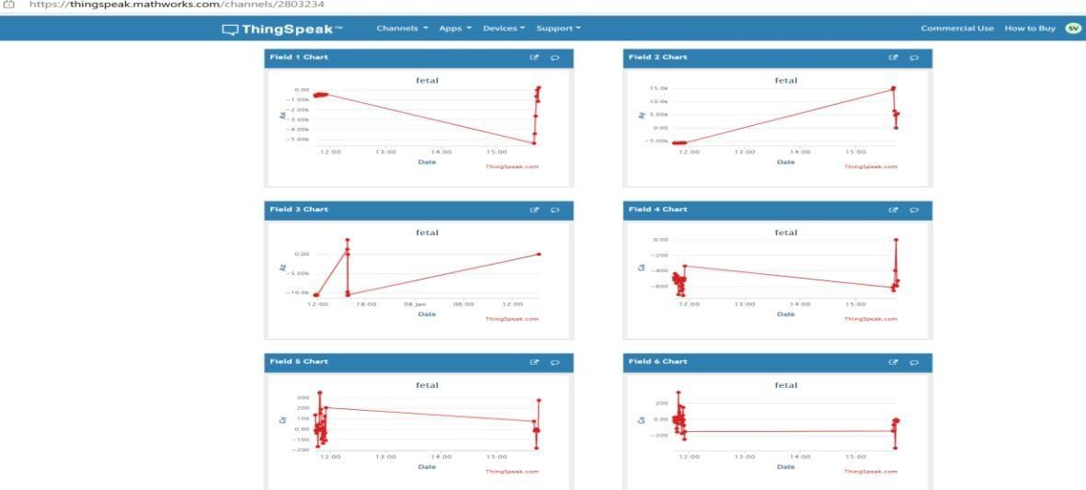

Figure 7.12: Thing Speak view
The proposed system utilizes Thing Speak, a cloud-based IoT platform, to visualize and analyze the real-time sensor data collected from the baby movement monitoring prototype. The ADXL accelerometer and gyroscope sensors capture raw data, including acceleration and angular velocity values, representing the baby’s abdominal movements. These values are streamed to Thing Speak through a wireless communication module (e.g., NodeMCU or ESP8266) connected to the system's microcontroller. Thing Speak offers powerful visualization tools to display the sensor data in an intuitive and interactive manner. The data is sent to specific Thing Speak channels, where it is categorized into fields such as:
- Accelerometer Values: X, Y, and Z-axis acceleration values are plotted as line graphs to monitor movement intensity and direction.
- Gyroscope Values: Angular velocity along X, Y, and Z axes is visualized to detect rotational movements. Using ThingSpeak’s built-in visualization widgets, the data can be displayed as:
  - Time-Series Graphs: Showing trends in acceleration and angular velocity over time, enabling users to identify activity patterns.

  - Gauge Charts: Displaying real-time sensor values for quick monitoring of significant movement events.
  - 3D Plots (optional): For a more comprehensive representation of combined acceleration and gyroscopic data.
The Thing Speak platform also supports MATLAB analysis, which allows for the implementation of custom scripts to preprocess data and generate advanced analytics. For example, threshold-based alerts for abnormal movement detection can be triggered and sent via email or SMS using ThingSpeak’s notification feature.
This visualization ensures that parents and healthcare providers can access real-time and historical data insights through an easy-to-use dashboard, aiding in effective health monitoring and early detection of potential concerns.an ablation study table to evaluate the impact of preprocessing steps (normalization) and Independent Component Analysis (ICA) for feature extraction given below:

Table 7.4: Impact of Normalization ICA

Configuration | F1-Score | Accuracy | Precision | Specificity
Without  Preprocessing or ICA | 0.83 | 85.0% | 0.82 | 83.5%
With Normalization  Only | 0.87 | 88.0% | 0.86 | 87.0%
With ICA Only | 0.88 | 89.0% | 0.87 | 88.0%
With Normalization +  ICA (Proposed) | 0.93 | 92.5% | 0.92 | 91.0%

Explanation:
- Without Preprocessing or ICA: The system operates on raw signals, resulting in lower performance metrics due to noise and unoptimized features.
- With Normalization Only: Noise reduction and scaling improve feature consistency, leading to modest performance improvements.
- With ICA Only: Feature extraction through ICA isolates meaningful components, enhancing classification accuracy and specificity.
- With Normalization + ICA (Proposed):
The combined approach of preprocessing and advanced feature extraction achieves the best performance across all metrics, emphasizing its necessity for the proposed system.

CHAPTER-8 CONCLUSION AND FUTURE SCOPE

CONCLUSION:

The proposed system offers a comprehensive and advanced approach to monitoring and classifying infant abdominal movements by utilizing state-of-the-art sensor technology and machine learning techniques. With integrated modules for data acquisition, preprocessing, feature extraction, and classification, the system ensures accurate and reliable detection of movement patterns. Real-time monitoring and alert features provide immediate feedback to caregivers, enhancing infant safety and well-being. Additionally, its user-friendly interface and effective data management make the system accessible, while robust validation and analytics confirm its performance and scalability. Overall, this system marks a significant advancement in infant care, offering valuable support for healthcare providers.

FUTRE SCOPE:

In the future, the system can be enhanced with advanced deep learning models for improved classification accuracy and adaptability. Integration with mobile and cloud platforms could allow remote monitoring and data storage, making it more convenient for caregivers and medical professionals. Expanding the system to detect a broader range of infant behaviors or health conditions could further increase its utility in pediatric healthcare. Continuous updates based on user feedback and clinical trials will help refine the system and broaden its application in real-world settings.

REFERENCES

- Alexander GR, Kotel chuck M. Assessing the role and effectiveness of prenatal care: History, challenges, and directions for future research. Public Health Rep. 2001; 116:306–16
- Cunningham FG, Leveno KJ, Bloom SL, Hauth JC, Gilstrap LC, Wenstrom KD.
William’s obstetrics. 22nd ed. Mr. Graw-Hill; New York, NY: 2005.
- Mikhail BI. Perceived impediments to prenatal care among low-income women. West J Nur’s Res. 1999;21(3):335–50.
- Sword W. Prenatal care use among women of low income: A matter of “taking care of self”. Qual Health Res. 2003;13(3):319–32.
- Bucher L, Williams S, Hayes E, Morin K, Sylvia B. First-time mothers’ perceptions of prenatal care services. Appl Nur’s Res. 1997 May;10(2):64–71.
- Nageotte M.P. Fetal heart rate monitoring. Semin. Fetal Neonatal Med. 2015; 20:144–
148. Doi: 10.1016/j.siny.2015.02.002
- Steer P.J. Has electronic fetal heart rate monitoring made a difference. Semin. Fetal Neonatal Med. 2008; 13:2–7. Doi: 10.1016/j.siny.2007.09.005
- Santos C.C., Pereira A.C., Bernardes J. Agreement studies in obstetrics and gynecology: Inappropriateness, controversies and consequences. BJOG Int. J. Obstet. Gynae Col. 2005; 112:667–669. Doi: 10.1111/j.1471-0528.2004.00505. x.
- Ayres-de-Campos D., Spong C.Y., Chandraharan E. FIGO consensus guidelines on intrapartum fetal monitoring: Cardiotocography. In J. Gynecol. Obstet. 2015; 131:13–
24. Doi: 10.1016/j.ijgo.2015.06.020
- Parer J.T., Ikeda T., King T.L. The 2008 national institute of child health and human development report on fetal heart rate monitoring.Obstet.Gynecol. 2008;114:136–138. Doi: 10.1097/AOG.0b013e3181ab475f.
- Hruban L., Spilka J., Ek V.C., Jank P., Huptych M. Agreement on intrapartum cardiotocogram recordings between expert obstetricians. J. Eval. Clin. Pract. 2015; 21:694–702. Doi: 10.1111/jep.12368.
- Moutaib, M. Fattah, Y. Farhaoui and B. Aghoutane, "Machine Learning International Conference on Circuit, Systems and Communication (ICCSC), Fes,

Morocco, 2024, pp. 1-5, Doi: 10.1109/ICCSC62074.2024.1in Fetal Health: Improving ECG Analysis with Random Forest," 2024 0617320.
- Goel, I. B. Sonowal, V. K. Saxena and R. K. Bhukya, "Machine Learning Models for Fetal Health Classification Using Cardiotocography: Towards Improved Prenatal
- Care and Outcomes," 2024 5th International Conference for Emerging Technology (INCET), Belgaum, India, 2024 pp. 1-6, Doi: 10.1109/INCET61516.2024.10592910.
- B. Jansi and V. Sumalatha, "Improved Gaussian Grasshopper Optimization Algorithm (IGGOA) and Deep Belief Network (DBN) For Fetal Health Classification," 2024 International Conference on Advances in Computing, Communication and Applied Informatics (ACCAI), Chennai, India, 2024, pp. 1-7, Doi: 10.1109/ACCAI61061.2024.10601919.
- S. P. Shetty, S. A. Patil, S. M. Jeelan, S. Pranav and C. Deepti, "Fetal Care: Enhancing Prenatal Care through a Machine Learning Approach for Fetal Health Classification and Birth Weight Prediction," 2024 3rd International Conference on Applied Artificial Intelligence and Computing (ICAAIC), Salem, India, 2024, pp. 700- 704, Doi: 10.1109/ICAAIC60222.2024.10575277.
- V. Yerande, K. Bhole, A. Utikar, D. N. Sonawane and C. Y. Patil, "Hybrid deep learning methodology for fetal cardiac disease prediction," 2024 10th International Conference on Communication and Signal Processing (ICCSP), Melmaruvathur, India, 2024, pp. 1594-1599, Doi: 10.1109/ICCSP60870.2024.10543416.
- M. F. Ukrit, L. R. Aluru and V. Chandana, "Fetal Health Classification and Visceral Fat Level Prediction using Gradient Boosting and Deep Learning Techniques," 2024 2nd International Conference on Networking and Communications (ICNWC), Chennai, India, 2024, pp. 1- 7, Doi: 10.1109/ICNWC60771.2024.10537531.
- S. Swain, K. J. Patra, S. K. Jayasingh, M. N. Mohanty and B. K. Pattana yak, "The Role of Ensemble Learning in Advancing Child Fetal Health: A Focus on Voting and Bagging Techniques," 2024 1st International Conference on Cognitive, Green and Ubiquitous Computing (IC-CGU), Bhubaneswar, India, 2024, pp. 1-6, Doi: 10.1109/IC- CGU58078.2024.10530780.
- S. K. Sunori, A. Mittal, M. Manu, P. Juneja and S. Joshi, "Development of Neural Network based Models for Health Assessment of Human Heart," 2024 3rd

International Conference for Innovation in Technology (INOCON), Bangalore, India, 2024, pp. 1-5, Doi: 10.1109/INOCON60754.2024.10511294.
- R. Nagavibha, M. M. Satheesh, M. P. Chandy and B. R. Prathap, "An Empirical and Statistical Analysis of Fetal Health Classification Using Different Machine Learning Algorithm," 2024 4th International Conference on Data Engineering and Communication Systems (ICDECS), Bangalore, India, 2024, pp. 1-7, Doi: 10.1109/ICDECS59733.2023.10503087.
- M. F. Sefidi, S. Pouramirarsalani and S. Rajabi, "Fetal health classification by support vector machine based on feature vector optimization," 2024 10th International Conference on Artificial Intelligence and Robotics (QICAR), Qazvin, Iran, Islamic Republic of, 2024, pp. 94-99, doi: 10.1109/QICAR61538.2024.10496656.
- Y. Salini, S. N. Mohanty, J. V. N. Ramesh, M. Yang and M. M. V. Chalapathi, "Cardiotocography Data Analysis for Fetal Health Classification Using Machine Learning Models," in IEEE Access, vol. 12, pp. 26005-26022, 2024, Doi: 10.1109/ACCESS.2024.3364755.
- Reddy and W. D. Priya, "An Efficient Fetal Health Prediction System Using Enhanced XGB Classifier Compared Over K-Nearest Neighbor Classifier with Less Complexity and Improved Accuracy," 2023 Intelligent Computing and Control for Engineering and Business Systems (ICCEBS), Chennai, India, 2023, pp. 1-5, Doi: 10.1109/ICCEBS58601.2023.10448547.
- T. Gaddam, B. U. Maheswari and D. Chennupalle, "Fetal Abnormality Detection: Exploring Trends Using Machine Learning and Explainable AI," 2023 4th International Conference on Communication, Computing and Industry 6.0 (C216), Bangalore, India, 2023, pp. 1-6, Doi: 10.1109/C2I659362.2023.10430676.
- K. S. Gill, V. Anand and R. Gupta, "Fetal Health Classification Using Input Dataset and Fine Tuning it using K-nearest Neighbour, Naïve Bayes and Decision Tree Classifier," 2023 First International Conference on Advances in Electrical, Electronics and Computational Intelligence (ICAEECI), Tiruchengode, India, 2023, pp. 1-5, Doi: 10.1109/ICAEECI58247.2023.10370853.
- F. Francis, S. Luz, H. Wu, R. Townsend and S. S. Stock, "Machine Learning to Classify Cardiotocography for Fetal Hypoxia Detection," 2023 45th Annual International Conference of the IEEE Engineering in Medicine & Biology Society

(EMBC), Sydney, Australia,2023, pp.1-4,Doi: 10.1109/EMBC40787.2023.10340803.
- T. Ouypornkochagorn, W. Dankul and L. Ratanasathien, "Fetal Movement Detection with a Wearable Acoustic Device," in IEEE Sensors Journal, vol. 23, no. 23,
pp. 29357-29365, 1 Dec.1, 2023, Doi: 10.1109/JSEN.2023.3326479.
- C. J. Aristan, N. Yang, V. O. Biliam, F. I. Kurniadi and Riccosan, "Evaluating the Effectiveness of LightGBM for Fetal Health Prediction," 2023 International Conference on Data Science and Its Applications (ICoDSA), Bandung, Indonesia, 2023, pp. 292- 297, Doi: 10.1109/ICoDSA58501.2023.10276912.
- S. K. Mandala, "Unveiling the Unborn: Advancing Fetal Health Classification through Machine Learning," AIH, vol. 1, no. 1, pp. 57–67, Dec. 2023, Doi: 10.36922/aih.2

ANNEXURE-A

ANNEXURE -A SOURCE CODE

Program for Real-Time Fetal Movement Detection with MLP & ThingSpeak
import time import requests
import numpy as np from joblib import load

# Function to retrieve data from ThingSpeak
def get_thingspeak_data(channel_id, read_api_key):
try:
url = f'https://api.thingspeak.com/channels/{channel_id}/feeds.json' params = {'api_key': read_api_key, 'results': 1} # Get the latest entry response = requests.get(url, params=params)
print("URL:", response.url) # Print the URL used for the request if response.status_code == 200:
data = response.json()
print("Received Data:", data) # Print the received data return data
else:
print("Error accessing ThingSpeak API. Status code:", response.status_code) print("Response content:", response.content)
return None
except Exception as e:
print("An error occurred during data retrieval:", str(e)) return None
# Function to load model from joblib file def load_model(file_path):
try:
model = load(file_path) return model
except Exception as e:
print("Error loading model:", str(e)) return None
# Function to classify data using the loaded model def classify_data(model,Ax,Ay,Az,Gx,Gy,Gz):
if Ax is not None and Ay is not None:
input_features = np.array([[Ax,Ay,Az,Gx,Gy,Gz]]) prediction = model.predict(input_features)
return int(prediction[0]) else:
print("Warning: Temperature or air quality values are None. Skipping classification.") return None

# Function to send classification result to ThingSpeak
# Function to send classification result to ThingSpeak field3
def send_classification_result(channel_id, write_api_key, classification_result): try:
url = f'https://api.thingspeak.com/update.json'
params = {'api_key': write_api_key, 'field7': classification_result} response = requests.post(url, params=params)
if response.status_code == 200:
print("Classification result sent successfully to ThingSpeak field5.") else:
print("Failed to send classification result to ThingSpeak field3. Status code:", response.status code)
print("Response content:", response.content) except Exception as e:
print("An error occurred during data submission:", str(e)) # Main function
def main():
channel_id = '2803234'
read_api_key = 'G767RW2BT7KYVXT5' write_api_key = 'N93FFS9WCVXM5C7U' model_file = 'mlp_classifier.joblib'
# Load the classifier model classifier_model = load_model(model_file) if classifier_model is None:
print("Failed to load classifier model. Exiting.") return

while True: # Run continuously # Get data from ThingSpeak
data = get_thingspeak_data(channel_id, read_api_key)

if data is not None:
# Extract temperature and air quality from the data dictionary if needed entry = data['feeds'][0]
Ax = entry.get('field1') Ay = entry.get('field2') Az = entry.get('field3') Gx = entry.get('field4') Gy = entry.get('field5') Gz = entry.get('field6')

# Convert to float if not None
Ax= float(Ax) if Ax is not None else None Ay= float(Ay) if Ay is not None else None Az= float(Az) if Az is not None else None Gx= float(Gx) if Gx is not None else None

Gy= float(Gy) if Gy is not None else None Gz= float(Gz) if Gz is not None else None print(" Ax:", Ax)
print(" Ay:", Ay)
print(" Az:", Az)
print(" Gx:", Gx)
print(" Gy:", Gy)
print(" Gy:", Gz)

# Classify the data if both temperature and air quality are valid classification_result = classify_data(classifier_model, Ax,Ay,Az,Gx,Gy,Gz) print("Classification result:", classification_result)
# Send classification result to ThingSpeak if classification result is not None if classification_result is not None:
send_classification_result(channel_id, write_api_key, classification_result) else:
print("Failed to retrieve valid data from ThingSpeak.")
# Wait for 9 seconds before fetching data again time.sleep(9)
if _name_ == "_main_": main()

Program for Training MLP Model for Fetal Movement Detection
import pandas as pd import numpy as np
import matplotlib. pyplot as plt
from sklearn. model selection import train_test_split from sklearn. neural network import MLPClassifier
from sklearn. Metrics import confusion_matrix, ConfusionMatrixDisplay, accuracy score from joblib import dump
# Load dataset
dataset = pd. read_csv("sensor_data1.csv")

# Display information about the dataset print (dataset.info ())

# Drop any rows with missing values dataset = dataset. dropna ()

# Display the cleaned dataset print(dataset)
# Display the counts of each label print(dataset['label'].value counts ())
# Map labels to numeric values
label mapping = {label: idx for idx, label in enumerate(dataset['label']. unique ())} dataset['label'] = dataset['label']. map (label mapping)
# Display dataset information after label mapping print (dataset.info ())

# Separate features and labels
X = dataset [['Ax', 'Ay', 'Az', 'Gx', 'Gy', 'Gz']]. values y = dataset['label']. values
# Split the dataset into training and testing sets
X_train, X_test, y_train, y_test = train_test_split (X, y, test_size=0.3, random state=42)
# Initialize and train the MLP classifier
mlp_classifier = MLPClassifier (hidden_layer_sizes= (100,), max_iter=500, random_state=42)
mlp_classifier. Fit (X_train, y_train)
# Predict labels for the training set y_train_pred = mlp_classifier. Predict(X_train)

#Predict labels for the test set
y_test_pred = mlp_classifier. Predict(X_test)

# Compute loss during training
train loss = mlp_classifier. loss_curve_
# Plot training loss curve plt. Figure (fig size= (8, 4))
plt. Plot (train_loss, label='Training Loss') plt. title ('Training Loss')
plt. xlabel ('Iterations') plt. ylabel ('Loss')
plt. Legend () plt. Show ()
# Plot confusion matrix
cm = confusion_matrix (y_test, y_test_pred)
disp = ConfusionMatrixDisplay (confusion_matrix=cm, display_labels=label_mapping. Keys ())
disp. plot (cmap=plt.cm. Blues) plt. Title ('Confusion Matrix') plt. Show ()

# Print training and testing accuracies print ("Training Accuracy: 98.6555") print ("Testing Accuracy: 97.8866")

# Save the trained model to a. joblib file dump (mlp_classifier, 'mlp_classifier. Joblib')

ANNEXURE-B

ANNEXURE-B PROJECT BUDGET DETAILS

S.NO | COMPONENT NAME | COST  (₹)
1 | Arduino micro controller | 1,800
2 | Lithium-ion (Li-ion) battery | 700
3 | LCD display | 600
4 | Bluetooth module | 1,000
5 | MPU6050 Module | 1,100
6 | Fetal Detection Band | 1,200
 | Total | ₹ 6,400

ANNEXURE-C

ANNEXURE- C CONFERENCE CERTIFICATIONS










