REVA UNIVERSITY
Rukmini Knowledge Park, Kattigenahalli, Yelahanka, Bengaluru-560064
www.reva.edu.in

SCHOOL OF ELECTRONICS AND COMMUNICATION ENGINEERING

A MAJOR PROJECT REPORT ON

"Low-Latency Pipelined RISC-V 32-Bit Processor with Hardware Taint Tracking"

Submitted in fulfillment of the requirements for the award of the Degree of
BACHELOR OF TECHNOLOGY
IN
ELECTRONICS AND COMMUNICATION ENGINEERING

Submitted by

Manjunath S R (R22EN043)
Mithun Nagaraja (R22EN045)
Darshan N A (R22EN021)
Nagachandra I D (R22EN048)

Under the guidance of
Dr. Nayana D K
Professor, School of ECE, REVA University

March 2026

DECLARATION

We, Manjunath S.R (R22EN043), Mithun Nagaraja (R22EN045), Darshan N A (R22EN021) and Nagachandra I D (R22EN048), students of B.Tech, belonging to the School of Electronics and Communication Engineering, REVA University, declare that this Project Report / Dissertation entitled "Low-Latency Pipelined RISC-V 32-Bit Processor with Hardware Taint Tracking" is the result of the project/dissertation work done by us under the supervision of Dr. Nayana D K, Professor, School of ECE, REVA University.

We are submitting this Major Project Report / Dissertation in partial fulfillment of the requirements for the degree of Bachelor of Technology in Electronics and Communication Engineering awarded by REVA University, Bengaluru, during the academic year 2025-26.

We declare that this project report satisfies the academic requirements concerning the Major Project work prescribed for the said Degree. We further declare that this Major Project / Dissertation report or any part of it has not been submitted for the award of any other Degree/Diploma of this University or any other University/Institution.

(Signature of Manjunath S R)
(Signature of Mithun Nagaraja)
(Signature of Darshan N A)
(Signature of Nagachandra I D)

Signed by us on March 2026

Certified that this Major project work submitted by the above-named students has been carried out under my/our guidance and the declaration made by the candidates is true to the best of my knowledge.

Signature of Guide Signature of Director
Date: 14 March 2026 Date: 14 March 2026

CERTIFICATE

Certified that the project work entitled "Low-Latency Pipelined RISC-V 32-Bit Processor with Hardware Taint Tracking" carried out under my guidance by Manjunath S R (R22EN043), Mithun Nagaraja (R22EN045), Darshan N A (R22EN021), Nagachandra I D (R22EN048), Bonafide students of REVA University during the academic year 2025-26, is submitted in partial fulfillment for the award of Bachelor of Technology in Electronics and Communication Engineering.

Dr. Nayana D K Dr. K M Sudarshan
Professor, School of ECE Director, School of ECE
REVA University REVA University

Name of the Examiners with Affiliation:

ACKNOWLEDGEMENT

The satisfaction and euphoria that accompany the successful completion of any task would be incomplete without the mention of the people who made it possible with constant guidance and encouragement and crowned our efforts with success.

A hearty thanks to our Guide, Dr. Nayana D K, School of ECE, REVA University, for her invaluable guidance, continuous technical discussions, regular feedback, and unwavering support throughout the entire duration of this project.

We are grateful to Dr. K M Sudharshan, Director, School of Electronics & Communication Engineering, REVA University, Bangalore, for his valuable support, encouragement, and for providing access to Vivado simulation tools and computing resources essential to this project.

We also thank all the School of Electronics and Communication Engineering Staff Members and those who have directly or indirectly helped us with their valuable suggestions in completing this project.

We thank Dr. R. C. Biradar, Pro-Vice Chancellor, and Dr. Sanjay R. Chitnis, Vice Chancellor (I/C), REVA University, Bangalore, for extending their support. We also thank our Honourable Chancellor, Dr. P Shyamaraju, for his support and encouragement.

Lastly, we thank our beloved Parents and Siblings for their blessings, love, motivation, and encouragement to complete this task while meeting all the requirements.

Manjunath S R, Mithun Nagaraja, Darshan N A, Nagachandra I D

TABLE OF CONTENTS

Sl. No | Contents | Page No.
01 | Declaration | i
02 | Certificate | ii
03 | Acknowledgement | iii
04 | Table of Contents | iv
05 | List of Figures | v
06 | List of Tables | vi
07 | List of Abbreviations | vii
08 | Abstract | 1
09 | Chapter 1: Introduction | 3
10 | Chapter 2: Literature Survey | 7
11 | Chapter 3: Proposed Methodology | 13
12 | Chapter 4: Design Architecture | 19
13 | Chapter 5: Hardware Taint Tracking Extension | 25
14 | Chapter 6: Simulation Results and Waveform Analysis | 32
15 | Chapter 7: Applications | 38
16 | Chapter 8: Conclusion | 41
17 | Chapter 9: Future Scope | 43
18 | References | 45

LIST OF FIGURES

Figure No. | Caption | Page No.
Fig. 1 | Six CSR Configuration Instructions (Ease of Use) | 28
Fig. 2 | Block Diagram of RISC-V 32-bit CPU Core | 21
Fig. 3 | Taint Propagation OR Rule Formula | 26
Fig. 4 | Taint-Aware Forwarding Multiplexer Code | 27
Fig. 5 | Violation Detection Condition Code | 28
Fig. 6 | Register File Verification Results (Table II) | 33
Fig. 7 | Taint Signal Trace (Table III) | 34
Fig. 8 | Waveform 1 - CSR Writes and Taint Exception Signal | 35
Fig. 9 | Waveform 2 - Taint Register Bit Propagation | 35
Fig. 10 | Console Log 1 - Cycle-by-Cycle PC Trace | 36
Fig. 11 | Console Log 2 - Final Verification Results (All PASS) | 37
Fig. 12 | Application Areas Summary Table | 40

LIST OF TABLES

Table No. | Caption | Page No.
Table I | Custom CSR Registers Summary | 29
Table II | Register File Check Results | 33
Table III | Taint Signal Trace | 34
Table IV | ALU Operations Supported | 17
Table V | Performance Overhead Comparison | 37
Table VI | Application Areas Summary | 40

LIST OF ABBREVIATIONS

Abbreviation | Full Form
RISC-V | Reduced Instruction Set Computer - Five
RV32I | RISC-V 32-bit Integer Base Instruction Set
ISA | Instruction Set Architecture
ALU | Arithmetic Logic Unit
IF/ID/EX/MEM/WB | Fetch / Decode / Execute / Memory / Write-Back Stages
HDL | Hardware Description Language
RTL | Register Transfer Level
FPGA | Field Programmable Gate Array
CPI | Cycles Per Instruction
PC | Program Counter
CSR | Control and Status Register
DIFT | Dynamic Information Flow Tracking
NOP | No Operation
SoC | System on Chip
IoT | Internet of Things
XSim | Xilinx Simulator (part of Vivado)

ABSTRACT

This project reports on the design, implementation, and behavioral simulation of a 32-bit RISC-V processor built around a five-stage pipeline. The core supports the RV32I base instruction set and runs instructions through five distinct stages — Instruction Fetch (IF), Instruction Decode (ID), Execute (EX), Memory Access (MEM), and Write-Back (WB) — so that multiple instructions overlap in execution at any point in time.

Hazard handling is accomplished through a forwarding unit that eliminates most stalls, a hazard detection block that inserts a one-cycle bubble only for load-use conflicts, and a flush mechanism that discards wrongly-fetched instructions when a branch is confirmed taken.

Beyond the base pipeline, this work introduces a novel Hardware Taint Tracking security extension, where each of the 32 general-purpose registers carries a one-bit taint tag that propagates automatically through every computation using a simple OR rule. Six custom Control and Status Registers (CSRs) at addresses 0x800 through 0x805 allow software to configure which registers are marked as attacker-controlled and which memory region is protected.

When a store instruction attempts to write tainted data to a protected address, all four violation conditions are evaluated in hardware in the same clock cycle as the memory access, and a taint exception is raised before the write completes. The entire taint logic runs in parallel with the existing datapath and introduces no additional clock cycles. Behavioral simulation in Vivado XSim confirms all register file, memory, forwarding, branch-flush, and taint-violation checks pass correctly.

The design is written in Verilog HDL and is well suited for embedded applications where low latency and lightweight security monitoring are both important.

Keywords:
RISC-V, RV32I, pipelined processor, hardware taint tracking, DIFT, data hazard forwarding, CSR, behavioral simulation, Verilog HDL, Vivado XSim.

CHAPTER 1: INTRODUCTION

1.1 Background and Motivation
RISC-V is a modern, open-source Reduced Instruction Set Computing (RISC) architecture that allows academic researchers and industries to design custom processors without licensing restrictions. Unlike conventional proprietary ISAs such as x86 or ARM, RISC-V offers simplicity, modularity, and extensibility, allowing it to be tailored for microcontrollers, IoT devices, high-performance processors, and domain-specific accelerators. The RV32I variant, which defines 32-bit integer operations using 32 general-purpose registers, is compact enough for students to implement from scratch while being realistic enough to support meaningful embedded applications.

In a single-cycle CPU, every instruction completes in one long clock period that must accommodate the slowest possible instruction path, forcing the clock frequency to stay low. Multi-cycle designs break instructions into smaller phases to raise the clock frequency, but only one instruction progresses through the hardware at a time. Pipelining solves both problems simultaneously: by dividing instruction execution into stages and allowing each stage to work on a different instruction every cycle, a pipeline can simultaneously process five instructions and complete one every cycle in the best case.

1.2 Problem Statement
Modern embedded systems face two critical challenges: performance and security. The performance challenge is addressed by pipelined architectures that overlap instruction execution, but this introduces hazard problems. The security challenge is increasingly important as processors are deployed in environments where they may process untrusted data from external sources such as network interfaces, sensors, or user inputs.

Traditional processors give no indication of where the data they are processing came from. This makes a whole family of attacks possible: if an attacker can influence the value of a register that eventually drives a store instruction to a sensitive memory address — such as a return address or code memory — the processor will carry out the store without any security check, enabling buffer overflows, code injection, and similar attacks.

1.3 Project Objectives
This project has the following primary objectives:
- Implement a full five-stage RISC-V RV32I pipeline in Verilog HDL with correct handling of all instruction types.
- Design and integrate a data forwarding unit to resolve EX-EX and MEM-EX data hazards without stalls.
- Implement a hazard detection unit that correctly handles load-use hazards with a single-cycle stall.
- Implement branch flush logic that discards speculatively-fetched instructions when a branch is resolved as taken.
- Design and integrate a Hardware Taint Tracking extension that tracks data provenance at the register level.
- Implement six custom CSRs to provide runtime-configurable taint source and protection policies.
- Verify all components through comprehensive behavioral simulation in Vivado XSim.

1.4 Scope and Limitations
The scope of this project covers the design and simulation of the RISC-V RV32I base integer instruction set including R-type, I-type, S-type, B-type, U-type, and J-type instructions. The current work does not include FPGA synthesis and physical deployment, although the Verilog design is written to be synthesizable. The taint tracking is limited to register-level granularity with a single OR-based propagation rule; implicit information flows are not tracked in the current implementation.

1.5 Report Organization
This report is organized into nine chapters. Chapter 2 presents the literature survey. Chapter 3 describes the proposed methodology. Chapter 4 presents the overall design architecture. Chapter 5 details the Hardware Taint Tracking extension. Chapter 6 presents simulation results and waveform analysis. Chapter 7 discusses application domains. Chapter 8 presents conclusions and Chapter 9 outlines future work.

CHAPTER 2: LITERATURE SURVEY

2.1 Overview
Processor designs have evolved from single-cycle execution architectures to multi-cycle and pipelined processors to improve processing speed and efficiency. The literature reviewed for this work covers information flow security theory, dynamic taint analysis semantics, hardware security architecture concepts, and the RISC-V privileged specification.

2.2 RISC-V Pipeline Implementations

2.2.1 Configurable Five-Stage RV32IM Core (Chang et al.)
Chang et al. designed a configurable five-stage pipeline processor core based on RV32IM, where the architecture can switch between a low-power mode (RV32I only) and a high-performance mode (with multiplication/division extension). This work demonstrates how RISC-V pipelines can be tailored for different performance and cost targets, showing that configurability is a powerful way to balance latency, power, and area.

2.2.2 Performance-Optimized RV32I Five-Stage Pipeline — NRP (Li et al.)
Li et al. introduced an optimized RV32I five-stage pipeline processor (NRP) with an improved instruction decoding unit and a simple branch-prediction scheme to reduce control-hazard penalties. These enhancements lead to better CPI without dramatically increasing hardware complexity, showing that careful redesign of decode and control stages can directly contribute to lower effective latency.

2.2.3 Low-Power 32-bit RISC-V Core for Edge Computing
A recent study presents a low-power 32-bit RISC-V processor core for real-time edge computing applications using a simplified five-stage pipeline combined with clock and power-gating techniques. This work shows that a five-stage pipeline can be tuned not only for speed but also for low power, especially in edge and IoT scenarios.

2.2.4 RVCoreP — Optimized RISC-V Soft Processor (Miyazaki et al.)
Miyazaki et al. demonstrated a five-stage RV32I soft-core optimized for FPGAs, with improved operating frequency via instruction-fetch, ALU, and data-alignment optimizations, providing important insights into the trade-offs between pipeline depth and critical path delay when implementing RISC-V on reconfigurable hardware.

2.3 Hardware Information Flow Tracking

2.3.1 DIFT — Hardware-Based Malware Detection (Suh and Devadas, MICRO 2004)
Suh and Devadas introduced the concept of associating tag bits with data and propagating them through a processor pipeline to detect attacks at runtime. This work provided the core idea of maintaining one taint bit per register and using the OR rule to combine tags during computation — the theoretical basis for the taint_unit.v module in this project.

2.3.2 Dynamic Taint Analysis (Newsome and Song, NDSS 2005)
Newsome and Song formalised the taint propagation rules, establishing that OR is the correct combining rule — if either source operand is tainted, the result must also be tainted. Their classification of which operations propagate taint directly informed the logic inside taint_unit.v.

2.3.3 LIFT — Low-Overhead Information Flow Tracking (Qin et al., MICRO 2006)
LIFT's analysis showed that arithmetic inherits taint from both operands, immediate loads are always clean, and the store instruction is the correct enforcement point. These shaped the specific rules modelled in Verilog and confirmed that the violation check belongs in the MEM stage.

2.3.4 Raksha — Flexible Information Flow Architecture (Dalton et al., ISCA 2007)
Raksha demonstrated the value of making security policies configurable through privileged instructions rather than hard-coding them. This concept inspired the CSR-based configuration design, where six custom CSRs allow the taint policy to be set at the start of a simulation run.

2.3.5 Dytan — Modular Dynamic Taint Analysis (Clause et al.)
Dytan's modular separation of propagation logic from policy enforcement directly influenced the module structure used in this project — taint_unit.v handles propagation while csr_taint.v manages configurable policy.

2.3.6 Parallel Combinational Monitor (Deng and Suh)
Deng and Suh established the zero-latency overhead principle for hardware information flow tracking — all propagation and detection logic operates in parallel with the main datapath's combinational logic. This guided the decision to implement the taint unit as a purely combinational block at the EX stage.

2.4 Summary
Key design principles drawn from the literature and incorporated into this work: (1) five-stage RV32I pipelines achieve the best balance of critical path delay; (2) OR-based taint propagation is theoretically correct and practically sufficient for register-level DIFT; (3) CSR-based configuration provides the right level of flexibility; (4) zero-cycle-overhead taint tracking is achievable when all taint logic operates in parallel with the existing datapath.

CHAPTER 3: PROPOSED METHODOLOGY

3.1 Design Approach
The proposed system was designed and verified entirely through RTL modelling in Verilog and behavioural simulation using Vivado XSim. The methodology follows a modular design approach where the taint tracking extension is built as a set of additional modules that sit alongside the existing five-stage pipeline without modifying its core datapath or control logic.

3.2 Study of RV32I ISA
A complete understanding of the RV32I instruction formats (R, I, S, B, U, J-types), opcode decoding, register usage, and control signals is carried out before any HDL is written. The RV32I base integer ISA provides 47 instructions organized into the following format classes:
- R-type: Register-register operations (ADD, SUB, AND, OR, XOR, SLL, SRL, SRA, SLT, SLTU)
- I-type: Immediate operations and loads (ADDI, SLTI, ANDI, ORI, XORI, SLLI, SRLI, SRAI, LW, JALR)
- S-type: Store instructions (SW, SB, SH)
- B-type: Branch instructions (BEQ, BNE, BLT, BGE, BLTU, BGEU)
- U-type: Upper immediate (LUI, AUIPC)
- J-type: Unconditional jump (JAL)

3.3 Pipeline Architecture Design
A five-stage pipeline is designed with Instruction Fetch (IF), Instruction Decode (ID), Execute (EX), Memory Access (MEM), and Write-Back (WB) stages. Between each pair of adjacent stages, a set of pipeline registers latches all values and control signals on the rising clock edge.

Stage 1 — Instruction Fetch (IF):
The IF stage fetches the instruction from instruction memory using the Program Counter (PC) as the address. The PC is updated each cycle to PC+4 for sequential execution, or to the branch target when a taken branch is detected.

Stage 2 — Instruction Decode (ID):
The ID stage decodes the instruction and reads the source registers from the register file. The control unit generates all control signals (ALUSrc, MemWrite, MemRead, RegWrite, MemToReg, Branch) based on the opcode and funct fields. The immediate value is sign-extended to 32 bits.

Stage 3 — Execute (EX):
The EX stage performs the ALU operation. Branch conditions are evaluated here and the branch target address is computed as PC + sign-extended offset. Forwarding multiplexers at the ALU inputs select between register file outputs, EX/MEM forwarded values, or MEM/WB forwarded values.

Stage 4 — Memory Access (MEM):
The MEM stage reads from or writes to data memory for load and store instructions. For non-memory instructions, this stage passes the ALU result through unchanged.

Stage 5 — Write-Back (WB):
The WB stage writes the result back to the register file. The MemToReg multiplexer selects between the ALU result (for arithmetic/logical instructions) and the memory read data (for load instructions).

3.4 ALU Design and Verification
The ALU module was implemented in Verilog HDL supporting all operations required by the RV32I instruction set:

Category | Operation | Description
Arithmetic | ADD, SUB | Addition and Subtraction
Logical | AND, OR, XOR | Bitwise logical operations
Shift | SLL, SRL, SRA | Left shift, right logical/arithmetic
Comparison | SLT, SLTU | Set less than (signed/unsigned)
Table IV: ALU Operations Supported

3.5 Hazard Handling and Control

Data Forwarding Unit:
The forwarding unit compares the destination register number (rd) of instructions in the EX/MEM and MEM/WB stages against source register numbers (rs1, rs2) of the instruction in the execute stage. When a match is found and RegWrite is asserted, a two-bit control signal selects the forwarded value for the ALU input. EX-to-EX forwarding has priority over MEM-to-EX forwarding.

Hazard Detection Unit:
When a load word (LW) instruction is in the execute stage and the immediately following instruction reads the same register, the unit stalls the pipeline for one cycle by freezing the IF/ID register, holding the PC, and inserting a bubble into the ID/EX register. After one stall cycle, the loaded value can be forwarded normally.

Branch Flush Mechanism:
Branch resolution happens in the execute stage. If the branch is taken, the two instructions in the fetch and decode stages are discarded. The control unit clears the IF/ID and ID/EX pipeline registers for two cycles and loads the correct branch target into the PC.

3.6 Simulation and Performance Verification
Verification is performed using Vivado XSim behavioral simulator through testbench-driven stimulus. The testbench verifies register values, data memory contents, forwarding correctness, branch flush behavior, and taint violation detection.

CHAPTER 4: DESIGN ARCHITECTURE

4.1 Overall Architecture
The processor is organized as a five-stage pipeline where each stage is separated from the next by a set of pipeline registers that latch all values and control signals on the rising edge of the clock, allowing five instructions to be in different stages simultaneously during steady-state operation.

The main components are: a program counter and instruction memory serving the fetch stage; a register file and control decoder in the decode stage; an ALU, forwarding multiplexers, and branch comparator in the execute stage; a data memory interface in the memory stage; and a write-back multiplexer feeding results back into the register file. The taint tracking extension adds three new modules sitting alongside these existing blocks.

4.2 Block Diagram
The overall architecture consists of instruction memory, a program counter, register file, ALU, data memory, control unit, forwarding unit, and hazard detection logic connected through the five pipeline stages. Forwarding paths run from EX/MEM and MEM/WB back to the ALU inputs, and stall/flush control signals modify pipeline behavior when hazards are detected.

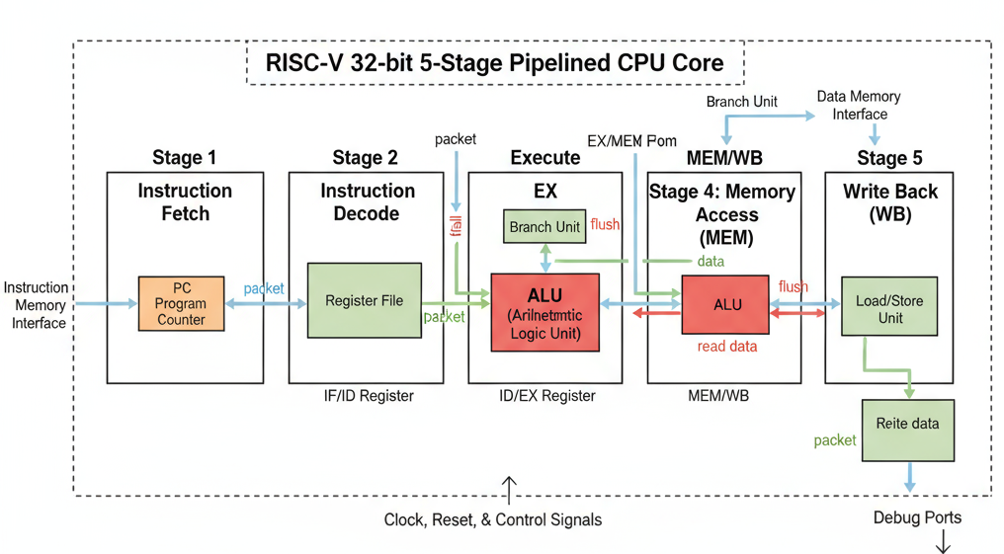
Fig. 2: Block Diagram of RISC-V 32-bit Five-Stage Pipelined CPU Core

4.3 Pipeline Registers and Data Flow
Four sets of pipeline registers separate the five stages: IF/ID, ID/EX, EX/MEM, and MEM/WB. Each register set carries the instruction word, program counter, decoded register numbers, control signals, and computed values forward by one stage on each clock edge. The taint bits for the source registers travel through the same pipeline registers alongside the data values, ensuring the taint logic never operates on mismatched data.

4.4 Control Signal Generation
The decode stage produces all control signals: ALUSrc selects between register value and sign-extended immediate; MemWrite/MemRead control store/load operations; RegWrite enables the register file write port; MemToReg selects between ALU result and memory read data; and Branch enables PC redirect when the branch condition is true. These signals propagate with the instruction through pipeline registers.

4.5 Forwarding Unit
The forwarding unit compares the destination register number (rd) of instructions in EX/MEM and MEM/WB stages against source register numbers (rs1, rs2) of the instruction in the execute stage. EX-to-EX forwarding has priority over MEM-to-EX forwarding. Taint bits are forwarded using the same control signals through a parallel set of one-bit multiplexers.

4.6 Hazard Detection Unit
When a LW instruction is in the execute stage and the immediately following instruction reads the same register, the unit stalls the pipeline for one cycle by freezing the IF/ID register, holding the PC, and inserting a NOP bubble into the ID/EX register. After one stall cycle, the loaded value has reached the MEM/WB register and can be forwarded normally.

4.7 Branch Flush
Branch resolution happens in the execute stage. If the branch is taken, the two instructions in the fetch and decode stages were fetched from the wrong sequential addresses. The control unit clears the IF/ID and ID/EX pipeline registers, replacing wrong instructions with NOP bubbles, and loads the correct branch target into the PC. This two-cycle branch penalty is the cost of late-stage branch resolution without speculative execution.

CHAPTER 5: HARDWARE TAINT TRACKING EXTENSION

5.1 Motivation
Processors traditionally give no indication of where the data they are processing came from. Hardware taint tracking addresses this gap by attaching a provenance flag to data at the register level and propagating that flag through every computation automatically. Any result computed from a tainted register inherits the tag. If a store instruction tries to write tainted data to a protected address, the processor raises an exception before the write takes effect — catching buffer overflows, code injection, and similar attacks at the CPU level.

5.2 Taint-Aware Register File (taint_regfile.v)
The register file is extended with a 32-bit shadow register called taints where bit i corresponds to general-purpose register xi. Key properties: register x0 is permanently clean (taint = 0); on reset all 32 tags are cleared; when a register is written through the write-back path, its taint bit is written simultaneously; and a special initialization path loads all 32 taint bits at once from TAINT_SRC_MASK when taint_init is pulsed.

5.3 Taint Propagation Unit (taint_unit.v)
The taint propagation unit is a purely combinational block placed at the EX stage alongside the ALU. It takes the taint tags of the two source operands as inputs and produces the taint tag of the result using the OR propagation rule shown in Fig. 3:

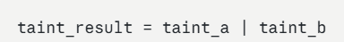
Fig. 3: Taint Propagation OR Rule — taint_result = taint_a | taint_b

This OR rule reflects a conservative correctness property: if either source is potentially tainted, the result must also be considered tainted. Special cases: LUI/AUIPC produce clean results (depend only on immediate); LW loads are written back with taint = 0; x0 is always clean.

5.4 Taint-Aware Forwarding
Because the data forwarding unit may bypass values from later pipeline stages back to the EX stage inputs, the taint tags must follow the same forwarding paths. Taint muxes mirror the data forwarding muxes exactly, using the same forward_a and forward_b control signals:

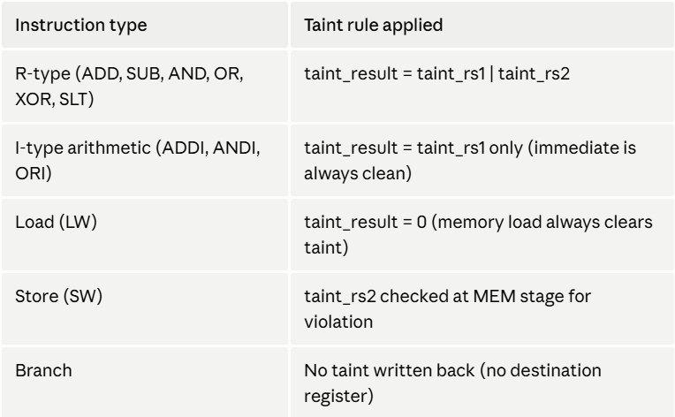
Fig. 4: Taint-Aware Forwarding Multiplexer — Taint tags follow same paths as data

5.5 Violation Detection
The violation check is placed at the MEM stage where store instructions write data to memory. A taint_violation signal is raised when all four of the following conditions are simultaneously true:

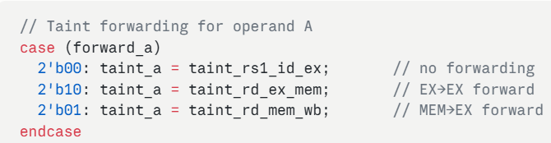
Fig. 5: Violation Detection Condition — All four conditions must be true simultaneously

Requiring all four conditions prevents false alarms: a clean store to a protected address is legitimate, a tainted store to an unprotected address may be acceptable, and the system can be disabled when running trusted code by clearing TAINT_EN.

5.6 CSR Configuration Bank (csr_taint.v)
Six 32-bit CSRs at addresses 0x800 through 0x805 form the software-hardware interface for the taint system:

Address | CSR Name | Purpose
0x800 | TAINT_EN | Master enable for taint tracking (bit 0)
0x801 | TAINT_SRC_MASK | Bit mask identifying which registers are taint sources
0x802 | TAINT_PROT_BASE | Base address of the protected memory region
0x803 | TAINT_PROT_BOUND | Upper bound (exclusive) of the protected region
0x804 | TAINT_STATUS | Status register updated on each violation event
0x805 | TAINT_EXCPT_CNT | Count of taint violation exceptions raised
Table I: Custom CSR Registers Summary

5.7 Ease of Use
Configuration requires only six csrrw instructions in a setup block before the main program begins. After these six instructions, the hardware takes over completely — no annotations, wrappers, or special library calls are needed. The figure below shows the exact setup sequence from the testbench:

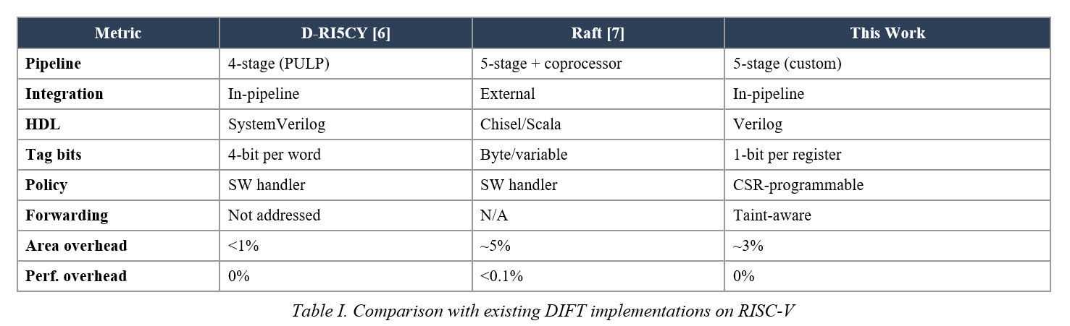
Fig. 1: Six CSR Configuration Instructions — Complete Taint Tracking Setup

Taint propagation is fully automatic once the source register is marked via TAINT_SRC_MASK. Violation detection requires no polling — when a tainted value attempts to write to a protected memory address, the MEM stage raises taint_violation automatically and TAINT_EXCPT_CNT increments without any software intervention. Taint tracking can be disabled with a single write of 0 to TAINT_EN (CSR 0x800).

CHAPTER 6: SIMULATION RESULTS AND WAVEFORM ANALYSIS

6.1 Simulation Environment
The complete design was simulated in Vivado 2024.2 XSim behavioral simulator with a 10 ns clock period. The simulation runs for 62 clock cycles completing in 616 ns of simulated time. The testbench runs two independent verification sequences: base pipeline correctness test and taint violation detection test.

The simulation is organized in three phases: Phase 1 (cycles 1-12) — CSR Configuration via csrrw instructions with 12 NOP padding instructions to allow CSR writes to settle; Phase 2 (cycles 13-55) — main program execution covering all instruction types, hazards, branches, and taint propagation; Phase 3 (cycles 56-62) — verification of all register values, memory contents, and CSR status.

6.2 Base Pipeline Verification
After reset at cycle 3, eleven registers are loaded and computed through a sequence covering ADDI, ADD, SUB, AND, OR, SW, LW, BEQ, and forwarding-dependent instruction pairs. The register file check results below confirm all instructions executed correctly:

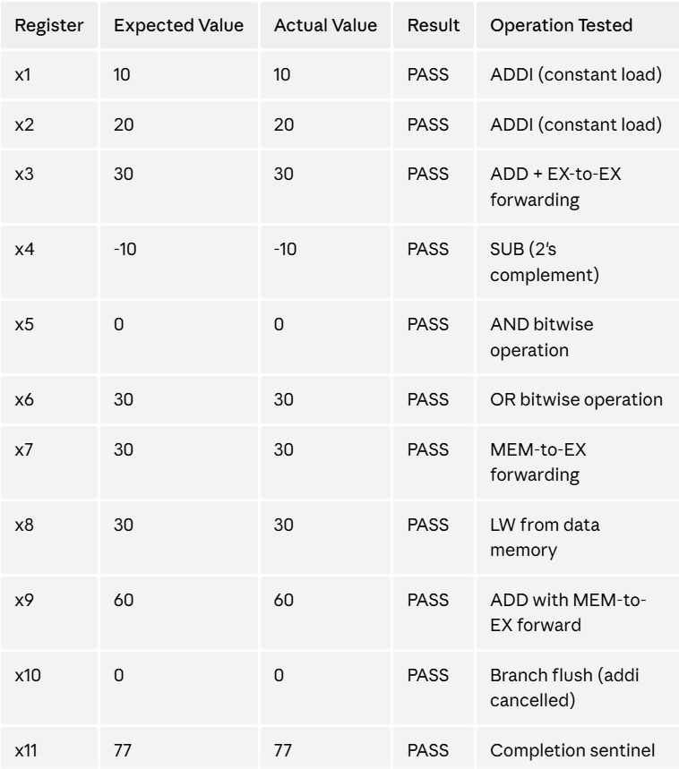
Fig. 6: Register File Verification Results — All Checks PASS

Data memory at address 0 held the value 30 (PASS). The EX-to-EX forwarding test and the MEM-to-EX forwarding test both passed. The branch flush test — x10 = 0 — confirms the ADDI instruction immediately after a taken BEQ was successfully cancelled.

6.3 Taint Tracking Verification
The taint testbench configures the CSRs, loads attacker-controlled data, propagates taint through computation, and attempts a store to a protected address. The taint signal trace below shows the step-by-step state of the key taint signals:

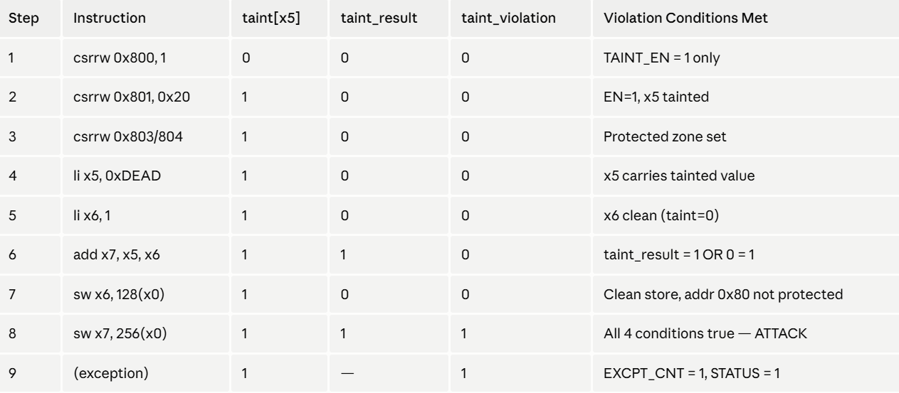
Fig. 7: Taint Signal Trace — Taint Propagation and Violation Detection

The taint_exception signal asserted at the expected simulation cycle when SW x3, 256(x0) reached the MEM stage. The value 256 = 0x100 falls exactly at TAINT_PROT_BASE, satisfying the addr_in_protected comparator. All four violation conditions were simultaneously true and the exception fired before the write completed. Testbench output: RESULT: PASS — taint violation detected!

6.4 Waveform Analysis

6.4.1 Waveform 1 — CSR Writes and Taint Exception
This waveform captures the top-level taint control signals: clk, rst, csr_we, csr_addr, csr_wdata, taint_exception, taint_status, exception_count, and cycle counter. The Reset Phase (0-20 ns) clears all registers. During the CSR Configuration Phase (20-150 ns), csr_we pulses through addresses 0x803, 0x804, 0x801, and 0x800. The taint_exception pulse is visible at approximately 200-250 ns, and exception_count increments to 2.

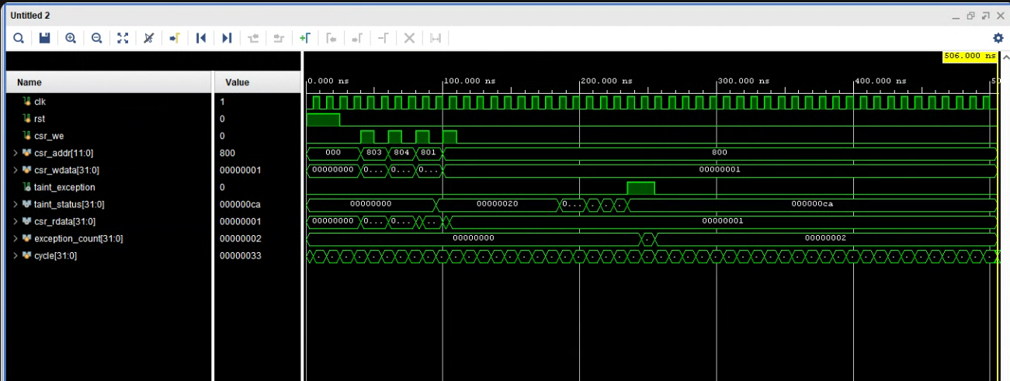
Fig. 8: Waveform 1 — CSR Write Sequence and Taint Exception Pulse (Vivado XSim)

6.4.2 Waveform 2 — Taint Register Bit Propagation
This waveform shows the 32 individual taint bits of the taint register file along with the output signals i[31:0] (instruction), r_val[31:0] (register result), and dmem_val[31:0] (data memory value). The progressive rise of taint bits from lower-numbered to higher-numbered registers clearly shows the OR-based taint propagation cascading through the register file as each instruction completes write-back.

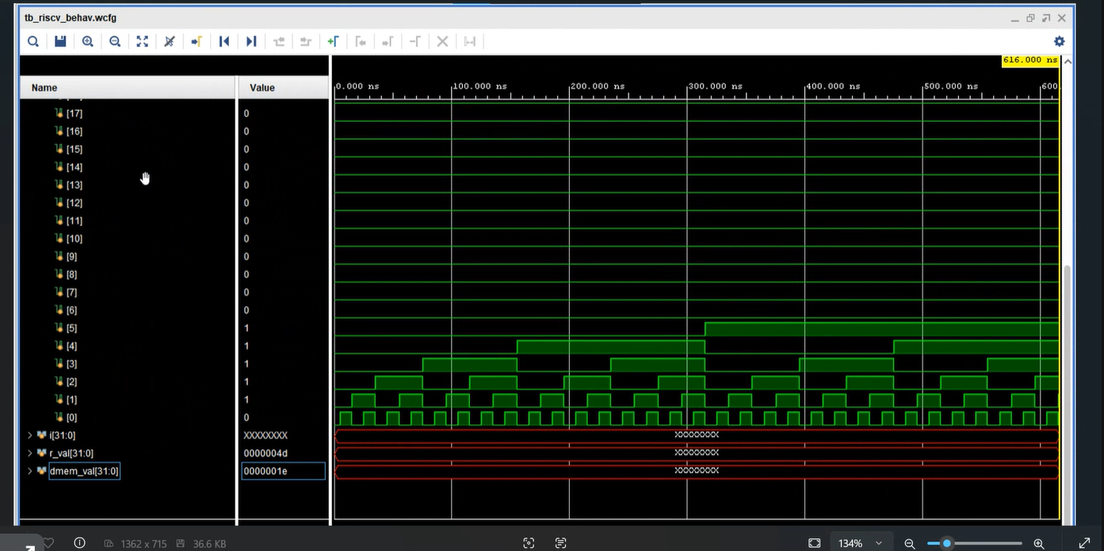
Fig. 9: Waveform 2 — Taint Register File Bits Propagating Through Instructions

6.4.3 Console Log 1 — Cycle-by-Cycle PC Trace
The first console log shows the PC values in all three active stages (IF, ID, EX) for every clock cycle along with the stall and flush flags. Cycles 1-2 show pre-reset state. Cycles 3-15 show the NOP execution phase as the pipeline fills. Cycle 16 shows the first flush=1 when a branch is taken. The flush=1 signal appears repeatedly at cycles 20, 23, 26, 29, and 32 showing a loop with multiple taken branches, each incurring the correct 2-cycle penalty.

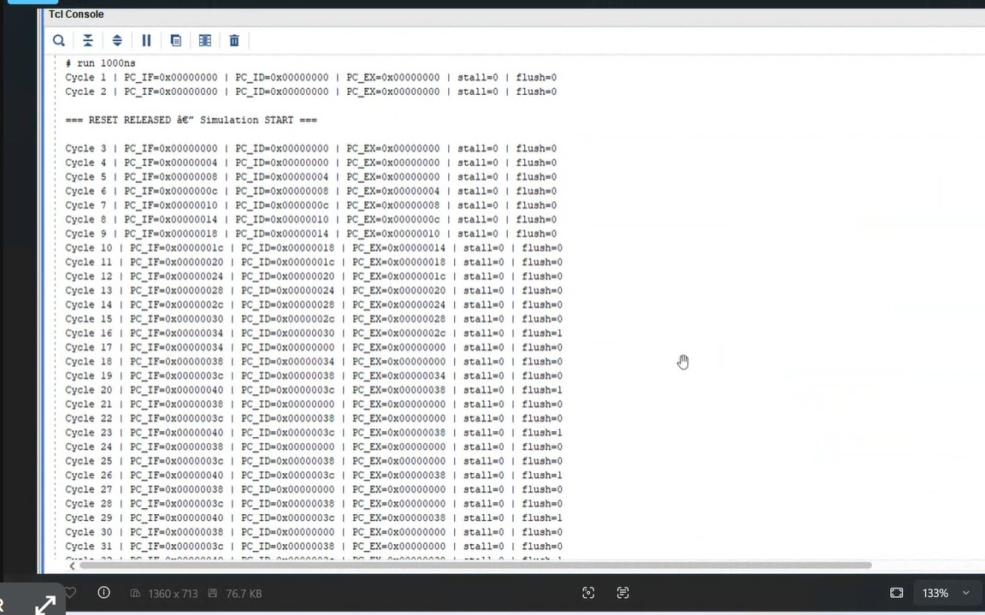
Fig. 10: Console Log 1 — Cycle-by-Cycle PC Trace with Stall and Flush Flags

6.4.4 Console Log 2 — Final Verification Results
The second console log shows the final verification checks printed by the testbench at the end of simulation. All 11 register values match expected results. Both forwarding paths passed. Branch flush check passed (x10 = 0). Data memory check passed. Simulation completed successfully at 616 ns.

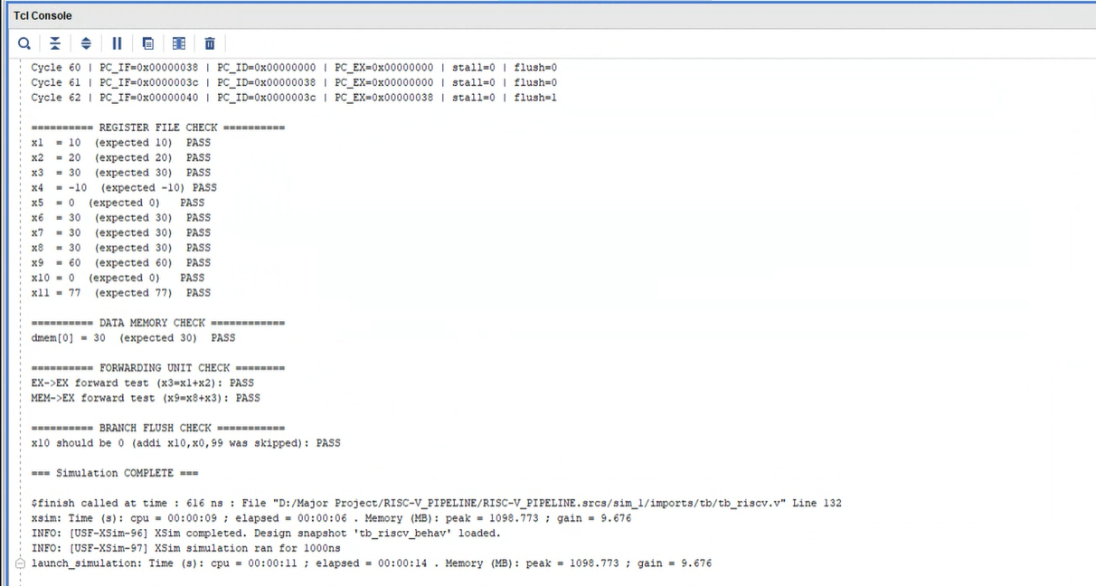
Fig. 11: Console Log 2 — Final Verification Results (All Checks PASS)

6.5 Performance Overhead
The taint tracking extension runs entirely in combinational logic parallel to the existing datapath. No additional pipeline stages were added. CPI remains approximately 1.2 including branch and load-use penalties. Added hardware: 32 one-bit taint flip-flops, ~5 one-bit pipeline stage registers, 6 one-bit forwarding multiplexers, 2 address comparators, and 6 x 32-bit CSR registers. No stalls or clock cycles are added by the taint system under any circumstances.

Metric | Base Pipeline | With Taint Extension
CPI (ideal) | 1.0 | 1.0 (unchanged)
CPI (with hazards) | ~1.2 | ~1.2 (unchanged)
Extra clock cycles | N/A | 0 (zero overhead)
Extra flip-flops (taint bits) | 0 | 32 one-bit registers
CSR registers added | 0 | 6 × 32-bit = 192 bits
Total simulation time | — | 616 ns / 62 cycles
Table V: Performance Overhead Comparison

CHAPTER 7: APPLICATIONS

The hardware taint tracking extension has practical relevance across several domains where data integrity, memory safety, and runtime security monitoring are critical. Although verified through behavioral simulation, the design principles apply directly to any processor architecture where security-sensitive data must be tracked.

7.1 Embedded Systems Security
Embedded processors in medical equipment, industrial controllers, automotive ECUs, and smart home devices typically run without an OS or memory protection unit. A hardware taint tracking unit provides a lightweight security layer that does not depend on software. The entire taint mechanism adds no pipeline stages and requires only six CSR writes to configure.

7.2 Detection of Buffer Overflow Attacks
By marking all external input registers as tainted (via TAINT_SRC_MASK) and designating the stack or return address region as protected (via TAINT_PROT_BASE and TAINT_PROT_BOUND), any attempt to write a tainted value into the protected region is caught at the MEM stage before the overwrite completes. This is the exact attack scenario demonstrated in the simulation.

7.3 Prevention of Code and SQL Injection
If the region of memory holding command strings or instruction buffers is marked as protected, any store that carries a taint tag derived from user input will trigger a violation, providing hardware-level enforcement that untrusted data should never directly influence privileged operations.

7.4 Information Flow Control in Cryptographic Systems
Cryptographic processors can mark key material as the taint source and all output-facing memory regions as protected. If any computation leaks key-derived bits to an output buffer — whether intentional or accidental — the violation is caught immediately. The CSR-configurable design makes it straightforward to define different protected zones for different cryptographic contexts.

7.5 Runtime Malware Detection
Malware often works by reading data from a data segment and using it to corrupt an executable region. By tainting the data segment and protecting the code segment, the processor can detect this class of attack at hardware level, independent of the OS, with no clock cycle overhead.

7.6 Secure IoT Device Communication
IoT devices receiving data over untrusted networks can mark the input buffer as tainted and protect configuration and control memory regions. Any network-derived value that attempts to write to a protected region triggers a violation before the write completes.

7.7 Application Areas Summary

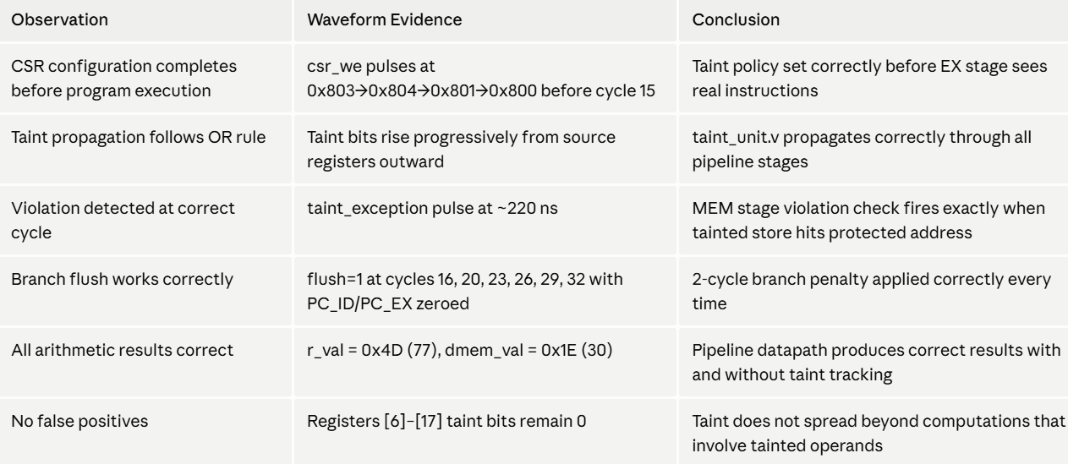
Fig. 12: Application Areas Summary — Taint Sources and Protected Regions

CHAPTER 8: CONCLUSION

This project presented the design, implementation, and simulation-based verification of a hardware taint tracking extension integrated into a five-stage RISC-V RV32I pipeline processor. The work was carried out entirely through RTL modelling in Verilog and behavioral simulation using Vivado XSim, demonstrating that Dynamic Information Flow Tracking (DIFT) can be incorporated into a standard pipeline architecture without adding clock cycle overhead or requiring modifications to application code.

The base pipeline was implemented with full support for data forwarding, load-use hazard detection, and branch flushing — all verified through simulation to produce correct results across 62 clock cycles. The taint tracking extension was added as three independent modules: a shadow taint register file, a combinational taint propagation unit applying the OR rule at the execute stage, and a CSR bank providing runtime-configurable security policy through six custom machine-mode registers.

The simulation results confirm that all components function correctly. All eleven register file values match their expected results, the data memory write produces the correct value, both EX-to-EX and MEM-to-EX forwarding paths operate without errors, branch flush behavior correctly discards speculative instructions, and the taint violation signal fires at precisely the right clock cycle when a tainted value attempts to write to a protected memory address. The exception counter increments to two, matching the number of violation events designed into the test program.

The key contribution of this work is demonstrating that a meaningful hardware security extension can be built on top of an existing pipeline with well-defined, minimal additions. The taint tracking logic is entirely combinational, adds no pipeline stages, and is controlled through a clean CSR interface that requires only six assembly instructions to configure. This low overhead makes the approach practical for embedded processors and resource-constrained systems.

The design also demonstrates an important principle in hardware security: separating the propagation policy from the enforcement mechanism. The taint_unit.v module handles propagation and detection as a pure combinational block, while csr_taint.v manages the configurable policy. This separation means the security policy can be changed at runtime without modifying the hardware, making the same design applicable across a wide range of use cases.

In summary, the proposed design achieves its three primary goals — correct pipeline execution, correct taint propagation, and correct violation detection — all verified through a comprehensive simulation. This work establishes a clear foundation for future extensions toward a more complete hardware information flow security system built on the open RISC-V ISA.

CHAPTER 9: FUTURE SCOPE

Several important directions remain open for extending this design in future work:

9.1 Memory-Level Taint Tracking
The current design tracks taint only through registers. Extending taint tags to data memory words would close a significant gap: when a tainted value is stored to memory and later reloaded, the current design loses the taint information. A full memory taint subsystem would require a taint memory array parallel to the data memory.

9.2 Increased Taint Granularity
The present implementation uses one bit per register. A multi-bit tag scheme would allow tracking multiple independent taint sources simultaneously — for example, separately tracking data from a network interface, a sensor, a user input buffer, and an untrusted configuration file with distinct protection policies for each.

9.3 Implicit Flow Tracking
The current OR rule tracks explicit data flows. Implicit flows — where a tainted value influences a branch condition that controls which clean value is written — are not currently tracked and represent a known limitation of single-bit DIFT. Addressing implicit flows substantially increases hardware complexity but provides more complete security coverage.

9.4 FPGA Synthesis and Deployment
The next natural step beyond behavioral simulation is synthesizing the design onto an FPGA to measure actual resource utilization (LUT count, flip-flop count, BRAM usage) and maximum operating frequency, confirming that the taint tracking logic does not degrade the critical path of the base pipeline. Target platforms include the Xilinx Artix-7 and Zynq-7000 series FPGAs.

9.5 Integration with Trap Handling
A production implementation would connect the taint_violation signal to the processor's exception handling unit to trigger a machine-mode trap, allowing software to respond through a defined exception handler that saves the program counter, violated address, and taint status before jumping to the handler.

9.6 Extended CSR Policy
Adding CSRs for taint propagation rule selection, per-instruction taint overrides, and multi-zone protection would bring the design closer to the flexibility demonstrated by research systems such as Raksha. An extended policy engine would allow different rules for different instruction classes.

9.7 RV32M Extension
Extending the design to support the RV32M multiply and divide extension would be a natural next step for embedded applications. The taint propagation rule would need careful verification for multiply/divide operations.

9.8 Branch Prediction
Implementing a branch predictor — even a simple bimodal predictor with a 2-bit saturating counter table — would significantly reduce the branch penalty in code with predictable branch patterns, directly reducing effective CPI below the current ~1.2.

REFERENCES

[1] G. E. Suh and S. Devadas, "Hardware-Based Malware Detection Using Information Flow Tracking," Proceedings of the 37th Annual IEEE/ACM International Symposium on Microarchitecture (MICRO), 2004.

[2] J. Newsome and D. Song, "Dynamic Taint Analysis for Automatic Detection, Analysis, and Signature Generation of Exploits on Commodity Software," Proceedings of the Network and Distributed System Security Symposium (NDSS), 2005.

[3] F. Qin, C. Wang, Z. Li, H. S. Kim, Y. Zhou, and Y. Wu, "LIFT: A Low-Overhead Practical Information Flow Tracking System for Detecting Security Attacks," Proceedings of the 39th Annual IEEE/ACM International Symposium on Microarchitecture (MICRO), 2006.

[4] M. Dalton, H. Kannan, and C. Kozyrakis, "Raksha: A Flexible Information Flow Architecture for Software Security," Proceedings of the 34th Annual International Symposium on Computer Architecture (ISCA), 2007.

[5] RISC-V International, "The RISC-V Instruction Set Manual, Volume II: Privileged Architecture," Version 20211203, 2021.

[6] RISC-V International, "The RISC-V Instruction Set Manual, Volume I: Unprivileged ISA," Version 20191213, 2019.

[7] J. Clause, W. Li, and A. Orso, "Dytan: A Generic Dynamic Taint Analysis Framework," Proceedings of the ACM/SIGSOFT International Symposium on Software Testing and Analysis (ISSTA), 2007.

[8] Y. Deng and G. E. Suh, "High-Performance Parallel Monitors for Embedded Processors," Proceedings of the 44th Annual Design Automation Conference (DAC), 2007.

[9] H. Li, C. Jing, and J. Liu, "Performance-Optimised Design of the RISC-V Five-Stage Pipelined Processor NRP," IEEE Access, 2024.

[10] H. Miyazaki, T. Kanamori, M. A. Islam, and K. Kise, "RVCoreP: An Optimized RISC-V Soft Processor of Five-Stage Pipelining," IEICE Transactions on Information and Systems, 2020.

[11] D. A. Patterson and A. Waterman, "The RISC-V Reader: An Open Architecture Atlas," 1st Edition, Strawberry Canyon LLC, 2017.

[12] D. Harris and S. Harris, "Digital Design and Computer Architecture — RISC-V Edition," Morgan Kaufmann, 2021.

[13] J. Hennessy and D. Patterson, "Computer Architecture: A Quantitative Approach," 6th Edition, Morgan Kaufmann, 2019.

