BMI CALCULATOR
- PROJECT OVERVIEW
Healzy's BMI (Body Mass Index) Calculator computes BMI from weight and height, classifies the result per WHO categories, and shows contextual, non-medical insights. Age and Gender fields are OPTIONAL and used only to tailor informational notes; they DO NOT change the BMI formula or category.
Project Link: https://stalwart-crostata-c590d8.netlify.app/

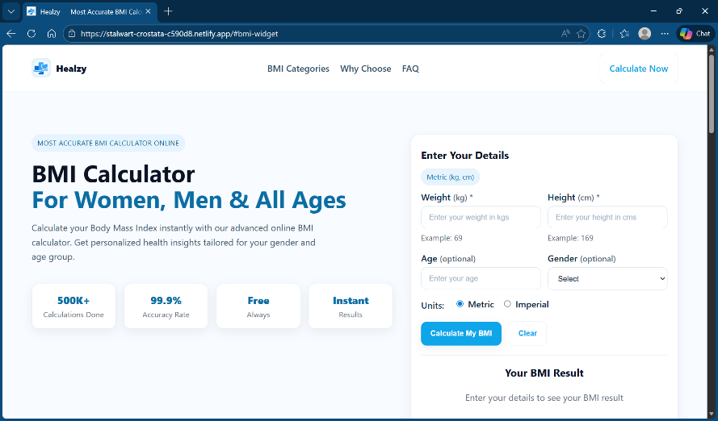

- FUNCTIONAL REQUIREMENTS
2.1 Input requirements
FIELD | TYPE | REQUIRED | VALIDATION
WEIGHT | Number | Yes | Metric: 1–500 kg; Imperial: 1–1100 lb; Positive only
HEIGHT | Number / Text (imperial feet ‘inches supported) | Yes | Metric: 30–300 cm; Imperial: 1–120 in; Positive only
AGE | Number | Optional | If provided: integer 1–120
GENDER | Select (Female/Male/Other) | Optional | If provided: must be one of the listed options
UNITS | Radio (metric/imperial) | Yes (default metric) | Switching units updates labels, placeholders, examples, and max values
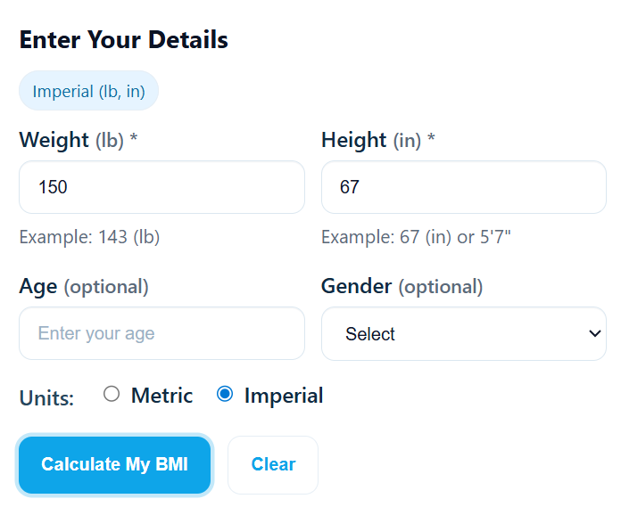
  - Formulas
Metric: BMI = weight (kg) / (height (m)) ^2
Imperial: BMI = 703 × weight (lb) / (height (in)) ^2

  - Output requirements
OUTPUT | DESCRIPTION
BMI Value | Displayed with two decimals.
BMI Category | Underweight, Normal weight, Overweight, or Obesity as per WHO ranges.
Tip Line | Short, non-medical guidance text per category.
Personalized Insights | Optional notes influenced by Age/Gender if provided.

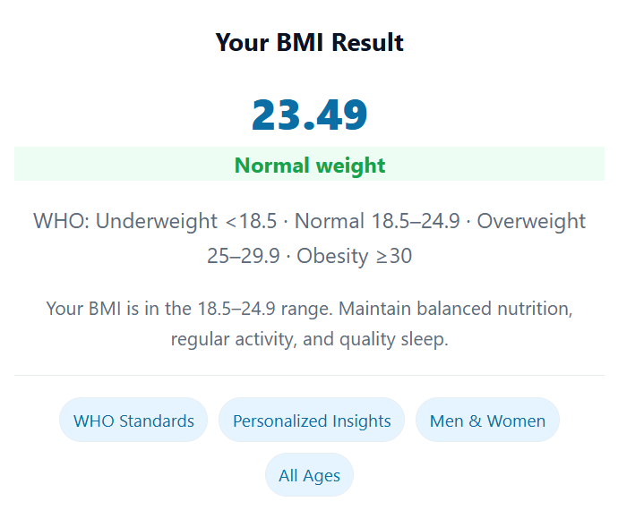
- BMI CLASSIFICATION
BMI RANGE | CATEGORY
< 18.5 | Underweight
18.5 – 24.9 | Normal Weight
25.0 – 29.9 | Overweight
≥ 30.0 | Obesity

- CORE FUNCTIONAL SCENARIOS
Units | Weight | Height | Age | Gender | Expected BMI | Expected Category | Notes
Metric | 69 kg | 169 cm |  |  | 24.16 | Normal weight | Standard case
Metric | 60 kg | 165 cm | 25 | Female | 22.04 | Normal weight | Age/Gender optional; accepted
Metric | 53.46 kg | 170 cm |  |  | 18.5 | Normal weight | Boundary 18.5 → Normal
Metric | 71.96 kg | 170 cm |  |  | 24.9 | Normal weight | Upper Normal 24.9
Metric | 72.25 kg | 170 cm |  |  | 24.65 | Normal weight | Boundary 25.0 → Overweight
Metric | 86.70 kg | 170 cm |  |  | 30.0 | Obesity | Boundary 30.0 → Obesity
Imperial | 150 lb | 67 in |  | Male | 23.49 | Normal weight | Traditional inches input

4.1 Edge Cases
- Weight empty/zero/negative/non-numeric → appropriate weight error messages.
- Height empty/zero/negative/non-numeric → appropriate height error messages.
- Metric: weight>500 or height>300 triggers max-limit messages.
- Imperial: weight>1100 or height>120 triggers max-limit messages.
- Age blank: accepted. Age non-numeric or out of 1–120: error.
- Gender not selected: accepted. Invalid option (via dev tools): rejected (UI only offers valid options).

Team - Lampart
INTQEA26SD002

