Week 3 – Development & Implementation

1. Introduction
In Week 3, the chatbot prototype was further developed by integrating AI search algorithms with database connectivity. The objective was to create a Smart Campus Assistant capable of:
- Providing navigation between campus facilities using AI search techniques.
- Answering frequently asked questions (FAQs) related to departments and staff.
This builds upon Week 1 (problem proposal) and Week 2 (campus map and requirements).

2. Chatbot Interface Development
The chatbot was developed using Python (with optional Rasa integration). It supports both text and simple rule-based queries. Slots such as source, destination, and department were defined.
Example Queries:
- “Show me the path from Hostel to Library”
- “Who is the HOD of CSE?”
The chatbot responds with either:
- AI-generated paths (using BFS, DFS, UCS, or A*).
- Database queries (for staff and department FAQs).

3. Navigation Module Implementation
The campus navigation problem was modeled as a graph:
- Nodes → Buildings and facilities (Library, Hostel, Sports Complex, etc.)
- Edges → Distances between them (in meters)
The following AI search algorithms were implemented:
- BFS (Breadth-First Search) – explores neighbors level by level.
- DFS (Depth-First Search) – explores deeper paths first.
- UCS (Uniform Cost Search / Dijkstra) – guarantees the shortest path by distance.
- A* – uses both path cost and heuristic (Euclidean distance).

Sample Output: Hostel → Library

Algorithm | Path | Distance | ETA (Walking)
BFS | Hostel → Food Court → AC2 → Library | 500 m | ~6 min
DFS | Hostel → Sports Complex → … → Library | Longer | Higher
UCS | Hostel → Food Court → AC2 → Library | 500 m | ~6 min
A* | Hostel → Food Court → AC2 → Library | 500 m | ~6 min

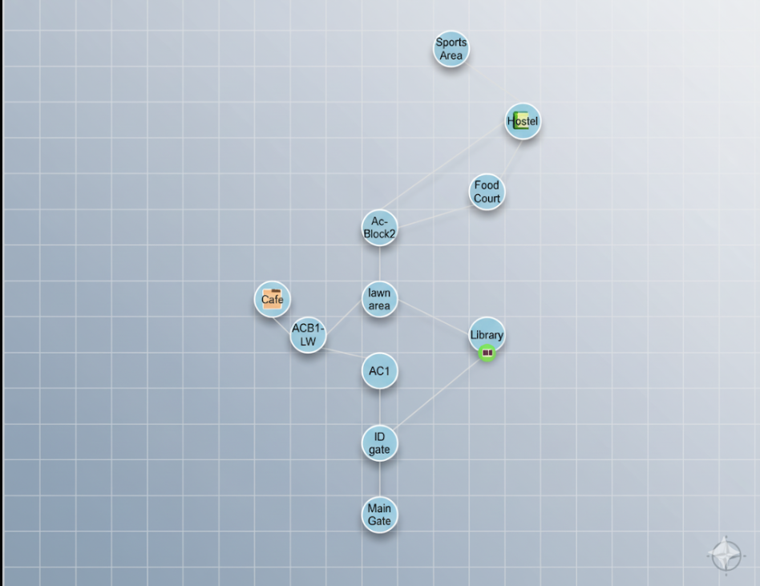

4. Database Connectivity
An SQLite database was created to store:
- Staff details (name, department, designation, contact)
- Department information (location, HOD)
- Facility data (timings, location)
The chatbot queries this database for FAQ-related responses.
Example Query:
- User: “Who is the HOD of CSE?”
- Chatbot: “The HOD of CSE is Dr. XYZ (Contact: 9876543210).”

5. Deliverables
By the end of Week 3, the following were completed:
Prototype chatbot capable of:
- Navigation queries (BFS, DFS, UCS, A*).
- FAQ queries from the database.
Working database connection (SQLite).

6. Conclusion
Week 3 successfully delivered a functional Smart Campus Assistant that integrates:
- AI search algorithms for shortest path navigation
- Database queries for staff and department information
- Chatbot interface for user interaction

