WAP to convert all non-diagonal ele’s to 0’s in a matrix that is filled with non-zero ele’s the given matrix will be of n*n
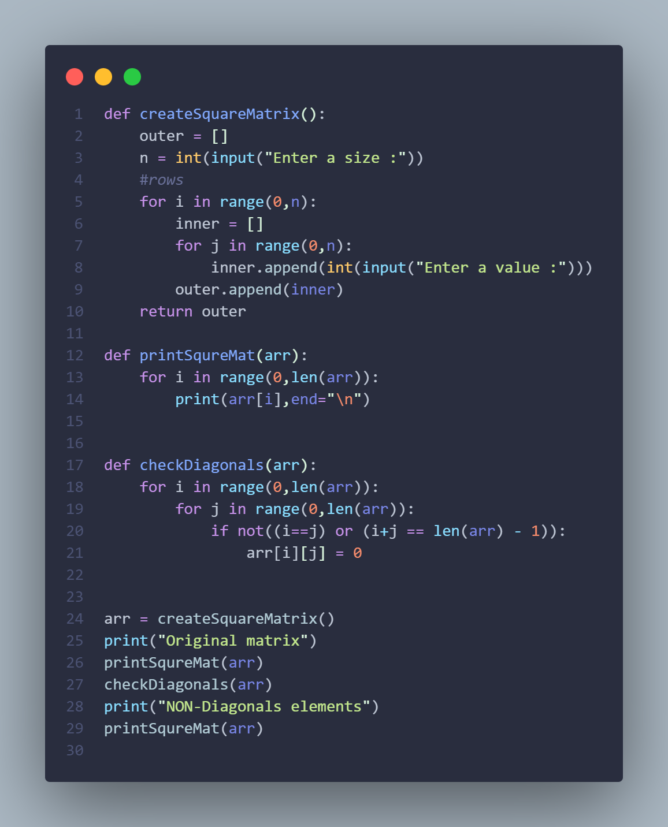

WAP to reverse each indusial row in a matrix
