COVERSION FRO CHARARRAY TODATE

-------------------------------------------------------------------------

1. File.txt Input

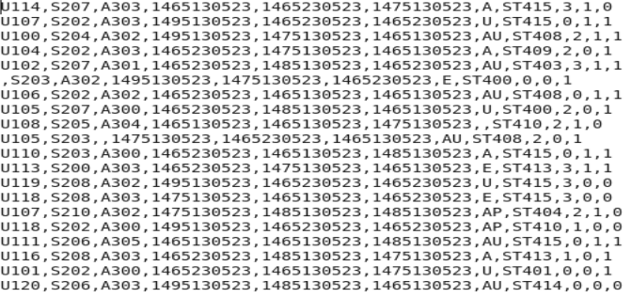

------------------------------------------------------------------------

Commands Used to Converting chararray to TimeStamp

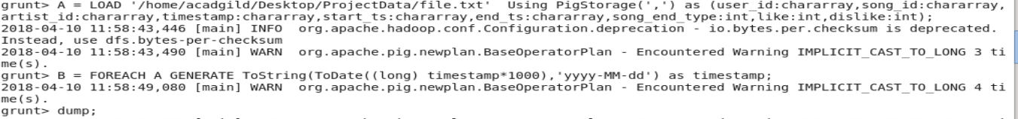

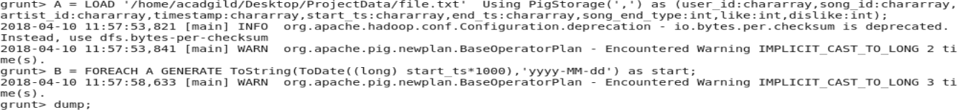

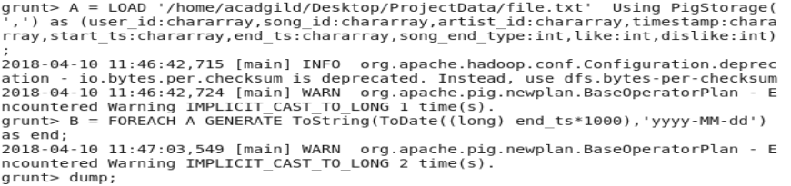

----------------------------------------------------------------

OutPut



