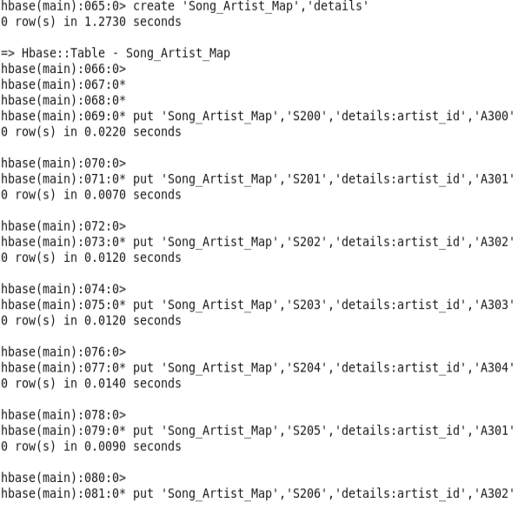

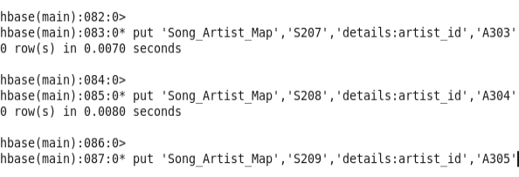

OUTPUT



