1. Data created and transferred to hdfs

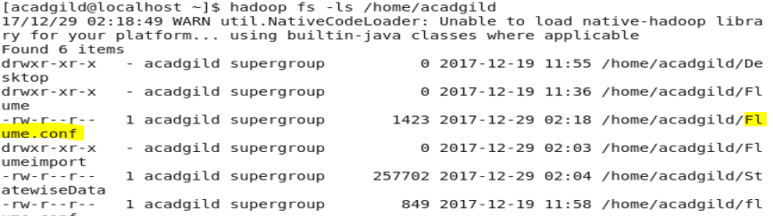

2. Flume.Conf File.

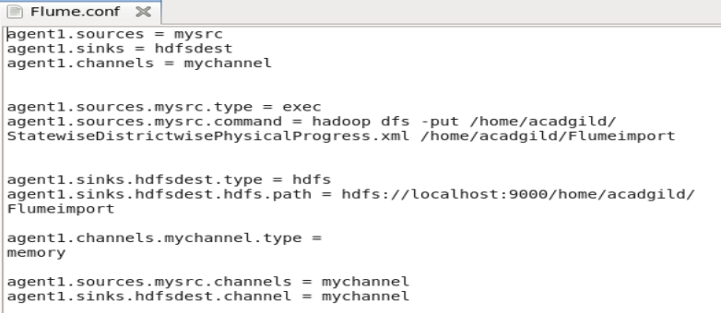

3. Flume-Agent

Command1

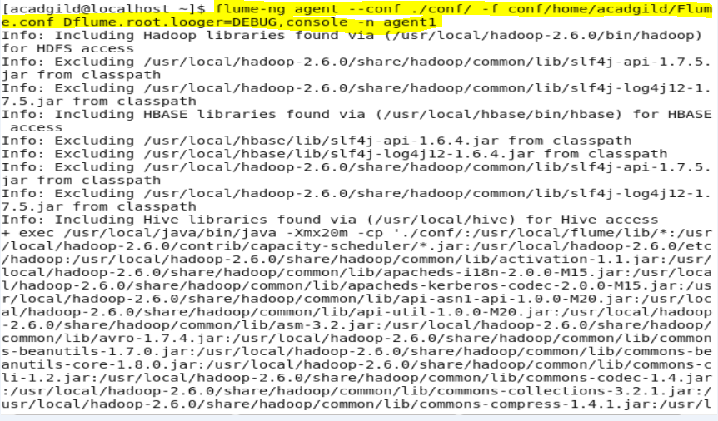

OutPut File1

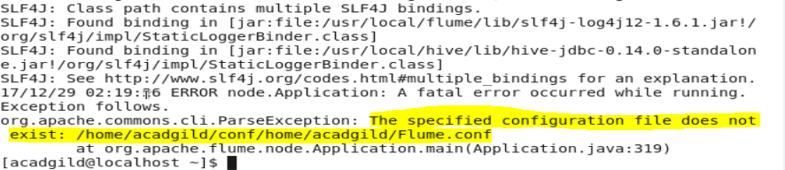

4. Command2



Output2

