1. File Created

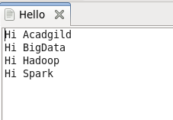

2. My File



3. Code and Lines Display



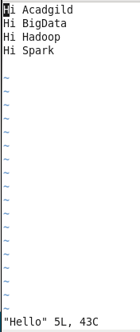

4. Code Printing the Lines.



5. Output

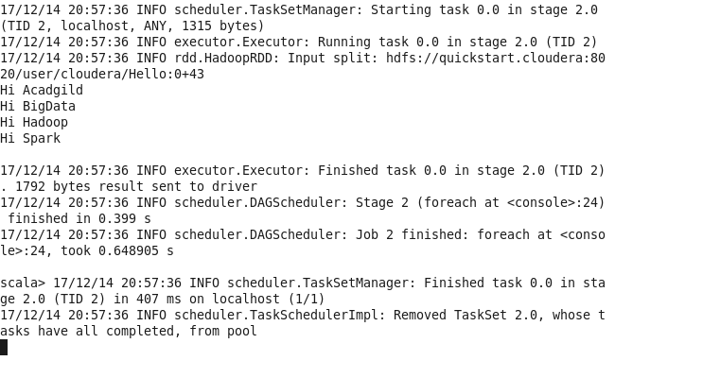

6. Code for counting the number of lines.

