**PROBLEM-I**

1. Create RDD and the FileData



2. count of students per grade in the school



3. Distinct subjects

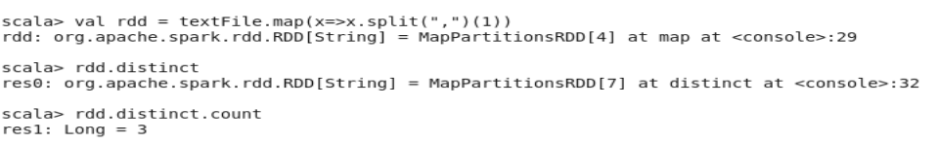

4. Count number of students with Name “Mathew” and marks “55”







**PROBLEM-II**

1.

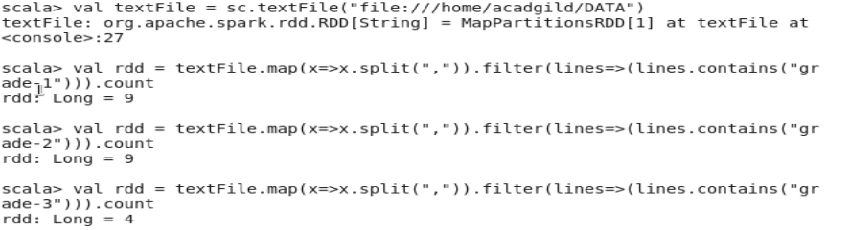

2. Average



3. Average score of students in each subject across all grades

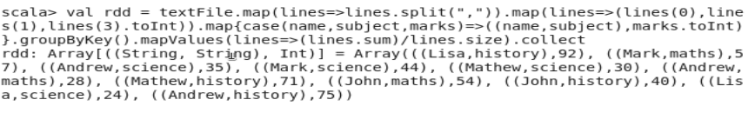

4. Average score of students in each subject per grade



5.

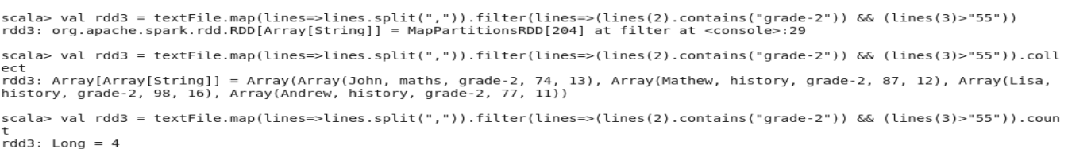

**PROBLEM-III**

Criteria do not match,

