INTERFACING BE33 WITH STM32 AND RUGGED BOARD

PRESENTED BY
MANJUNATH.EL
PRADEEP.S
PAVITHRA.R

TABLE OF CONTENTS:

1.Project Summary
2.Key Features of the Project
3.Hardware Used and there Specification
3.1 BE33 Bluetooth Module
3.2 USB TTL
3.3 Rugged Board
3.4 STM32 Microcontroller
4.Stages to implement the sensor
4.1 BE33 with TTL
4.2 BE33 with rba5d2x
4.3 BE33 with rba5d2x and STM32
5.Connection Diagram for all Stages
6.Code Snippet to Bluetooth Module initialization
and connection with AT commands
7.Project Code
8.Results
9.Conclusion and Future of the Project
10.Real time Applications

1.PROJECT SUMMARY :
The project involves the integration of a BE33 Bluetooth module with a TTL (Transistor-Transistor Logic) interface, a rugged board (A5D2x), and an STM32 microcontroller to establish a robust and versatile wireless communication system. The BE33 Bluetooth module serves as the wireless communication bridge, enabling seamless data exchange between the rugged board and external devices. The TTL interface facilitates the connection between the BE33 module and the rugged board, allowing for reliable UART-based communication. The rugged board, A5D2x, with its durable and ruggedized design, enhances the project's suitability for deployment in challenging environments. The STM32 microcontroller acts as the central processing unit, managing the communication between the Bluetooth module and the rugged board while providing additional processing capabilities. This integrated system is designed to support various applications, such as IoT deployments and industrial automation, where wireless communication, ruggedness, and microcontroller processing are critical. The project aims to offer a comprehensive solution for wireless data transfer and control, leveraging the capabilities of the BE33 Bluetooth module, TTL interface, rugged board, and STM32 microcontroller in a synergistic manner.

This comprehensive project leverages the BE33 Bluetooth module, TTL interface, rugged board A5D2x, and an STM32 microcontroller to create a robust and adaptable wireless communication system. The BE33 Bluetooth module facilitates seamless wireless connectivity, allowing for efficient data exchange between the rugged board and external devices. The integration of a TTL interface ensures a reliable communication link, utilizing UART protocols for effective information transfer. The rugged board, A5D2x, adds a layer of durability and resilience, making the system well-suited for deployment in challenging environments that demand robust performance. The STM32 microcontroller, functioning as the central processing unit, orchestrates the communication between the Bluetooth module and the rugged board, while also providing additional processing power for enhanced versatility.

2. KEY FEATURES OF THE PROJECT :
The project involving the interfacing of a BE33 Bluetooth module with a rugged board and STM32 microcontroller brings together various features to enable robust and wireless communication in challenging environments. Key features of the project include:

- Wireless Connectivity:
  - The integration of the BE33 Bluetooth module enables wireless communication between the rugged board and other Bluetooth-enabled devices, facilitating remote data exchange and control.

- Rugged Board Compatibility:
  - The project ensures seamless integration with a rugged board, making it suitable for deployment in harsh environments where durability and reliability are essential.
- STM32 Microcontroller Integration:
  - The STM32 microcontroller serves as the central processing unit, managing the communication interface between the Bluetooth module and the rugged board. Its capabilities enhance the project's overall performance and versatility.
- UART Communication:
  - The project utilizes UART communication protocols between the BE33 Bluetooth module and the STM32 microcontroller, ensuring efficient and reliable data transfer.
- Versatile Applications:
  - The combined system is adaptable to various applications, including Internet of Things (IoT) deployments, industrial automation, and outdoor monitoring, where ruggedness and wireless connectivity are crucial.
- Remote Monitoring and Control:
  - The wireless communication capabilities enable remote monitoring and control of the rugged board, providing flexibility in managing devices and processes.
- USB Compatibility:
  - The system may also incorporate USB connectivity through the STM32 microcontroller, allowing for additional wired communication options and flexibility in interfacing with different devices.
- Configurability:
  - The project offers configuration options for optimizing performance based on specific application requirements, ensuring adaptability to diverse use cases.
- Data Security and Encryption:
  - Security features may be implemented, such as data encryption, to safeguard sensitive information during wireless transmission, enhancing the overall integrity of the system.
- Power Efficiency:
  - The project may include power optimization mechanisms to ensure efficient energy usage, extending the operational life of the system, particularly in remote or battery-powered applications.

3.HARDWARE USED AND THERE SPECIFICATIONS:

3.1 BE33 BLUETOOTH MODULE

BE33 is a high performance, super efficient BLE 5.2 module, targeted for applications where highly reliable wireless connection, ultra low power consumption and ease of integration are the key requirements. BE33 modules are ideal for battery operated applications that require medium to long range connectivity. BE33 modules features a high performance integrated chip antenna with native USB 2.0 support.Bluetooth modules are compact electronic devices that enable wireless communication between devices over short distances. These modules typically adhere to the Bluetooth standard and are widely used for establishing connections between various electronic devices, such as microcontrollers, single-board computers, and embedded systems. Bluetooth modules like BE33 often support protocols like UART for serial communication and are designed for easy integration into electronic projects. They may have features such as low energy consumption, different operational modes (master or slave), and compatibility with various Bluetooth profiles. These modules are commonly used in applications like IoT devices, home automation, and industrial automation for creating wireless links between devices for data transfer and control. For specific details about the BE33 Bluetooth module, please refer to the product datasheet, user manual, or contact the manufacturer directly for the most accurate and up-to-date information.

3.2 USB TTL

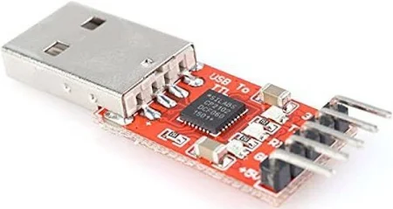

A USB TTL (Transistor-Transistor Logic) adapter is a compact electronic device that serves as an interface between a device with TTL-level serial communication and a computer or other USB-enabled host device. This adapter is commonly used in electronics projects and embedded systems to facilitate communication between microcontrollers, sensors, or other devices with UART (Universal Asynchronous Receiver-Transmitter) interfaces and a computer's USB port. The USB TTL adapter typically features RX (receive), TX (transmit), and ground pins, which are connected to the corresponding pins on the device with TTL-level serial communication. This enables bidirectional data transfer, allowing the microcontroller or device to communicate with and be controlled by software running on the computer. USB TTL adapters are versatile tools, providing a convenient way to bridge the gap between devices operating at TTL logic levels and modern computing systems with USB connectivity. They find applications in programming, debugging, and configuring various electronic devices, offering a simple and efficient solution for serial communication over USB.

3.3 RUGGED BOARD

RuggedBoard - A5D2x is a Single Board Computer providing as easy migration path from Microcontroller to Microprocessor. RuggedBoard is enabled with industry Standard Yocto Build Embedded Linux platform and open-source libraries for industrial application development. RuggedBoard is an open source industrial single board computer powered by ARM Cortex-A5 SoC @500 MHz, implemented with the finest platform for rapid prototyping. The usage of System On Module over a System On Chip is the most rapid way to achieve time to market, curtail development risks for product quantities ranging from a few hundred to thousands.
RuggedBoard- A5D2x consists of multiple interfaces such as Ethernet, RS232, CAN, RS485, Digital Input and Digital Output with optically isolated, Standard MikroBus header for Add-On Sensors, Actuators and Multiple Wireless Modules such as ZigBee, LoRa, Bluetooth etc. mPCIe connector with USB interface used for Cloud Connectivity modules 3G, 4G, NB-IoT, WiFi. Expansion header with GPIO, UART, I2C, SPI, PWR etc.

The pin diagram of RuggedBoard - A5D2x shown in below.
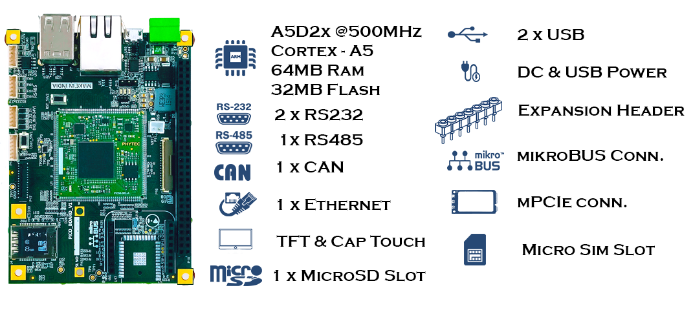

RuggedBoard - A5D2x Specifications:
1. System On Module
• SOC: Microchip ATSAMA5d2x Cortex-A5
• Frequency: 500MHz
• RAM: 64 MB DDR3
• Flash: 32 MB NOR flash
• SD Card : Upto 32 GB
2. Industrial Interface
• RS232: 2x RS232
• USB: 2 x USB*(1x Muxed with mPCIe)
• Digital Input: 4x DIN (Isolated ~ 24V)
• Digital Output: 4x DOUT (Isolated ~ 24V)
• RS485: 1xRs485
• CAN: 1xCAN
3. Internet Access
• Ethernet: 1 x Ethernet 10/100
• Wi-Fi/BT: Optional on Board Wi-Fi/BT
• SIM Card: 1 x SIM Slot (for mPCIe Based GSM Module)
4. Add-On Module Interfaces
• Mikro-BUS: Standard Mikro-BUS
• mPCIe: 1 x mPCIe* (Internally USB Signals is used)
• Expansion Header: SPI, I2C, UART, PWM, GPIO,ADC

5. Power
• Input Power: DC +5V or Micro USB Supply
• Temperature Range: - 40°to + 85°C
6. Optional Accessories
• Accessories Set Micro USB Cable, Ethernet Cable, Power Adapter 5V/3A

3.4 STM32 MICROCONTROLLER

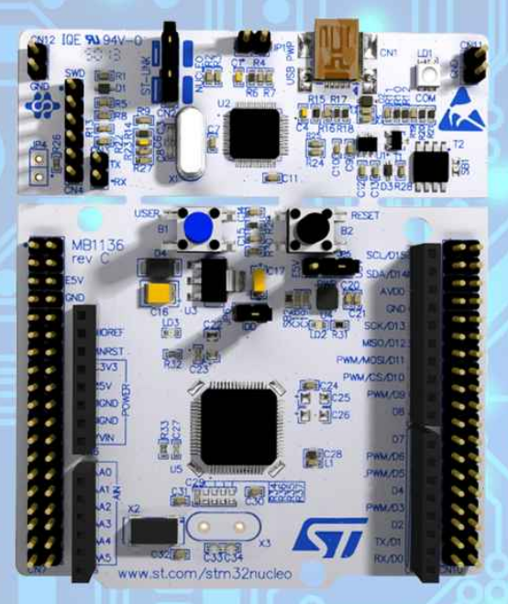

The STM32F446xC/E devices are based on the high-performance Arm® Cortex®-M4 32-bit RISC core operating at a frequency of up to 180 MHz. The Cortex-M4 core features a floating point unit (FPU) single precision supporting all Arm® single-precision data-processing instructions and data types. It also implements a full set of DSP instructions and a memory protection unit (MPU) that enhances application security.The STM32F446xC/E devices incorporate high-speed embedded memories (Flash memory up to 512 Kbytes, up to 128 Kbytes of SRAM), up to 4 Kbytes of backup SRAM, and an extensive range of enhanced I/Os and peripherals connected to two APB buses, two AHB buses and a 32-bit multi-AHB bus matrix.All devices offer three 12-bit ADCs, two DACs, a low-power RTC, twelve general-purpose 16-bit timers including two PWM timers for motor control, two general-purpose 32-bit timers.They also feature standard and advanced communication interfaces.Integration of services from STM32CubeMX:STM32 microcontroller, microprocessor, development platform and example project selectionPinout, clock, peripheral, and middleware configurationProject creation and generation of the initialization codeSoftware and middleware completed with enhanced STM32Cube Expansion Packages . Based on Eclipse®/CDT™, with support for Eclipse® add-ons, GNU C/C++ for Arm® toolchain and GDB debugger. STM32MP1 Series:Support for OpenSTLinux projects: LinuxSupport for Linux. Additional advanced debug features including:CPU core, peripheral register, and memory

4.STAGES TO IMPLEMENT SENSOR :

4.1 BE33 WITH USB TTL

Interfacing a BE33 Bluetooth module with a USB TTL (Transistor-Transistor Logic) adapter involves establishing a wireless communication bridge between the module and a computer or other USB-enabled devices. The BE33 Bluetooth module typically utilizes UART (Universal Asynchronous Receiver-Transmitter) communication, and a USB TTL adapter serves as a convenient interface between the module and the USB port of a host device. To achieve this, connect the TX (transmit), RX (receive), and ground pins of the BE33 module to the corresponding pins on the USB TTL adapter. The USB TTL adapter can then be plugged into a USB port on a computer or embedded system. This setup allows for bidirectional communication between the BE33 Bluetooth module and the host device, enabling wireless data transfer and control. The USB TTL adapter acts as a converter, translating the UART signals from the Bluetooth module into a format compatible with USB, facilitating seamless integration and communication between the BE33 module and USB-enabled devices. This interfacing solution is particularly useful for applications that require wireless connectivity and control in scenarios where a direct physical connection is impractical or inconvenient.

4.2 BE33 With rba5d2x
Interfacing a BE33 Bluetooth module with a rugged board involves establishing a wireless communication link between the two components, enabling seamless data exchange in challenging environments. The BE33 Bluetooth module is designed for robust connectivity and can be integrated with rugged boards for applications in industries such as IoT, automation, and outdoor environments. The process typically includes connecting the BE33 module to the rugged board's communication interfaces, such as UART or SPI, to facilitate data transmission. Additionally, the rugged board may require configuration settings to ensure compatibility and optimize performance. The Bluetooth module enables the rugged board to wirelessly communicate with other devices, expanding its versatility in harsh conditions where wired connections may be impractical. This interfacing solution opens up possibilities for remote monitoring, control, and data acquisition, making it suitable for diverse applications in challenging and demanding settings.

4.3 BE33 With rba5d2x And STM32
To interface a Bluetooth module with an STM32 microcontroller and a rugged board, such as the RBA5D2X, follow these steps. First, select a suitable Bluetooth module, like HC-05 or BLE-based modules. Establish hardware connections by connecting the module's TX and RX pins to the STM32's RX and TX pins, respectively, and connect power and ground accordingly. Configure the UART/USART peripheral on the STM32 for communication, and initialize and control the Bluetooth module by sending appropriate AT commands for configuration. In the STM32 firmware, implement code for Bluetooth communication, ensuring compatibility with the rugged board by addressing specific interfaces or requirements. Test the setup to confirm proper communication with a Bluetooth-enabled device. Consider power requirements and adhere to safety and regulatory guidelines throughout the process. Always refer to the documentation provided by the manufacturers for accurate and detailed information on the components used.
when interfacing a Bluetooth module with an STM32 microcontroller and a rugged board. Ensure that the chosen Bluetooth module supports the required Bluetooth profiles and features for your application, and consider security measures such as pairing mechanisms and encryption if handling sensitive data. Implement error handling and robust communication protocols in your firmware to enhance system reliability. Furthermore, be aware of power consumption, especially in battery-powered applications, and employ power-saving strategies where possible. If your rugged board has specific GPIO requirements or peripherals that need configuration for proper integration, consult the board's documentation thoroughly. Lastly, adhere to industry standards and regulations, especially in safety-critical applications, and document your design choices and configurations for future reference and troubleshooting.

5.CONNECTION DIAGRAMS :

5.1 BE33 WITH USB TTL-
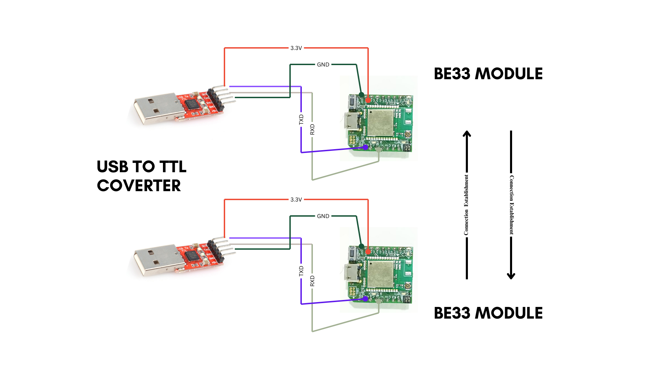

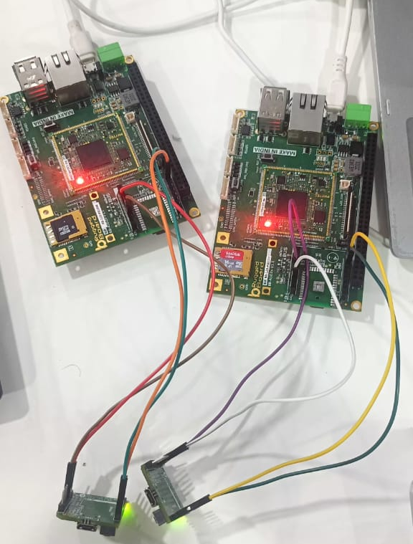
5.2 BE33 WITH rba5d2x

