Eporting Answers-2
part-A
1)5.15.0-87-generic
#1 Download the source
#2 Set the toolchain
#3 Clean the source only for the first time
$make distclean
#4 Configure the kernel source for ruggedboard-a5d2x
$make rb_a5d2x_defconfig
#5 Do additional configuration if required using menuconfig
$make menuconfig
#6 Compile the Kernel code
$make

2)
A "device tree node" refers to a specific entry or node within the device tree data structure that describes a particular hardware device or component. Each node contains information about a specific piece of hardware, such as its type, address, interrupt lines, and various configuration parameters.

3)
of_platform_populate()
of_driver_match_device()
of_find_node_by_name()
of_property_read_u32()

4)
$dtc –I dtd –O dts <dtb_filename> -o <dts_filename>
$make dtbs

5)
The "Kconfig" system is part of the kernel configuration infrastructure and is used to define configuration options, dependencies, and settings for various kernel features and components.

6)
obj-$(CONFIG_<MODULE>) += module.o

7) linux/arch/arm/confugs

part -B

1)
1. Kernel maintainers wanted unified way to add more board without adding board.c files
which are hard to maintain
2. Change in hardware configuration should be possible without re-compiling the kernel
3. Re-use same kernel image for different boards of same SOC.
linux/arch/arm/boot/dts/board.dts
2)

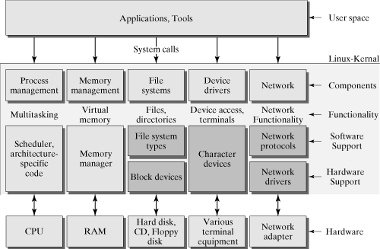
3)

4)
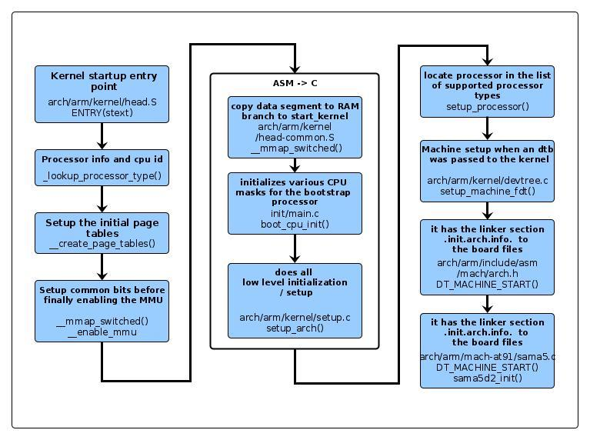
5)
Enable toolchain

$ make distclean

$ make clean

**( Adding Driver in kernel in static way )**

Step1:

copy sled.c drivers/misc/

Step2:
vim drivers/misc/Makefile
obj-$(CONFIG_SLED) += sled.o

Step3:
vim drivers/misc/Kconfig
Step4:
Describe Hardware in a5d2x_rugged_board_common.dtsi file....
$ make rb_a5d2x_defconfig

$ make menuconfig

$ make -j4

6)

Step1:

copy sled.c drivers/misc/

Step2:
vim drivers/misc/Makefile
obj-$(CONFIG_SLED) += sled.o

Step3:
vim drivers/misc/Kconfig
Step4:
Describe Hardware in a5d2x_rugged_board_common.dtsi file....

$ make rb_a5d2x_defconfig

$ make menuconfig

$ make -j4

