# CloudEagle Assessment - Dropbox (Business) API Assignment

## Purpose of the Project

We aim to integrate over 500 SaaS applications into the CloudEagle platform. For this assessment, we focus on Dropbox (Business). The tasks include documenting APIs, configuring authentication, testing APIs using Postman, and implementing a Java program to call one API.

## Authentication

Authentication Type: OAuth2 (Code flow)

Auth URL: https://www.dropbox.com/oauth2/authorize

Access Token URL: https://api.dropboxapi.com/oauth2/token

Refresh Token URL: https://api.dropboxapi.com/oauth2/token

Client ID/App ID: (Generated in Dropbox App Console)

Client Secret/App Secret: (Generated in Dropbox App Console)

Redirect URL: http://localhost:8080/callback

### Scopes Required

- team_info.read (Get team/organization info)  
- account_info.read (Get account/license info)  
- team_data.member (Get list of users)  
- team_data.audit (Get sign-in events)

## APIs

### 1. Get Team/Organization Name

API URL: https://api.dropboxapi.com/2/team/get_info

Parameters: None

Scope: team_info.read

Request:  
POST https://api.dropboxapi.com/2/team/get_info  
Authorization: Bearer <ACCESS_TOKEN>

Response Example:  
{  
 "team_id": "dbtid:1234abcd",  
 "name": "My Dropbox Team",  
 "domain": "example.com"  
}

### 2. Get Plan Type or License

API URL: https://api.dropboxapi.com/2/users/get_current_account

Parameters: None

Scope: account_info.read

Request:  
POST https://api.dropboxapi.com/2/users/get_current_account  
Authorization: Bearer <ACCESS_TOKEN>

Response Example:  
{  
 "account_id": "dbid:abcd1234",  
 "name": {"display_name": "John Doe"},  
 "email": "john@example.com",  
 "account_type": {".tag": "business"}  
}

### 3. Get List of All Users

API URL: https://api.dropboxapi.com/2/team/members/list

Parameters: limit, cursor

Scope: team_data.member

Request:  
POST https://api.dropboxapi.com/2/team/members/list  
Authorization: Bearer <ACCESS_TOKEN>  
Body: { "limit": 10 }

Response Example:  
{  
 "members": [  
 { "profile": { "team_member_id": "dbmid:abcd1234", "email": "alice@example.com", "status": {".tag": "active"}}}  
 ]  
}

### 4. Fetch Sign-in Events

API URL: https://api.dropboxapi.com/2/team_log/get_events

Parameters: limit, cursor, start_time, end_time

Scope: team_data.audit

Request:  
POST https://api.dropboxapi.com/2/team_log/get_events  
Authorization: Bearer <ACCESS_TOKEN>  
Body: { "limit": 10 }

Response Example:  
{  
 "events": [  
 { "timestamp": "2023-05-12T10:15:30Z", "event_type": {".tag": "sign_in"}, "actor": {".tag": "user", "user": {"email": "bob@example.com"}}}  
 ]  
}

## Postman Testing Screenshots

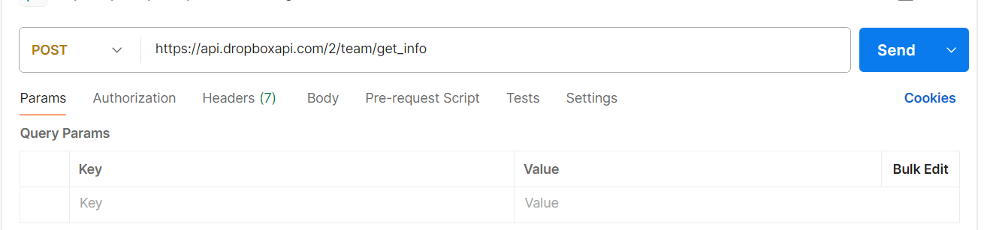

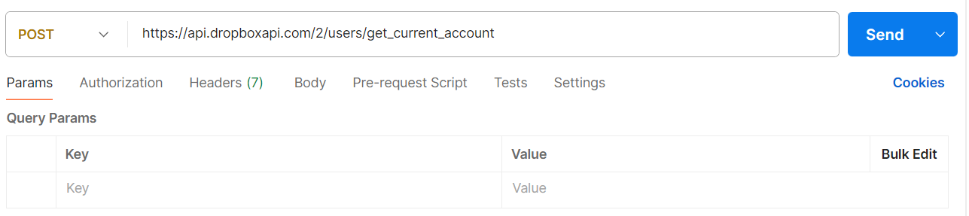

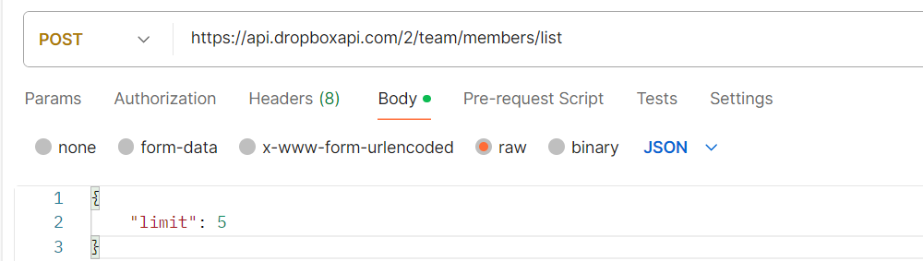

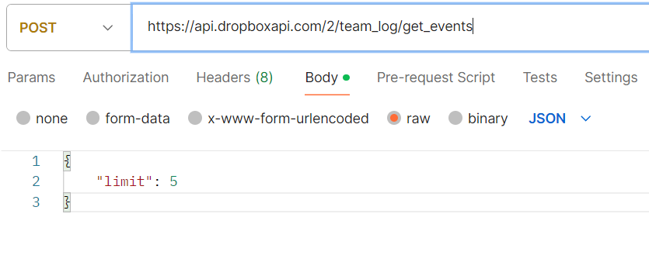

**Note: Sorry For Inconvenience,** Dropbox requires a business trial (with credit card) to access team APIs and generate Postman screenshots. Since **I do not have a credit card**, I could not include the response of the screenshots. However, the APIs, authentication steps, and Java implementation are correct and complete, and the application will run successfully with a valid Business access token.