### VISVESVARAYA TECHNOLOGICAL UNIVERSITY

#### Jnana Sangma, Belagavi-590010



REPORT ON

“SOCIETAL PROJECT”

Submitted in partial fulfillment for the requirements for the FIRST semester

**MASTER OF BUSINESS ADMINISTRATION**

For the Academic Year 2022-2023

Submitted by:

#### BHOOMIKA B P 1RR22BA008

Under the guidance of:

#### Sowmya G

AssistantProfessor, Department of MBA

Raja Rajeswari College of Engineering, Bengaluru

#### RRCMS-Raja Rajeshwari College of Management Studies

**DEPARTMENT OF MASTER OF BUSINESS ADMINISTRATION**

**RAJA RAJESWARICOLLEGE OF ENGINEERING, BENGALURU-560074**

INTRODUCTION

A societal project refers to a collective effort aimed at addressing and improving various

aspects of society. These projects often involve individuals, communities, organizations, and

even governments working together to create positive change, promote social welfare, and

address societal challenges.

Societal projects can encompass a wide range of areas, such as education, healthcare, poverty

alleviation, environmental conservation, community development, human rights, and more.

The primary objective is to bring about long-term improvements in the well-being and quality

of life for individuals and communities.

These projects may involve various activities, including research, advocacy, policy

development, resource mobilization, and implementation of interventions. They often aim to

address systemic issues and promote sustainable solutions that benefit society as a whole.

Societal projects are driven by the belief that collaboration and collective action are necessary

to tackle complex social problems. They often rely on the participation and engagement of

diverse stakeholders, including individuals, civil society organizations, businesses, and

governments. By combining efforts and resources, societal projects strive to create a positive

impact and contribute to the betterment of society.

Successful societal projects often require careful planning, effective coordination, and the

involvement of experts and professionals from different fields. They may also rely on

innovative approaches, technology, and data-driven strategies to maximize their impact.

Overall, societal projects are vital in driving social progress, promoting equality, and

addressing pressing issues that affect individuals and communities

PROJECT GOALS:

1. Infrastructure Development: The project will focus on enhancing the school's

infrastructure, ensuring that students have access to a conducive learning

environment. This includes renovating classrooms, providing necessary furniture and

equipment, and improving the overall aesthetics of the premises.

2. Educational Resources: The project aims to address the lack of educational

resources by procuring and distributing books, stationery, and learning materials to

the students.

3. Skill Enhancement Programs: To foster the holistic development of the students,

skill enhancement programs will be conducted. These programs will focus on various

areas such as art, music, sports, and other co-curricular activities, providing

opportunities for students to explore and develop their talents beyond academics.

4. Health and Hygiene Initiatives: The project recognizes the importance of good

health and hygiene practices in promoting overall well-being. Awareness programs on

hygiene, sanitation facilities improvement, and the provision of clean drinking water

will be implemented to create a healthier and safer environment for the students.

5. Community Engagement: The project will encourage community involvement and

engagement in the betterment of the school. Local volunteers, parents, and community

leaders will be invited to participate in activities, workshops, and events, fostering a

sense of collective responsibility and support for the school and its students.

**INTRODUCTION ABOUT THE SCHOOL**



Government Higher Primary School is a co-educational government school located

in village, Bidare Channarayapattaana Taluk Hassan Dist Karnataka. It was established in 1980 and offers education from class 1 to 7.

It has a total of 52 students and 5 teachers. Here the food has been Provide from the Government of Karnataka for all the student who is studying in government schools

The school has won several prizes in sports and cultural competitions at the district and

state levels.

The school is committed to providing quality education to all students. It strives to create a

conducive environment for learning and to develop the overall personality of the students.

The primary objective of Government Higher Primary School is to deliver quality

education and foster the holistic development of its students. The school follows the

curriculum prescribed by the Karnataka State Education Board, ensuring that students receive

a comprehensive education that encompasses academic, physical, and moral aspects.

The main goal of this activity was to encourage talents in local schools and create awareness among students about Malnutrition. For this activity ,I visited government schools in Bidare , Hassan Dist. We conducted this activity for one week from 24th June 2023 to 1st July 2023.

I mentored the students and thought them about the importance of healthy food and provide information about the air pollution,child labour,educating girl child and gender equalitity.

As a part of observation, I found out that the students in government schools are with lots of energy and interests to learn about the new things. They have many talents to showcase and need a bit of motivation. Coming to the education part, we think the curriculum of local schools must include more practical subjects like computers and modern science to improve the quality of education and teachers and staff must extract talents from students and motivate them accordingly. Spending quality time with students was a great experience as, I could add some knowledge to their ideas and perspectives.

**Malnutrition**

**INTRODUCTION**

* Malnutrition is a condition that occurs when the body doesn't receive adequate amounts of nutrients it needs to function properly. It can result from an insufficient intake of essential nutrients, such as proteins, carbohydrates, fats, vitamins, and minerals, or from an inability to absorb or utilize them effectively.
* Malnutrition can manifest in two primary forms: undernutrition and overnutrition. Undernutrition refers to a lack of essential nutrients, leading to deficiencies and stunted growth. This condition is often associated with poverty, limited access to food, inadequate diet, or underlying health issues. Undernutrition affects millions of people worldwide, particularly in developing countries, and can have severe consequences for physical and cognitive development, weakened immune system, and increased vulnerability to diseases.
* On the other hand, overnutrition occurs when there is an excessive intake of calories, often coupled with an imbalanced diet high in unhealthy fats, sugars, and processed foods. Overnutrition can lead to obesity, which is a major risk factor for various chronic conditions such as cardiovascular diseases, type 2 diabetes, and certain types of cancer.
* Malnutrition can affect individuals of all ages, but it is especially detrimental to children, pregnant women, and older adults. In children, malnutrition can hinder growth and development, impair cognitive abilities, and increase the risk of infections. Pregnant women who are malnourished are more likely to experience complications during pregnancy and have infants with low birth weight. In older adults, malnutrition can contribute to muscle wasting, weakened immune system, and increased frailty.
* Addressing malnutrition requires a multi-faceted approach, including improving access to nutritious food, promoting education about healthy eating habits, and ensuring adequate healthcare and sanitation facilities. It also involves raising awareness about the importance of a balanced diet and the consequences of both undernutrition and overnutrition.
* Overall, malnutrition is a complex and pervasive issue that affects individuals and communities worldwide. Efforts to combat malnutrition are crucial for promoting the well-being and sustainable development of populations globally.

**Underlying causes**:

Insufficient food availability: Limited access to an adequate quantity and variety of nutritious foods.

Poverty: Economic constraints that restrict the ability to purchase nutritious food.

Inadequate healthcare: Lack of access to healthcare services, including prenatal and postnatal care, which affects maternal and child nutrition.

Poor sanitation and hygiene: Inadequate sanitation facilities and hygiene practices that lead to increased susceptibility to infections and nutrient absorption problems.

Lack of education and awareness: Limited knowledge about proper nutrition and healthy dietary practices.

Immediate causes:

Inadequate dietary intake: Insufficient consumption of essential nutrients due to limited food availability, poor food choices, or inappropriate feeding practices.

Disease and infections: Illnesses, especially those affecting the gastrointestinal system, can impair nutrient absorption, increase nutrient requirements, or reduce appetite.

Poor breastfeeding and complementary feeding practices: Inadequate breastfeeding in infants and inappropriate introduction of complementary foods can result in nutrient deficiencies.

Environmental factors: Disasters, such as droughts or conflicts, can disrupt food production and distribution systems, exacerbating malnutrition.

Addressing malnutrition requires a multi-faceted approach, including interventions focused on improving food security, promoting balanced diets, enhancing healthcare services, and educating communities about proper nutrition. It involves initiatives such as promoting breastfeeding, fortifying staple foods, providing nutrient supplementation, and implementing social safety nets to alleviate poverty and enhance access to nutritious foods.

Overall, combating malnutrition is crucial for achieving optimal health and well-being, promoting sustainable development, and reducing health disparities worldwide.

According to my survey in government higher primary school I came to know thatw there is no malnutrition in food in their school, because food which serve from government withgood quality nutrient food to the student. Student have good health and strenght due to thegood hyegience food which they were consuming everyday, student are happliy feel which they were conusming food along providing milk, banana, egg for the student, through the survey teacher as said that the food which we recive for student its contain hygeince foodthat’s help student growth themsleves physically as well as mentally. So finally understandthat there is no malnurtition in government higher primary school.

AIR AND NOISE POLLUTION

INTRODUCTION

Air pollution refers to the contamination of the air by harmful substances, such as gases, particulate matter, and toxic chemicals. These pollutants can originate from both natural sources, such as dust storms and volcanic eruptions, as well as human activities, including industrial emissions, vehicle exhaust, and the burning of fossil fuels. The main air pollutants of concern include carbon monoxide (CO), nitrogen dioxide (NO2), sulfur dioxide (SO2), ozone (O3), and fine particulate matter (PM2.5). These pollutants can have detrimental effects on human health, causing respiratory problems, cardiovascular diseases, and even premature death. Additionally, air pollution can contribute to climate change and damage ecosystems by harming plant and animal life.

Noise pollution, on the other hand, refers to excessive or unwanted noise that disrupts the natural acoustic environment. It can be caused by various sources, such as transportation (road traffic, aircraft, railways), industrial activities, construction sites, and recreational activities. Common sources of noise pollution include loud music, honking horns, machinery, and aircraft noise. Prolonged exposure to high noise levels can lead to numerous health issues, including hearing loss, sleep disturbances, stress, and reduced cognitive performance. It can also disturb wildlife, affecting their behavior, communication, and reproductive patterns.

To mitigate air and noise pollution, various measures can be taken. For air pollution, the adoption of cleaner technologies, such as renewable energy sources and electric vehicles, can help reduce emissions. Additionally, the implementation of stricter emission standards, improved industrial practices, and better waste management can contribute to cleaner air. Noise pollution can be reduced through the use of noise barriers, soundproofing buildings, and implementing regulations regarding noise levels in different settings.

Public awareness, education, and individual actions also play a crucial role in combating air and noise pollution. By making environmentally conscious choices, such as using public transportation, carpooling, and reducing personal exposure to loud noises, individuals can contribute to a healthier and more sustainable environment.

Overall, addressing air and noise pollution is essential for protecting human health, preserving ecosystems, and ensuring a better quality of life for future generations

Noise pollution effects on human health

* **Hypertension:** It is a direct result of noise pollution which is caused due to elevated blood levels for a longer duration.
* **Hearing loss:** Constant exposure of human ears to loud noise that are beyond the range of sound that human ears can withstand damages the eardrums, resulting in loss of hearing.
* **Sleeping disorders:** Lack of sleep might result in fatigue and low energy level throughout the day affecting everyday activities. Noise pollution hampers the sleep cycles leading to irritation and an uncomfortable state of mind.
* **Cardiovascular issues:** Heart-related problems such as blood pressure level, stress and cardiovascular diseases might come up in a normal person and a person suffering from any of these diseases might feel a sudden shoot up in the level.

Air pollution on human health

People experience a wide range of health effects from being exposed to air pollution. Effects can be broken down into short-term effects and long-term effects.  
  
Short-term effects, which are temporary, include illnesses such as pneumonia or bronchitis. They also include discomfort such as irritation to the nose, throat, eyes, or skin. Air pollution can also cause headaches, dizziness, and nausea. Bad smells made by factories, garbage, or sewer systems are considered air pollution, too. These odors are less seriousbutstill unpleasant.  
  
Long-term effects of air pollution can last for years or for an entire lifetime. They can even lead to a person's death. Long-term health effects from air pollution include heart disease, lung cancer, and respiratory diseases such as emphysema.

Air and noise pollution are significant environmental issues that have adverse effects on human health, ecosystems, and overall quality of life. Both types of pollution result from various human activities and can have far-reaching consequences on a local and global scale. Air pollution refers to the presence of harmful substances in the air, such as particulate matter, nitrogen oxides, sulfur dioxide, carbon monoxide, and volatile organic compounds. These pollutants are released by industrial processes, transportation, power generation, and residential activities. When inhaled, they can cause or worsen respiratory problems, cardiovascular diseases, and other health issues. rain. On the other hand, noise pollution refers to excessive orunwanted sound that disrupts the natural environment or normal activities

**Gender Equality**

Gender equality refers to the equal rights, opportunities, and treatment of individuals regardless of their gender. It is a fundamental human right and a crucial aspect of social justice and sustainable development. Achieving gender equality involves eliminating discrimination and biases that are based on gender, challenging traditional gender roles and stereotypes, and ensuring that all individuals have equal access to resources, opportunities, and decision-making power.

Here are some key points about gender equality:

Equal Rights and Opportunities: Gender equality emphasizes that all individuals, regardless of their gender, should have equal rights and opportunities in various areas of life, including education, employment, healthcare, politics, and legal rights.

Eliminating Gender Discrimination: Gender discrimination involves treating individuals unfairly or differently based on their gender. Gender equality seeks to eliminate such discrimination and create a society where everyone is valued and respected, regardless of their gender identity.

Challenging Gender Stereotypes: Gender stereotypes are societal expectations and norms about how individuals should behave, dress, or pursue certain careers based on their gender. Gender equality encourages challenging and breaking down these stereotypes, allowing individuals to express themselves freely and pursue their interests and goals without constraints.

Empowering Women and Girls: Gender equality recognizes the historical disadvantages and discrimination faced by women and girls. It aims to empower them by providing equal to education, healthcare, economic opportunities, and leadership positions, enabling them to reach their full potential and participate actively in all aspects of society.

Engaging Men and Boys: Gender equality is not solely about women's rights but involves engaging men and boys as allies and champions for change. By challenging harmful masculinity norms and promoting positive and egalitarian attitudes towards gender, it helps create a more inclusive and equitable society.

Intersectionality: Gender equality acknowledges that gender intersects with other social identities such as race, ethnicity, socioeconomic status, disability, and sexual orientation. Intersectional approaches are important to address the unique challenges and discrimination faced by individuals who belong to multiple marginalized groups.

Policy and Legal Reforms: Achieving gender equality requires the implementation of policies and legal reforms that promote gender equity. These may include laws against gender-based violence, equal pay legislation, maternity and paternity leave policies, and measures to promote women's representation and participation in decision-making roles.

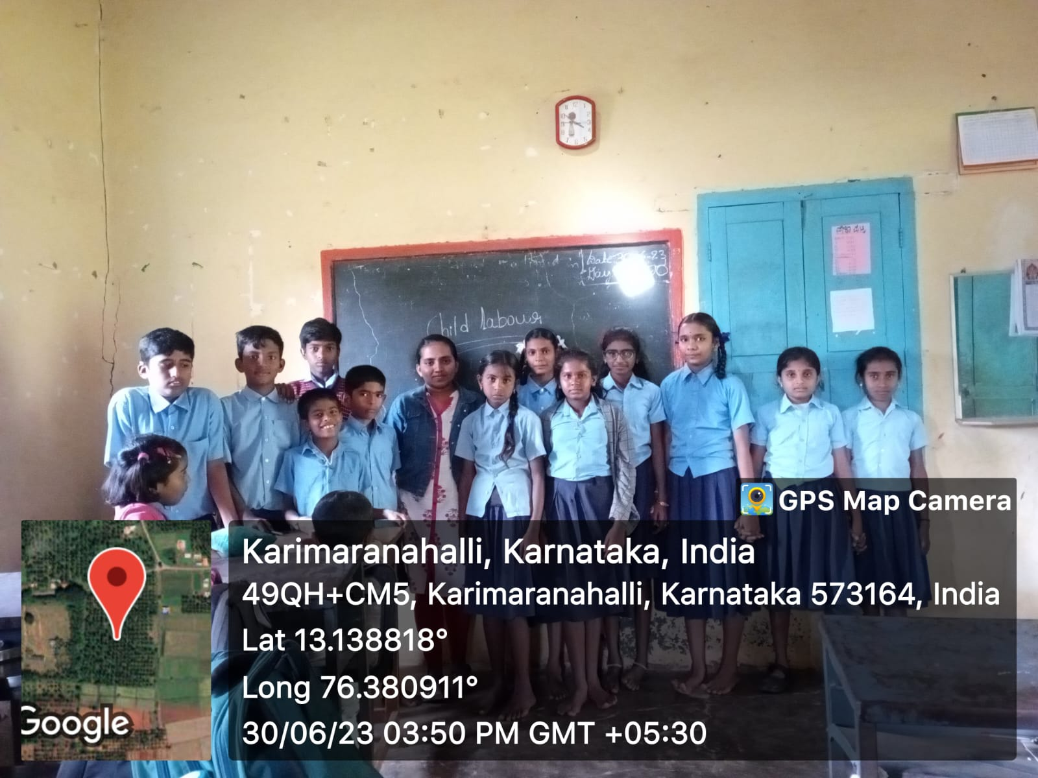

Global Efforts: Gender equality is a global issue, and various international organizations, governments, and advocacy groups work towards its achievement. Initiatives like the United Nations Sustainable Development Goals (SDGs) include specific targets related to gender equality, highlighting its importance in the global development agenda.

Promoting gender equality benefits society as a whole, leading to greater social and economic well-being. It fosters inclusive and diverse communities, reduces poverty, improves health outcomes, enhances educational attainment, and drives innovation and economic growth.

Therefore, according to my survey in the Government higher primary school in

Bidare there is no gender inequality in the school. They are providing eqaual

education,opporunites and facilities for both boys and the girls in the school . providing

equality education that’s help the children to grab the knowledge and skill for both boys and

grils towards their education. Even this equality enchance the children to grow in their future.

Educating Girl child

Education empowers girls by providing them with knowledge, skills, and opportunities for personal growth and development. It promotes gender equality by challenging traditional gender roles and empowering girls to become active participants in society.

Education plays a pivotal role in breaking the cycle of poverty. When girls are educated, they are more likely to earn higher incomes, have better job opportunities, and contribute to the economic well-being of their families and communities.

Educated girls are more likely to make informed decisions about their health, leading to better maternal and child health outcomes. They are more likely to marry later, have fewer children, and have improved access to healthcare and family planning services.

Education acts as a protective factor against gender-based violence. It helps girls develop critical thinking skills, assertiveness, and awareness of their rights, making them less vulnerable to various forms of abuse, including child marriage and female genital mutilation.

When girls receive an education, they are more likely to raise educated children. Educated mothers tend to prioritize their children's education, breaking the intergenerational cycle of illiteracy and poverty.

Education equips girls with the knowledge and skills needed to engage actively in political, social, and economic decision-making processes. When girls have a voice, they can contribute to policy development, advocate for their rights, and influence positive change in their communities.

Educating girls has a positive impact on economic growth. It leads to a more skilled workforce, increased productivity, and greater innovation. When girls and women are economically empowered, it benefits society as a whole.

Education challenges harmful social norms and cultural practices that discriminate against girls. It promotes inclusivity, tolerance, and respect for diversity, contributing to the overall social transformation of communities.

To ensure girls' access to education, it is essential to address various barriers, including poverty, gender-based discrimination, cultural norms, child marriage, and lack of infrastructure. Strategies for promoting girls' education include implementing policies that remove financial barriers, providing safe and gender-responsive learning environments,

offering scholarships and incentives, and raising awareness about the importance of educating girls.Investing in the education of girls is not only a matter of justice and human rights but also a catalyst for achieving sustainable development and creating a more equitable and prosperous society.

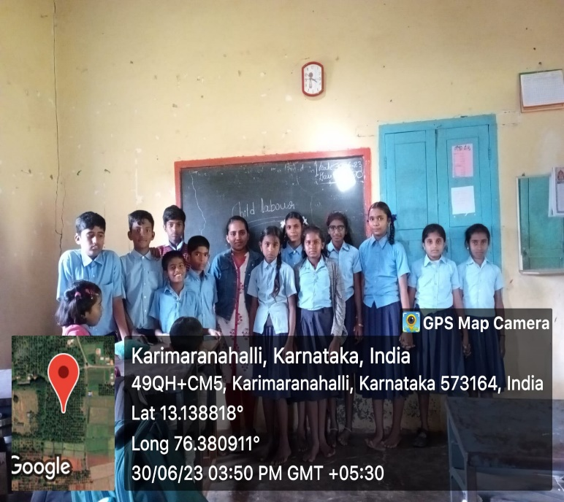

That’s wonderful to hear that are interested

in educating the girl child in the

government higher primary school bidare

Giving equal education to the girl child in

school. And providing opportunity to learn

That have been show the equal importance for the children towards the increase the

personal growth, empowerment and the overall development in school premise. When girls

receive an education, they have the opportunity to acquire knowledge, develop essential

skills, and gain confidence.

In government higher primary school, the children are showing more interest to learn

and teachers are motivating the children about the equal acces to education, importance of

education, empowerment, health and well being, reducing the early child marriage social

development and breaking the poverty.educating girl child is more important Women should be given equivalent chance in education like men and they should not be cut off from any development opportunities. To extend the significance and progress the level of women education all over the country, proper awareness programs are necessary, especially in the rural areas. A knowledgeable female can teach her whole family and also the whole country.

**Conserving the water and electricity**

Repair any leaks in faucets, toilets, and pipes promptly. Even small leaks can waste a significant amount of water over time.

Practice efficient water use habits such as turning off the faucet while brushing your teeth, using a broom instead of a hose to clean outdoor spaces, and running dishwashers and washing machines only when they are fully loaded.

Install water-saving fixtures such as low-flow showerheads, faucets, and toilets. These fixtures reduce water usage without compromising functionality.

Use efficient irrigation methods, such as drip irrigation or a soaker hose, for gardens and plants. Water plants during cooler parts of the day to minimize evaporation.

Set up rainwater collection systems to collect and reuse rainwater for watering plants or other non-potable uses.

Consider xeriscaping techniques for landscaping, which involves using native plants that require less water and designing landscapes to minimize water usage.

Energy-Efficient Appliances: Use energy-efficient appliances with high Energy Star ratings. These appliances consume less electricity while maintaining optimal functionality.

Replace traditional incandescent light bulbs with energy-efficient LED or CFL bulbs. These bulbs consume significantly less electricity and have a longer lifespan.

Unplug electronics and chargers when they are not in use. Many devices continue to consume electricity even when they are turned off or in standby mode.

Use power strips to easily turn off multiple devices at once. This helps eliminate "phantom loads" and saves electricity.

Utilize natural lighting as much as possible during the day to reduce the need for artificial lighting.

Set your thermostat to energy-saving temperatures and use programmable thermostats to adjust temperatures based on occupancy. Proper insulation and weather stripping can also reduce cooling and heating energy needs.

Consider conducting an energy audit of your home to identify areas where energy efficiency can be improved. This can help you prioritize energy-saving upgrades.

Explore the use of renewable energy sources such as solar panels to generate clean electricity for your home.

CHILD LABOUR

INTRODUCTION:

Child labour refers to the employment of children in work that is harmful to their physical and mental development. It is a global issue that deprives children of their right to education, health, and a safe childhood. Here is some information about child labour:

Definition: Child labour is defined by the International Labour Organization (ILO) as work that deprives children of their childhood, interferes with their ability to attend regular schools, and is mentally, physically, socially, or morally harmful.

Prevalence: Child labour is a widespread problem, particularly in developing countries. According to the ILO, in 2020, approximately 152 million children worldwide were engaged in child labour, with nearly half involved in hazardous work.

Forms of child labour: Child labour can take various forms, including but not limited to, agriculture (working on farms), domestic work (as maids or servants), manufacturing (in factories), mining, street vending, and involvement in armed conflict.

Causes: Child labour is caused by a complex interplay of various factors, such as poverty, lack of access to education, cultural norms, inadequate labour laws and enforcement, armed conflicts, and the demand for cheap labour.

Consequences: Child labour has severe consequences on children's physical and mental well-being. It hampers their education, limits their future prospects, exposes them to hazardous conditions, and perpetuates cycles of poverty.

International efforts: The international community, through organizations like the ILO and UNICEF, has been working to combat child labour. The ILO's Convention No. 182 on the Worst Forms of Child Labour and Convention No. 138 on the Minimum Age for Employment are key international standards in this regard.

National laws: Many countries have enacted laws and regulations to address child labour. These laws define minimum ages for employment, restrict hazardous work, and aim to protect children's rights.

Challenges: Eradicating child labour faces several challenges, including poverty, lack of awareness, weak enforcement of laws, limited access to education, and complex global supply chains.

Efforts towards elimination: Governments, NGOs, and businesses have been working to eliminate child labour through measures such as promoting education, improving labor standards, raising awareness, providing social support, and implementing supply chain transparency.

Sustainable Development Goals: The United Nations' Sustainable Development Goal 8.7 calls for the eradication of child labour by 2025, emphasizing the need for concerted efforts from all stakeholders.

It is important to raise awareness, advocate for stronger laws and enforcement, support responsible business practices, and address the root causes of child labour to ensure the well-being and rights of all children are protected.

Reasons for the child labour :

1. Poverty: One of the primary causes of child labour is poverty. Families living in

poverty may rely on their children's income to supplement their own, leading them to

engage in labour-intensive activities instead of attending school.

2. Cultural and societal factors: Societal norms and cultural practices can also

contribute to child labour. In some communities, children may be expected to work

from an early age, either to support their families or to learn vocational skills. These

practices can perpetuate the cycle of child labour.

3. Migration and displacement: In regions affected by conflict, natural disasters, or

economic instability, families may be forced to migrate or become displaced. This

disruption can result in a lack of access to education and increased vulnerability to

child labour.

4. Lack of awareness and social support: Some families may not be aware of the

importance of education or the negative consequences of child labour. Limited access

to social support systems, such as child protection services or financial assistance

programs, can also contribute to the prevalence of child labour.

Many people in our society cannot able to meet the minimum basic need for their family, so

that they are taking their child to the work along with them in different sector like