## **1. Introduction**

### **1.1 Background and Motivation**

In today's fast-paced digital landscape, computer science education has become integral to both personal and professional growth. E-learning platforms offer seamless access to educational content, facilitating efficient learning regardless of geographical distances. These platforms provide users with diverse features designed to enhance the learning experience, from basic course materials to interactive exercises and AI-powered assistance.

At the heart of any e-learning platform lies the core functionality of content delivery. Users can engage with courses individually or participate in group learning environments, fostering fluid and dynamic educational experiences. This approach to learning eliminates the barriers of time and space, allowing students to remain connected and engaged with course materials at all times.

Security and privacy are paramount in e-learning platforms, and user authentication and authorization mechanisms ensure that only authorized individuals have access to the platform. By verifying users' identities through credentials such as usernames and passwords, these applications safeguard user accounts and sensitive information from unauthorized access.

Course management is another crucial feature of e-learning platforms, allowing administrators to organize educational content for efficient learning. Users can access various courses, track their progress, and manage their learning paths, streamlining the process of skill acquisition and knowledge development.

Progress indicators provide users with valuable insights into their learning journey, displaying their course completion status in real-time. By indicating whether specific modules are completed, in progress, or not started, these indicators help users gauge their advancement and plan their studies effectively.

E-learning platforms also offer additional features such as certificate generation, search functionality, and AI-powered learning assistance, further enhancing the user experience. Notifications alert users to new course materials or deadlines, while search functionality enables quick retrieval of specific topics and resources. AI assistants provide personalized guidance, helping users overcome learning challenges.

### **1.2 Objective**

The objective of this project is to develop a comprehensive e-learning platform for computer science education that caters to the diverse learning needs of both students and professionals. This application aims to provide a seamless and efficient platform for educational content delivery, enabling users to engage with courses and track their progress with real-time feedback. Key functionalities include robust security and privacy measures through user authentication and authorization, efficient course management for streamlined learning, and progress tracking to display the real-time status of course completion. Additional features such as certificates, search functionality, and AI-powered learning assistance are integrated to enhance the overall user experience. Ultimately, this project seeks to create a versatile and user-friendly e-learning platform that fosters fluid learning and skill development, ensuring users remain connected, informed, and engaged in today's fast-paced digital landscape.

### **1.3 Current Challenges in Computer Science Education**

* Slow Knowledge Transfer: Traditional education suffers from slow curriculum updates and adaptation to industry needs. This lag undermines the purpose of education, leading to graduates with outdated skills and frustrations among employers.
* Inefficient Learning: Learning often happens in isolated environments where students cannot easily interact with instructors or peers, making the process slower and less effective due to outdated teaching methods and limited feedback channels.
* No Progress Tracking: Without comprehensive progress tracking, learners cannot effectively gauge their advancement or identify areas needing improvement.
* Limited Personalization: Traditional education systems often lack the ability to tailor learning experiences to individual needs and learning styles.

### **1.4 Drawbacks of Existing Solutions**

* Limited Learning Capabilities: Users are constrained in their ability to learn effectively, particularly in complex computer science topics requiring hands-on practice.
* Lack of Security: User data, including passwords and learning records, is vulnerable to unauthorized access and potential breaches in many existing platforms.
* Slow Performance: Delayed content loading and response times hinder the learning experience, causing frustration and inefficiency.
* No Integration with Industry Tools: Many platforms fail to incorporate real-world tools and technologies used in the industry, creating a disconnect between education and practical application.

### **1.5 Tech Learn Advantages**

* Unlimited Learning Access: Users can access educational content without restrictions, supporting dynamic and extensive learning journeys.
* Improved Performance: The platform is designed to deliver content instantaneously, providing a seamless learning experience. Optimized algorithms and efficient data handling ensure rapid content delivery and response times.
* Progress Tracking: Users can see their learning progress in real-time, leading to more effective study planning and skill development.
* Data Storage in PostgreSQL: Persistent data storage allows users to access their learning history and important information at any time.
* Enhanced Security: User data is protected from unauthorized access and potential cyber threats, ensuring privacy and security through Supabase's authentication and Row Level Security.

## **2. System Requirements**

### **2.1 Hardware Requirements**

* Operating System: Windows, MacOS, Android, iOS, Linux, Chromebook
* Internet Connection: Minimum 2 Mbps
* Storage: 500 MB free space for web application cache
* RAM: 4 GB (recommended)
* Processor: 1.6 GHz dual-core or better

### **2.2 Browser Compatibility**

The Tech Learn platform supports the following browsers:

* Chrome 49 and above (release: 2016/3/2)
* Firefox 50 and above (release: 2016/11/15)
* Safari 10 and above (release: 2016/9/20)
* Edge 14 and above (release: 2016/2/18)

### **2.3 Technology Stack**

The Tech Learn platform leverages modern web technologies for optimal performance and user experience:

* React: A JavaScript library for building user interfaces with component-based architecture
* TypeScript: A strongly typed programming language that builds on JavaScript
* Tailwind CSS: A utility-first CSS framework for rapid UI development
* Supabase: Backend-as-a-service platform providing authentication, database, and storage services
* PostgreSQL: Advanced open-source relational database
* Edge Functions: Serverless computing for backend logic
* Shadcn UI: Component library for consistent design
* Tanstack Query: Data fetching and state management library

## **3. Technology Overview**

### **3.1 React Frontend**

The top tier of the Tech Learn stack is React.js, the declarative JavaScript framework for creating dynamic client-side applications in HTML. React lets you build up complex interfaces through simple Components, connect them to data on your backend server, and render them as HTML.

### **3.2 HTML (Hypertext Markup Language)**

HTML is the standard Markup language for creating Web pages and describes the structure of a Web page. A browser does not display the HTML tags, but uses them to determine how to display the document.

HTML was developed with the intent of defining the structure of documents like headings, paragraphs, lists, and so forth to facilitate the sharing of scientific information between researchers. Now, HTML is being widely used to format web pages with the help of different tags available in HTML language.

Advantages

* Create Web site - You can create a website or customize an existing web template if you know HTML well.
* Become a web designer - If you want to start a career as a professional web designer, HTML and CSS designing is a must skill.
* Understand web - If you want to optimize your website, to boost its speed and performance, it is good to know HTML to yield best results.
* Learn other languages - Once you understand the basic of HTML then other related technologies like JavaScript, PHP, or Angular become easier to understand.

### **3.3 CSS (Cascading Style Sheets)**

CSS describes how HTML elements are to be displayed on screen, paper, or in other media and saves a lot of work. It can control the layout of multiple web pages all at once. Cascading Style Sheets, fondly referred to as CSS, is a simple design language intended to simplify the process of making web pages presentable.

Advantages

* Create Stunning Web site - CSS handles the look and feel part of a web page. Using CSS, you can control the color of the text, the style of fonts, the spacing between paragraphs, how columns are sized and laid out, what background images or colors are used, layout designs, and variations in display for different devices and screen sizes as well as a variety of other effects.
* Become a web designer - If you want to start a career as a professional web designer, HTML and CSS designing is a must skill.
* Control web - CSS is easy to learn and understand but it provides powerful control over the presentation of an HTML document. Most commonly, CSS is combined with the markup languages HTML or XHTML.
* Learn other languages - Once you understand the basic of HTML and CSS then other related technologies like JavaScript, PHP, or Angular are become easier to understand.

### **3.4 JavaScript (JS)**

JavaScript enables interactive webpages and is an essential part of web applications. They can be written right in a web page's HTML and run automatically as the page loads. Scripts are provided and executed as plain text. They don't need special preparation or compilation to run. JavaScript is a lightweight, interpreted programming language. It is designed for creating network-centric applications. It is complementary to and integrated with Java. JavaScript is very easy to implement because it is integrated with HTML. It is open and cross-platform.

Advantages

* JavaScript is the most popular programming language in the world and that makes it a programmer's great choice. Once you learn JavaScript, it helps you developing great front-end as well as back-end software using different JavaScript-based frameworks like jQuery, Node.JS etc.
* JavaScript is everywhere, it comes installed on every modern web browser and so to learn JavaScript you really do not need any special environment setup. For example, Chrome, Mozilla Firefox, Safari and every browser you know as of today, supports JavaScript.
* JavaScript helps you create really beautiful and fast websites. You can develop your website with a console-like look and feel and give your users the best Graphical User Experience.

### **3.5 Tailwind CSS**

Tailwind CSS is a utility-first CSS framework for building custom user interfaces quickly. It is highly customizable and provides low-level utility classes to build designs directly in your markup. Unlike traditional frameworks, Tailwind does not impose design decisions and instead allows developers to create bespoke designs by combining utility classes. Tailwind CSS is open source and maintained by a community of developers.

Advantages

* Highly Customizable: Tailwind allows you to customize every aspect of your design system, enabling you to create unique and bespoke designs.
* Utility-First Approach: It provides low-level utility classes that can be composed to build any design, eliminating the need to write custom CSS for every component.
* Responsive Design: Built-in responsive design utilities make it easy to create responsive interfaces without writing custom media queries.
* Purging Unused CSS: Tailwind includes a built-in tool to purge unused CSS, resulting in smaller file sizes and faster load times.

### **3.6 Supabase Backend**

Supabase provides the backend infrastructure for the Tech Learn platform, offering a comprehensive suite of services:

Why use Supabase?

* Authentication Service: Built-in user management with email/password authentication, social login options, and JWT token handling.
* PostgreSQL Database: Powerful relational database with real-time capabilities and Row Level Security for fine-grained access control.
* Storage: Secure file storage system for course materials, images, and videos with access control based on user permissions.
* Edge Functions: Serverless computing for custom backend logic, enabling features like certificate generation and AI integration.
* Real-time Subscriptions: Live updates for collaborative features and instant notifications.

### **4. Feasibility Study**

A feasibility study is an analysis and evaluation of a proposed project to determine if it is technically feasible, financially viable, and practically achievable within a given timeframe and budget. It helps organizations assess the potential success and risks associated with a project before investing significant time, resources, and capital. A comprehensive feasibility study typically covers various aspects including economic, technical, legal, operational, and social factors to provide a holistic view of the project's potential outcomes.

### **4.1 Economic Feasibility**

Economic feasibility examines the financial aspects of the project. It involves a thorough cost-benefit analysis where the expenses associated with the project are weighed against the expected benefits and revenue streams. This includes estimating the initial investment required for development, marketing, and legal fees, as well as identifying potential sources of income such as subscriptions, course sales, or advertising.

Profitability projections are made to forecast revenue growth over time, ensuring that the platform will be financially sustainable. The expected return on investment (ROI) is also calculated to determine if the financial returns justify the investment.

For Tech Learn, the economic feasibility is positive due to:

* Low initial infrastructure costs using cloud services
* Scalable subscription model for revenue generation
* Growing market demand for computer science education
* Potential enterprise partnerships for corporate training

### **4.2 Social Feasibility**

Social feasibility focuses on the project's impact on and acceptance by the target community or market. It involves understanding the needs and preferences of the target audience to ensure that the project addresses a real demand. Evaluating the likelihood of user adoption and engagement is crucial, as it indicates how well the project will be received.

Social feasibility also considers the community impact, assessing how the project will affect the educational community, including potential social benefits like increased access to quality education. Ensuring transparency and trust is especially important in education, where these factors can significantly influence user behavior and satisfaction.

Tech Learn shows strong social feasibility with:

* Addressing the skills gap in computer science education
* Providing accessible learning opportunities to underserved communities
* Creating a collaborative learning environment
* Supporting lifelong learning and career development

### **4.3 Technical Feasibility**

Technical feasibility assesses whether the necessary technology, resources, and expertise are available to successfully complete the project. This involves identifying the software, hardware, and technological infrastructure needed to develop and operate the platform. The study evaluates whether the project can seamlessly integrate with existing systems and databases and whether it can handle growth and increasing demand over time.

Potential technical challenges are identified, and plans are made to address these issues, ensuring that the project can be implemented using current technology within the set timeframe and budget.

Tech Learn demonstrates strong technical feasibility through:

* Use of established, mature web technologies
* Cloud-based infrastructure with proven scalability
* Modern frontend frameworks for responsive design
* Robust backend services through Supabase
* Integration capabilities with third-party educational tools

### **5. System Design**

### **5.1 Design Methodology**

Systems design is the process of defining the architecture, product design, modules, interfaces, and data for a system to satisfy specified requirements. The purpose of the System Design process is to provide sufficient detailed data and information about the system and its system elements to enable implementation consistent with architectural entities as defined in models and views of the system architecture.

For Tech Learn, we employ a user-centered design methodology, focusing on the needs and experiences of learners, instructors, and administrators. This approach ensures that the platform is intuitive, accessible, and effective for all user groups.

### **5.2 Data Flow Diagram**

A data flow diagram is a graphical tool used to describe and analyze the movement of data through a system. These are central tools and the basis from which other components are developed. The transformation of data from input to output, through processes, may be described logically and independently of physical components associated with the system.

In the DFD, there are four primary symbols:

* A square defines a source (originator) or destination of system data
* An arrow identifies data flow - the pipeline through which information flows
* A circle or bubble represents a process that transforms incoming data flow into outgoing data flows
* An open rectangle is a data store - data at rest or a temporary repository of data

### **5.3 Database Design**

## User Entity

The User entity represents individuals who use the learning platform:

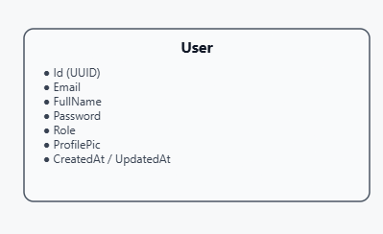

## Course Entity

The Course entity represents educational courses available on the platform:

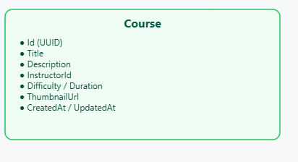

## Video Entity

The Video entity represents video content within courses:

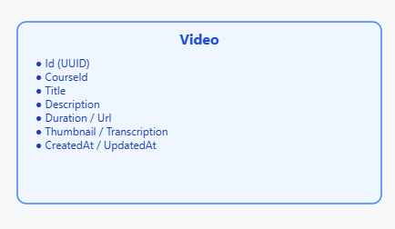

## Quiz Entity

The Quiz entity represents assessment components:

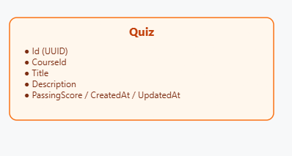

## Enrollment Entity

The Enrollment entity tracks student course registrations:

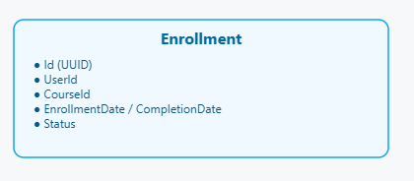

## Progress Entity

The Progress entity monitors student advancement:

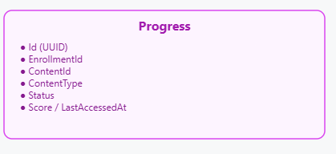

### Certificate Entity

The Certificate entity manages completion credentials:

### 

### **5.4 Entity-Relationship Diagrams**

The Entity-Relationship diagram illustrates the relationships between entities 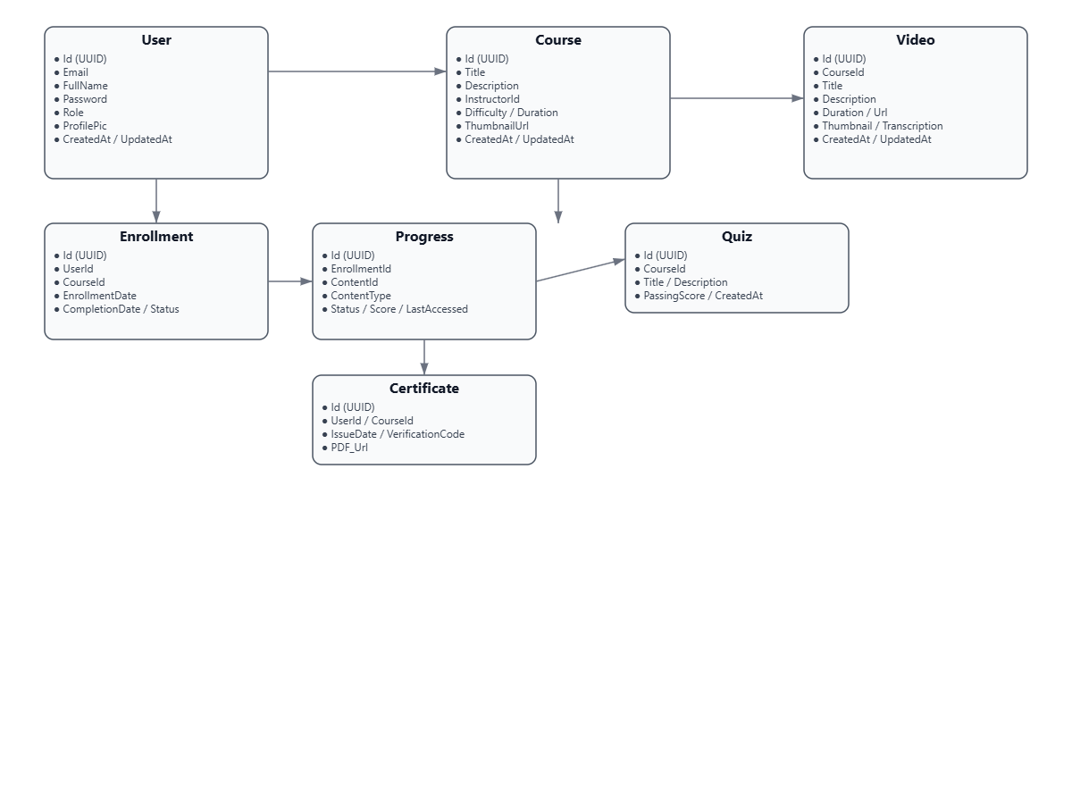

**User=Module :**

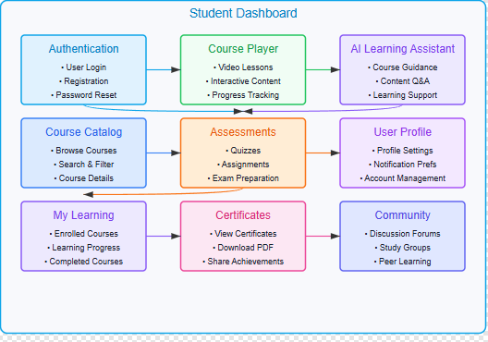

# Admin=Module :

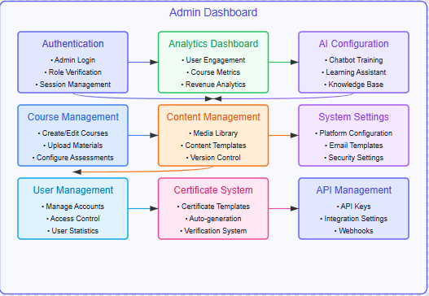

# Admin=WorkFlow :

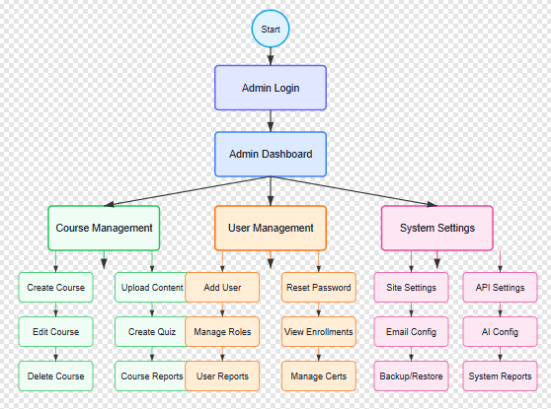

# Front_End Component :

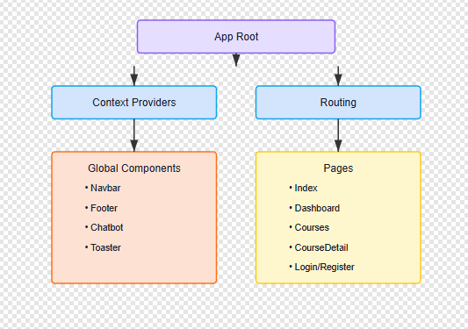

# Backend-Architecture :

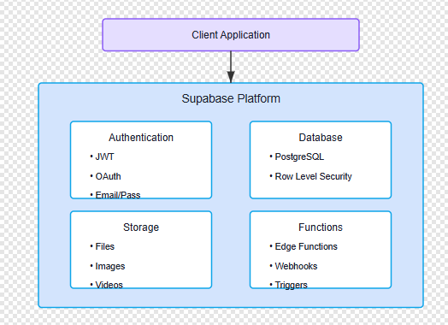

# Auth-Flow :

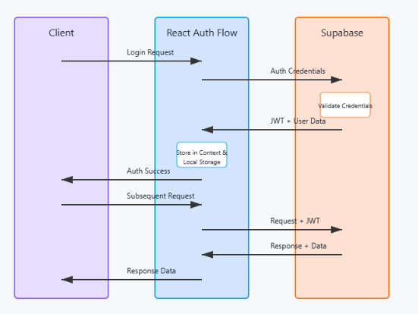

# Data=Flow :

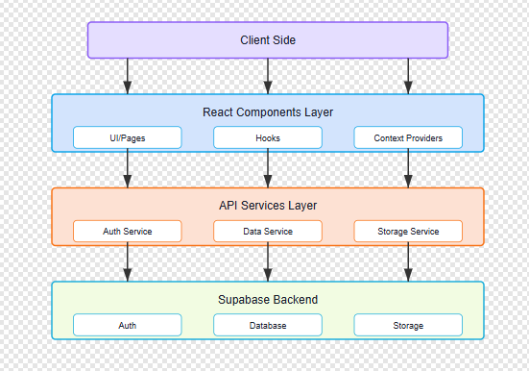

# Database-Schema :

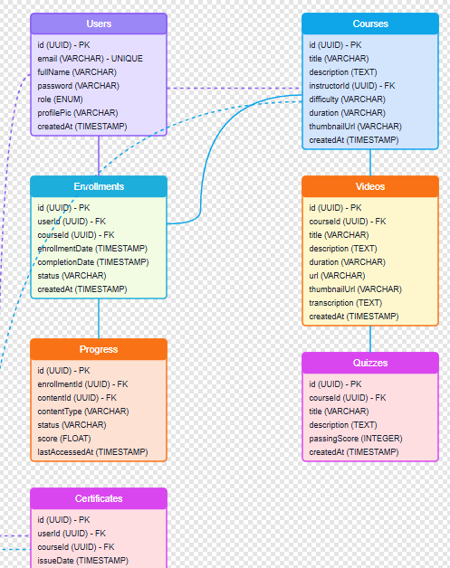

# Entity-Relation(E-R) Visual Represantation:

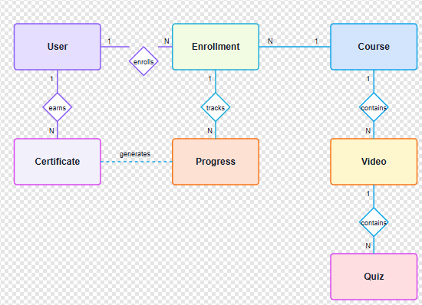

# Model-View Architecture (MVC) :

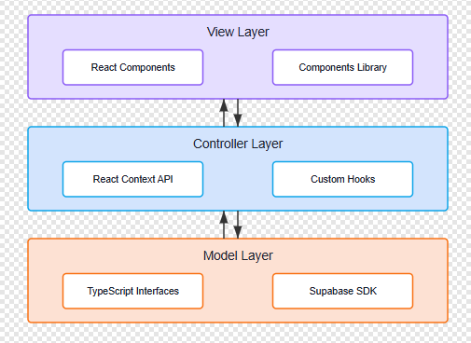

**6. System Features**

### **6.1 Functional Requirements**

## User Management

* The system allows users to register with email/password or social login
* The system supports different user roles (student, instructor, administrator)
* The system enables profile management including personal information and preferences

## Course Management

* The system allow instructors to create and edit courses
* The system support organizing content into modules and lessons
* The system handle various content types (videos, text, quizzes)
* The system enable enrollment tracking and management

## Learning Experience

* The system provides video playback with adjustable settings
* The system delivers interactive quizzes with automatic grading
* The system tracks and display user progress
* The system issues certificates upon course completion

## AI Learning Assistant

* The system provides context-aware help for course content
* The system answers student queries using natural language processing
* The system offers personalized learning recommendations
* The system provides automated feedback on exercises

## Administration

* The system includes a dashboard for user management
* The system supports content moderation workflows
* The system generates analytics on platform usage and effectiveness
* The system provides configuration tools for system maintenance

### **6.2 Non-functional Requirements**

## Performance

* The system loads pages in under 2 seconds on standard connections
* The system supports at least 1,000 concurrent users
* The system optimizes video streaming for various connection speeds
* The system responds to API requests within 500ms for 95% of requests

## Security

* The system uses HTTPS for all data transmission
* The system securely store user passwords with encryption
* The system implements row-level security for database access
* The system protects against common web vulnerabilities
* The system comply with data protection regulations

## Usability

* The system provides intuitive navigation with minimal learning curve
* The system be responsive across devices from mobile to desktop
* The system meet WCAG 2.1 Level AA accessibility standards
* The system supports multiple languages

## Reliability

* The system maintain 99.9% uptime
* The system include automated backup procedures
* The system gracefully handle partial system failures
* The system logs errors comprehensively for monitoring

### **7. Market Analysis**

### **7.1 Overview of the E-Learning Market**

The e-learning market, particularly for computer science education, is a dynamic and rapidly growing sector within the broader educational technology industry. With the increasing need for technical skills in the digital economy, online platforms for computer science education have become essential tools. According to market research reports, the global e-learning market is expected to grow significantly, driven by advancements in technology and increased internet penetration.

### **7.2 Growth Drivers**

* Technological Advancements: The development of advanced learning technologies, including AI-powered tutoring, interactive simulations, and virtual labs, has fueled the growth of computer science e-learning platforms. These technologies enable more engaging and effective learning experiences.
* Skills Gap: The widening gap between industry skill requirements and traditional education output has created strong demand for alternative learning pathways. Computer science skills are particularly sought after across industries undergoing digital transformation.
* Remote Learning Trends: The global shift toward remote and flexible learning options, accelerated by the COVID-19 pandemic, has significantly increased the adoption of e-learning platforms. This trend is likely to continue as educational institutions and learners recognize the benefits of online learning.
* Continuous Learning Culture: The rapid pace of technological change has created a need for continuous professional development. Workers increasingly seek flexible learning options to stay current with emerging technologies and maintain career relevance.

### **7.3 Market Segmentation**

* Academic Education: Platforms serving university students and educational institutions, offering structured computer science curricula that complement or replace traditional coursework.
* Professional Development: Platforms targeting working professionals seeking to upskill or reskill, with focused, practical courses on specific technologies and concepts.
* Coding Bootcamps: Intensive, immersive programs designed to rapidly prepare learners for entry-level technical positions in the industry.
* Self-Directed Learning: Resources for independent learners exploring computer science topics at their own pace, often with community support and interactive elements.

### **7.4 Competitive Landscape**

* Major Players: The market includes established platforms like Coursera, edX, Udemy, and Pluralsight, which offer extensive computer science course catalogs from multiple providers.
* Specialized Providers: Niche platforms focused exclusively on computer science education, such as Codecademy, LeetCode, and freeCodeCamp, provide specialized learning experiences.
* Emerging Players: New entrants are differentiating through innovative approaches like peer learning, project-based curricula, and AI-enhanced personalization.

### **7.5 Challenges and Opportunities**

* Personalization: There is significant opportunity in leveraging AI and machine learning to create truly personalized learning experiences that adapt to individual needs and learning styles.
* Practical Application: Platforms that can bridge the gap between theoretical knowledge and practical application through real-world projects and simulations have a competitive advantage.
* Credentialing: As alternative education pathways become more common, there's growing importance in providing recognized credentials that signal competence to employers.
* Community Building: Creating engaged learning communities that foster peer support and collaborative problem-solving can significantly enhance the learning experience and retention.

# 8. IMPLEMENTATION AND CODING

### **8.1 App and Routing**

## App.tsx - Root Component Structure

function App() {

return (

<ThemeProvider defaultTheme="light" attribute="class">

<Router>

<AuthProvider>

<CourseProvider>

<ChatbotProvider>

<Routes>

<Route path="/" element={<Index />} />

<Route path="/dashboard" element={<Dashboard />} />

<Route path="/login" element={<Login />} />

<Route path="/register" element={<Register />} />

<Route path="/courses" element={<Courses />} />

<Route path="/courses/:id" element={<CourseDetail />} />

<Route path="/admin/courses" element={<AdminCourses />} />

<Route path="/admin/users" element={<AdminUsers />} />

<Route path="/about" element={<About />} />

<Route path="*" element={<NotFound />} />

</Routes>

</ChatbotProvider>

</CourseProvider>

</AuthProvider>

</Router>

<Toaster />

</ThemeProvider>

);

}

**8.2 Page Components Structure**

## Dashboard.tsx - Dashboard Page Structure

export default function Dashboard() {

const { user, isAuthenticated, isLoading: authLoading } = useAuth();

const { courses, isLoading: coursesLoading } = useCourses();

const navigate = useNavigate();

// Redirect if not authenticated

useEffect(() => {

if (!authLoading && !isAuthenticated) {

navigate("/login");

}

}, [authLoading, isAuthenticated, navigate]);

// Set page title based on user role

useEffect(() => {

if (user) {

document.title = user.role === 'admin'

? "Admin Dashboard - TechLearn"

: "Student Dashboard - TechLearn";

}

}, [user]);

if (!user) {

return null;

}

return (

<>

<Navbar />

<main className="container mx-auto px-4 py-8">

{user.role === 'admin' ? (

<AdminDashboard courses={courses} />

) : (

<StudentDashboard user={user} courses={courses} />

)}

</main>

<Footer />

</>

);

}

### 8.3 Global Context Provider

## AuthContext.tsx - Authentication Context

export const AuthProvider = ({ children }: { children: React.ReactNode }) => {

const [user, setUser] = useState<User | null>(null);

const [isLoading, setIsLoading] = useState<boolean>(true);

useEffect(() => {

// Set up auth state listener

const { data: { subscription } } = supabase.auth.onAuthStateChange(

(event, session) => {

if (session?.user) {

fetchUserProfile(session.user.id)

.then(profile => {

setUser(profile);

})

.catch(console.error);

} else {

setUser(null);

}

}

);

// Check for existing session

supabase.auth.getSession().then(({ data: { session } }) => {

if (session?.user) {

fetchUserProfile(session.user.id)

.then(profile => {

setUser(profile);

})

.catch(console.error)

.finally(() => {

setIsLoading(false);

});

} else {

setIsLoading(false);

}

});

return () => subscription.unsubscribe();

}, []);

return (

<AuthContext.Provider value={{ user, isLoading, isAuthenticated: !!user }}>

{children}

</AuthContext.Provider>

);

};

## 8.3 Authentication Module

// Key authentication functions

const login = async (email: string, password: string) => {

try {

const { data, error } = await supabase.auth.signInWithPassword({

email,

password

});

if (error) throw error;

return data.user;

} catch (error) {

console.error("Login error:", error);

throw error;

}

};

### 8.4 Course Management Module

// Course context for managing global course state

export const CourseProvider = ({ children }: { children: React.ReactNode }) => {

const [courses, setCourses] = useState<Course[]>([]);

const [isLoading, setIsLoading] = useState<boolean>(true);

const [error, setError] = useState<string | null>(null);

useEffect(() => {

const fetchCourses = async () => {

try {

const { data, error } = await supabase

.from('courses')

.select('*')

.order('created_at', { ascending: false });

if (error) {

throw error;

}

setCourses(data || []);

} catch (err) {

setError('Failed to fetch courses');

console.error(err);

} finally {

setIsLoading(false);

}

};

fetchCourses();

}, []);

return (

<CourseContext.Provider value={{

courses,

isLoading,

error,

refetchCourses: async () => {

// Implementation of refetch logic

}

}}>

{children}

</CourseContext.Provider>

);

};

### 8.5 Student Dashboard Module

export const StudentDashboard = ({ user, courses }) => {

const [enrolledCourses, setEnrolledCourses] = useState([]);

const [progress, setProgress] = useState({});

useEffect(() => {

const fetchEnrollments = async () => {

try {

const { data, error } = await supabase

.from('course_enrollments')

.select('*, courses(*)')

.eq('user_id', user.id);

if (error) throw error;

setEnrolledCourses(data || []);

} catch (error) {

console.error('Error fetching enrolled courses:', error);

}

};

const fetchProgress = async () => {

try {

const { data, error } = await supabase

.from('course_progress')

.select('*')

.eq('user_id', user.id);

if (error) throw error;

// Transform progress data for easier access

const progressMap = {};

data?.forEach(item => {

progressMap[item.course_id] = item;

});

setProgress(progressMap);

} catch (error) {

console.error('Error fetching course progress:', error);

}

};

fetchEnrollments();

fetchProgress();

}, [user.id]);

return (

<div className="space-y-8">

<WelcomeCard user={user} />

<EnrolledCourses courses={enrolledCourses} progress={progress} />

<RecommendedCourses allCourses={courses} enrolledIds={enrolledCourses.map(e => e.course_id)} />

<AchievementsSection userId={user.id} />

</div>

);

};

### 8.6 Admin Module

export const AdminDashboard = ({ courses }) => {

const [users, setUsers] = useState([]);

const [stats, setStats] = useState({

totalUsers: 0,

totalCourses: 0,

activeEnrollments: 0,

completedCourses: 0

});

useEffect(() => {

const fetchAdminData = async () => {

try {

// Fetch users

const { data: userData, error: userError } = await supabase

.from('profiles')

.select('*')

.order('created_at', { ascending: false })

.limit(10);

if (userError) throw userError;

setUsers(userData || []);

// Fetch statistics

const { data: statData, error: statError } = await supabase

.rpc('get_admin_statistics');

if (statError) throw statError;

setStats(statData || stats);

} catch (error) {

console.error('Error fetching admin data:', error);

}

};

fetchAdminData();

}, []);

return (

<div className="space-y-8">

<AdminStats stats={stats} />

<RecentUsers users={users} />

<CoursesManagement courses={courses} />

</div>

);

};

### 8.7 Certificate Generation Module

export const CertificateComponent = ({ certificate }) => {

const certificateRef = useRef(null);

const downloadAsPDF = async () => {

if (!certificateRef.current) return;

const canvas = await html2canvas(certificateRef.current);

const imgData = canvas.toDataURL('image/png');

const pdf = new jsPDF({

orientation: 'landscape',

unit: 'mm',

format: 'a4'

});

const pdfWidth = pdf.internal.pageSize.getWidth();

const pdfHeight = pdf.internal.pageSize.getHeight();

pdf.addImage(imgData, 'PNG', 0, 0, pdfWidth, pdfHeight);

pdf.save(`${certificate.courseTitle}_Certificate.pdf`);

};

return (

<div>

<div ref={certificateRef} className="certificate-container">

<div className="certificate-header">

<h1>Certificate of Completion</h1>

<h2>{certificate.appName}</h2>

</div>

<div className="certificate-body">

<p>This is to certify that</p>

<h2>{certificate.userName}</h2>

<p>has successfully completed the course</p>

<h3>{certificate.courseTitle}</h3>

<p>on {certificate.completionDate}</p>

</div>

<div className="certificate-footer">

<div className="certificate-signature">

<hr />

<p>Instructor Signature</p>

</div>

<div className="certificate-id">

<p>Certificate ID: {certificate.certificateId}</p>

</div>

</div>

</div>

<Button onClick={downloadAsPDF}>Download Certificate</Button>

</div>

);

};

### Testing Implementation

The Tech Learn platform employs a comprehensive testing strategy, encompassing various testing levels and methodologies to ensure a high-quality learning experience. Here's a breakdown:

* **Unit Testing:**
  + Verifies individual components, hooks, and utility functions in isolation.
  + Ensures each piece functions correctly.
  + Tools: Vitest and React Testing Library.
  + Focus: Correct rendering and response to user interactions.
* **Integration Testing:**
  + Validates the interaction between different modules.
  + Focus: Component interaction and application state management.
  + Specific user flows tested: Course enrollment, progress tracking, and certificate generation.
* **End-to-End (E2E) Testing:**
  + Simulates real user journeys in a browser environment.
  + Tool: Cypress.
  + Key user flows automated: Authentication, course browsing, enrollment, and completion.
* **API Testing:**
  + Verifies backend integration.
  + Validates communication between frontend and Supabase services.
  + Focus: Correct data formatting, response handling, and error management in API calls.
* **Accessibility Testing:**
  + Ensures compliance with WCAG standards.
  + Tools: axe-core.
  + Methodology: Automated and manual testing.
* **Performance Testing:**
  + Identifies performance bottlenecks.
  + Focus: Rendering large course lists, video playback, and resource-intensive operations.
  + Goal: Optimize user experience, especially on lower-powered devices.

### Test Cases For Tech-Learn

### Test cases

Field Testing will be performed manually and Functional test will be written In detail

Authentication and Authorization :

| **Test ID** | **Description** | **Test Steps** | **Expected Result** |
| --- | --- | --- | --- |
| AUTH-01 | Valid Login | 1. Navigate to login page2. Enter valid credentials3. Click login | User is redirected to the dashboard |
| AUTH-02 | Invalid Login | 1. Navigate to login page2. Enter invalid credentials3. Click login | Error message is displayed |
| AUTH-03 | Password Reset | 1. Click 'Forgot Password'2. Enter registered email3. Submit | Password reset link is sent to the email |
| AUTH-04 | Access Control | 1. Log in as a student2. Attempt to access admin panel | Access is denied with appropriate message |

Course Management :

| **Test ID** | **Description** | **Test Steps** | **Expected Result** |
| --- | --- | --- | --- |
| COURSE-01 | Course Listing | 1. Log in as student2. Navigate to courses page | List of available courses is displayed |
| COURSE-02 | Course Enrollment | 1. Select a course2. Click 'Enroll' | User is enrolled and course appears in dashboard |
| COURSE-03 | Course Details View | 1. Click on a course title | Detailed course information is displayed |
| COURSE-04 | Course Completion | 1. Complete all modules2. Mark course as complete | Course status is updated to 'Completed' |

Certificate Generation :

| **Test ID** | **Description** | **Test Steps** | **Expected Result** |
| --- | --- | --- | --- |
| CERT-01 | Certificate Generation | 1. Complete a course2. Navigate to certificate section | Certificate is generated and available for download |
| CERT-02 | Certificate Download | 1. Click on 'Download Certificate' | Certificate is downloaded in PDF format |
| CERT-03 | Certificate Verification | 1. Enter certificate ID in verification tool | Certificate details are displayed |

1. ScreenShot

Landing Page :

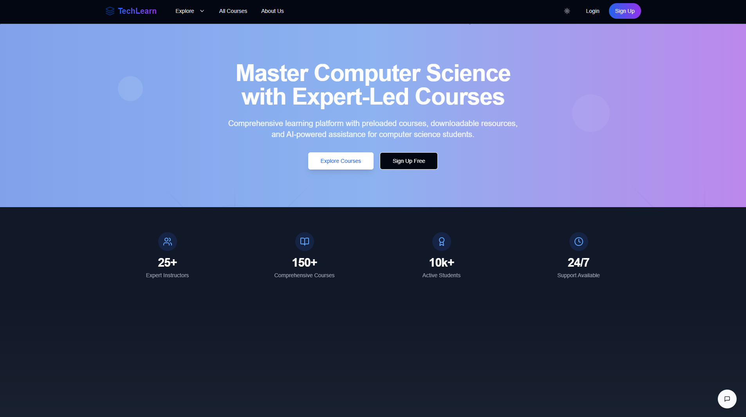

# Register Page :

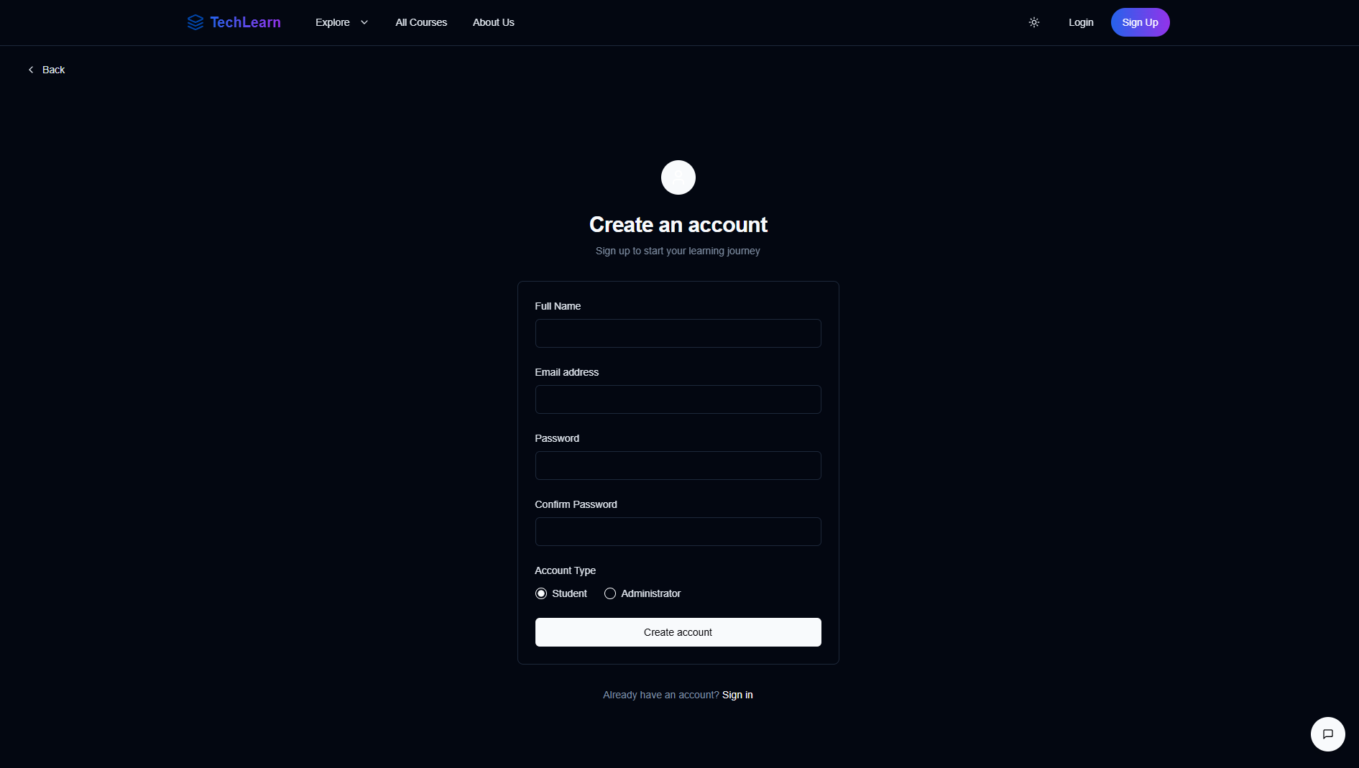

# Login Page :

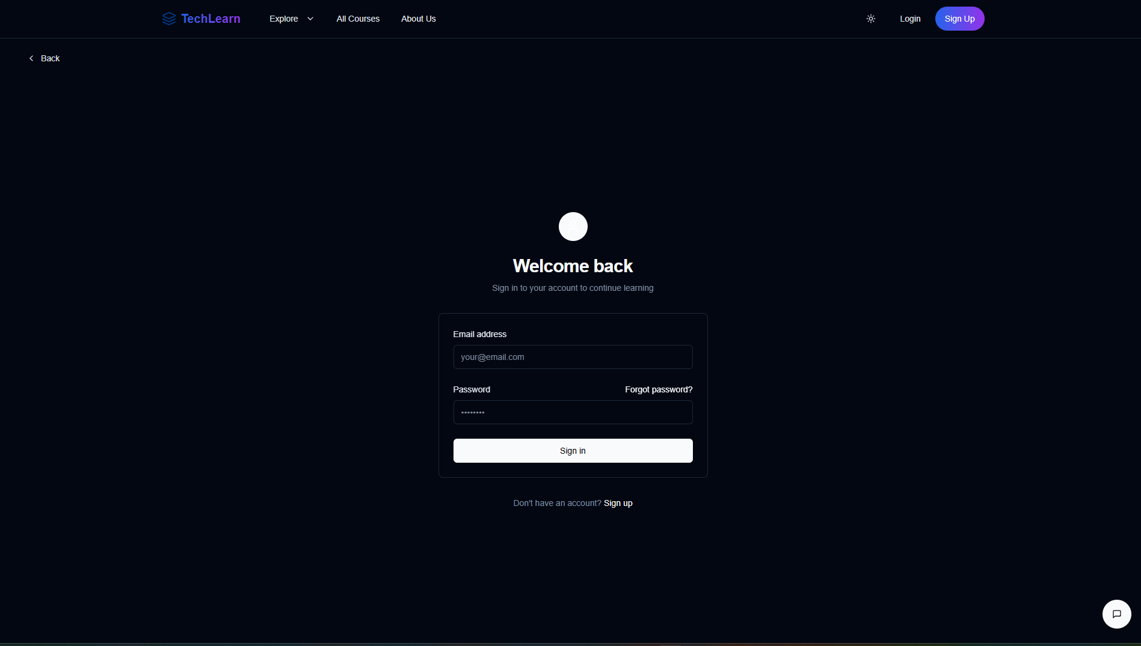

# Admin Dashboard :

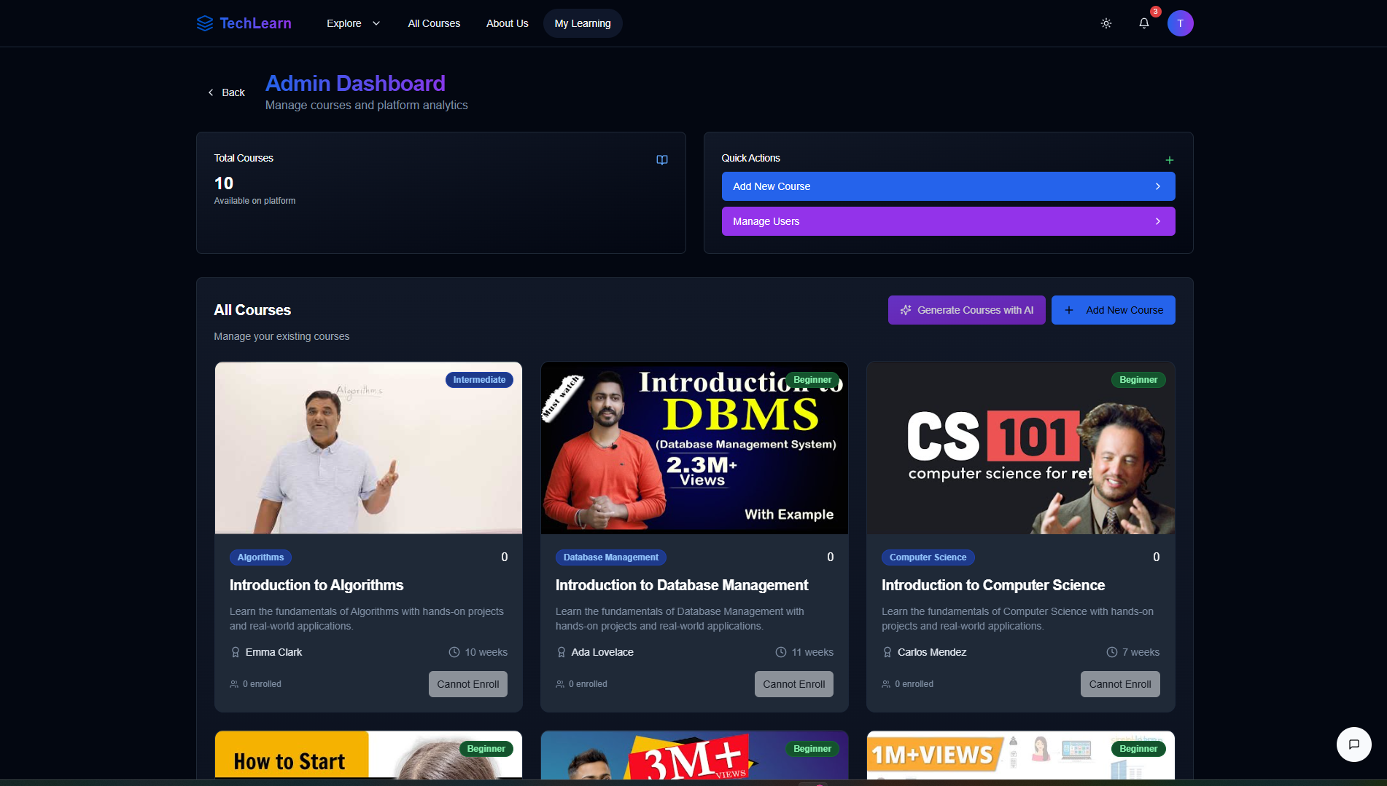

# Admin Course Management :

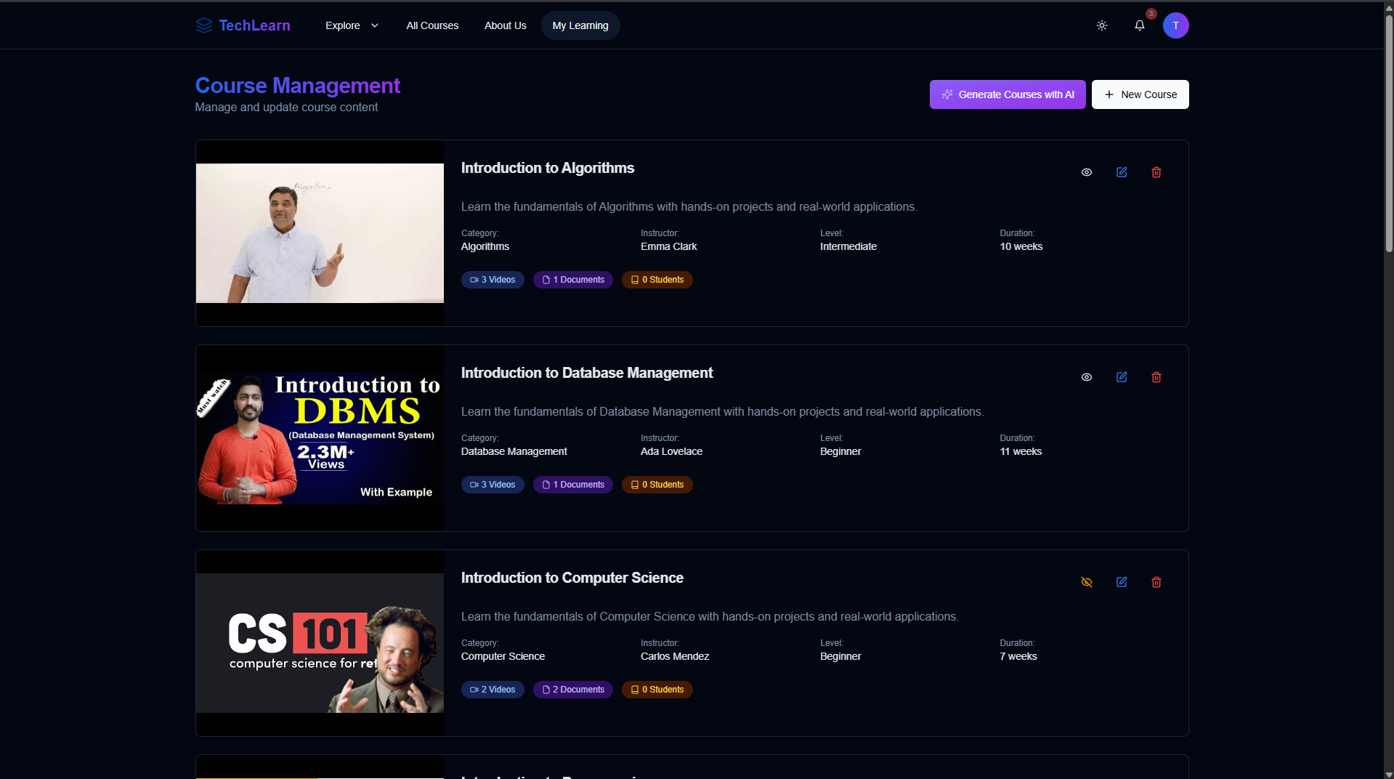

# All Courses :

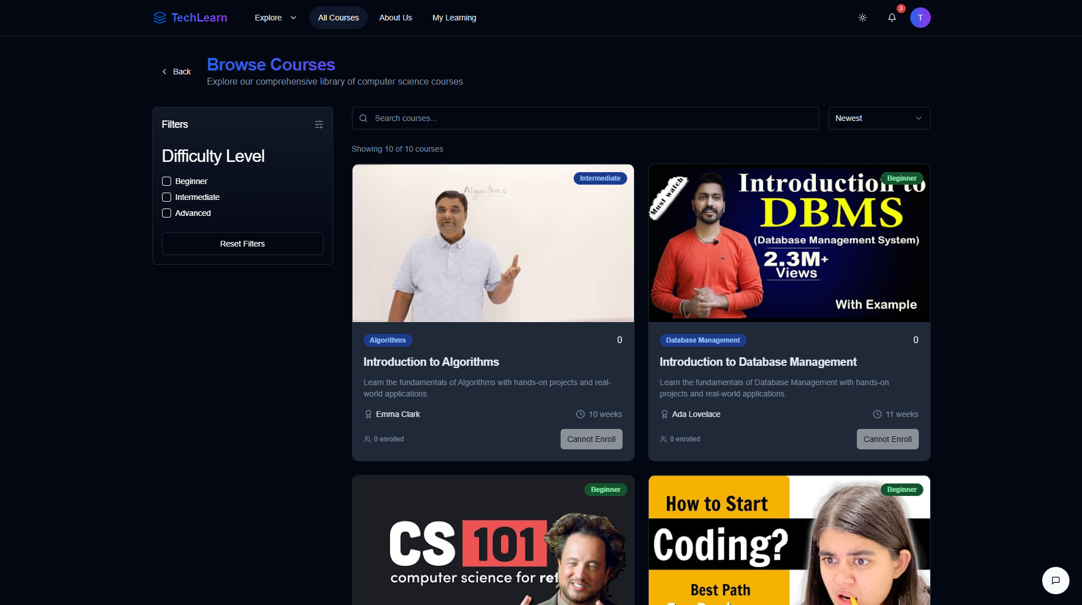

# Adding New Courses :

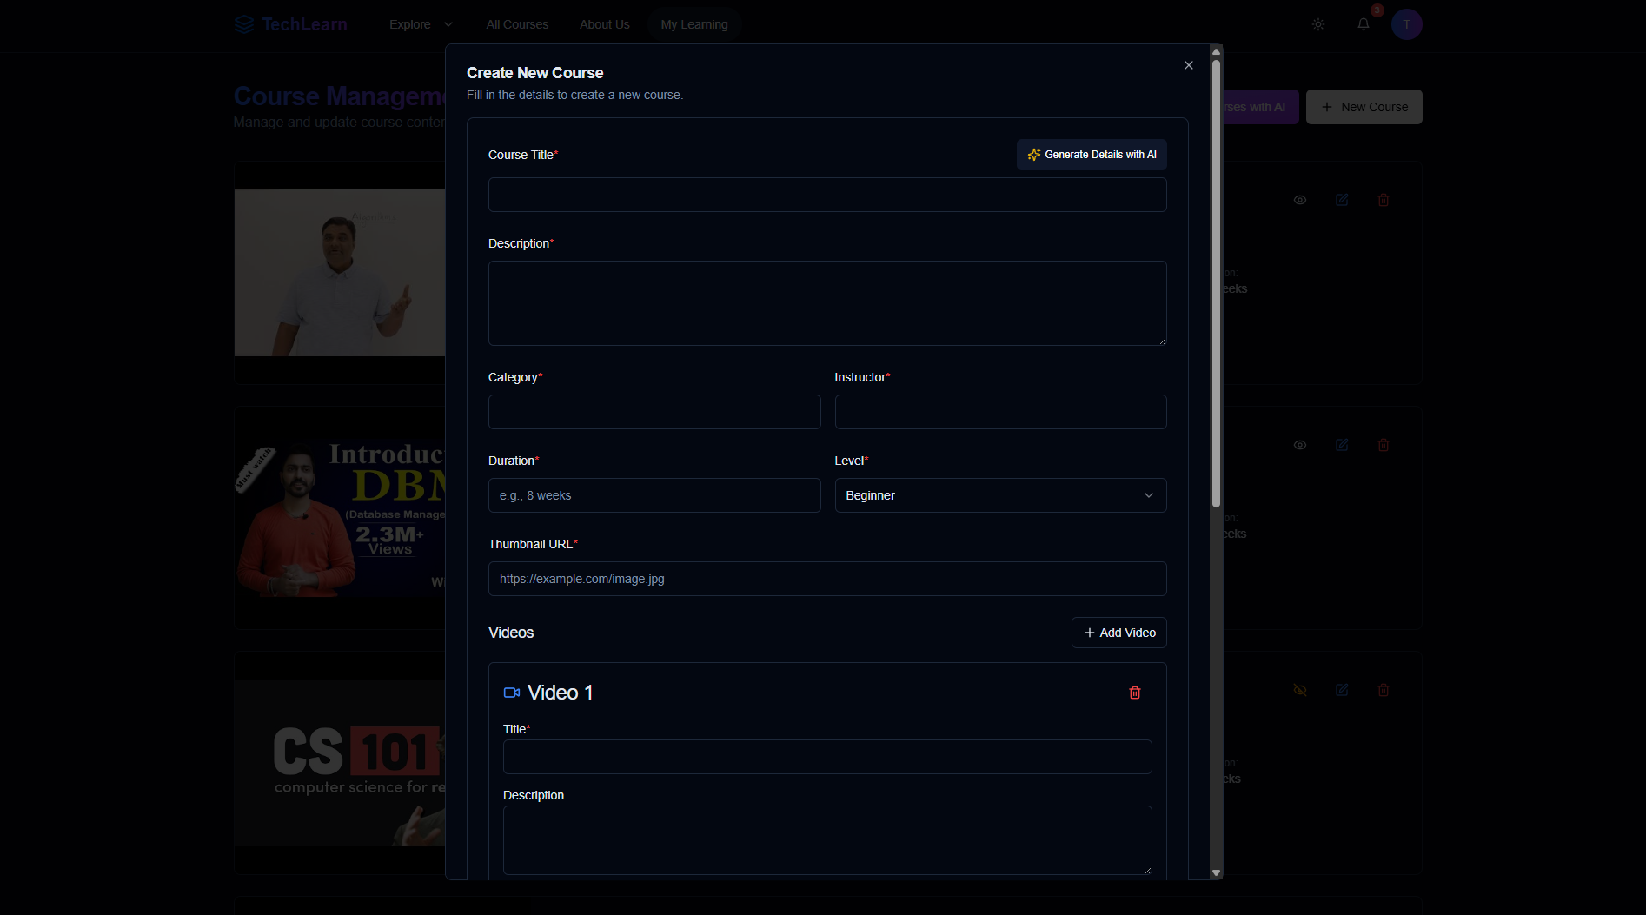

# User Management :

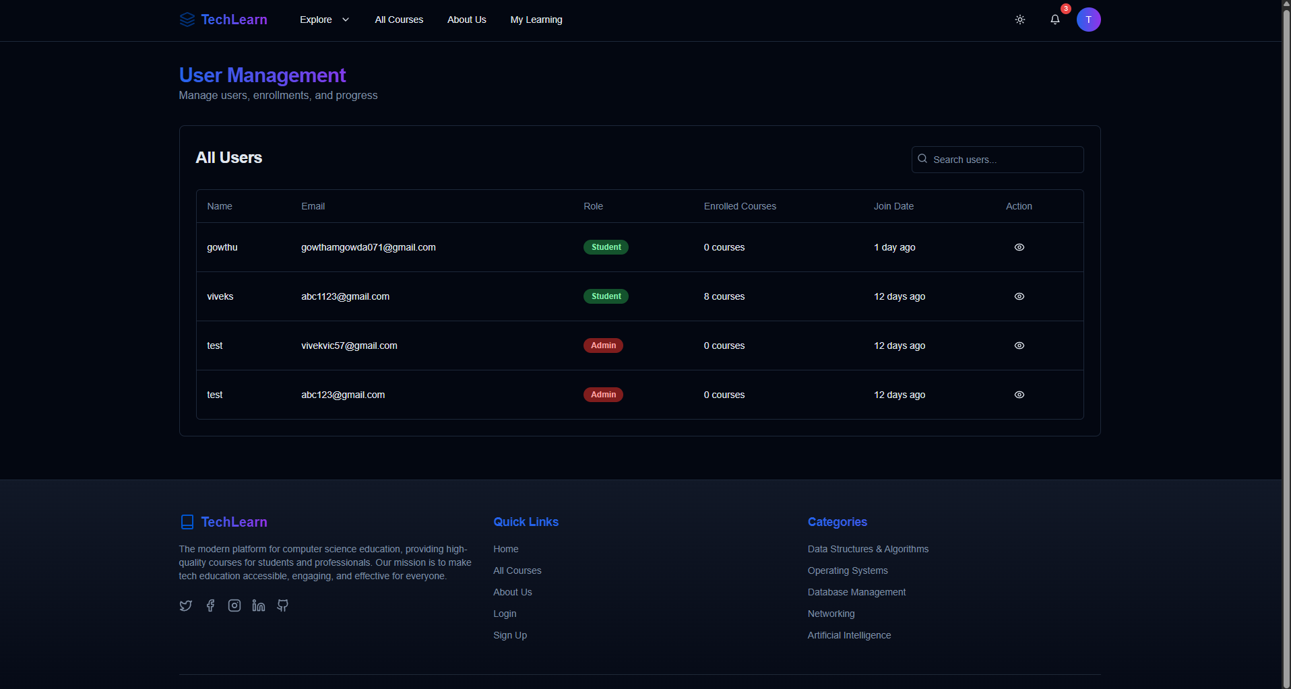

# User Data :

