**SAS ASSIGNMENT**

* MANJUNATH

**QUESTION 1**

/*Question 1*/

/* Step A: Create a library pointing to the directory containing customer_dim */

libname customer '/home/u64007678/my_shared_file_links/jhshows0/STA5066';

/* Step B & C: Create a temporary dataset 'youth' with the specified conditions and only keep the necessary variables */

data youth;

set customer.customer_dim;

where Customer_Gender = 'F'

and Customer_Age between 18 and 36

and find(Customer_Group, 'Gold', 'i') > 0;

run;

proc print data=youth;

run;

data youth;

set customer.customer_dim(keep=Customer_Name Customer_Age Customer_BirthDate Customer_Gender Customer_Group);

where Customer_Gender = 'F'

and Customer_Age between 18 and 36

and find(Customer_Group, 'Gold', 'i') > 0;

run;

proc print data=youth;

run;

**OUTPUT :**

**QUESTION 2:**

/* Part A: Create a library called prg1 that points to the directory STA5066 */

libname prg1 '/home/u64007678/my_shared_file_links/jhshows0/STA5066';

/* Part B, C, D, and E: Create a temporary dataset 'sports' with the specified conditions,

exclude unnecessary variables, assign labels, and apply formats */

data sports;

set prg1.product_dim(drop=Product_ID Product_Line Product_Group Supplier_ID);

where Supplier_Country in ('GB', 'ES', 'NL')

and substr(Product_Category, length(Product_Category) - 5) = 'Sports';

label

Product_Category = 'Sports Category'

Product_Name = 'Product Name (Abbrev)'

Supplier_Name = 'Supplier Name (Abbrev)';

format Product_Name $15. Supplier_Name $15.;

run;

/* Part F: Include a PROC CONTENTS step to verify labels and formats */

proc contents data=sports;

run;

/* Part G: Include a PROC PRINT step to display 14 observations from the dataset work.sports */

proc print data=sports(obs=14);

run;

**OUTPUT:**

**QUESTION 3**

/* Define a library for the exam data set */

libname Nhanes3 '/home/u64007678/my_shared_file_links/jhshows0/STA5066';

/* step A & B :Create a temporary data set 'examsub1' with the specified variables */

data work.examsub1;

set Nhanes3.exam;

keep hsageir hssex dmaracer bmpwt bmpht pep6g1 pep6h1 pep6i1 pep6g3 pep6h3 pep6i3 sppfvc sppfev1;

rename hsageir = age hssex = gender dmaracer = race bmpwt = wt_kg bmpht = ht_cm

pep6g1 = sbp1 pep6h1 = sbp2 pep6i1 = sbp3 pep6g3 = dbp1 pep6h3 = dbp2 pep6i3 = dbp3;

format pep6g1 pep6h1 pep6i1 pep6g3 pep6h3 pep6i3 8.;

run;

/* Part C : Print the first 7 observations of 'examsub1*/

proc print data=work.examsub1 (obs=7);

run;

/* Part D Display the descriptor portion of the data set 'examsub1' */

proc contents data=work.examsub1;

run;

**OUTPUT:**

**Question 4:**

/* Part A: Create a library pointing to the location of the lab data set*/

libname NH '/home/u64007678/my_shared_file_links/jhshows0/STA5066';

/* Part B & C : Create a temporary SAS data set 'labsub1' with the specified variables */

data work.labsub1;

set NH.lab;

keep seqn hgp htp tcp tgp lcp hdp fbpsi crp sgp urp;

run;

/* Part D : Verify the variables in 'labsub1' using PROC CONTENTS */

proc contents data=work.labsub1;

run;

/* Part E : Print the first 5 observations of the 'labsub1' data set */

proc print data=work.labsub1 (obs=5);

run;

**OUTPUT:**

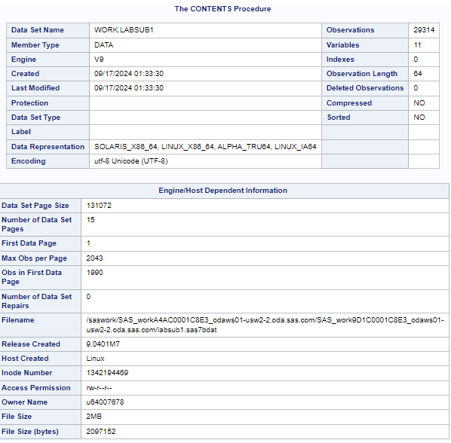

**QUESTION 5:**

/* Part A: Create a library pointing to the location of the mortality data set */

libname nh3 '/home/u64007678/my_shared_file_links/jhshows0/STA5066';

/* Part B & C Create a temporary SAS data set 'mortsub1' with only observations where eligstat = 1 */

data work.mortsub1;

set nh3.mortality;

where eligstat = 1;

keep SEQN MORTSTAT;

label MORTSTAT = 'Mortality Status';

run;

/* Part D: Verify the descriptor portion of 'mortsub1' using PROC CONTENTS */

proc contents data=work.mortsub1;

run;

/* Part E: Print the first 100 observations of the 'mortsub1' data set */

proc print data=work.mortsub1 (obs=100);

run;

**OUTPUT:**



