**\*QUESTION 1\***

**SAS ASSIGNMENT 2**

/* Step A: Create a library pointing to the directory containing customer_dim */

libname customer '/home/u64007678/my_shared_file_links/jhshows0/STA5066';

/* Step B & C: Create a temporary dataset 'youth' with the specified conditions and only keep the necessary variables */

data youth;

set customer.customer_dim;

where Customer_Gender = 'F'

and Customer_Age between 18 and 36

and find(Customer_Group, 'Gold', 'i') > 0;

run;

proc print data=youth;

run;

data youth;

set customer.customer_dim(keep=Customer_Name Customer_Age Customer_BirthDate Customer_Gender Customer_Group);

where Customer_Gender = 'F'

and Customer_Age between 18 and 36

and find(Customer_Group, 'Gold', 'i') > 0;

run;

proc print data=youth;

run;

**OUTPUT**:

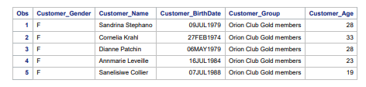

**\*QUESTION 2\***

/* Part A: Create a library called prg1 that points to the directory STA5066 */

libname prg1 '/home/u64007678/my_shared_file_links/jhshows0/STA5066';

/* Part B, C, D, and E: Create a temporary dataset 'sports' with the specified conditions,

exclude unnecessary variables, assign labels, and apply formats */

data sports;

set prg1.product_dim(drop=Product_ID Product_Line Product_Group Supplier_ID);

where Supplier_Country in ('GB', 'ES', 'NL')

and substr(Product_Category, length(Product_Category) - 5) = 'Sports';

label

Product_Category = 'Sports Category'

Product_Name = 'Product Name (Abbrev)'

Supplier_Name = 'Supplier Name (Abbrev)';

format Product_Name $15. Supplier_Name $15.;

run;

/* Part F: Include a PROC CONTENTS step to verify labels and formats */

proc contents data=sports;

run;

/* Part G: Include a PROC PRINT step to display 14 observations from the dataset work.sports */

proc print data=sports(obs=14);

run;

**OUTPUT;**

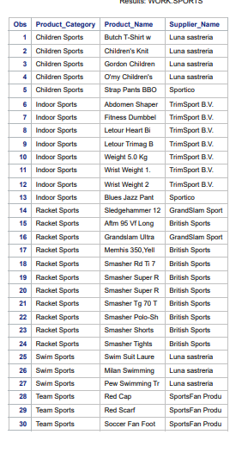

**QUESTION 3\***

/* Define the library Nhanes3 pointing to the appropriate directory */

libname Nhanes3 '/home/u64007678/my_shared_file_links/jhshows0/STA5066';

/* Create the temporary dataset examsub1 with renamed variables and formats */

data examsub1;

set Nhanes3.exam;

/* Keep only the selected variables */

keep hsageir hssex dmaracer bmpwt bmpht pep6g1 pep6h1 pep6i1 pep6g3 pep6h3 pep6i3 sppfvc sppfev1;

/* Rename the variables */

rename hsageir = age

hssex = gender

dmaracer = race

bmpwt = wt_kg

bmpht = ht_cm

pep6g1 = sbp1

pep6h1 = sbp2

pep6i1 = sbp3

pep6g3 = dbp1

pep6h3 = dbp2

pep6i3 = dbp3

sppfvc = fvc

sppfev1 = fev1;

/* Apply formats to ensure integer display */

format sbp1 sbp2 sbp3 dbp1 dbp2 dbp3 8.;

run;

/* Display the descriptor portion of the dataset examsub1 */

proc contents data=examsub1;

run;

/* Print the first 7 observations of the dataset examsub1 */

proc print data=examsub1(obs=7);

run;**OUTPUT;** 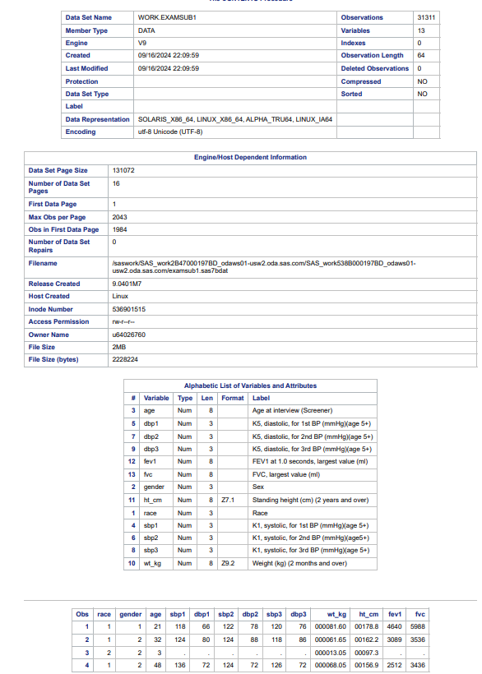

**\*QUESTION 4\***

/* Define the library NH pointing to the appropriate directory */

libname NH ' /home/u64007678/my_shared_file_links/jhshows0/STA5066';

/* Create the temporary dataset labsub1 with the specified variables */

data labsub1;

set NH.lab;

/* Keep only the selected variables */

keep seqn hgp htp tcp tgp lcp hdp fbpsi crp sgp urp;

run;

/* Display the descriptor portion of the dataset labsub1 */

proc contents data=labsub1;

run;

/* Print the first 5 observations of the dataset labsub1 */

proc print data=labsub1(obs=5);

run;

**OUTPUT;**

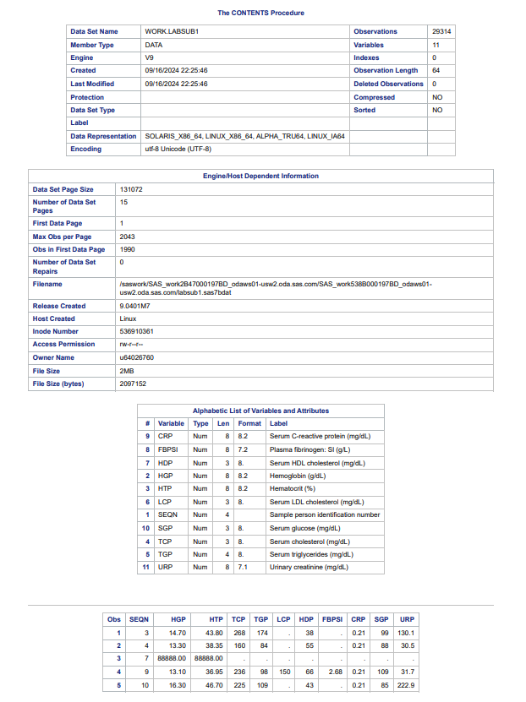

**\*QUESTION 5\***

/* Define the library nh3 pointing to the appropriate directory */

libname nh3 '/home/u64007678/my_shared_file_links/jhshows0/STA5066';

/* Create the temporary dataset mortsub1 with filtering, variable selection, and labels */

data mortsub1;

set nh3.mortality;

/* Filter data where eligstat equals 1 */

if eligstat = 1;

/* Keep only the specified variables and assign labels */

keep SEQN MORTSTAT;

label MORTSTAT = 'Mortality Status';

run;

/* Display the descriptor portion of the dataset mortsub1 */

proc contents data=mortsub1;

run;

/* Print the first 100 observations of the dataset mortsub1 */

proc print data=mortsub1(obs=100);

run;

**OUTPUT;**



