Prediction accuracy — heart_attack_youngsters_india.csv
- Test-set performance
Model | CV ROC-AUC (mean ± SD) | Test ROC-AUC (95% CI) | Acc. | Sens. | Spec. | F1 | MCC | Brier
Soft voting | 0.997 ± 0.002 | 1.000 (0.999–1.000) | 99.0% | 0.991 | 0.988 | 0.991 | 0.979 | 0.008
Stacking | 0.997 ± 0.002 | 1.000 (0.999–1.000) | 99.0% | 0.991 | 0.988 | 0.991 | 0.979 | 0.008
LightGBM | 0.996 ± 0.002 | 1.000 (0.999–1.000) | 99.0% | 0.991 | 0.988 | 0.991 | 0.979 | 0.006
EBM | 0.996 ± 0.002 | 1.000 (0.998–1.000) | 99.5% | 1.000 | 0.988 | 0.996 | 0.990 | 0.005
XGBoost | 0.994 ± 0.005 | 0.999 (0.998–1.000) | 98.5% | 0.991 | 0.976 | 0.987 | 0.969 | 0.009
CatBoost | 0.996 ± 0.002 | 0.999 (0.998–1.000) | 99.0% | 0.991 | 0.988 | 0.991 | 0.979 | 0.007
Random forest | 0.996 ± 0.001 | 0.999 (0.997–1.000) | 99.0% | 0.983 | 1.000 | 0.991 | 0.980 | 0.019
Logistic regression | 0.991 ± 0.004 | 0.999 (0.996–1.000) | 98.5% | 0.983 | 0.988 | 0.987 | 0.969 | 0.013

- Cross-validation on the development set
Model | ROC-AUC | PR-AUC | Accuracy | Sensitivity | Specificity | MCC | Brier
Soft voting | 0.997 | 0.998 | 96.8% | 0.970 | 0.964 | 0.933 | 0.020
Stacking | 0.997 | 0.998 | 96.8% | 0.970 | 0.964 | 0.933 | 0.021
LightGBM | 0.996 | 0.997 | 96.5% | 0.959 | 0.973 | 0.929 | 0.020
EBM | 0.996 | 0.997 | 97.5% | 0.983 | 0.964 | 0.949 | 0.019
XGBoost | 0.994 | 0.995 | 95.7% | 0.959 | 0.955 | 0.914 | 0.029
CatBoost | 0.996 | 0.997 | 96.1% | 0.959 | 0.964 | 0.921 | 0.022
Random forest | 0.996 | 0.997 | 96.0% | 0.961 | 0.959 | 0.919 | 0.027
Logistic regression | 0.991 | 0.993 | 96.4% | 0.968 | 0.958 | 0.926 | 0.029

- Calibration and operating points
Model | Youden threshold | Cal. intercept | Cal. slope | Sens ≥ 0.90 threshold | Sensitivity there | Specificity there
Soft voting | 0.523 | -0.13 | 1.84 | 0.826 | 0.983 | 1.000
Stacking | 0.536 | 0.00 | 1.32 | 0.955 | 0.983 | 1.000
LightGBM | 0.499 | -0.17 | 0.88 | 0.986 | 0.966 | 1.000
EBM | 0.373 | -0.44 | 1.03 | 0.976 | 0.948 | 1.000
XGBoost | 0.295 | -0.03 | 1.12 | 0.966 | 0.931 | 1.000
CatBoost | 0.614 | -0.45 | 1.17 | 0.952 | 0.957 | 0.988
Random forest | 0.637 | -0.09 | 3.29 | 0.763 | 0.957 | 1.000
Logistic regression | 0.460 | -0.04 | 1.44 | 0.861 | 0.940 | 0.988
- Figures
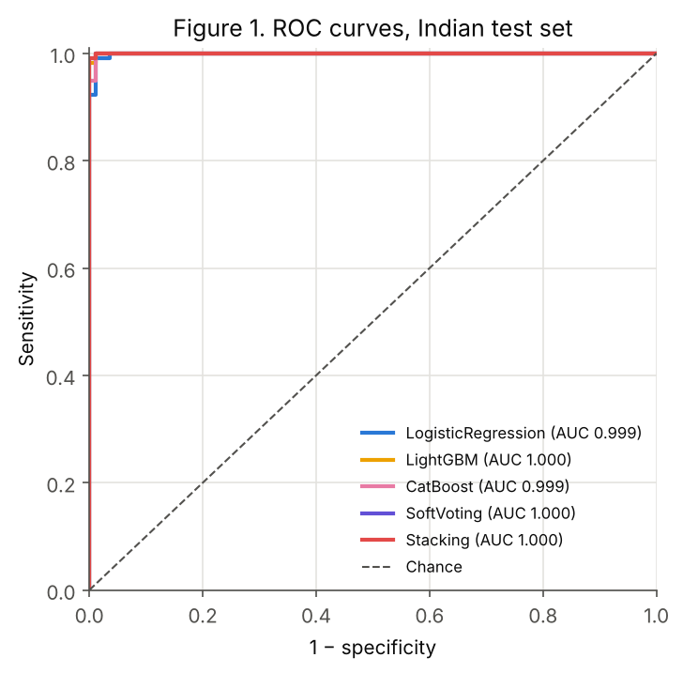
Figure 1. ROC curves on the test set
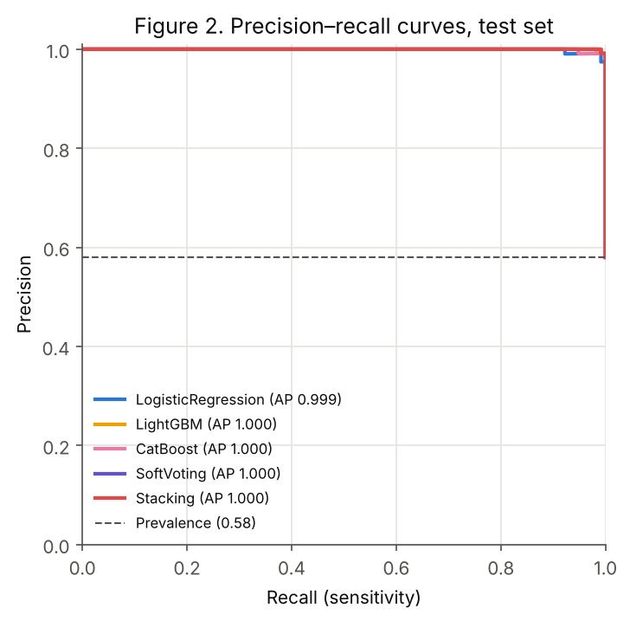
Figure 2. Precision–recall curves on the test set
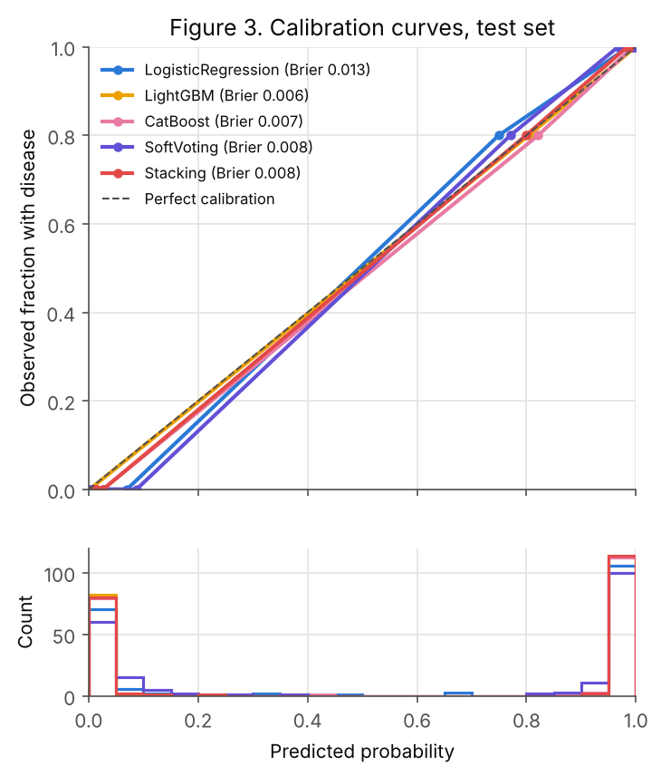
Figure 3. Calibration curves and distribution of predicted probabilities on the test set
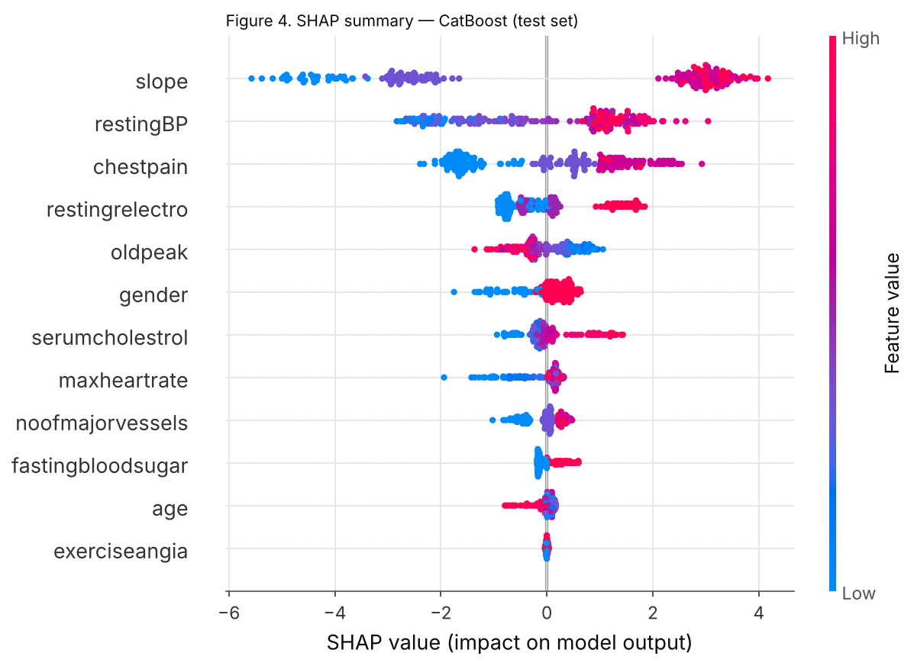
Figure 4. SHAP summary for CatBoost on the test set
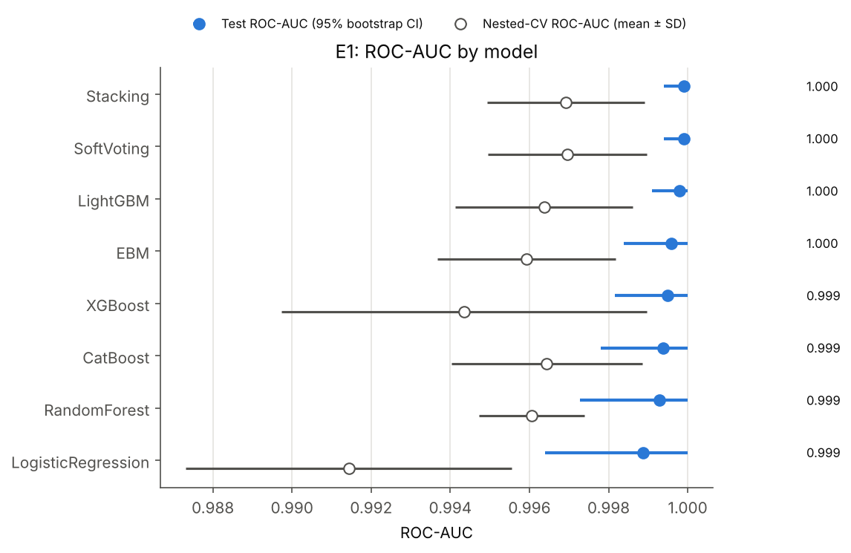
Figure 5. ROC-AUC by model: test set (95% bootstrap CI) and nested cross-validation (mean ± SD)
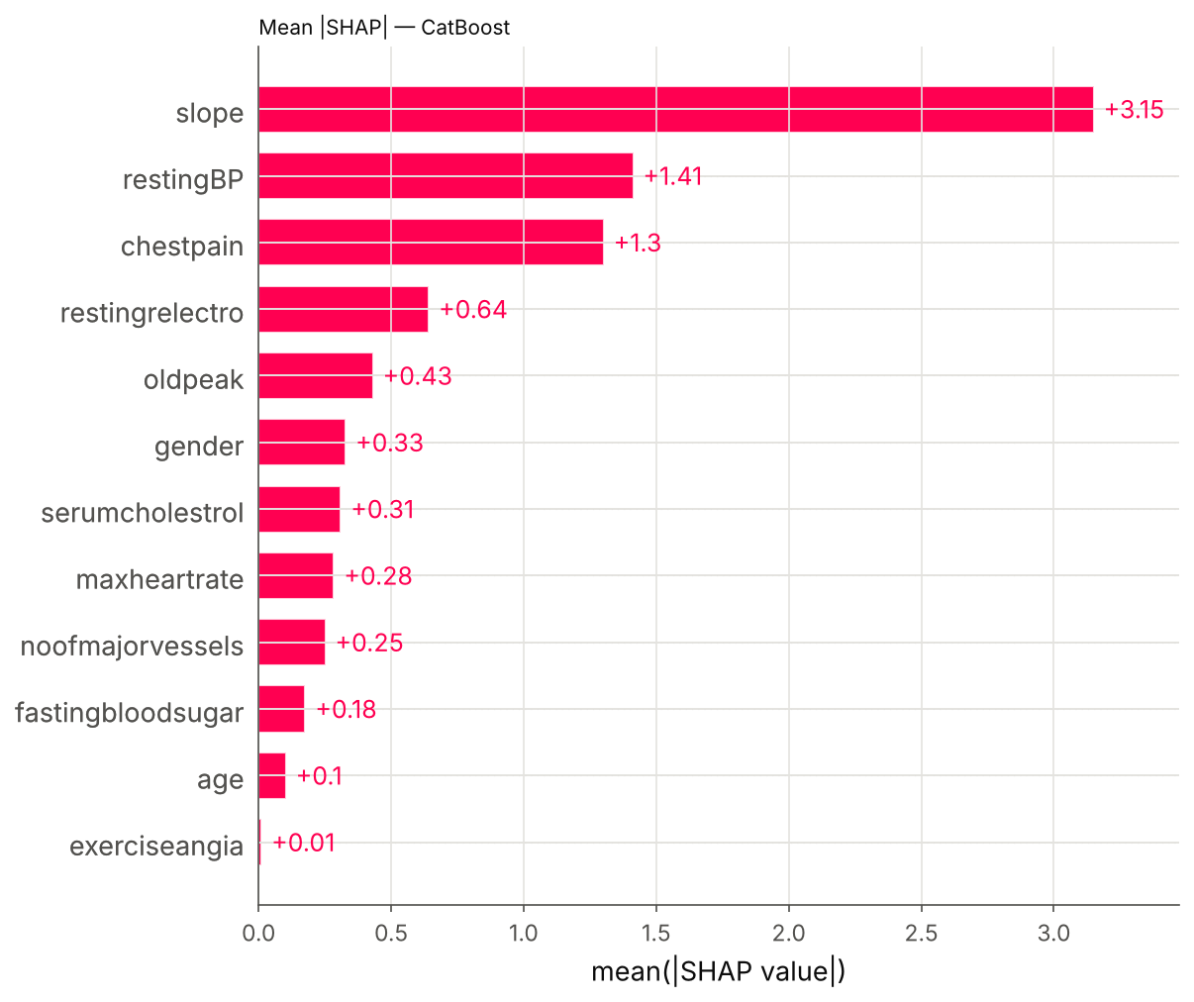
Figure 6. Mean absolute SHAP value per attribute (CatBoost)
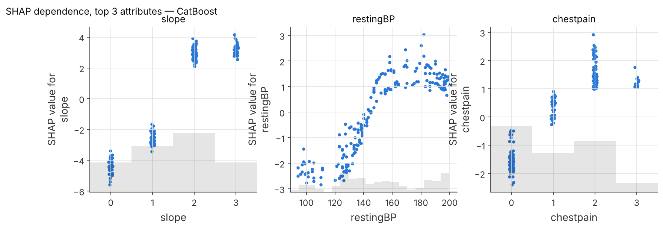
Figure 7. SHAP dependence plots for the three most important attributes (CatBoost)
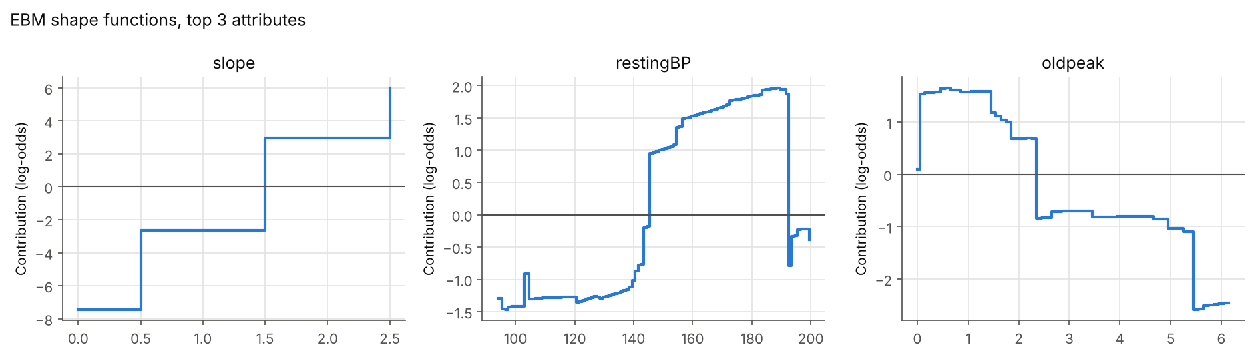
Figure 8. EBM shape functions for the three most important attributes
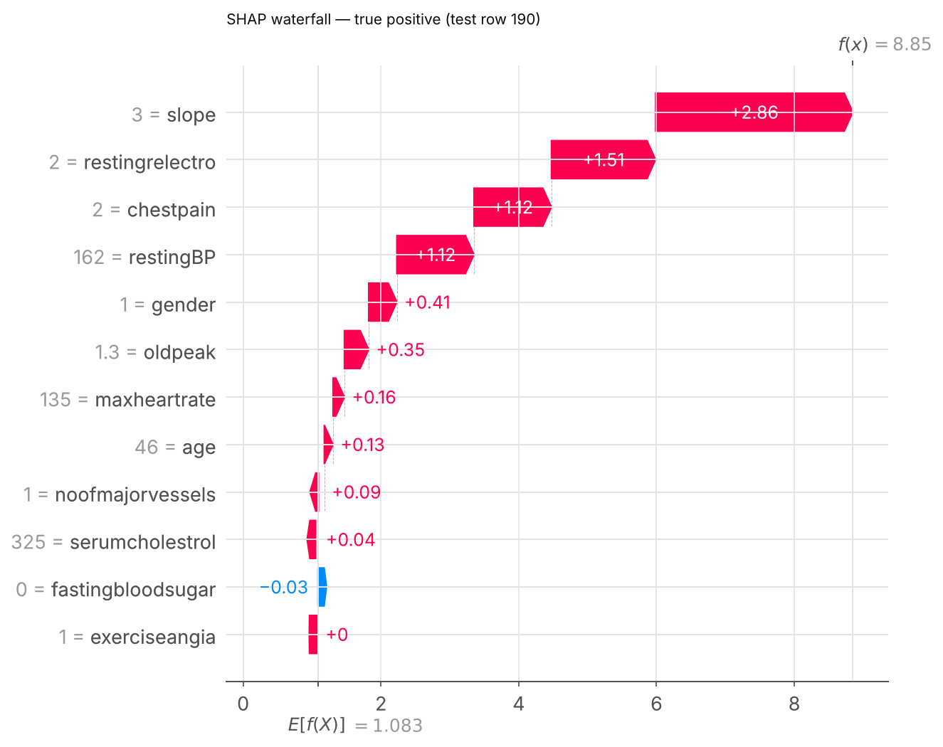
Figure 9. SHAP explanation for a correctly detected patient (true positive)
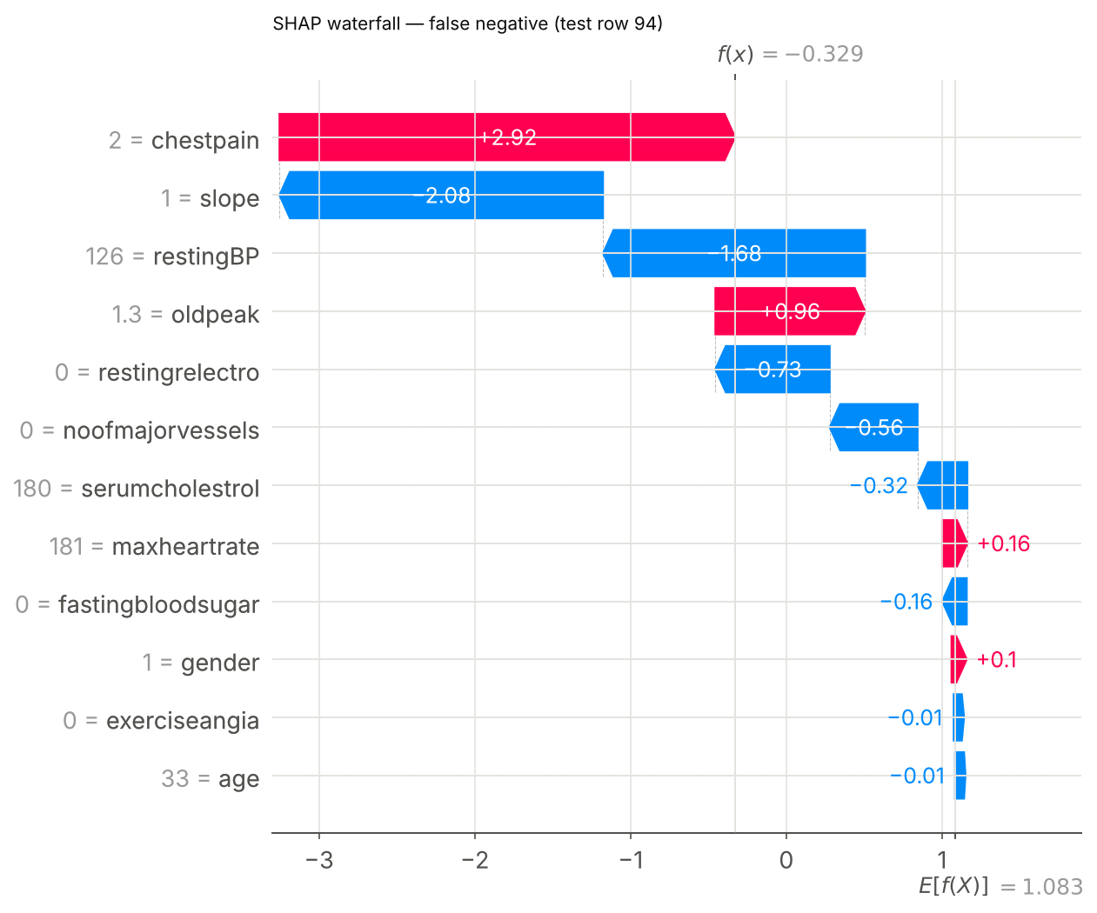
Figure 10. SHAP explanation for a missed patient (false negative)

