**LOCALIZATION USING RUBY**

**BreatheMapper Mobile App**

ER#: *xxxxxxx*

Version#: *1.0*

Prepared by: Manish Rathi

Philips Innovation Campus.

Manyata Tech Park,

Bengaluru, INDIA 560045

© 2018 Koninklijke Philips N.V.

All rights are reserved.

Reproduction in whole or in part is prohibited without the prior written consent of the copyright holder

**Revision History**

|  |  |  |  |
| --- | --- | --- | --- |
| **Version Number** | **Date** | **Description of Changes** | **Contributors** |
| 1.0 | 05/21/2018 | Original Release | MR |
| 1.1 | 06/06/2018 | Added Export Feature | MR |

**Contributors**

MR Manish Rathi

**Table of Contents**

1. Introduction 3

1.1 Purpose 3

1.2 Acronyms and Definitions 3

2. Welcome to Ruby Localization 3

2.1 About Ruby Localization 3

2.1.1 About LocalizationConfiguration.yml 3

2.1.2 About Localization.xlsx 4

2.1.3 About iOS Resource File 4

2.1.4 About Android Resource File 5

2.2 Dependency 5

2.2.1 Ruby 5

2.2.2 rubyXL Ruby gem 6

2.2.3 fileutils Ruby gem 6

2.2.4 os Ruby gem 6

3. Localization Import Feature 6

3.1 About Import Feature 6

3.2 Configuration Reader Ruby Script File 7

3.3 Localization Converter Ruby Script File 7

3.4 Resource File Injector Ruby Script File 7

4. Localization Export Feature 7

4.1 About Export Feature 7

4.2 Resource File to Excel Converter Ruby Script File 8

5. Integration with BreatheMapper 8

5.1 Hosting Ruby Scripts 8

5.2 Integrate with BreatheMapper Mobile App 8

5.3 Update Localization.xlsx File 9

5.4 Run Localization Ruby Scripts 9

# Introduction

## Purpose

This Localization using Ruby describes the localization process by using Ruby scripts that used in the iOS Mobile App, “Breath Mapper” development.

## Acronyms and Definitions

* IDE Integrated Development Environment
* Xcode macOS IDE developed by Apple for developing software for iOS
* iOS Apple’s mobile operating system
* macOS Apple’s mac-book operating system
* SDK Software Development Kit
* Android Google’s mobile operating system

# Welcome to Ruby Localization

## About Ruby Localization

Ruby is a fantastic way to write scripts. In Ruby Localization process, Ruby scripts will take input from one excel file and generate localize resource files, Localizable.strings file in case of iOS and string.xml file in case of Android. Every run of Ruby scripts will replace the content of older resource file(s).

### About LocalizationConfiguration.yml

Ruby scripts will read configuration from “LocalizationConfiguration.yml” file. LocalizationConfiguration.yml should be exist any folder of BreatheMapper git repository. LocalizationConfiguration.yml contain below parameters for import (excel file => resource files) feature:

**excel_file_path**: Ruby scripts will use this path to read localization input excel file.

**platform**: Platform can be iOS or Android. Based on this parameter, Ruby scripts will generate Localizable.strings file in case of iOS or string.xml file in case of Android.

**project_resource_folder_path**: Ruby scripts will use this path as output folder of resources file.

Sample LocalizationConfiguration.yml file will look like below:

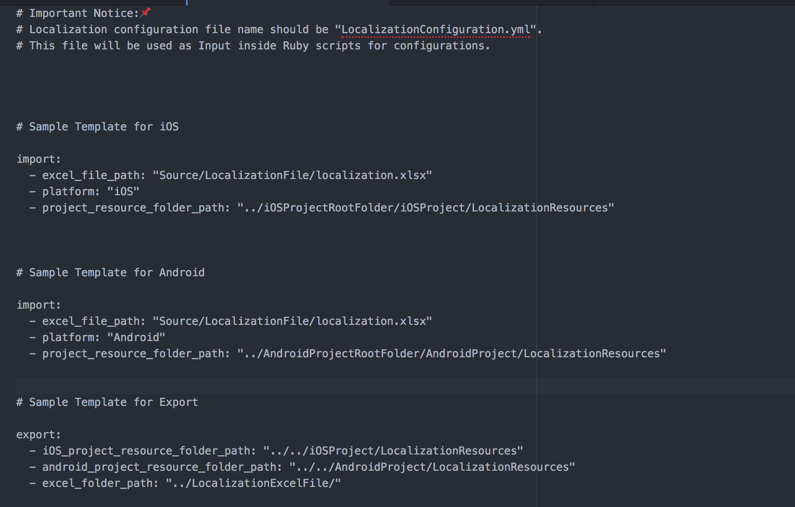

### About Localization.xlsx

Ruby scripts will use Localization.xlsx file for input.

Sample Localization.xlsx file will look like below:

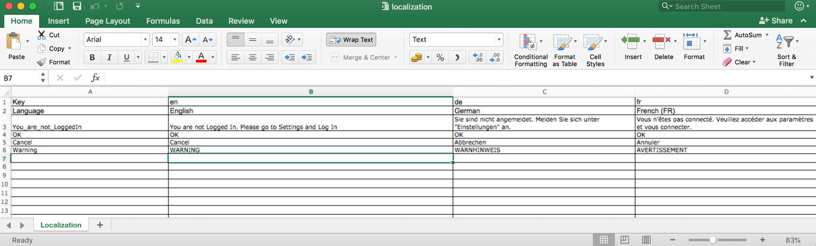

### About iOS Resource File

If User is running Ruby scripts for iOS localization then Ruby scripts will generate the Localizable.strings resource file, which can be directly consume inside iOS project.

Sample auto-generated Localizable.strings resource file will look like below:

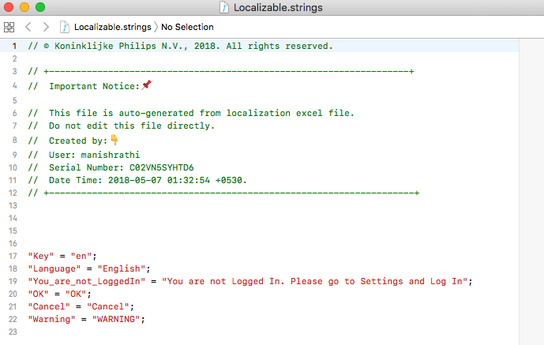

### About Android Resource File

If User is running Ruby scripts for Android localization then Ruby scripts will generate the string.xml resource file, which can be directly consume inside Android project.

Sample auto-generated string.xml resource file will look like below:

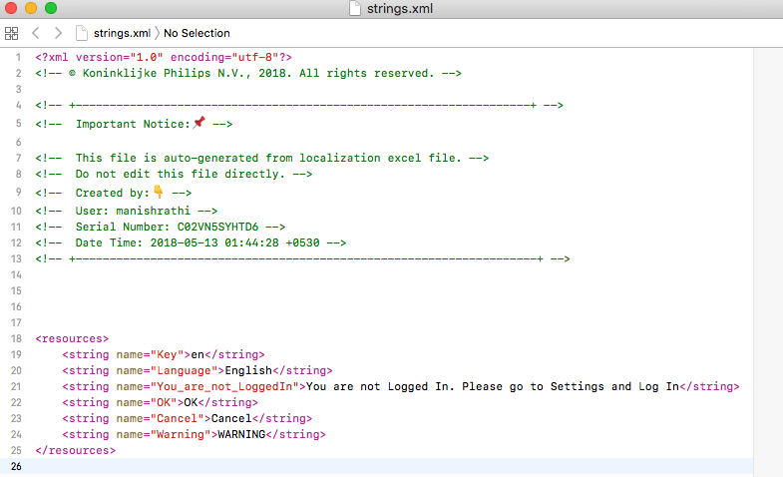

## Dependency

Ruby Localization scripts have following dependencies:

### Ruby

Ruby Localization script will not work if Ruby is not installed in machine.

To check if Ruby is installed or not, use command: **which ruby**

This command should print the path where ruby is installed. i.e.  
/Users/manishrathi/.rvm/rubies/ruby-2.5.0/bin/ruby

To install Ruby: <https://www.ruby-lang.org/en/documentation/installation/>

### rubyXL Ruby gem

“rubyXL” is a Ruby library for reading/writing/modifying .xlsx file, can be found at GitHub <https://github.com/weshatheleopard/rubyXL> .

To install rubyXL: [sudo] gem install rubyXL

### fileutils Ruby gem

“fileutils” is a Ruby library which have utility methods for copying, moving, removing file utility apis, can be found at GitHub <https://github.com/ruby/fileutils> .

To install fileutils: [sudo] gem install fileutils

### os Ruby gem

“os” is a Ruby library which have utility methods allows for some easy telling if you’re on windows or not, can be found at GitHub <https://github.com/rdp/os> .

To install fileutils: [sudo] gem install os

# Localization Import Feature

## About Import Feature

In import feature, Ruby scripts will take input from excel(.xlsx) file and generate localize resource files, Localizable.strings file in case of iOS and string.xml file in case of Android.

Localization.xlsx file

Resources Files (.strings or .xml)

Localization Converter Ruby Script

Resource File Injector Ruby Script

LocalizationConfiguration.yml

Configuration Reader Ruby Script

Ruby Scripts

## Configuration Reader Ruby Script File

Localization Ruby script file named as “ConfigurationReader.rb” used to read configurations from “LocalizationConfiguration.yml” file.

## Localization Converter Ruby Script File

Localization Ruby script file named as “LocalizationConverter.rb” is the core of localization process. This Ruby script file first read the “localization.xlsx” input excel file, parse the excel file and then create localized resource files, Localizable.strings files in case of iOS and string.xml files in case of Android.

## Resource File Injector Ruby Script File

Localization Ruby script file named as “ResourceFileInjector.rb” used to paste newly generated resources files (.strings or .xml files) into project resource folder.

# Localization Export Feature

## About Export Feature

In export feature, Ruby scripts will take input from localize resource files (.strings and .xml files) and generate excel(.xlsx) file.

Resources Files (.strings or .xml)

Resource File to Excel Ruby Script

Localization.xlsx Excel File

LocalizationConfiguration.yml

Configuration Reader Ruby Script

Ruby Scripts

## Resource File to Excel Converter Ruby Script File

Localization Ruby script file named as “ResourceFileToExcelConverter.rb” perform the reverse functionality. This Ruby script file first read localized resource files, Localizable.strings files in case of iOS and string.xml files in case of Android then generate the “localization.xlsx” excel file with all localized details.

# Integration with BreatheMapper

## Hosting Ruby Scripts

Localization Ruby scripts has been hosted at [Gitlab server](https://scm.sapphirepri.com/Mapper/BreatheMapperLocalization).

## Integrate with BreatheMapper Mobile App

Localization Ruby scripts has been hosted at Gitlab server, we can integrate with BreatheMapper Mobile App by using git-submodule feature.

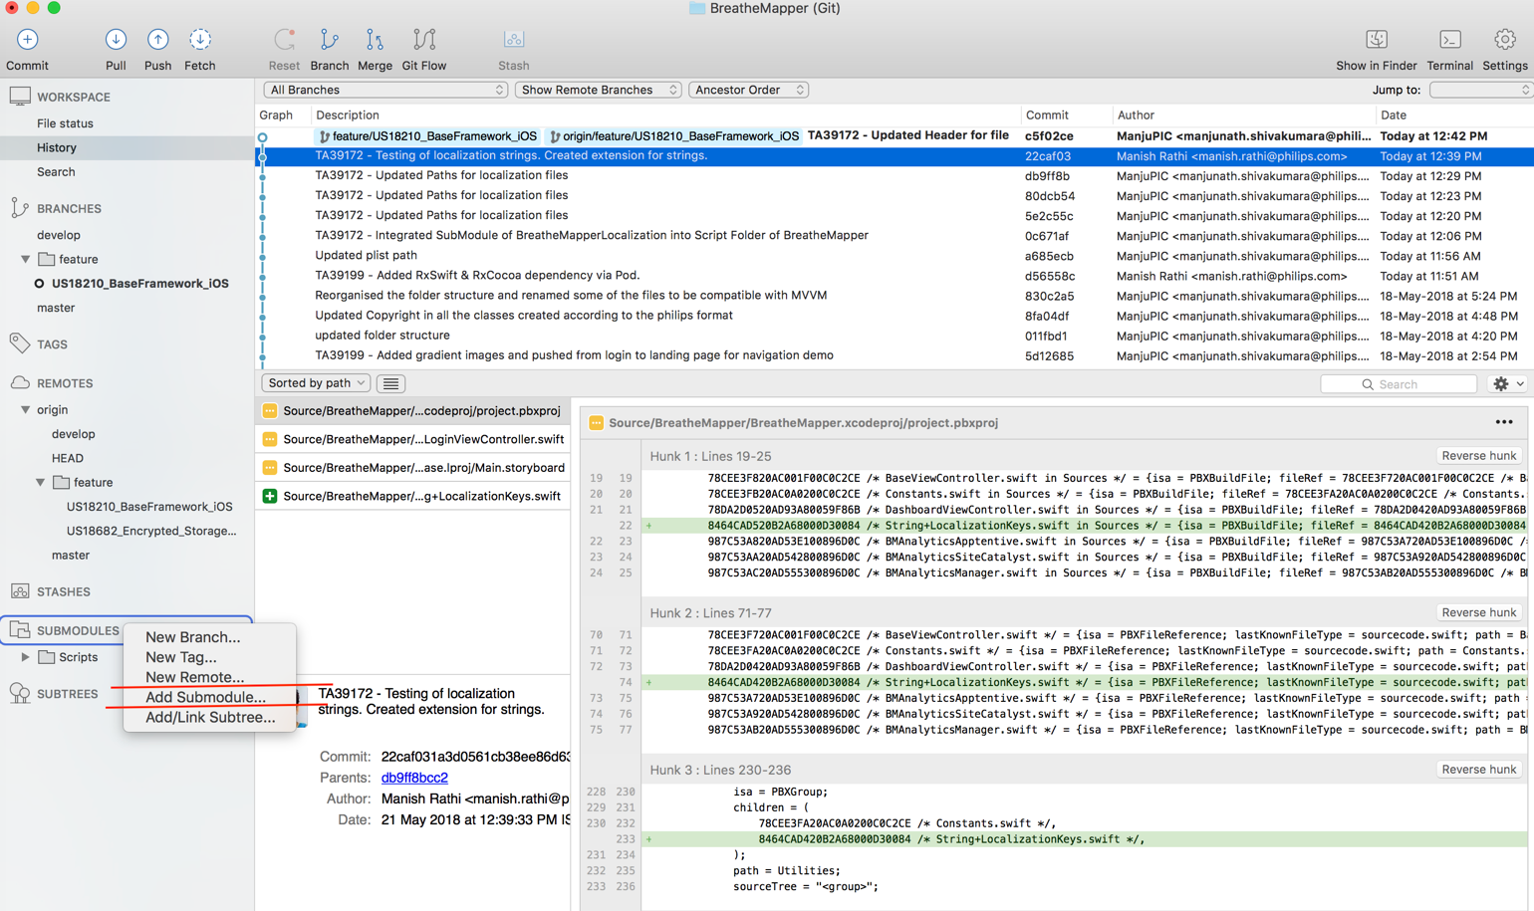

## 5.3 Update Localization.xlsx File

After integration with BreatheMapper mobile app, User can easily update localization.xlsx excel file. localization.xlsx file can be found under LocalizationFile folder. Once we have changes inside localization.xlsx excel file then we need to run the ruby scripts to get latest localized strings into BreatheMapper iOS/Android project.

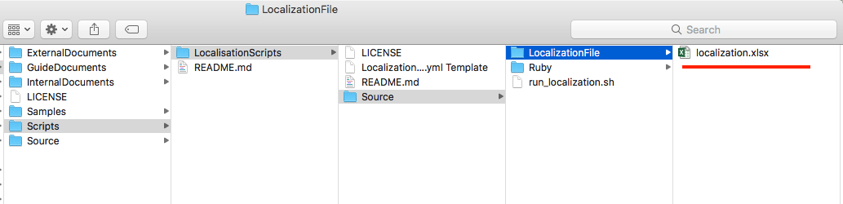

## 5.4 Run Localization Ruby Scripts

After integration with BreatheMapper mobile app, User can run the localization Ruby script by using helper shell script named as “run_loacalization.sh”. Every time we need to run scripts whenever there is an update in localization.xlsx excel input file.

Steps to Run Localization by using shell-script:

Step1: Open terminal

Step2: Go to Localization script’s source folder i.e. cd ~/Scripts/LocalisationScripts/Source

Step3: Run localization shell script i.e. sh run_localization.sh  
Step4: Done.

Steps to Run Localization by using ruby-script:

Step1: Open terminal

Step2: Go to Localization script’s ruby folder i.e. cd ~/Scripts/LocalisationScripts/Source/Ruby

Step3: Run localization convertor ruby script i.e. ruby LocalizationConverter.rb

Step4: Run File Injector ruby script i.e. ruby ResourceFileInjector.rb   
Step5: Done.  
  
Image Reference for BreatheMapper iOS project:

