SECRETE IMAGE SHARING BASED ON ENCRYPTED PIXELS

A project report submitted to

Visvesvaraya Technological University. Belgaum, Karnataka

in the partial fulfillment of the requirements for the award of degree of

Bachelor of Engineering

in

Computer Science and Engineering

by

Gagandeep G A 1SI16CS039

Sagar S B 1SI16CS089

Shashank 1SI16CS097

Sushruth R Iyengar 1SI16CS117

under the guidance of

Shwetha A N

Assistant Professor

Department of Computer Science and Engineering

Siddaganga Institute of Technology, Tumakuru

May, 2020

Department of Computer Science and Engineering Siddaganga Institute of Technology Tumakuru - 572103


CERTIFICATE

Certified that the Project Report entitled "My Wonderful Project" is a bonafide work carried out by Gagandeep G A(1SI16CS039), Sagar S B(1SI16CS089), Shashank(1SI16CS097) and Sushruth R Iyengar(1SI16CS117) in the partial fulfillment of the requirement for the award

of the degree of Bachelor of Engineering in Computer Science and Engineering , Visves-varaya Technological University, Belagavi during the year 2019-20. It is certified that all corrections/suggestions indicated for the internal assessment have been incorporated in the report. The project report has been approved as it satisfies the academic requirements in respect of project work prescribed for the Bachelor of Engineering Degree.

 | ................................. | .................................
 | Guide | Group Convener
 | Shwetha A N | Dr. Manjunath K G
 | Asst. Professor | Professor
 | Dept of CSE, SIT | Dept of CSE, SIT
 | ................................. | .................................
 | Dr. R. Sumathi | Dr. Shivananda K P
 | Professor and Head | Principal
 | Dept of CSE, SIT | SIT, Tumakuru
Name of the Examiners |  | Signature with Date
1. | Prof.
2. | Prof.

Department of Computer Science and Engineering Siddaganga Institute of Technology Tumakuru - 572103

DECLARATION

I hereby declare that the entire work embodied in this dissertation has been carried out by me at Siddaganga Institute of Technology under the supervision of ——

————-. This dissertation has not been submitted in part or full for the award of any diploma or degree of this or any other University.

Department of Computer Science and Engineering

Siddaganga Institute of Technology

Tumakuru - 572103

Abstract

- Paragraph on motivation:

The image hiding and watermarking are techniques that can increase the security of the secret information. However, there is a drawback that the information is kept in a single information-carrier. If the information-carrier is lost or destroyed by an attacker, the secret information might disappear. Thus motivated, the secret sharing method might be the better technique that not only increases the security but also has an extremely high opportunity of recovering the secret information completely. It aims to distribute the secret information to several shadow information holders, and we can completely recover the desired information by collecting an enough number of multiple carriers.

- The social relevance:
This project will helpful for the society to secure the secret data from the attackers, especially in the military data sharing.
This project will helpful for the users who wants to share the secret information

- Problem Statement and Objectives:

Problem Statement:

- Shamir’s scheme only uses one coefﬁcient of a (k−1) – degree polynomial for embedding secret, and thus it has perfect security. Different from Shamir’s scheme, Thein and Lin’s (k, n) - SIS scheme and its extended versions use all coefficients of a (k −1)-degree polynomial for embedding secret pixels to reduce the shadow size.
- To avoid residual image effect, all of those existing (k, n)-SIS schemes which are mentioned above permute the pixels of a secret image before the secret sharing.
Objectives:
- To reduces the computational time.
- To prevent from the hackers and attackers.
- To securely share information to others.
- To improve the accuracy of the image while data retrieval.

- Process used to solve the problem

Distribution:
- The dealer selects a random key K =(k1,k2,...,k128) (for simplicity we use|K| = 128), and encrypts I to obtain ˆ I =EK(I).
- Subdivide I and ˆ I into 128 super blocks SBi andc SBi, 1 ≤ i ≤ 128, respectively, where every super block has b 16-pixel blocks Bi,j and b Bi,j, 1 ≤ i ≤ b, respectively (note: the block length is 128 bits; we use XTS-AES mode (IEEE standard 1619-2007), which employs a cipher text stealing technique instead of padding, and thus no extra appended bits are required).
- For i = 1 to 128, do {if XOR(c SBi) = ki skip the super block, else {for j = 1 to b do {I0 = LSB(Bi,j); ˆ Bi,j = EK(LSB(Bi,j)); if XOR(c SBi) = ki skip the superblock}}}.
- Encrypt the modiﬁed image, i.e.,b I =EK(I0).
- We generate n shadows{S1,S2,...,Sn}f rom CSk,n(ˆ I).
Reconstruction
- Any k shadows are used for secret image reconstruction (w.l.o.g. say S1, S2,..., and Sk).
- Recover the encrypted image ˆ I = CS−1 k,n(S1, S2,...,Sk).
- Obtain the key K from ki =XOR(c SBi),1≤i≤128.
- Via ˆ I and K, decrypt the secret image I0 =DK(ˆ I).

- Objectives achieved and Results summary:

Because all coefficients of (k − 1)-degree polynomial are used for embedding secret image pixels and permutation-only ciphers are in secure, in all of the existing(k, n)-SIS schemes, one may recover some partial secret pixels from (k − 1) shadows. Thus, the threshold properties of those schemes. are compromised. In this paper, we address this weakness, and propose a (k, n)-SIS scheme based on encrypted pixels. Moreover, by slightly modifying the secret image, we propose a modiﬁed (k, n)-SIS scheme with the same shadow size of Thien and Lin’s scheme. Both schemes are proved to be computationally secure.

Contents

Acknowledgements
Abstract
1 |  | Introduction |  |  | 1
 | 1.1 |  | Background Study . . . . . . . . . . . . . . . . . . . . . . . . . . . . | 1
 | 1.2 |  | Related Works . . . . . . . . . . . . . . . . . . . . . . . . . . . . . . . | 1
 | 1.3 |  | Summary of Gaps identified (optional) . . . . . . . . . . . . . . . . . | 2
2 | High-level Design |  |  | 3
 | 2.1 |  | Software development methodology . . . . . . . . . . . . . . . . . . . | 3
 | 2.2 |  | Architecture . . . . . . . . . . . . . . . . . . . . . . . . . . . . . . . . | 3
 | 2.3 |  | Modules Description (optional) . . . . . . . . . . . . . . . . . . . . . | 4
 | 2.4 |  | Functional Requirements . . . . . . . . . . . . . . . . . . . . . . . . . | 4
 |  |  | 2.4.1 Name of the function (e.g., search Article, Remove Article, Add
 |  |  | Record) . . . . . . . . . . . . . . . . . . . . . . . . . . . . . . | 4
 |  |  | 2.4.2 Name of the function . . . . . . . . . . . . . . . . . . . . . . . | 4
3 | Detailed Design |  |  | 5
 | 3.1 |  | Interface design . . . . . . . . . . . . . . . . . . . . . . . . . . . . . . | 5
 | 3.2 |  | Data Structures and Algorithms . . . . . . . . . . . . . . . . . . . . . | 5

 |  | 3.2.1 | Function Name1 . . . . . . . . . . . . . . . . . . . . . . . . . | 5
 |  | 3.2.2 | Function Name2 . . . . . . . . . . . . . . . . . . . . . . . . . | 6
 | 3.3 | UML diagrams with discussions . . . . . . . . . . . . . . . . . . . . . |  |  | 6
 | 3.4 | Data Source/Database used and Formats . . . . . . . . . . . . . . . . |  |  | 6

Chapter 1

Introduction

1.1 Background Study

To protect and communicate the secret image data, a variety of techniques such as image steganography, copy detection and encryption have been widely researched. Different from these techniques, a secret sharing scheme shares a secret among n shadow images in such a way that the secret can be recovered from any k shadows but no information can be obtained from k−1or fewer shadows. In 1979, Shamir proposed a (k, n) secret sharing, where k ≤ n, to hide a secret data in the constant term of a (k−1)-degree polynomial to generate the shadows. Thien and Lin firstly extended Shamir’s(k,n) secret sharing to (k,n) secret image sharing (SIS) scheme for dealing with images. To reduce the shadow size, instead of using only one coefficient, Thien and Lin’s (k, n)-SIS scheme uses all coefficients (a0, a1,...,ak−1) of a (k − 1)-degree polynomial f(x) = (a0 + a1x + ...+ak−1xk−1) over GF(251) (or GF(28)) to embed secret pixels, so that the shadow size is reduced to1/k times of secret image size. By using i ∈ [1,n], the dealer can generate n shadow pixels as f(i). After repeating the above procedure for every k pixels, n shadows are created. Any k shadows can jointly reconstruct the secret image via Lagrange interpolation, but (k−1)or fewer shadows cannot Thus, the (k, n)-SIS scheme can be regarded as a threshold scheme.
Afterwards, various SIS schemes were accordingly proposed. Noise-like shadows are suspected by censorships, and thus some (k, n)-SIS schemes were proposed using steganography and authentication so that the shadows reveal meaningful image and meanwhile have the tamper detection capability. For some applications, a part of privileged participants may have shadows more important than others. Several SIS schemes are designed to provide shadows with different importance. The above SIS schemes recover either the entire image or nothing. A new scalable SIS scheme with the scalability that the information amount of reconstructed image is proportional to the number of involved shadows was introduced. Since all of those SIS schemes are based on Thien and Lin’s(k, n)-SIS scheme, they can be regarded as its extended versions.

1.2 Related Works

1. Title: Coverless image steganography using histograms of oriented gradients-based hashing algorithm
Author: Z. L. Zhou, Q. M. J. Wu, C.-N. Yang, X. Sun, and Z. Pan
Abstract: The traditional image steganography approaches usually need a cover image so that the secret information can be imperceptibly embedded into it for secret communication. However, by utilizing the embedding traces left in the cover image, the existence of secret information could be successfully determined by steganalysis methods. To resist the existing steganalysis methods, a coverless image steganography approach is proposed using histograms of oriented gradients (HOGs)-based hashing algorithm. More specially, instead of designating a cover image for secret information embedding, the original images whose hash sequences equal to the secret information are directly selected from a large-scale database, which can be used as the stego-images for secret communication. In this approach, each image's hash sequences are obtained from its non-overlapping blocks by using the HOGs-based hashing algorithm. Both the theoretical analysis and experiments demonstrate that our coverless image steganography approach has good resistance to the existing steganalysis methods, and has good security and strong robustness to the common attacks such as resampling, brightness and contrast change, smoothing as well as addition of Gaussian noise.

Disadvantages:
Less security
Hackers easily can hack the information.

2. Title: Effective and efficient global context verification for image copy detection
Author: Z. Zhou, Y. Wang, Q. M. J. Wu, C.-N. Yang, and X. Sun
Abstract: To detect illegal copies of copyrighted images, recent copy detection methods mostly rely on the bag-of-visual-words (BOW) model, in which local features are quantized into visual words for image matching. However, both the limited discriminability of local features and the BOW quantization errors will lead to many false local matches, which make it hard to distinguish similar images from copies. Geometric consistency verification is a popular technology for reducing the false matches, but it neglects global context information of local features and thus cannot solve this problem well. To address this problem, this paper proposes a global context verification scheme to filter false matches for copy detection. More specifically, after obtaining initial scale invariant feature transform (SIFT) matches between images based on the BOW quantization, the overlapping region-based global context descriptor (OR-GCD) is proposed for the verification of these matches to filter false matches. The OR-GCD not only encodes relatively rich global context information of SIFT features but also has good robustness and efficiency. Thus, it allows an effective and efficient verification. Furthermore, a fast image similarity measurement based on random verification is proposed to efficiently implement copy detection. In addition, we also extend the proposed method for partial-duplicate image detection. Extensive experiments demonstrate that our method achieves higher accuracy than the state-of-the-art methods, and has comparable efficiency to the baseline method based on the BOW quantization.

Disadvantages:
It requires huge storage space
It requires huge computational power

3. Title: Fast and accurate near-duplicate image elimination for visual sensor networks
Author: Z. Zhou, Q. M. J. Wu, F. Huang, and X. M. Sun
Abstract: Currently, a huge amount of visual data such as digital images and videos have been collected by visual sensor nodes, that is, camera nodes, and distributed on visual sensor networks. Among the visual data, there are a lot of near-duplicate images, which cause a serious waste of limited storage, computing, and transmission resources of visual sensor networks and a negative impact on users’ experience. Thus, near-duplicate image elimination is urgently demanded. This article proposes a fast and accurate near-duplicate elimination approach for visual sensor networks. First, a coarse-to-fine clustering method based on a combination of global feature and local feature is proposed to cluster near-duplicate images. Then in each near-duplicate group, we adopt PageRank algorithm to analyze the contextual relevance among images to select and reserve seed image and remove the others. The experimental results prove that the proposed approach achieves better performances in the aspects of both efficiency and accuracy compared with the state-of-the-art approaches.

Disadvantages:
In this they are concentrating only to avoid the duplicate copies of images.
There is no security of secret information.

4. Title: An integer wavelet transform based scheme for reversible data hiding in encrypted images
Author: L. Xiong, Z. Xu, and Y.-Q. Shi
Abstract: In this paper, a novel reversible data hiding (RDH) scheme for encrypted digital images using integer wavelet transform, histogram shifting and orthogonal decomposition is presented. This scheme takes advantage of the Laplacian-like distribution of integer wavelet high-frequency coefficients in high frequency sub-bands and the independence of orthogonal coefficients to facilitate data hiding operation in encrypted domain, and to keep the reversibility. Experimental results has demonstrated that this scheme outperforms all of other existing RDH schemes in encrypted domain in terms of higher PSNR at the same amount of payload. Compared with the state-of-the-arts, the proposed scheme can be applied to all natural images with higher embedding rate.

Disadvantages:
In this approach they are hiding secret content in selected blocks of a image.
Less secure in data hiding and retrieval.

5. Title: How to share a secret
Author: A. Shamir
Abstract: In this paper we show how to divide data D into n pieces in such a way that D is easily reconstructable from any k pieces, but even complete knowledge of k - 1 pieces reveals absolutely no information about D. This technique enables the construction of robust key management schemes for cryptographic systems that can function securely and reliably even when misfortunes destroy half the pieces and security breaches expose all but one of the remaining pieces.

Disadvantages:
Key Management issues and key distribution issues.
LSB and MSB is less secure.

Chapter 2

High-level Design

2.1 Software development methodology

The Waterfall Model was the first Process Model to be introduced. It is also referred to as a linear-sequential life cycle model. It is very simple to understand and use. In a waterfall model, each phase must be completed before the next phase can begin and there is no overlapping in the phases.
The Waterfall model is the earliest SDLC approach that was used for software development.
The waterfall Model illustrates the software development process in a linear sequential flow. This means that any phase in the development process begins only if the previous phase is complete. In this waterfall model, the phases do not overlap.

Waterfall Model - Design
Waterfall approach was first SDLC Model to be used widely in Software Engineering to ensure success of the project. In "The Waterfall" approach, the whole process of software development is divided into separate phases. In this Waterfall model, typically, the outcome of one phase acts as the input for the next phase sequentially.
The following illustration is a representation of the different phases of the Waterfall Model.
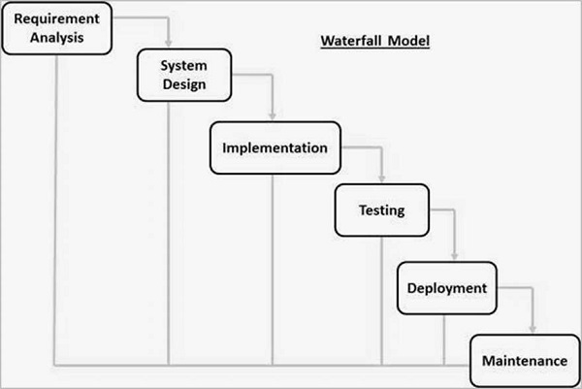
The sequential phases in Waterfall model are −
- Requirement Gathering and analysis − All possible requirements of the system to be developed are captured in this phase and documented in a requirement specification document.
- System Design − The requirement specifications from first phase are studied in this phase and the system design is prepared. This system design helps in specifying hardware and system requirements and helps in defining the overall system architecture.
- Implementation − With inputs from the system design, the system is first developed in small programs called units, which are integrated in the next phase. Each unit is developed and tested for its functionality, which is referred to as Unit Testing.
- Integration and Testing − All the units developed in the implementation phase are integrated into a system after testing of each unit. Post integration the entire system is tested for any faults and failures.
- Deployment of system − Once the functional and non-functional testing is done; the product is deployed in the customer environment or released into the market.
- Maintenance − There are some issues which come up in the client environment. To fix those issues, patches are released. Also to enhance the product some better versions are released. Maintenance is done to deliver these changes in the customer environment.
All these phases are cascaded to each other in which progress is seen as flowing steadily downwards (like a waterfall) through the phases. The next phase is started only after the defined set of goals are achieved for previous phase and it is signed off, so the name "Waterfall Model". In this model, phases do not overlap.

Waterfall Model - Application
Every software developed is different and requires a suitable SDLC approach to be followed based on the internal and external factors. Some situations where the use of Waterfall model is most appropriate are −
- Requirements are very well documented, clear and fixed.
- Product definition is stable.
- Technology is understood and is not dynamic.
- There are no ambiguous requirements.
- Ample resources with required expertise are available to support the product.
- The project is short.

Waterfall Model - Advantages
The advantages of waterfall development are that it allows for departmentalization and control. A schedule can be set with deadlines for each stage of development and a product can proceed through the development process model phases one by one.
Development moves from concept, through design, implementation, testing, installation, troubleshooting, and ends up at operation and maintenance. Each phase of development proceeds in strict order.
Some of the major advantages of the Waterfall Model are as follows −
- Simple and easy to understand and use
- Easy to manage due to the rigidity of the model. Each phase has specific deliverables and a review process.
- Phases are processed and completed one at a time.
- Works well for smaller projects where requirements are very well understood.
- Clearly defined stages.
- Well understood milestones.
- Easy to arrange tasks.
- Process and results are well documented.

Waterfall Model - Disadvantages
The disadvantage of waterfall development is that it does not allow much reflection or revision. Once an application is in the testing stage, it is very difficult to go back and change something that was not well-documented or thought upon in the concept stage.
The major disadvantages of the Waterfall Model are as follows −
- No working software is produced until late during the life cycle.
- High amounts of risk and uncertainty.
- Not a good model for complex and object-oriented projects.
- Poor model for long and ongoing projects.
- Not suitable for the projects where requirements are at a moderate to high risk of changing. So, risk and uncertainty is high with this process model.
- It is difficult to measure progress within stages.
- Cannot accommodate changing requirements.
- Adjusting scope during the life cycle can end a project.
- Integration is done as a "big-bang. at the very end, which doesn't allow identifying any technological or business bottleneck or challenges early.
In the Iterative model, iterative process starts with a simple implementation of a small set of the software requirements and iteratively enhances the evolving versions until the complete system is implemented and ready to be deployed.
An iterative life cycle model does not attempt to start with a full specification of requirements. Instead, development begins by specifying and implementing just part of the software, which is then reviewed to identify further requirements. This process is then repeated, producing a new version of the software at the end of each iteration of the model.

Iterative Model - Design
Iterative process starts with a simple implementation of a subset of the software requirements and iteratively enhances the evolving versions until the full system is implemented. At each iteration, design modifications are made and new functional capabilities are added. The basic idea behind this method is to develop a system through repeated cycles (iterative) and in smaller portions at a time (incremental).
The following illustration is a representation of the Iterative and Incremental model −
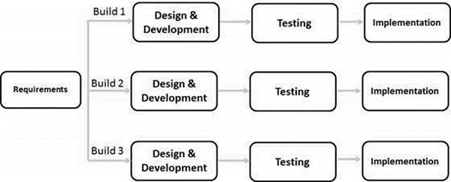

Iterative and Incremental development is a combination of both iterative design or iterative method and incremental build model for development. "During software development, more than one iteration of the software development cycle may be in progress at the same time." This process may be described as an "evolutionary acquisition" or "incremental build" approach."
In this incremental model, the whole requirement is divided into various builds. During each iteration, the development module goes through the requirements, design, implementation and testing phases. Each subsequent release of the module adds function to the previous release. The process continues till the complete system is ready as per the requirement.
The key to a successful use of an iterative software development lifecycle is rigorous validation of requirements, and verification & testing of each version of the software against those requirements within each cycle of the model. As the software evolves through successive cycles, tests must be repeated and extended to verify each version of the software.

Iterative Model - Application
Like other SDLC models, Iterative and incremental development has some specific applications in the software industry. This model is most often used in the following scenarios −
- Requirements of the complete system are clearly defined and understood.
- Major requirements must be defined; however, some functionalities or requested enhancements may evolve with time.
- There is a time to the market constraint.
- A new technology is being used and is being learnt by the development team while working on the project.
- Resources with needed skill sets are not available and are planned to be used on contract basis for specific iterations.
- There are some high-risk features and goals which may change in the future.

Iterative Model - Pros and Cons
The advantage of this model is that there is a working model of the system at a very early stage of development, which makes it easier to find functional or design flaws. Finding issues at an early stage of development enables to take corrective measures in a limited budget.
The disadvantage with this SDLC model is that it is applicable only to large and bulky software development projects. This is because it is hard to break a small software system into further small serviceable increments/modules.
The advantages of the Iterative and Incremental SDLC Model are as follows −
- Some working functionality can be developed quickly and early in the life cycle.
- Results are obtained early and periodically.
- Parallel development can be planned.
- Progress can be measured.
- Less costly to change the scope/requirements.
- Testing and debugging during smaller iteration is easy.
- Risks are identified and resolved during iteration; and each iteration is an easily managed milestone.
- Easier to manage risk - High risk part is done first.
- With every increment, operational product is delivered.
- Issues, challenges and risks identified from each increment can be utilized/applied to the next increment.
- Risk analysis is better.
- It supports changing requirements.
- Initial Operating time is less.
- Better suited for large and mission-critical projects.
- During the life cycle, software is produced early which facilitates customer evaluation and feedback.
The disadvantages of the Iterative and Incremental SDLC Model are as follows −
- More resources may be required.
- Although cost of change is lesser, but it is not very suitable for changing requirements.
- More management attention is required.
- System architecture or design issues may arise because not all requirements are gathered in the beginning of the entire life cycle.
- Defining increments may require definition of the complete system.
- Not suitable for smaller projects.
- Management complexity is more.
- End of project may not be known which is a risk.
- Highly skilled resources are required for risk analysis.
- Projects progress is highly dependent upon the risk analysis phase.
2.2 Architecture

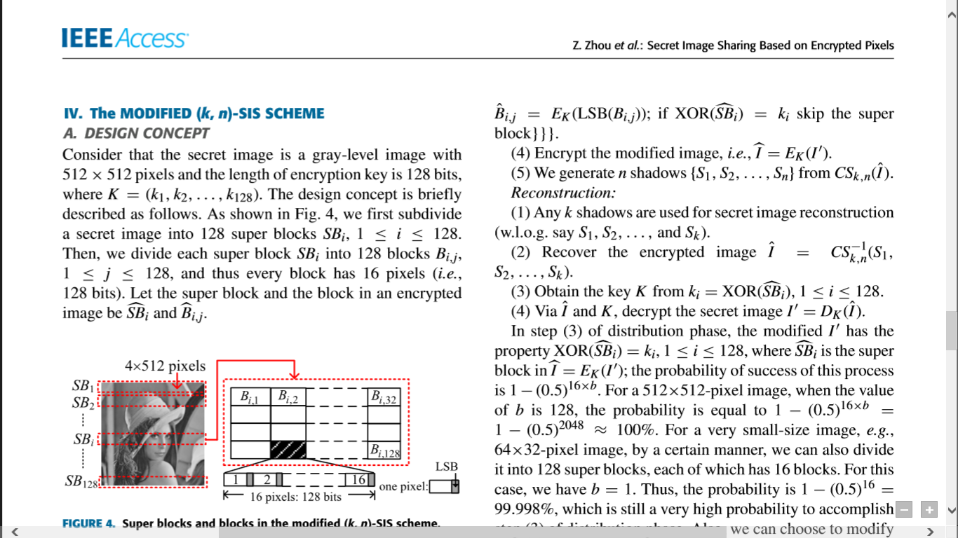
2.3 Modules Description

- Image Encryption
- Lossless Compression of Encrypted Image
- Data embedding
- Image decryption
- Data retrieval
Image Encryption
For encryption then compression system, the design of the encryption algorithm should simultaneously consider the security and the ease of compressing the encrypted data. To this end, an image encryption scheme is proposed and operated over the prediction error domain. For each pixel Ii, j of the image I to be encrypted, a prediction Ii, j is first made by using an image predictor according to its causal surroundings. The prediction result ¯ Ii, j can be further refined to ˜ Ii, j through a context-adaptive, feedback mechanism.

Lossless Compression of Encrypted Image
The compression of the encrypted file Ie needs to be performed in the encrypted domain, as channel provider does not have access to the secret key K. A de-assembler can be utilized to parse Ie into L segments ˜C0, ˜C1, . . . , ˜CL−1 in the exactly same way as that done at the encryption stage. A context-adaptive arithmetic coding (AC) is then shown to be able to efficiently compress the encrypted data. An adaptive AC is then employed to losslessly encode each prediction error sequence ˜C k into a binary bit stream Bk. Note that the generation of all Bk can be carried out in a parallel manner to improve the throughput. Eventually, an assembler concatenates all Bk to produce the final compressed and encrypted bit stream B.
Data Embedding
Sender can hide some secret data ‘D’ to the encrypted image. Sender needs to give a secret key to retrieve the data hidden in encrypted image. As the image is encrypted and compressed the malicious user cannot identify the hidden data in the encrypted image.

Image decryption
With the decompressed image, the decoding of the pixel values can be performed in a raster-scan order. For each location (i, j ), the associated error energy estimator i, j and the predicted value ˜ Ii, j can be calculated from the causal surroundings that have already been decoded. Given i, j , the corresponding cluster index k can be determined. The first ‘unused’ prediction error in the kth cluster is selected as ˜ei, j, which will be used to derive ei, j according to ˜ Ii, j and the mapping rule described. Afterwards, a ‘used’ flag will be attached to the processed prediction error.
Data retrieval
Data from the encrypted image can be retrieved by the receiver by giving the proposer key input. The data hidden in the image as cipher text format can retrieved by the receiver. Similarly receiver can get the decrypted image by giving the key.
Detailed Design
Algorithm: Image encryption
Step 1: Compute all the mapped prediction errors ˜ei, j of the whole image I .
Step 2: Divide all the prediction errors into L clusters Ck , for 0 ≤ k ≤ L − 1, where k is determined by (5), and each Ck is formed by concatenating the mapped prediction errors in a raster-scan order.
Step 3: Reshape the prediction errors in each Ck into a 2-D block having four columns and |Ck |/4 rows, where |Ck| denotes the number of prediction errors in Ck .
Step 4: Perform two key-driven cyclical shift operations to each resulting prediction error block, and read out the data in raster-scan order to obtain the permuted cluster ˜Ck .
Step 5: The assembler concatenates all the permuted clusters ˜C k, for 0 ≤ k ≤ L − 1, and generates the final encrypted image Ie = ˜C0 ˜C 1 . . . ˜CL−1 (6) in which each prediction error is represented by 8 bits. As the number of prediction errors equals that of the pixels, the file size before and after the encryption preserves.
Step 6: Pass Ie to Charlie, together with the length of each cluster |˜Ck |, for 0 ≤ k ≤ L − 2. The values of |˜Ck| enable Charlie to divide Ie into L clusters correctly. In comparison with the file size of the encrypted data, the overhead induced by sending the length |˜Ck | is negligible.
To build the use the two steps:
1. Distribution
2. Reconstruction
Distribution:
- The dealer selects a random key K =(k1,k2,...,k128) (for simplicity we use|K| = 128), and encrypts I to obtain ˆ I =EK(I).
- Subdivide I and ˆ I into 128 super blocks SBi andc SBi, 1 ≤ i ≤ 128, respectively, where every super block has b 16-pixel blocks Bi,j and b Bi,j, 1 ≤ i ≤ b, respectively (note: the block length is 128 bits; we use XTS-AES mode (IEEE standard 1619-2007), which employs a cipher text stealing technique instead of padding, and thus no extra appended bits are required).
- For i = 1 to 128, do {if XOR(c SBi) = ki skip the super block, else {for j = 1 to b do {I0 = LSB(Bi,j); ˆ Bi,j = EK(LSB(Bi,j)); if XOR(c SBi) = ki skip the superblock}}}.
- Encrypt the modiﬁed image, i.e.,b I =EK(I0).
- We generate n shadows{S1,S2,...,Sn}f rom CSk,n(ˆ I).

Reconstruction
- Any k shadows are used for secret image reconstruction (w.l.o.g. say S1, S2,..., and Sk).
- Recover the encrypted image ˆ I = CS−1 k,n(S1, S2,...,Sk).
- Obtain the key K from ki =XOR(c SBi),1≤i≤128.
- Via ˆ I and K, decrypt the secret image I0 =DK(ˆ I).

2.4 Functional Requirements

2.4.1 Name of the function

Name of the module: Encrypt pixels

Parameters: Image pixels

Purpose: to encrypt the image by pixel by pixel

2.4.2 Name of the function

Name of the module: Data Hide

Parameters: Data , key, encrypted pixels

Purpose: To hide the secret data into the encrypted pixels

2.4.3 Name of the function

Name of the module: Compress

Parameters: Data hidden images

Purpose: To reduce the size of hidden and cover image.

2.4.4 Name of the function

Name of the module: decrypt

Parameters: Data hidden images,key

Purpose: recover the data and decrypt.

UML DIAGRAM
USE CASE DIAGRAM
Original Image

Encrypt Image
Get image Enc Key

Hide Data
Get Data Enc Key
Give image Enc Key

Decrypt image

Give Data Enc Key
Sender
Receiver
Get data

SEQUENCE DIAGRAM
Sender
Receiver
Image
Data

Encrypt

Compress

Hide
Send enc/compressed image

Decrypt

Get data

COLLABORATION DIAGRAM
Content Owner
Image
1:choose
Encryption
2:encrypt

3:compress
4:get
Compression
Encrypted /compressed image
5:load

6:Hide
7:send
Hide data
Receiver

8:give key
9:give key
Decryption of image
Get hidden text

ACTIVITY DIAGRAM

Content Owner

Original Image

Give Key
Encrypt Image

Compress Image
Give Key

Hide text

Receiver

Give Key
Decrypt Image
Yes
Yes
Get Text

4

