Application screen shots

Login page:
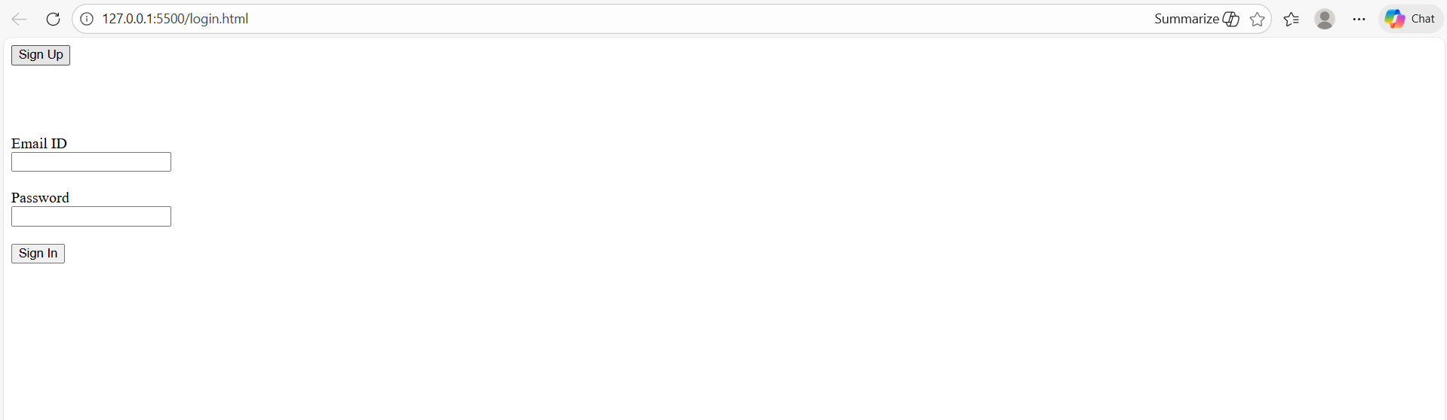

Dummy Signup page:
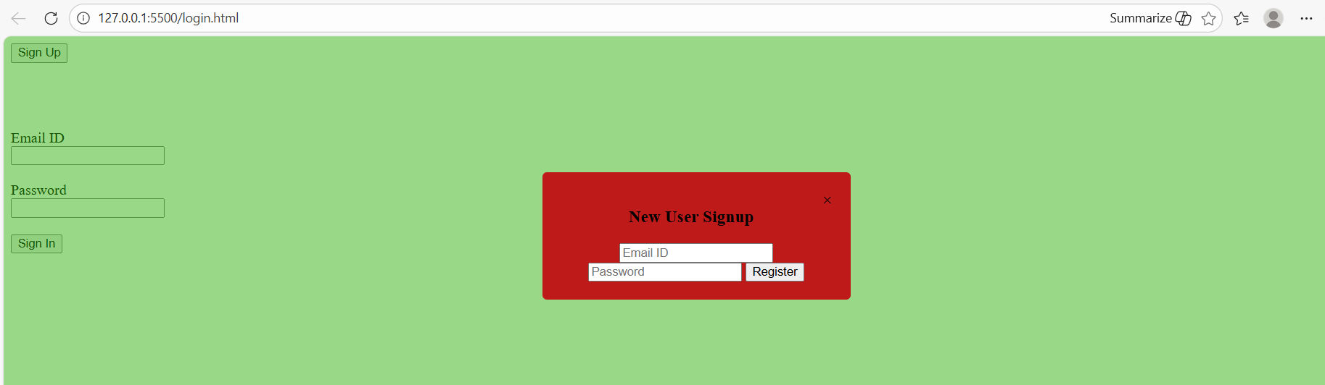

Sign in Alert:
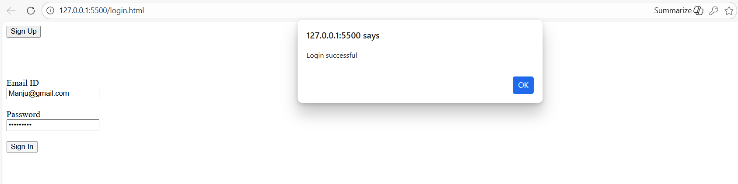

Dash board page:
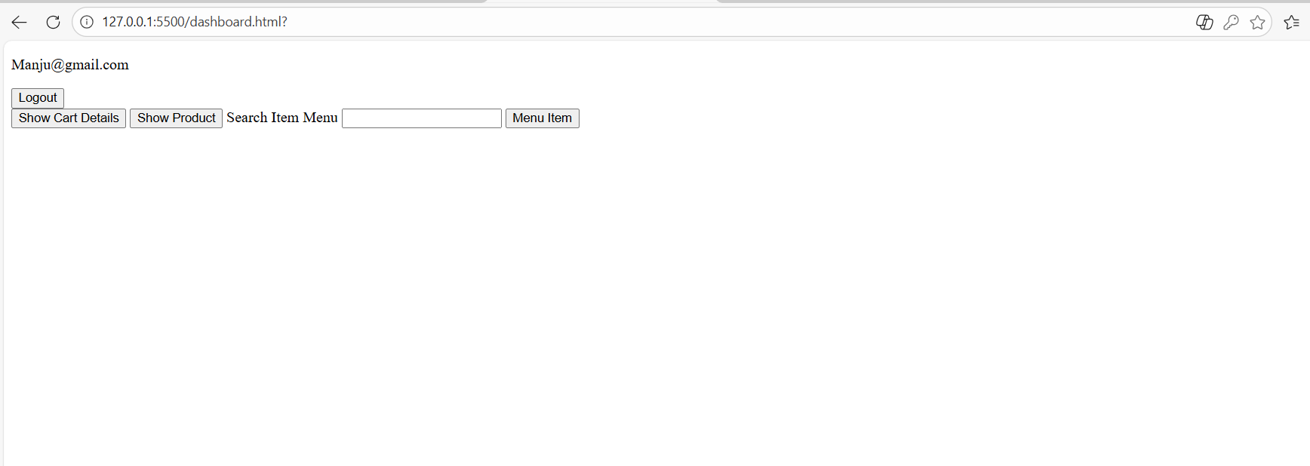
Menu Page:
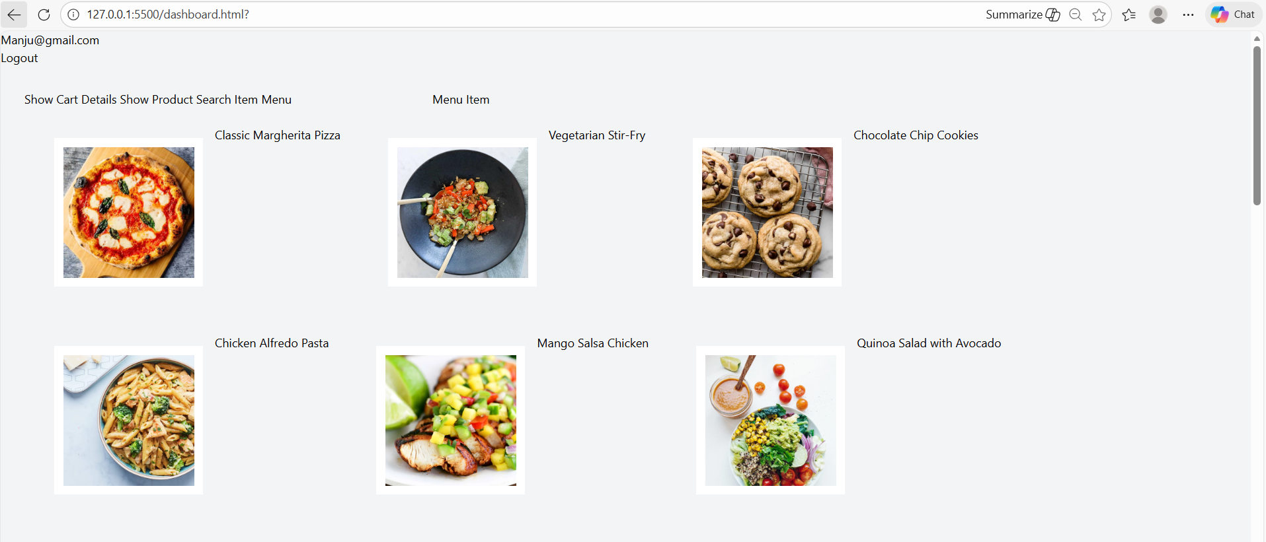

Adding Item to cart:
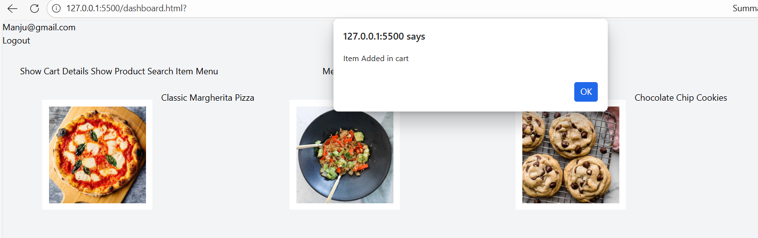

Cart Item display with individual cost and Total value: Added remove functionality from the cart.
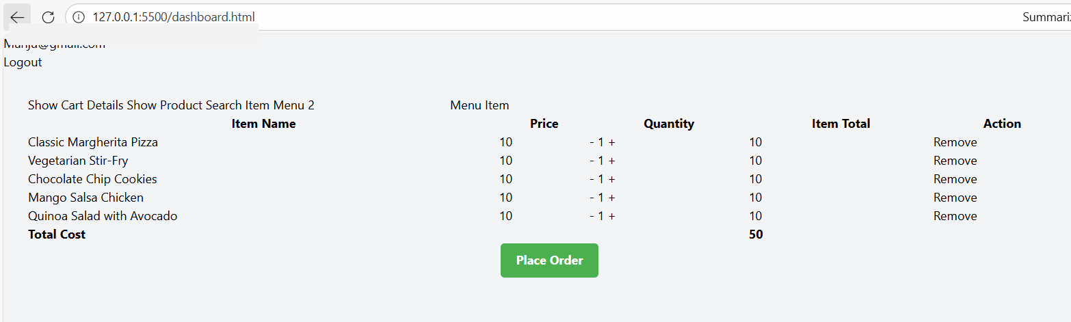

Place order page with address and payment option:
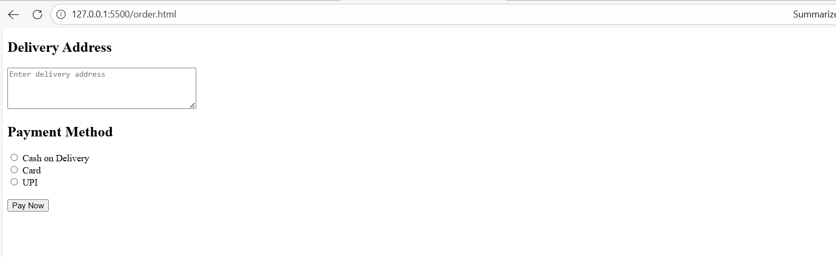
Payment successful message:
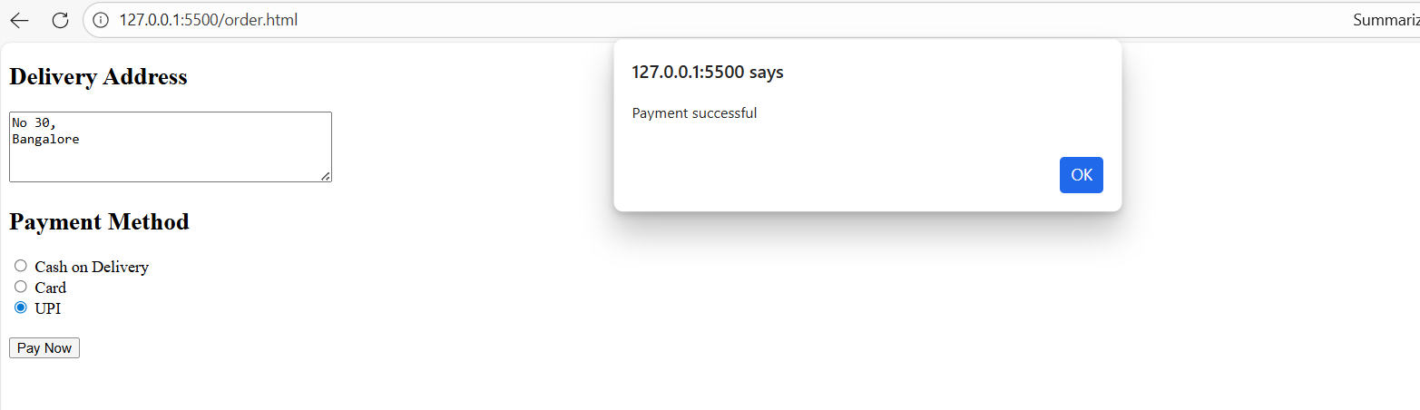

Order successful message:
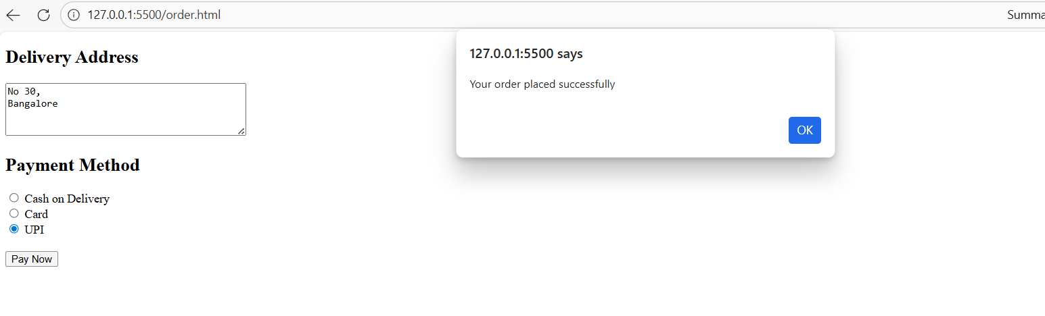
Redirected to dash board with empty cart for fresh ordering:
