Name :Maddi Sai Manjunatha

Reg no : 192111458

Course Code : CSA0726

**COMPUTER NETWORKS LAB EXPERMIENTS**

**DAY-3**

1. **Network layer protocol analysis with IPV4 and IPV6 statistics**

**AIM :** To create Network layer protocol analysis with IPV4 and IPV6 statistics using packet tracer

step1:-first take router

step2:-link that server 2 pc , 3 router and 1 switch

step3:-connect that router and switches with server and pc with connection

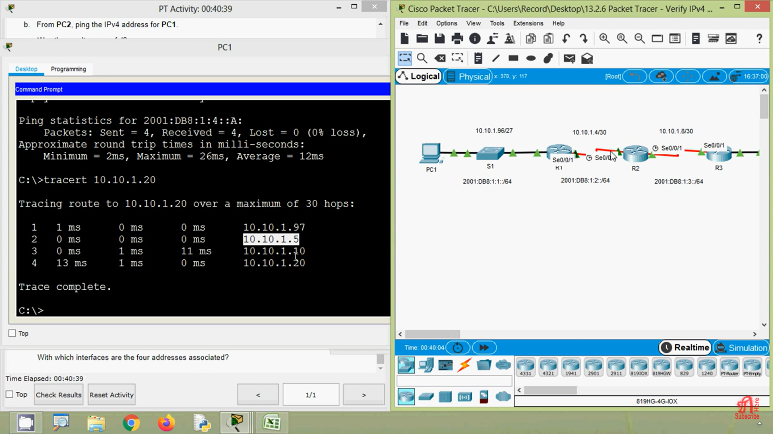

step4:-after connection Network layer protocol analysis with IPV4 and IPV6 statistics packet tracer

step5:-if message send correctly you got successfull other wise recheck the connections

Step6:- then the Network layer protocol analysis with IPV4 and IPV6 statistics Packet Tracer Distance is successfully simulated

