Name :Maddi Sai Manjunatha

Reg no : 192111458

Course Code : CSA0726

**COMPUTER NETWORKS LAB EXPERMIENTS**

**DAY-3**

1. Smart Garden in Cisco Packet Tracer

**AIM :** to create Smart Garden in Cisco Packet Tracer

step1:-first take home router

step2:-link that router with serever , lawn sprinkle , water level monitor and laptop

step3:-connect that serever , lawn sprinkle , water level monitor with the laptop

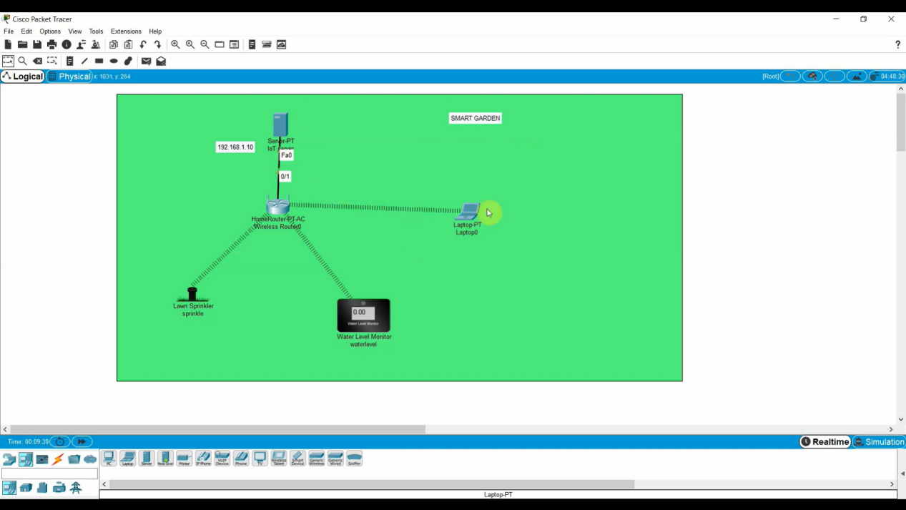

step4:- after connection serever , lawn sprinkle , water level monitor with connection of laptop Check the connection with the appliances

step5:- if command send correctly you got successfull other wise recheck the connections

Step6:- then the serever , lawn sprinkle , water level monitor with the laptop is successfully simulated and the appliances are working .

