**DAY-3 PROGRAMS:-**

**NAME:** Maddi Sai Manjunatha

**REG NO:** 192111458

1. Write a java program for factorial using OOPS.

**Program:-**

import java.util.*;  
class FactusingOOP{  
 int n, fact=1, i, res;  
 void fact(){  
 Scanner s=new Scanner(System.*in*);  
 System.*out*.print("Enter the Number to find Factorial:");  
 n=s.nextInt();  
 for(i=1;i<=n;i++){  
 fact=fact*i;  
 }  
 res=fact;  
 }  
 void result(){  
 System.*out*.println("The factorial of Given Number "+n+" is "+res);  
 }  
}  
class FACT{  
 public static void main(String[] args){  
 FactusingOOP obj=new FactusingOOP();  
 obj.fact();  
 obj.result();  
 }  
}

**Output:-**

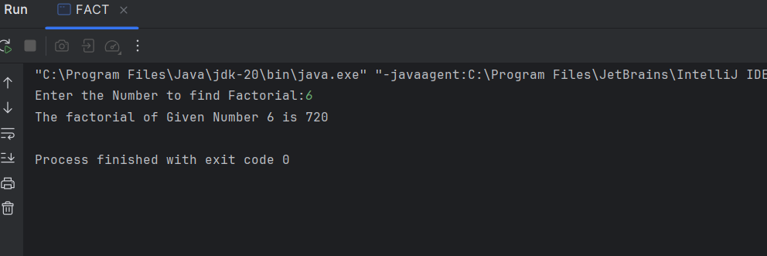

2. Write a java program for Simple Interest using OOPS Argument Passing.

**Program:-**

import java.util.*;

class SI{

    int p, t, r, intr=0;

    SI(){

        Scanner s=new Scanner(System.in);

        System.out.print("Enter Principal Amount:");

        p=s.nextInt();

        System.out.print("Enter Time Period:");

        t=s.nextInt();

        System.out.print("Enter the Rate of Interest:");

        r=s.nextInt();

    }

    void intr(){

        intr=(p*t*r)/100;

        System.out.println("The Simple Interest for Principal Amount "+p+" for Time Period "+t+" is : "+intr);

    }

    public static void main(String[] args){

        SI obj=new SI();

        obj.intr();

    }

}

**Output:-**

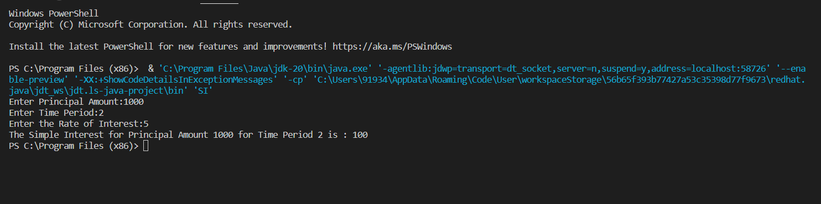

3. Write a java program that has a overload method. The first method should accept no arguments, the second method will accept a string and third method will accept a string and an integer. The first method should display the message “Welcome to java.” once. The second method should display the message “Welcome to Polymorphism.” twice. The third method should display “Welcome to Overloading.” thrice.

**Program:-**

import java.util.*;

class MethodOverloading{

    void arg(){

        System.out.print("Welcome to java!\n");

    }

    void arg(String a){

        for(int i=1;i<=2;i++){

            System.out.println(a);

        }

    }

    void arg(String b,int c)

    {

        for(int i=1;i<=3;i++){

            System.out.println(b);

        }

    }

    public static void main(String[] args){

        MethodOverloading t=new MethodOverloading();

        t.arg();

        t.arg("Welcome to Polymorphism!");

        t.arg("Welcome to Overloading!", 4);

    }

}

**Output:-**

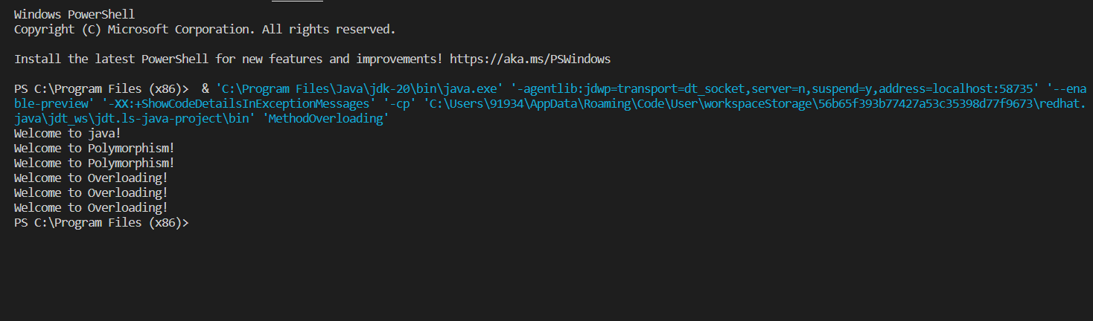

4. Write a java program for finding :

1. Area of circle :- pi*radius*radius
2. Volume of cylinder :- pi*radius*radius*height

Using Inheritance concept{especially:- Single Inheritance}

**Program:-**

import java.util.*;

class Circle{

    protected double area;

    private int r;

    void get(int a){

        r=a;

    }

    void cal(){

        area=3.14*r*r;

    }

}

class Cylinder extends Circle{

    protected double volume;

    private int h;

    void get1(int b){

        h=b;

    }

    void cal1(){

        volume=area*h;

    }

    void display(){

        System.out.println("The area of Circle is :"+area);

        System.out.println("The volume of Cylinder is: "+volume);

    }

}

class Inher{

    public static void main(String[] args){

        int x,y;

        Scanner s=new Scanner(System.in);

        System.out.print("Enter Radius:");

        x=s.nextInt();

        System.out.print("Enter Height:");

        y=s.nextInt();

        Cylinder obj=new Cylinder();

        obj.get(x);

        obj.cal();

        obj.get1(y);

        obj.cal1();

        obj.display();

    }

}

**Output:-**

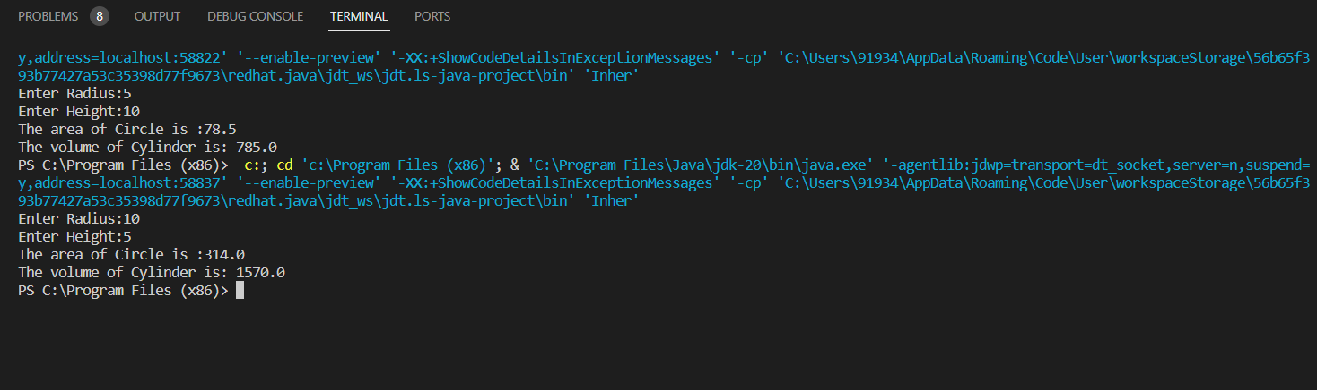

**ASSIGNMENT – 3:-**

1. Write a Java program to enter the marks of a student in four subjects. Then calculate the total and aggregate, and display the grade obtained by the student. If the student scores an aggregate greater than 75%, then the grade is Distinction. If the aggregate is 60>= and <75, then the grade is First Division. If the aggregate is 50 >= and <60, then the grade is Second Division. If the aggregate is 40>= and <50, then the grade is Third Division, else the grade is Fail. Using Multilevel inheritance concept.

Sample Input & Output:

Enter the marks in python: 90

Enter the marks in c programming: 91

Enter the marks in Mathematics: 92

Enter the marks in Physics: 93

Total= 366

Aggregate = 91.5

DISTINCTION

Test cases:

a) 18, 76,93,65

b) 73,78,79,75

c) 98,106,120,95

d) 96,73, -85,95

e) 78,59.8,76,79

**Program:-**

import java.util.*;

class Marks{

    private int S1, S2, S3, S4;

    protected int total=0;

    void getmarks(int A, int B, int C, int D){

        S1=A;

        S2=B;

        S3=C;

        S4=D;

    }

    void caltotal(){

        int sum=S1+S2+S3+S4;

        total = total+sum;

    }

}

class Aggregate extends Marks{

    protected double aggregate;

    void calaggregate(){

        aggregate=(total/4);

    }

}

class Grade extends Aggregate{

    void calgrade(){

        if(aggregate>75){

            System.out.print("You Scored DISTINCTION.\n");

            System.out.print("CONGRATULATIONS!!");

        }

        else if(aggregate>=60 && aggregate<75){

            System.out.print("You scored FIRST DIVISION.");

        }

        else if(aggregate>=50 && aggregate<60){

            System.out.print("You scored SECOND DIVISION.");

        }

        else if(aggregate>=40 && aggregate<50){

            System.out.print("You scored THIRD DIVISION.");

        }

        else if(aggregate>=0 && aggregate<40){

            System.out.print("You have FAILED in Exams.");

            System.out.print("Improve your Grades!!");

        }

        else{

            System.out.print("Aggregate is not defined!!");

        }

    }

    void display(){

        System.out.println("\nTotal Marks are : "+total);

        System.out.println("Your aggregate is : "+aggregate);

    }

}

class StudentMarks{

    public static void main(String[] args){

        Scanner s=new Scanner(System.in);

        int W, X, Y, Z;

        System.out.print("Enter the marks in Python: ");

        W=s.nextInt();

        System.out.print("Enter the marks in C-Programming: ");

        X=s.nextInt();

        System.out.print("Enter the marks in Mathematics: ");

        Y=s.nextInt();

        System.out.print("Enter the marks in Physics: ");

        Z=s.nextInt();

        do{

            System.out.print("Enter a valid mark(i.e between 0 and 100)!!\n");

            System.out.print("Re-Enter Again Marks Properly.\n");

            System.out.print("Enter the marks in Python: ");

            W=s.nextInt();

            System.out.print("Enter the marks in C-Programming: ");

            X=s.nextInt();

            System.out.print("Enter the marks in Mathematics: ");

            Y=s.nextInt();

            System.out.print("Enter the marks in Physics: ");

            Z=s.nextInt();

        }while(W<0||W>100||X<0||X>100||Y<0||Y>100||Z<0||Z>100);

        Grade obj=new Grade();

        obj.getmarks(W, X, Y, Z);

        obj.caltotal();

        obj.calaggregate();

        obj.calgrade();

        obj.display();

    }

}

**Output:-**

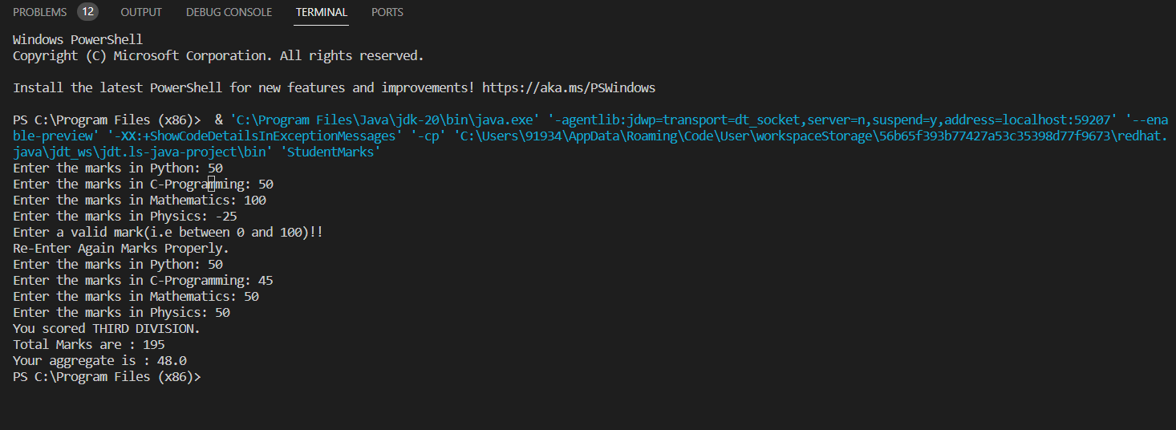

2. Write a Java program for the area of the circle, the volume of the cylinder, and the volume of the cone. Using Multilevel inheritance concept.

Area of Circle: pi × radius2

Volume of cylinder: pi × radius2 × height

Volume of cone: (1/3) × pi × radius2 × height

**Program:-**

import java.util.*;

class Circle1{

    protected double area;

    private int r;

    void get(int a){

        r=a;

    }

    void cal(){

        area=3.14*r*r;

    }

}

class Cylinder1 extends Circle1{

    protected double volume;

    private int h;

    void get1(int b){

        h=b;

    }

    void cal1(){

        volume=area*h;

    }

}

class Cone extends Cylinder1{

    protected double Cvolume;

    void cal2(){

        Cvolume=0.33*volume;

    }

    void display(){

        System.out.println("The Area of Circle is :"+area);

        System.out.println("The Volume of Cylinder is: "+volume);

        System.out.println("The Volume of Cone is :"+Cvolume);

    }

}

class Inheri{

    public static void main(String[] args){

        int x,y;

        Scanner s=new Scanner(System.in);

        System.out.print("Enter Radius:");

        x=s.nextInt();

        System.out.print("Enter Height:");

        y=s.nextInt();

        Cone obj=new Cone();

        obj.get(x);

        obj.cal();

        obj.get1(y);

        obj.cal1();

        obj.cal2();

        obj.display();

    }

}

**Output:-**

