**DAY-4 PROGRAMS:-**

**NAME:** Maddi Sai Manjunatha

**REG NO:** 192111458

1. Write a java program for factorial and Sum of Series using Inheritance.

**Program:-**

import java.util.*;

class Sum{

    protected int n, i, sum=0;

    void get(){

        System.out.print("Enter the no of terms: ");

        Scanner s=new Scanner(System.in);

        n=s.nextInt();

    }

    void sumof(){

        for(i=0;i<=n;i++){

            sum=sum+i;

        }

    }

}

class Fact extends Sum{

    private int fact=1;

    void fact(){

        for(i=1;i<=n;i++){

            fact=fact*i;

        }

    }

    void display(){

        System.out.println("Sum of "+n+" Numbers is : "+sum);

        System.out.println("Factorial of "+n+" Numbers is : "+fact);

    }

}

class Factsum{

    public static void main(String[] args){

        Fact obj=new Fact();

        obj.get();

        obj.sumof();

        obj.fact();

        obj.display();

    }

}

**Output:-**

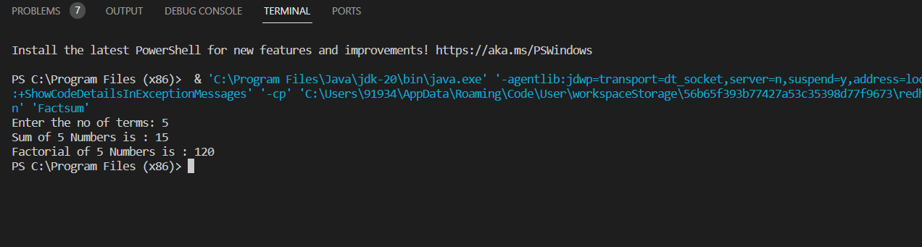

2. Write a java program to print the following:

String 1 = I Love java

String 2 = java

String 3 = JAVA

output:-

i) print String 1 as "i love java"

ii) print String 1 as "I LOVE JAVA"

iii) print String 1 as "I Live java"

iv) Display String 1 as "Love java"

v) Display String 1 as "Love"

vi) Find the position of 'L' in S1

vii) Find length of S1

viii) Find S2 is equals tto S3 and find S2 is equal to S3 using IgnoreCase

ix) Find Character at Position 2 in S1

x) Comparision of S2 & S3

**Program:-**

import java.util.*;

class Str{

    String S1="I Love java";

    String S2="java";

    String S3="JAVA";

    String S4, S5, S6, S7, S8;

    int S9, S10, S14;

    char S13;

    boolean S11, S12;

    void stri(){

        S4=S1.toLowerCase();

        S5=S1.toUpperCase();

        S6=S1.replace('o','i');

        S7=S1.substring(2);

        S8=S1.substring(2, 6);

        S9=S1.indexOf('L');

        S10=S1.length();

        S11=S2.equals(S3);

        S12=S2.equalsIgnoreCase(S3);

        S13=S1.charAt(2);

        S14=S2.compareTo(S3);

    }

    void display(){

        System.out.println("1: "+S4);

        System.out.println("2: "+S5);

        System.out.println("3: "+S6);

        System.out.println("4: "+S7);

        System.out.println("5: "+S8);

        //System.out.println("6: "+S1.indexOf('L')); We can directly print using this.

        System.out.println("6: "+S9);

        System.out.println("7: "+S10);

        System.out.println("8-i: "+S11);

        System.out.println("8-ii: "+S12);

        System.out.println("9: " +S13);

        System.out.println("10: "+S14);

    }

}

class StringEx{

    public static void main(String[] args){

        Str obj=new Str();

        obj.stri();

        obj.display();

    }

}

**Output:-**

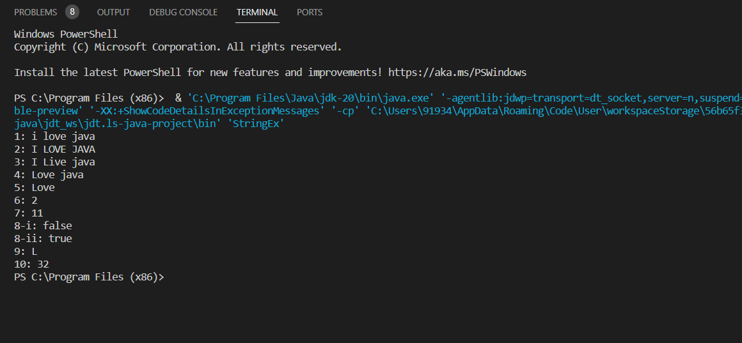

3. Write a java program for Username is valid or not using OOPS.

**Program:-**

import java.util.*;

class Username{

    protected String U1, U2;

    Username(){

        Scanner s=new Scanner(System.in);

        System.out.println("Enter String A:");

        U1=s.nextLine();

        System.out.println("Enter String 2:");

        U2=s.nextLine();

    }

    void Comparision(){

        if(U1.equals(U2)){

            System.out.println("Username is Valid\n");

        }

        else{

            System.out.println("Username is Invalid\n");

        }

    }

    public static void main(String[] args){

        Username obj=new Username();

        obj.Comparision();

    }

}

**Output:-**

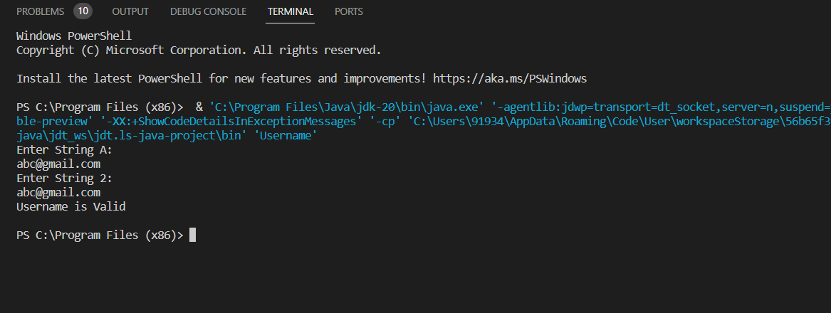

**ASSIGNMENT – 4:-**

1. Write a java program to read a character until a * is encountered. Also count the number of uppercase, lowercase, and numbers entered by the users.

Sample Input:

Enter * to exit…

Enter any character: W

Enter any character: d

Enter any character: A

Enter any character: G

Enter any character: g

Enter any character: H

Enter any character: *

Sample Output:

Total count of lower case:2

Total count of upper case:4

Total count of numbers =0

Test cases:

1. 1,7,6,9,5

2. S, Q, l, K,7, j, M

3. M, j, L, &, @, G

4. D, K, I, 6, L, *

5. *, K, A, e, 1, 8, %, *

**Program:-**

import java.util.*;

class Star{

    char ch;

    int i, cl=0, cu=0, cn=0;

    void get(){

        do{

            System.out.print("Enter any character: ");

            Scanner s=new Scanner(System.in);

            ch=s.next().charAt(0);

            if(ch=='*'){

                System.out.print("'*'-Encountered Exiting Program!!\n");

                break;

            }

            else if(Character.isLowerCase(ch)){

                cl++;

            }

            else if(Character.isUpperCase(ch)){

                cu++;

            }

            else if(Character.isDigit(ch)){

                cn++;

            }

            else{

                System.out.print("Enter a valid Character!!\n");

            }

        }while(true);

    }

    void display(){

        System.out.println("Total count of lower case: "+cl);

        System.out.println("Total count of upper case: "+cu);

        System.out.println("Total count of numbers: "+cn);

    }

}

class Star1{

    public static void main(String[] args){

        Star obj=new Star();

        obj.get();

        obj.display();

    }

}

**Output:-**

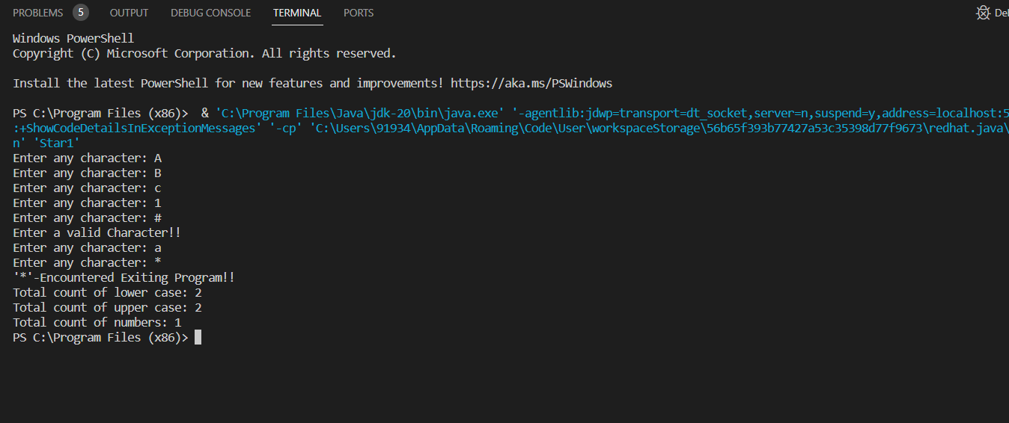

2. Bring out the situation in which member names of a subclass hide members by the same name in the super class. How it can be resolved? Write Suitable code in Java and

Implement above scenario with the Parametrized Constructor (accept int type parameter) of the Super Class can be called from Sub Class Using super () and display the input values provided.

Input :

Assign or input values for super class and sub class members.

Pseudo :

Define super class and sub class with one member (has same name)

Define method in super class and sub class with same method signature

Declare the object in main method

Invoke methods using object to display the values

Output :

Sample Input : 100, 200

Sample Output : 100, 200

Test Cases

1. 10, 20

2. -20, -30

3. 0, 0

4. EIGHT FIVE

5. 10.57, 12.58

**Program:-**

import java.util.*;

class Superclass{

    protected int number1;

    Superclass(int number1){

        this.number1=number1;

    }

    void display(){

        System.out.println("The Numbers are:\n"+number1);

    }

}

class Subclass extends Superclass{

    private int number1, number2;

    Subclass(int number1, int number2){

        super(number1);

        this.number2=number2;

    }

    void display(){

        super.display();

        System.out.println(number2);

    }

}

class Main{

    public static void main(String[] args){

        Scanner s=new Scanner(System.in);

        System.out.print("Enter Numbers:\n");

        int number1, number2;

        try {

            number1 = s.nextInt();

            number2 = s.nextInt();

        } catch (InputMismatchException e) {

            System.out.println("Enter a Numerical Input!!");

            return;

        }

        Subclass obj=new Subclass(number1, number2);

        obj.display();

    }

}

**Output:-**

