PROJECT REPORT TEMPLATE (TIMELINE-BASED)

1. Title Page
Project Title: Smart City Issue Reporting
Students Name: Manjunath V Poojari and Spandana M Jagatap
USN: 4JN22CS077 and 4JN22CS164
College: Jawaharlal Nehru New College of Engineering
Guide Name: Arqam Zakriya, Puneeth

2. Abstract
- Problem addressed
Urban infrastructure issues such as potholes, garbage overflow, broken streetlights, and drainage problems often remain unresolved due to inefficient and fragmented complaint reporting systems. Traditional methods lack transparency, real-time tracking, and effective communication between citizens and municipal authorities. To address this problem, a Smart City Issue Reporting and Civic Engagement system is proposed, which enables citizens to report issues through a mobile application using images, descriptions, and GPS-based location data.

- Solution proposed
- A simple citizen interface to report issues with photo, description, and auto-detected GPS location
- A real-time public map showing all reported issues in the area
- An admin dashboard for authorities to view, categorize, prioritize, and update issue status
- Push notifications to keep citizens informed about the status of their reports
- Status tracking: Pending → In Progress → Resolved

- Final outcome
The final outcome is a scalable, user-friendly platform that enhances citizen participation, streamlines municipal workflows, and promotes transparent governance. By reducing delays and improving issue resolution rates, the system contributes to smarter urban management and improved quality of life in cities.

3. Introduction
- Background of the project
Urban infrastructure in Indian cities faces constant challenges — potholes, broken streetlights, drainage failures, overflowing garbage bins, and encroachments. Despite these issues being widespread and visible, citizens currently have no efficient, unified channel to report them to the concerned authorities.
Existing methods such as calling helplines, visiting municipal offices, or posting on social media are fragmented, slow, and offer no accountability or status tracking. Issues are often ignored or lost in bureaucratic delays, and citizens have no way of knowing whether their complaint was even received, let alone acted upon.

- Problem Statement
Urban areas face persistent civic issues such as potholes, garbage accumulation, drainage failures, and malfunctioning streetlights. Existing complaint reporting methods—like phone calls, office visits, or social media—are fragmented, time-consuming, and lack transparency. Citizens often do not receive updates on their complaints, and many issues remain unresolved due to poor coordination among municipal departments. Additionally, there is no centralized system to prioritize complaints based on severity or location, leading to inefficient resource allocation.
Thus, the core problem is the absence of an integrated, user-friendly, and transparent platform that enables citizens to report issues efficiently while allowing authorities to track, manage, and resolve them in a timely and organized manner.

- Objectives
- To develop a mobile application that allows users to report civic issues using photos, descriptions, and GPS location.
- To provide a system where users can track the status of their complaints (Pending, In Progress, Resolved).
- To create an admin interface for authorities to view and update reported issues.
- To improve communication between citizens and municipal authorities through a single platform.
- To make the complaint process more transparent and efficient.

4. Project Planning & Requirement Analysis (Week 1–2)
- Project selection explanation
The Smart City Issue Reporting & Civic Engagement App was selected to address a real-world problem faced in almost every urban area. Citizens frequently encounter issues like potholes, garbage overflow, and damaged infrastructure, yet there is no efficient and unified system to report and track these problems. Existing solutions are slow, fragmented, and lack accountability.
This project was chosen because it is highly relevant to the Smart City Mission, promotes digital governance, and encourages citizen participation. It also provides an opportunity to implement modern technologies such as mobile app development, GPS integration, cloud storage, and AI-based classification. Additionally, the project is practical, impactful, and feasible to develop within the given timeline.

- Existing system
Current systems for reporting civic issues include helplines, manual complaints at municipal offices, and social media platforms. These methods are inefficient, time-consuming, and lack proper tracking mechanisms.
Most systems:
- Do not provide real-time status updates
- Require manual processing and verification
- Lack proper categorization and prioritization
- Have poor coordination between departments
As a result, many complaints remain unresolved or delayed, leading to reduced citizen satisfaction and inefficient governance.

- Functional Requirements
FR-01: User Authentication
- The app shall allow users to register and log in using Google Sign-In
- Supabase/Firebase Auth shall manage authentication tokens securely
- Admin users shall have a separate role flag in the database

FR-02: Issue Reporting
- Citizens shall be able to capture or upload a photo of the issue
- Citizens shall add a text description (max 300 characters)
- Citizens shall select a category from a predefined list
- The app shall automatically detect and attach GPS coordinates
- Submitted issues shall be stored in Supabase/Firebase with status 'Pending'

FR-03: Issue Tracking
- Citizens shall view a list of their submitted issues with current status
- Citizens shall tap an issue to view its full details and status history
- Status values: Pending, In Progress, Resolved

FR-04: Public Map View
- The app shall display all reported issues on an OpenStreetMap
- Each issue shall appear as a pin with color indicating status
- Tapping a pin shall show issue details

FR-05: Admin Dashboard
- Admin shall see all issues in a list, sortable by date and category
- Admin shall be able to change issue status with a dropdown
- Admin shall be able to add a resolution note when closing an issue

FR-06: Push Notifications
- Citizens shall receive a push notification when their issue status changes
- FCM shall be used for delivering notifications

- Non-functional Requirements
Category | Requirement
Performance | App shall load issue list within 3 seconds on a 4G connection
Security | All API calls shall use Supabase Row Level Security (RLS) policies
Usability | UI shall follow Material Design 3 guidelines
Reliability | App shall handle offline state gracefully with appropriate error messages
Scalability | Database schema shall support future addition of new issue categories
Compatibility | App shall support Android 8.0 (API 26) and above

- Tools & Technologies
Frontend:
- Flutter (Dart) – Mobile app development
Backend:
- Supabase / Firebase – Authentication, database, storage
Database:
- PostgreSQL (via Supabase) / Firebase Firestore
APIs & Services:
- Google Maps / OpenStreetMap – Location & maps
- GPS (Geolocator) – Location tracking
- Firebase Cloud Messaging (FCM) – Notifications
Other Tools:
- Android Studio – Development environment
- Git & GitHub – Version control

5. System Design (Week 2)
- Architecture Diagram

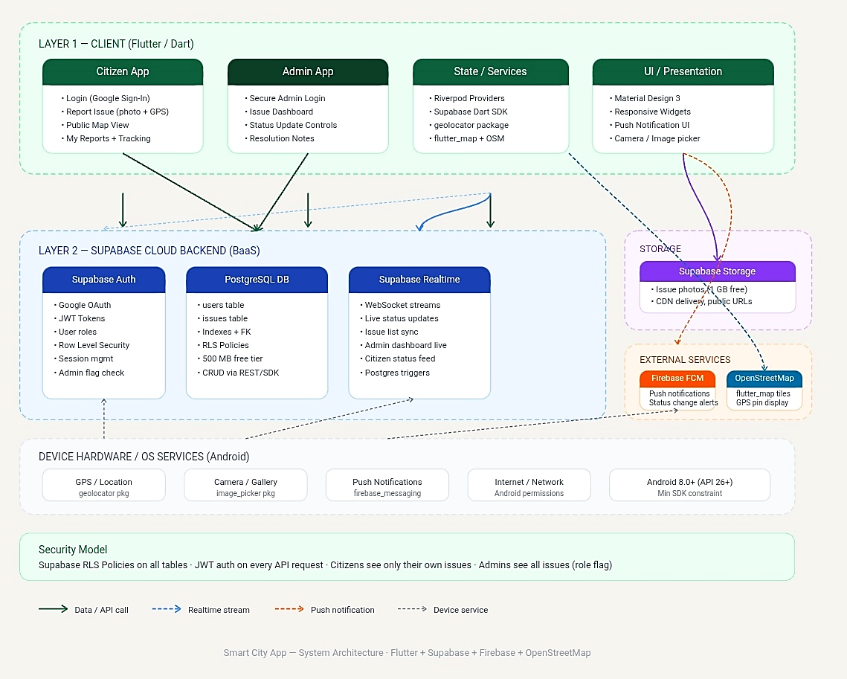

-Flowcharts
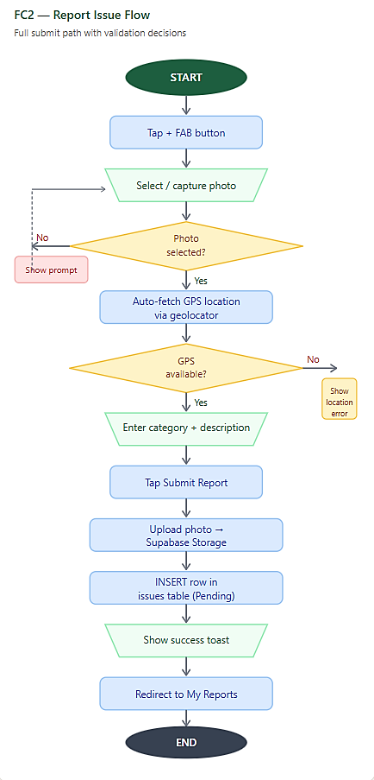
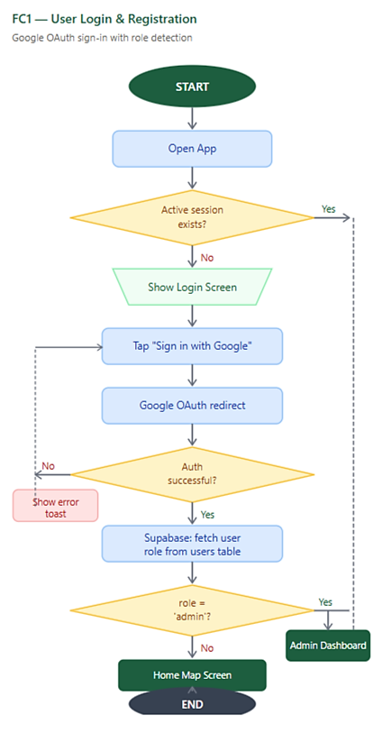
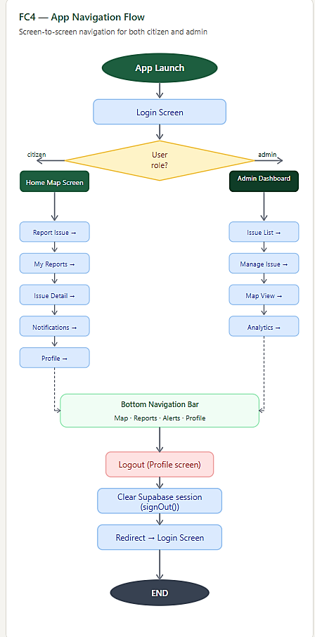
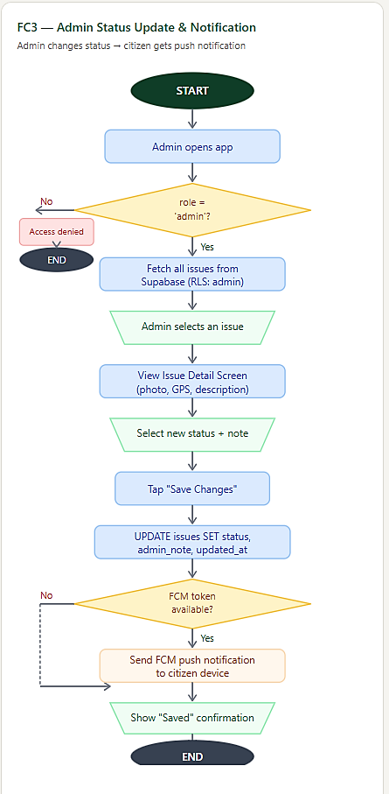
- UI Wireframes
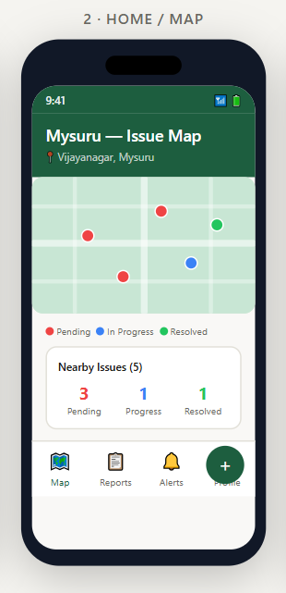
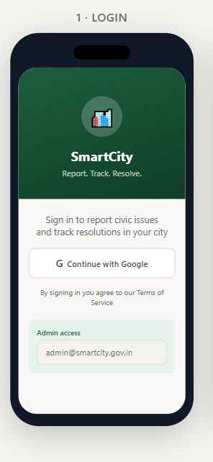

1. Login Screen
- Secure Google Sign-In for users and admins.
- Simple and user-friendly smart city themed interface.
2. Home / Map Screen
- Displays civic issues using color-coded map markers.
- Provides quick navigation and nearby issue statistics.

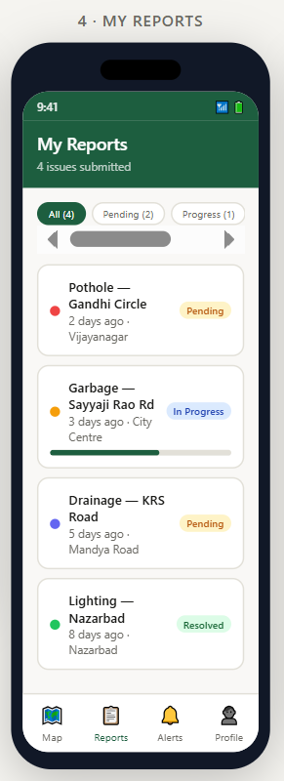
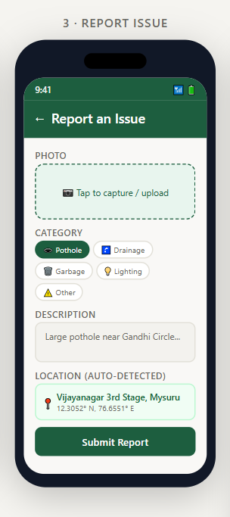

3. Report Issue Screen
- Allows image upload and GPS-based complaint reporting.
- Supports category selection and issue description input.
4. My Reports Screen
- Shows all submitted complaints in one place.
- Uses status badges and filters for easy tracking.

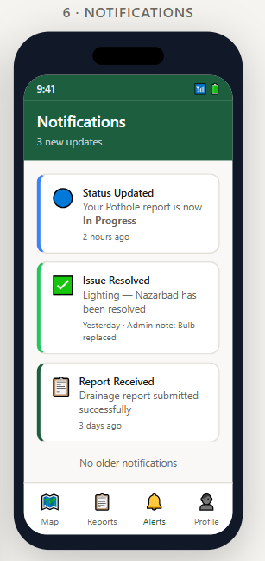
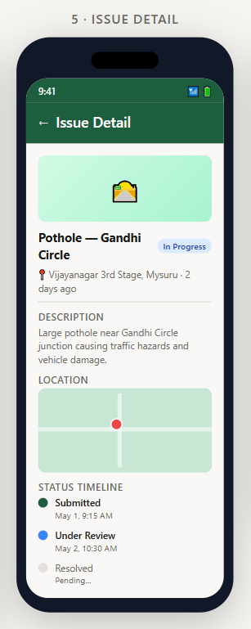

5. Issue Detail Screen
- Displays complaint details, image, and location.
- Includes timeline-based status tracking.
6. Notifications Screen
- Shows real-time complaint update alerts.
- Improves communication with users through notifications.

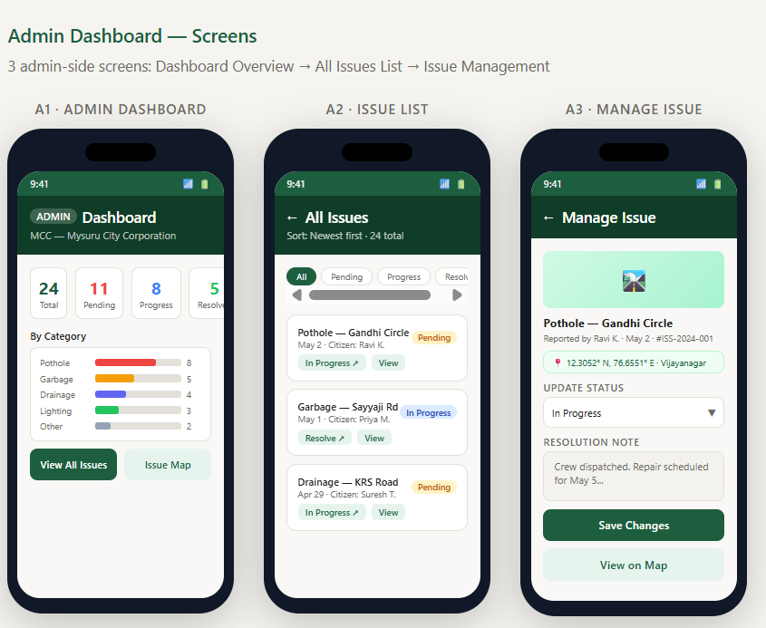

Admin Dashboard Screen
- Displays analytics and issue statistics for administrators.
- Helps manage and monitor complaints efficiently.
Issue List Screen (Admin)
- Shows all complaints with filtering options.
- Allows admins to review and update complaint status.
Manage Issue Screen (Admin)
- Enables status updates and task assignment.
- Supports efficient complaint handling and tracking.

- Database Design
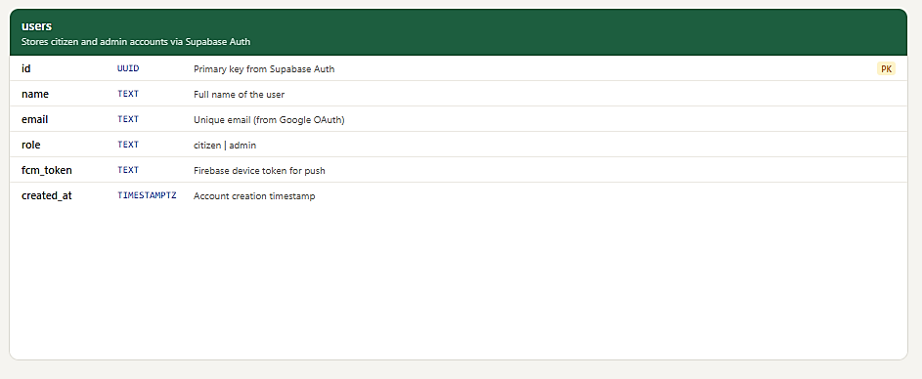
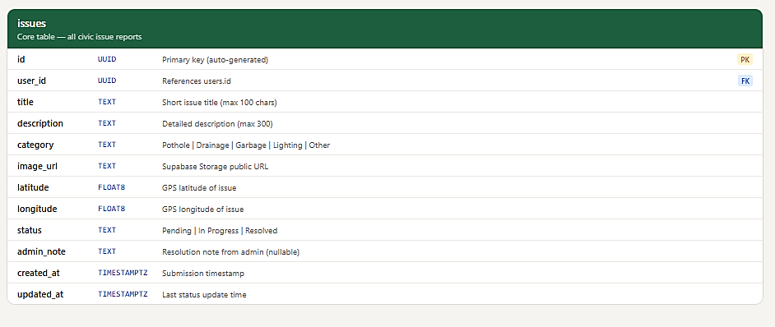

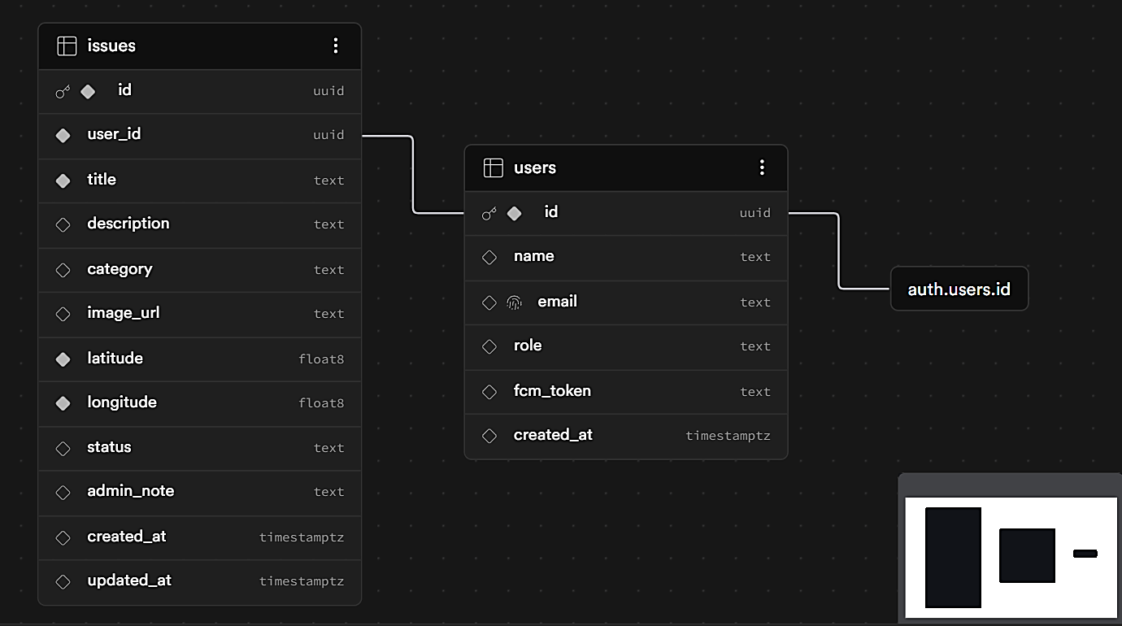

6. Prototype Development (Week 3)
- Initial UI Screens (add screenshots)
- Backend setup (Firebase/API)
- Early working prototype

7. Development Phase (Week 4–6)
Frontend Development:
- UI implementation
Backend Development:
- Database & APIs
Integration:
- Connecting frontend and backend

8. Feature Implementation (Week 6)
- List of features
- Explanation of each feature
- Screenshots

9. Testing & Debugging (Week 7)
- Test cases
- Bugs identified
- Fixes applied

10. Final System & Results (Week 8)
- Final system screenshots
- Output explanation
- Working demo description

11. Challenges Faced
- Technical issues
- Team coordination
- Solutions applied

12. Conclusion
- What was achieved
- Objectives met or not

13. Future Scope
- Improvements
- Additional features

14. References
- Websites
- Tools
- Documentation

