<https://ust-global.zoom.us/j/92544380546>

**829763**

1. <https://docs.microsoft.com/en-us/learn/modules/create-azure-storage-account/5-exercise-create-a-storage-account>
2. https://confluence.atlassian.com/jira064/jira-user-s-guide-720416011.html<https://docs.microsoft.com/en-us/learn/modules/create-windows-virtual-machine-in-azure/3-exercise-create-a-vm>
3. <https://www.quora.com/How-is-India-connected-to-the-internet>
4. <https://www.virtualbox.org/wiki/Downloads>
5. <https://ubuntu.com/download/desktop>
6. Host IP - 54.85.143.224User Name - hirwuser150430
7. <https://www.tutorialspoint.com/codingground.htm>
8. <https://teachablemachine.withgoogle.com/>
9. <https://desktop.github.com/>
10. <https://www.eclipse.org/downloads/download.php?file=/technology/epp/downloads/release/2022-06/R/eclipse-java-2022-06-R-win32-x86_64.zip>
11. <https://repo1.maven.org/maven2/>
12. <https://confluence.atlassian.com/jira064/jira-user-s-guide-720416011.html>
13. <https://docs.microsoft.com/en-us/learn/modules/create-azure-storage-account/5-exercise-create-a-storage-account>
14. <https://docs.microsoft.com/en-us/visualstudio/msbuild/msbuild-task-reference?view=vs-2022>
15. <https://github.com/Thejeshmm/MVCproject1>
16. <https://github.com/Thejeshmm/MVCfirstproject1>
17. <https://github.com/Thejeshmm/GITHubDemo>
18. <https://downloads.digitaltrends.com/draw-io/windows>
19. <https://www.java.com/download/ie_manual.jsp>
20. <https://download.oracle.com/java/18/latest/jdk-18_windows-x64_bin.exe>
21. <https://accounts.jenkins.io/login>
22. <https://chrome.google.com/webstore/detail/ubuntu-free-online-linux/pmaonbjcobmgkemldgcedmpbmmncpbgi/related?hl=en>
23. <https://sso.redhat.com/auth/realms/redhat-external/protocol/openid-connect/auth?client_id=rh_product_trials&redirect_uri=https%3A%2F%2Fwww.redhat.com%2Fen%2Ftechnologies%2Fmanagement%2Fansible%2Ftrial%3Ftrialid%3D4d4b54474556414c31303339%26bypass%3D0&state=529bb978-59d1-435a-afdb-a7b8c111197d&response_mode=fragment&response_type=code&scope=openid&nonce=7fc70c97-80da-4e5b-a081-19a2cc86e5f8&code_challenge=C4ScRcXnuGzcqDEfMFox8fYbP_q84Rh63jsRUXtTtjA&code_challenge_method=S256>
24. <https://www.onworks.net/os-distributions/rpm-based/free-centos-workstation-online>
25. <https://www.onworks.net/runos/create-os.html>

<https://www.osboxes.org/ubuntu-server/#ubuntu-server-22-04-vbox>

<https://www.osboxes.org/ubuntu-server/#ubuntu-server-22-04-vbox>

<https://sourceforge.net/projects/osboxes/files/v/vb/55-U-u/22.04/64bit.7z/download>

<https://www.osboxes.org/ubuntu-server/>

<http://repo.extreme-ix.org/centos/7.9.2009/isos/x86_64/>

<https://github.com/srikanta052/GitHubDemo>

<https://docs.microsoft.com/en-us/visualstudio/msbuild/msbuild-task-reference?view=vs-2022>

<https://docs.microsoft.com/en-us/visualstudio/msbuild/msbuild?view=vs-2022>

<https://github.com/srikanta052/GitHubDemo/blob/main/MSbuild.txt>

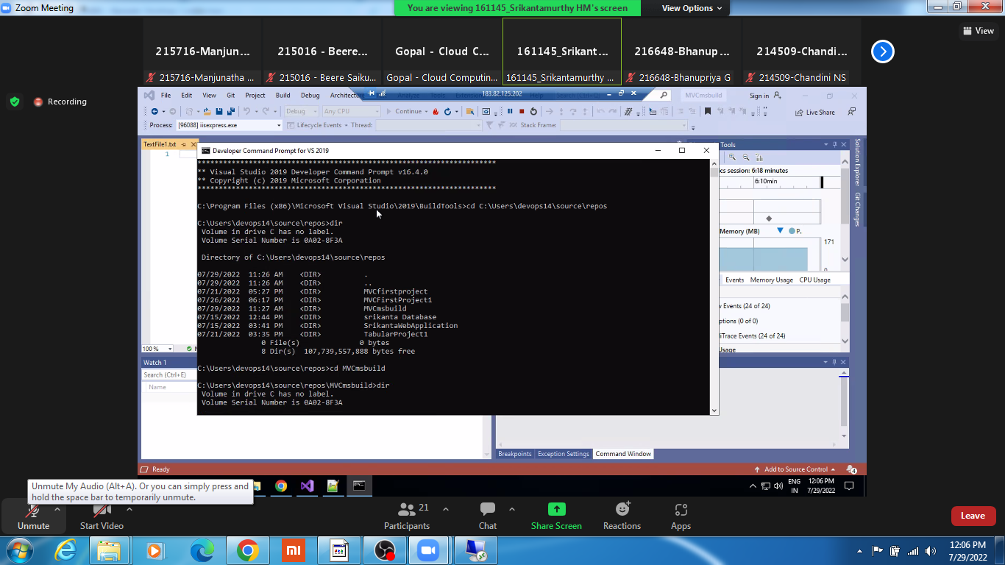

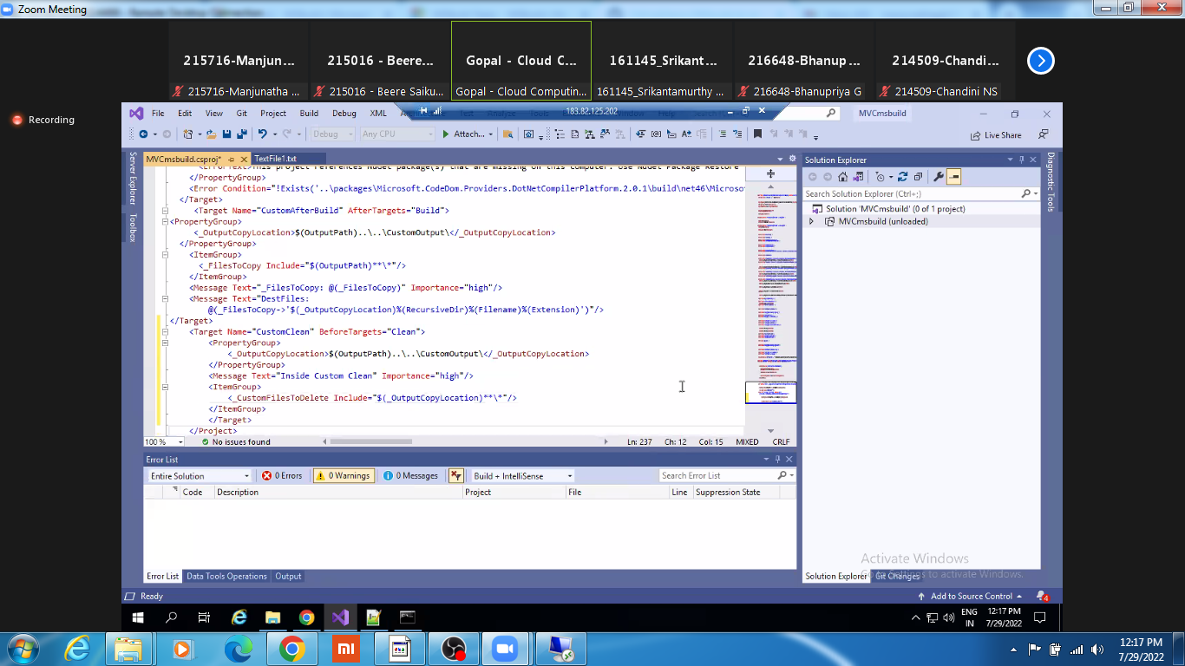

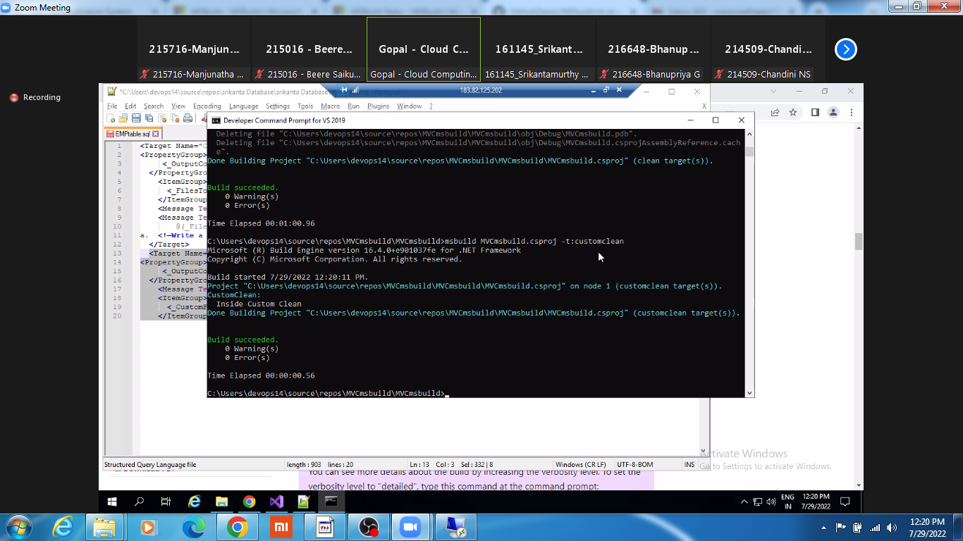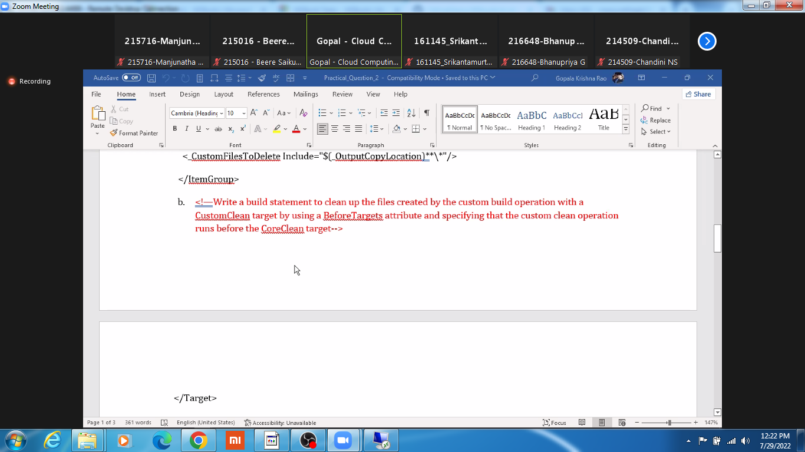

<project> <build> <!—Specify the TARGET Dirctory --> <!—Specify the OUTPUT Dirctory --> <finalName>${project.artifactId}-${project.version}</finalName> <testOutputDirectory>${project.build.directory}/test-classes</testOutputDirectory> <!—Specify the SOURCE Dirctory --> <scriptSourceDirectory>${project.basedir}/src/main/scripts</scriptSourceDirectory> <testSourceDirectory>${project.basedir}/src/test/java</testSourceDirectory> <resources> <resource> <directory>${project.basedir}/src/main/resources</directory> </resource> </resources> <testResources> <testResource> <directory>${project.basedir}/src/test/resources</directory> </testResource> </testResources> </build> </project>

Step 1: Update the System with the latest packages and security patches using these commands.sudo yum -y updateStep 2: Install EPEL or Extra Packages for Enterprise Linux repository as the Ansible available in the default YUM repository is very old and must be updated.sudo yum -y install epel-repoStep 3: Update the repository cache by running the command.sudo yum -y updateStep 4: Install the latest Ansiblesudo yum -y install ansibleStep 5: Check if Ansible is installed successfully by finding its version.ansible –version

Step 11: Securely login to remote host by generating SSH key pair based authentication.ssh-keygenStep 11.2: check the generated filesls -alStep 11.3: go into the ssh directorycd .sshStep 11.4: check the SSH key pairls –alrtStep 11.5: restart the ssh service on master and slaveSystemctl restart sshdStep 12: Copy the SSH public key into the target systems (slaves).ssh-copy-id root@target system ip addressStep 13: Check the connectivityssh root@target system ip address

Step 14: Configure the hosts file sudo vi /etc/ansible/hosts[servers]server1 ansible_host=192.168.0.101 ansible_user=rootserver2 ansible_host=192.168.0.102 ansible_user=rootserver3 ansible_host=192.168.0.103 ansible_user=rootStep 15: Test the connectivity from the hosts file ansible -m ping all

[gopal.rhce@gmail.com](mailto:gopal.rhce@gmail.com)

<https://docs.microsoft.com/en-us/learn/modules/create-windows-virtual-machine-in-azure/3-exercise-create-a-vm>

<https://crontab.guru/every-minute>

<https://github.com/saikumarbeere06/Demoproject>

<Target Name="CustomAfterBuild" AfterTargets="Build"><PropertyGroup> <_OutputCopyLocation>$(OutputPath)..\..\CustomOutput\</_OutputCopyLocation> </PropertyGroup> <ItemGroup> <_FilesToCopy Include="$(OutputPath)**\*"/> </ItemGroup> <Message Text="_FilesToCopy: @(_FilesToCopy)" Importance="high"/> <Message Text="DestFiles: @(_FilesToCopy->'$(_OutputCopyLocation)%(RecursiveDir)%(Filename)%(Extension)')"/>a. <!—Write a build statement which will copy all the output files to a new folder CustomOutput--> </Target> <Target Name="CustomClean" BeforeTargets="Clean"><PropertyGroup> <_OutputCopyLocation>$(OutputPath)..\..\CustomOutput\</_OutputCopyLocation> </PropertyGroup> <Message Text="Inside Custom Clean" Importance="high"/> <ItemGroup> <_CustomFilesToDelete Include="$(_OutputCopyLocation)**\*"/> </ItemGroup>

On the navigation bar, choose Create new (+), and then choose New repository.In the Create a new repository page, do the following:In the Repository name box, enter MySourceHub.Select Public.Check Initialize this repositoryChoose Create repositoryClone repository with your local machine using Git CommandsPush the sample application from repository using Git Commands

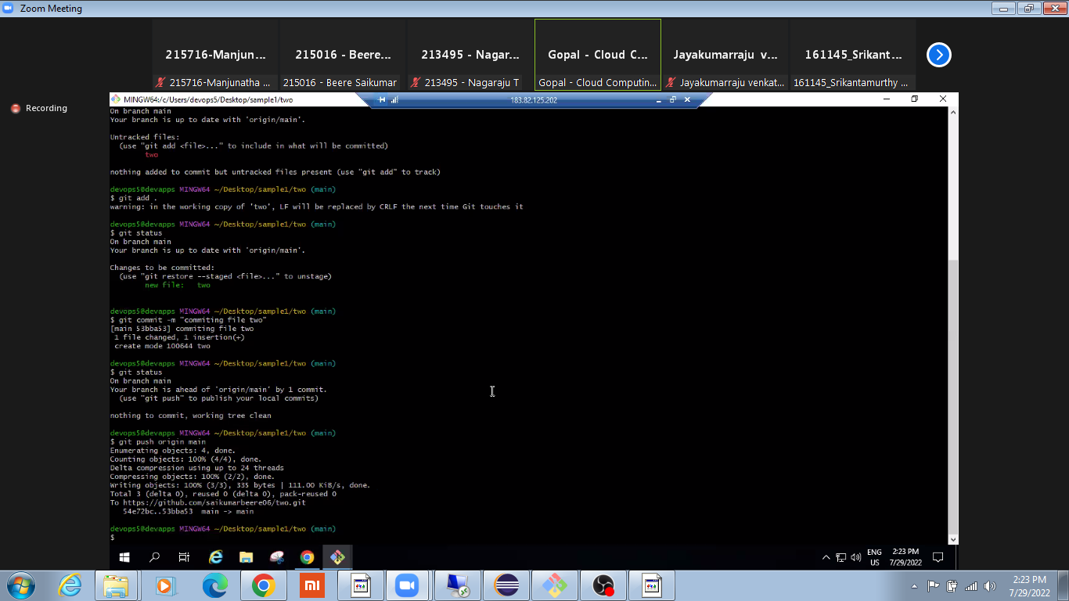

1. <directory>${project.basedir}/target</directory>b. <outputDirectory>${project.build.directory}/classes</outputDirectory>c. <sourceDirectory>${project.basedir}/src/main/java</sourceDirectory>

Jenkins – Maven Integration1. Run Jenkins as a Standalone Application2. Login to the Jenkins 3. Click on Manage Jenkins4. Click on Global Tool Configuration5. Under Maven, click on Add Maven6. Uncheck install automatically 7. Provide the path for the Maven bin folder 8. Click on Apply 9. In the Jenkins Dashboard click on New Item Enter an Item Name Select Maven Project Click on apply and save In the configure page of the Maven, enter a description, and under Maven click on advanced. Choose a custom workspace. Custom workspace is the path where pom.xml is present Under build, set the goals and options to packageClick on Save Click on Build Now which is present in New Item Wait till the build is a success

<https://docs.microsoft.com/en-us/learn/modules/create-azure-storage-account/5-exercise-create-a-storage-account>

CREATE TABLE EMPLOYEE( EmpID INT(6), Name VARCHAR(15), Role VARCHAR(15), Location VARCHAR(45), DOJ DATE, );

<https://www.knowledgehut.com/practice-tests/devops-practice-test-series-1/Result/TWZGZHlncEhvZUJXS042V0VZNVJwY1RDWmJZejRlR1g>=

MnwI6MJ9a2pxXbEd

157.50.26.107/32

<https://learn-automation.com/jenkins-with-selenium/>

34th. awk -F: '{print $1}' /etc/passwd

35. sed -i $((1 + RANDOM 20 ))d file.txt

for f in `find`; do mv -v "$f" "`echo $f | tr '[A-Z]' '[a-z]'`"; done