Co-relation of price with other features

| **price** | **sqft_living** | **bedrooms** | **bathrooms** | **floor** |
| --- | --- | --- | --- | --- |
| 0.702035 | 0.315438 | 0.525138 | 0.256794 |

There is a high correlation between price and sqftsliving and bathrooms

There is moderate correlation between price and bedrooms

There is moderate correlation between price and bedrooms

**Linear Regression**

**Sq Ft vs Housing Price**

Training Set

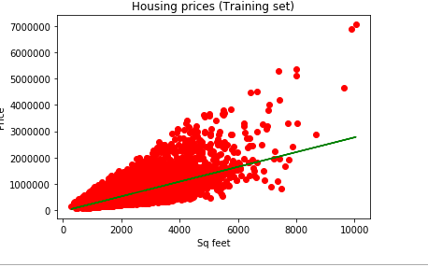

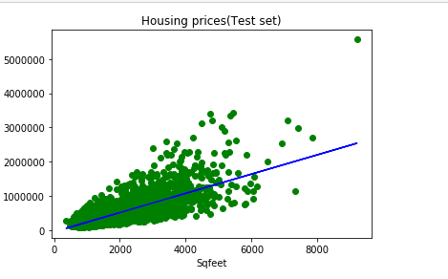

Linear regression relation

**Housing Price = 281.02*(SqFeet) - 44979.64**

**R Squared = 0.4928**

**49.28 % variation in Housing price can be explained in the model by Sq feet**

**Bedrooms vs Price**

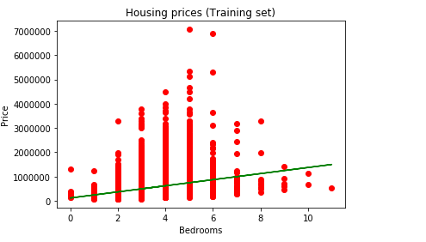

**Housing Price=125586.39*(No. Of Bedrooms)+117207.49**

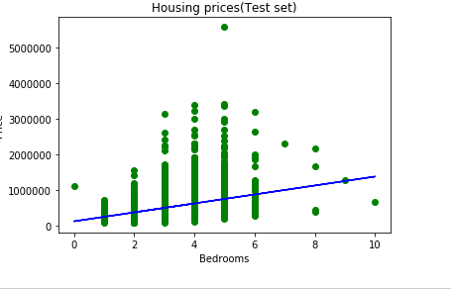

**Rsquared = 0.1075**

**As the correlation is low , the model can explain 10.75 % of variation in housing price on the basis of no. of bedrooms**

**Bathrooms vs Price**

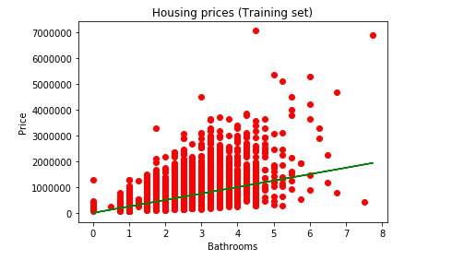

Housing Price=249555.11*(No of Bedrooms)+12104.99

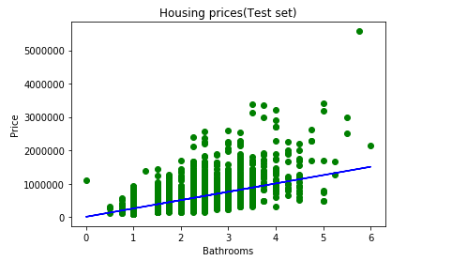

Rquared=0.2727

So, 27.27% of the variation in housing price is based on the change in no of bathrooms

**Floors vs Price**

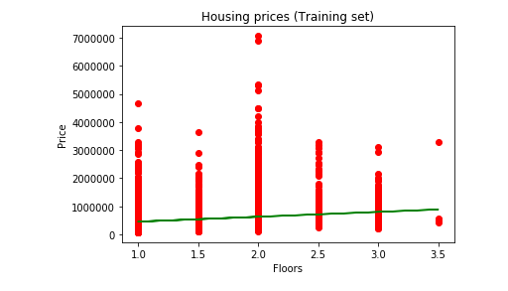

**Housing Price=173143.18*(Floor)+282613.35**

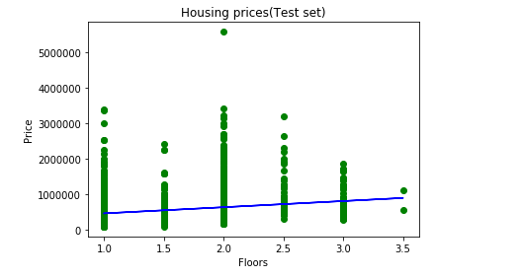

**Rsquared=0.0715**

Only 7.15% of variation in house price is based on floor