Logistic Regression for Attrition Data

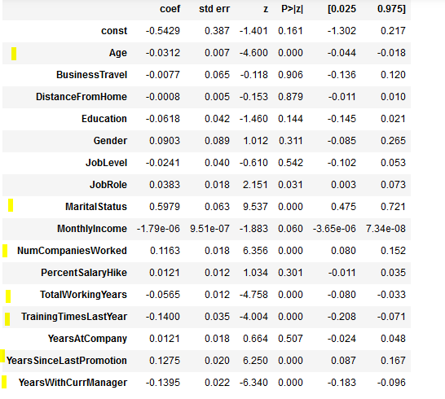

Key Features which determine Attrition are :

* Age (A)
* Marital Status (MS)
* NumCompaniesWorked (NCW)
* TotalWorkingYears (TWY)
* TrainingTimesLastYear (TLY)
* YearsSinceLastPromotion (YLP)
* YearsWithCurrManager (YCM)

**P(Attrition=Y/N)=1/1+ $e^{-(}$-0.5429-0.0312(A)+0.5979(MS)+0.1163(NCW)-0.0565(TWY)-0.14(TLY)+0.1275(YLP)-0.1395(YCM))**