LOgistic Regression on Bank Loan Data

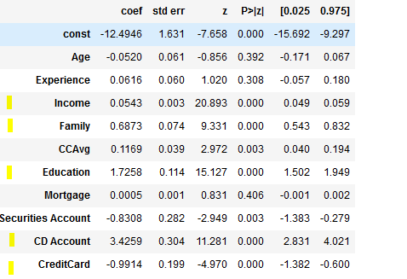

The features which are important for getting a bank loan are

* Income
* Family
* Education
* CD Account
* CreditCard

P(Loan=Y/N)=

1 /(${1+e}^{-(-12.4946+0.0543\left(Income\right)+0.6873\left(Family\right)+1.7258\left(Education\right)+3.4259\left(CD Account\right)-0.9914(CreditCard)})$